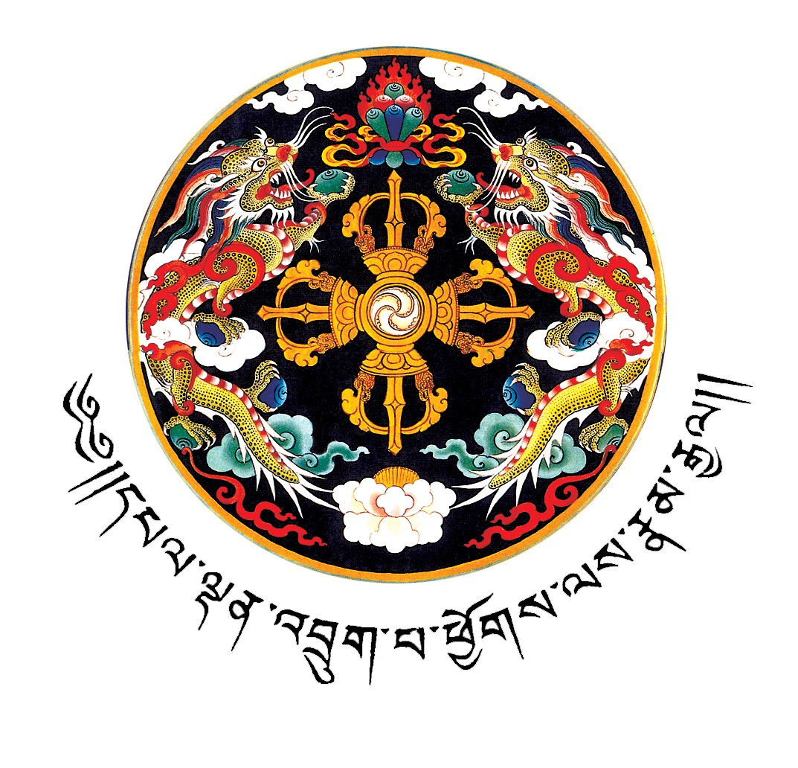 UN BHUTAN COUNTRY FUND 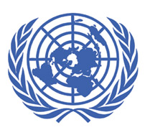
Terms of Reference
Introduction:
- The UN system in Bhutan is into the second year of implementation of its UNDAF Action Plan (common Country Programme Action Plan: cCPAP 2008-2012). The cCPAP is the result of a highly consultative and participatory process involving the Royal Government of Bhutan, key national implementing partners, all resident and non-resident UN agencies supporting Bhutan and other international partners. The cCPAP reflects the activities of 14 UN agencies supporting Bhutan within the five UNDAF outcome areas of support namely: poverty reduction; health; education; good governance and environment conservation & disaster risk management, with gender and ICT as cross cutting areas for support.
- As a result of this participatory approach, the UNDAF/cCPAP and the Government’s 10th Five Year Plan (2008-2013), have mutually benefitted from cross fertilization. The MDG Needs Assessment and Costing Exercise that Bhutan undertook in 2006 has been a useful input both to the UNDAF/cCPAP and to the 10th Five Year Plan formulation in terms of ascertaining critical resource needs, flexible financial models and policy options to consider development scenarios for achieving the MDGs. The Government’s 10th Five Year Plan is MDG-based and has as its overarching objective, poverty reduction, which is key to UN assistance. (Annex A: Alignment between national priorities & UN System areas of support).
- Bhutan’s unique long term vision and guiding development philosophy of Gross National Happiness (GNH) is seamlessly aligned with the MDGs. The core pillars of GNH: sustainable and equitable socio-economic development, conservation of the environment, preservation and promotion of cultural heritage and good governance cover all of the MDGs. As such, just as the MDGs serve as a practical global road map for the Millennium Declaration, in Bhutan the MDGs are viewed as highly relevant development strategic framework contributing to realizing Gross National Happiness as the country’s long term development goal. (Annex B: GNH&MDGs – Synergistic Linkages) This synergy between GNH and MDGs has enabled Bhutan to be one of the few countries in the region which is on track to achieving almost all of the MDGs by 2015. Thus, the UNDAF/cCPAP has been a catalyst to this realization.
- The Government is fully involved at all levels of the UNDAF/cCPAP implementation. As reflected in the Management & Implementation Framework (see figure 1), the joint Government-UN Country Programme Board is responsible for the overall implementation and supervision. The Board provides supervision and guidance to the joint Theme Groups who are responsible for the formulation, monitoring and evaluating the implementation of the cCPAP through the 18 month Workplans with the implementing partners.

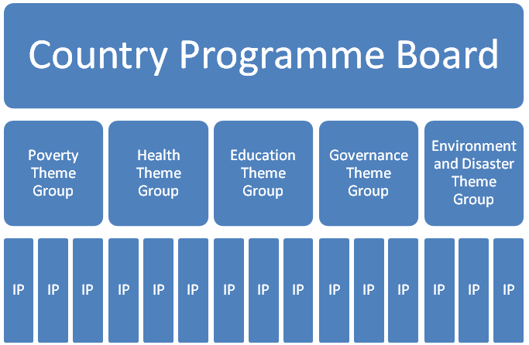
CPB:
Overall supervision and guidance

Theme Groups:
Policy dialogue, planning of joint work plans and monitoring of implementation of 5 UNDAF/cCPAP priority areas

IPs:
Implementation of joint AWPs (Implementing Partners, i.e. Ministries, Commissions and NGOs

Figure 1: Management & Implementation Framework

- UN Bhutan’s Delivering as One approach is driven along six different work streams as described in the DOCO toolkit, namely:
- UN programme: The overall goal of a common CPAP, an UNDAF operational Plan is to maximize the contributions of Participating UN Organizations by enhancing coordination, coherence, and programmatic synergies to assist in building an equitable, prosperous and democratic Bhutan. There has already been a significant reduction in the number of work plans and project documents between the Royal Government and the UN Organizations. In 2008, the number of work plans was reduced by more than 65% from around 60 projects in the past to 22 in 2008.
- Common services and harmonized business practices: The UN Bhutan Operations Management Team (OMT) under the UNCT guidance has undertaken several harmonized business practices in the areas of Human Resource, Procurement, Finance and financial reporting, Administration, IT and other common services. Taking advantage of the robust UN harmonization, both at programme and operations level, a joint Business Continuity Plan was developed in March 2009, which further reinforces UN Bhutan’s Delivering as One with mutual back-up facilities and equipment in case of major disruptive events.
- Joint communication: The UN Bhutan Communications Group comprising of representatives from all six resident agencies is responsible for ensuring a One UN image. The Group provides advisory support to the UNCT and ensures UN advocacy and communications through various channels: Bi-annual thematic UN newsletters, focusing on the main areas of UN support in Bhutan; monthly internal E newsletters for resident and non-resident agencies, and Solution Exchange – a UNCT initiated E discussion platform for knowledge management among development practitioners.
- Common premises: The design phase of the new UN-house, accommodating all resident agencies except WHO, has been completed. This common premise will be the tangible translation of the Delivering as One approach. The design incorporates a one ‘UN Operations Centre’ as opposed to agency-specific administrations. Such a set up is expected to achieve stronger integration of UN agencies’ administration promoting more efficient work flows.
- Common budgetary framework and joint resource mobilization: The cCPAP Results Matrix includes the resource requirements to realize the outcomes and outputs. Therefore, it is opportune for UN Bhutan to have a common Fund as a new pooled mechanism to mobilize and allocate additional resources at the country level, targeting the unfunded gaps in the cCPAP. Further, such a pooled funding mechanism is highly applicable for Bhutan, a country with limited access to sources of funding at the country level from bilateral and non-UN sources. The already limited donor presence is likely to reduce with some development partners phasing out their assistance in the coming years.
- Organizational Change – leadership, structure, skills, culture: Organizational change has taken root in UN Bhutan through successful UN harmonization, both at programme and operations level. While the joint Government-UN Thematic Groups ensure collaboration at the programmatic level, the OMT task forces are increasingly harmonizing business practices. The Government has expressed its appreciation to the subsequent reduction in transaction costs as a result of the harmonized processes. UNCT Bhutan identified a need for reinforcing the organizational change management process to further improve the effectiveness, efficiency and coherence of the UN development system. Regular updates on UN coherence initiatives are provided to all staff to ensure an increased understanding and working knowledge on the Delivering as One approach.
Purpose of the UN Bhutan Country Fund:
- The objective of the UN Bhutan Country Fund is to channel additional donors’ funding to support the un(der)funded portions of the UNDAF/cCPAP and new initiatives responding to emerging needs. This will enhance the flexibility and responsiveness of the UN system through the UNDAF/cCPAP to adapt to national priorities. The Fund will support allocation and disbursement of donor resources and coherent resource mobilization. The UN Bhutan Country Fund will contribute to realizing the UNDAF/cCPAP outcomes by strengthening the planning and coordination process, and channeling consistent and predictable funds towards the highest programme priorities.
- Bhutan became the world’s youngest democracy following the successful elections to the country’s first democratically elected Parliament in March 2008. This major political transition requires support over the long term. Challenges remain to build a firm foundation for the smooth functioning of a democratically elected government, through further strengthening of the constitutional bodies, enhanced capacity development of local governments, and expanding the role of civil society, an independent media and continued progress in the socio-economic arena. The credibility of democratic governance, central to the achievement of human development, is dependent on the success of this new democracy.
Subscription & Utilization of the UN Bhutan Country Fund:
- The UN Bhutan Country Fund is open to all UN agencies signatory to the UNDAF/cCPAP. They can access the funds upon signing the Memorandum of Understanding as Participating UN Organizations, and upon submission of their annual funding gaps based on the UNDAF/cCPAP Results Matrix.
- Participating UN Organizations’ regular funds remain outside the UN Bhutan Country Fund and therefore they will continue to manage and handle their own core funding. Participating UN Organizations will continue to raise other resources on an agency basis, and will be required to periodically inform the RC/UNCT on the amount mobilized and the planned allocation of those resources to ensure that the UN system has an up-to-date overview of the available and required resources to provide an accurate picture of the resource gaps for submission to the UN Bhutan Country Fund.
- Joint resource mobilization increases the probability of realizing the UNDAF/cCPAP results by ensuring adequate resources are raised in a structured manner. It will reduce transaction costs through integrated reporting by the UN system to donors on expenditures.
- The Participating UN Organizations have appointed UNDP to serve as the Administrative Agent, and this has been endorsed by the Royal Government of Bhutan. UNDP, through its Multi-Donor Trust Fund Office (MDTF Office), will administer the Fund in accordance with the provisions of the Memorandum of Understanding for the UN Bhutan Country Fund and with these ToR.
- The Administrative Agent and the Participating UN Organizations will be entitled to deduct their indirect costs on contributions received as stated in the Memorandum of Understanding under Section I, Paragraph 6 and Section II, Paragraph 8, respectively. The Administrative Agent’s administrative fee will be 1%. The fee will be deducted from the contribution to the One Fund at the time they are deposited. The indirect costs of the Participating UN Organizations will be 7%.

Contributions to the UN Bhutan Country Fund:
- Contributions to the UN Bhutan Country Fund may be accepted from governments of Member States to the United Nations, from intergovernmental, non-governmental organizations, or from private sources. Acceptance of funds from the private sector will be guided by criteria stipulated in the UN system-wide guidelines on cooperation between the UN and the Business Community the UN Secretary General’s guidelines:
http://www.un.org/partners/business/otherpages/guide.htm
- To achieve optimal progress and ensure maximum flexibility and adaptation to national priorities, a guiding principle for resource mobilization would be that donors are encouraged to contribute with multi-year un-earmarked resources. However, if this is not possible, earmarking at the level of the 5 UNDAF/cCPAP Outcomes: poverty reduction; health; education; good governance, environment and disaster risk management, will be accepted.
- The setting up of the UN Bhutan Country Fund responds to both the Delivering as One approach and commitment to Aid Effectiveness as per the Paris Declaration. The Fund could in the future become the favoured funding channel in Bhutan.
- Contributions to the UN Bhutan Country Fund may be accepted in fully convertible currency. Such contributions shall be deposited in the bank accounts designated by UNDP. The value of a contribution-payment, if made in other currencies than United States dollars, shall be determined by applying the UN operational rate of exchange in effect on the date of payment.

Governance Arrangements:
- The UNDAF/cCPAP 18 month Work Plans (see footnote 3) is the programmatic planning document that will serve as the basis for funding requests and allocations. The 18-month work plan is a functional compromise to adapt to the national fiscal cycle and is in accordance with the Paris Declaration on Aid Effectiveness. These Work Plans are derived from the budgetary framework of the cCPAP.
- The fund allocation will follow a two-tier process as reflected in the Fund Allocation Process in Annex C. The joint Theme Groups (refer to Figure 1.) will submit their priorities for funding based on the updated funding gap matrix, finalized at their Annual Review meetings in November each year. These proposed priorities will be compiled and reviewed by the Office of the Resident Coordinator and the GNH Commission and submitted to the Steering Committee.
- The Steering Committee will review the proposed priorities and approve the initial prioritization if required, and based on it, the Steering Committee will submit an overview of the Resource Gap matrix to the donors in December each year.
- Upon receipt of the funds from donors in February, or as and when needed, the Steering Committee will make the final allocation decisions, based on the financial status of the Fund and the needs of the Government. The Steering Committee will inform the Country Programme Board of the final endorsement at the Board’s annual meeting. For decision making, at least half of the Steering Committee members should be present or provide delegated authority. Decisions will be based on a consultative process and will be documented jointly by the Office of the Resident Coordinator and the GNH Commission. (Refer: Annex C Fund Allocation Process)

Fund Allocation Criteria
- The allocation criteria for the UN Bhutan Country Fund (Refer Annex D) provide an objective basis for resource allocation decisions by the Steering Committee to allocate resources to the respective outcomes/outputs of the UNDAF/cCPAP. The criteria for initial allocation are mainly related to UNDAF/cCPAP relevance, Delivering as One, resource gaps and agency’s comparative advantage. Additional criteria for subsequent allocation are related to absorption capacity. The Joint Theme Groups are responsible for ensuring that their proposed activities meet the fund allocation criteria. The requests should preferably not be below US$ 10,000 in order to encourage programmatic approaches and ensure operational efficiency.

The Resident Coordinator
- The overall management of the UN Bhutan Country Fund will be led and coordinated by the Resident Coordinator in consensus with the Heads of the Participating UN Organizations.
- In line with the overall objective of ‘Delivering as One’ in Bhutan, the Resident Coordinator will be responsible for:
- Strategic leadership of the UN Bhutan Country Fund on the basis of the UNDAF/cCPAP
- Advocating and mobilizing resources for the UN Bhutan Country Fund in collaboration with Participating UN Organizations
- Lead a consultative process on allocations from the UN Bhutan Country Fund, and make final decision if consensus cannot be reached, with documented process and rationale for these decisions
- Signing the Memorandum of Understanding with Participating UN Organizations and the Standard Administrative Agreement(s) as witness
- Implementation of the programme activities funded by the resources from the UN Bhutan Country Fund will be the responsibility of the Participating UN Organizations, as stipulated in the Memorandum of Understanding. The RC will hold the Heads of Participating UN Organizations accountable for their Organization’s components of the results of initiatives funded through the UN Bhutan Country Fund.

The Steering Committee
- The Steering Committee is comprised of UN signatories to the UN Bhutan Country Fund and the Gross National Happiness (GNH) Commission, and is co-chaired by the Secretary of the GNH Commission and the UN Resident Coordinator. ToR for the Steering Committee are attached as Annex E.
- The Steering Committee will be responsible for prioritization and allocation decisions of the UN Bhutan Country Fund. The initial prioritization for allocation will be guided by recommendations from the Joint Theme Groups’ annual review process.
- The Steering Committee will guide the operations and management of the Fund; it will annually review the joint resource mobilization strategy and subsequently implement it. The Steering Committee will ensure that the Country Programme Board is informed of the allocations, and will take into consideration the Country Programme Board’s strategic priorities.

The Administrative Agent
- As stated in the Memorandum of Understanding, Section I, the UNDP MDTF Office will, as the Administrative Agent:
- Receive contributions from donors that wish to provide financial support to the Fund;

- Administer such funds received, in accordance with this Memorandum of Understanding including the provisions relating to winding up the Fund Account and related matters;

- Subject to availability of funds, disburse such funds to each of the Participating UN Organizations in accordance with instructions from the Steering Committee, taking into account the budget set out in the approved programmatic document, as amended in writing from time to time by the Steering Committee;

- Consolidate statements and reports, based on submissions provided to the Administrative Agent by each Participating UN Organization, as set forth in the TOR, and provide these to each donor that has contributed to the Fund Account and to the Steering Committee;

- Provide final reporting, including notification that the Fund has been operationally completed, in accordance with Section IV below;

- Disburse funds to any Participating UN Organization for any additional costs of the task that the Steering Committee may decide to allocate (as referred to in Section I, Paragraph 3) in accordance with TOR.

- In line with the provisions of the Memorandum of Understanding, the Administrative Agent will ensure that the finalized annual consolidated report on the UN Bhutan Country Fund, is compiled and distributed to all donors contributing to the Fund and to the Participating UN Organizations, including maintaining an appropriate level of fund information on the UN system website for Bhutan (www.unct.org.bt) and the UNDP MDTF Office’s website (www.undp.org/mdtf) to ensure transparency.

Support Services provided by the Resident Coordinator’s Office
- The Office of the Resident Coordinator is responsible for support to the strategic leadership role of the Resident Coordinator for the UN Bhutan Country Fund, in line with the UNDAF/cCPAP. It will provide support in all the designated tasks for the Resident Coordinator as listed in paragraph 22 and 23.
- Drawing on the Joint Theme Groups’ annual report, including results reports, the financial report and the funding gap matrices, the Office of the Resident Coordinator and the GNH Commission will compile and review the proposed priorities for funding allocation and submit to the Steering Committee for prioritization and allocation decisions.
- One staff member designated within the Office of the Resident Coordinator will be dedicated to supporting the consolidation of the narrative reports, to support inter-agency consultations on the cCPAP and the UN Bhutan Country Fund where appropriate, and to prepare and report on consultations with stakeholders regarding the cCPAP and the UN Bhutan Country Fund.

Activities of Participating UN Organizations
- As stated in Section III of the Memorandum of Understanding, the implementation of programme activities will be the responsibility of the Participating UN Organizations and will be carried out by each Participating UN Organization in accordance with applicable regulations, rules, directives and procedures. Accordingly, personnel will be engaged and administered, equipment, supplies and services purchased, and contracts entered into in accordance with the provisions of such regulations, rules, directives and procedures. The UNDAF/cCPAP Work Plans will serve as the reference document for proposed programme activities.
- The Participating UN Organizations will carry out the activities for which they are responsible, in line with the budget contained in the approved Work Plan, as amended annually or as and when required by the Steering Committee to adapt to changing emerging situations.
- In the event where a Participating UN Organization is unable to deliver as committed in a given year, any resources allotted should be re-allocated the following year to other agreed priorities, as approved by the Steering Committee.
- The Participating UN Organizations recognize that it is important to take all necessary precautions to avoid corrupt, collusive or coercive practices (Memorandum of Understanding, Section III, Paragraph 7, refers).

Monitoring and Evaluation
- Monitoring and evaluation of the Work Plans is the responsibility of the UNCT. The monitoring and evaluation of the work plans will be done using the Royal Government’s Planning and Monitoring System (PlaMS) Standard Progress Report. The UNCT adopted this to use the national monitoring and reporting system which is in accordance with the Paris Declaration on Aid Effectiveness.
- The five Thematic Groups will be responsible for monitoring achievement of relevant outputs and outcomes, ensuring that gender is mainstreamed, and for preparing an annual progress report on the five UNDAF/cCPAP Outcomes. Assurance activities will be conducted by Participating UN Organizations and national implementing partners

Audit
- As stated in Section VI of the Memorandum of Understanding, the Administrative Agent and Participating UN Organizations will be audited in accordance with their own Financial Regulations and Rules. The Internal Audit Services (IAS) of each Participating UN Organization will prepare a summary of the internal audit reports on activities related to the Fund of Bhutan at intervals agreed upon between the IAS of Participating UN Organizations and of the Administrative Agent. The IAS of each Participating UN Organization will share its summary with its Representative in Bhutan Country Office, who will then share it with the Steering Committee.
Reporting
- Each Participating UN Organization shall provide the Administrative Agent with the following statements and reports prepared in accordance with harmonized accounting and reporting procedures applicable to the Participating UN Organizations and as reflected in the Memorandum of Understanding signed between the Administrative Agent and the Participating UN Organizations concerned:
- Annual narrative progress reports, to be provided no later than three months (31 March) after the end of the calendar year;
- Annual financial statements and reports as of 31 December with respect to the funds disbursed to it from the Fund Account, to be provided no later than four months (30 April) after the end of the calendar year;
- Final narrative reports, after the completion of the activities in the approved programmatic document and including the final year of the activities in the approved programmatic document, to be provided no later than four months (30 April) of the year following the financial closing of the Fund. The final report will give a summary of results and achievements compared to the goals and objectives of the Fund; and
- Certified final financial statements and final financial reports after the completion of the activities in the approved programmatic document and including the final year of the activities in the approved programmatic document, to be provided no later than six months (30 June) of the year following the financial closing of the Fund/Programme. (Annex F provides a snapshot of the Standard Reporting Requirements under the Memorandum of Understanding for Participating UN organizations and for the AA under the SAA).
- In line with the Memorandum of Understanding, the Administrative Agent will prepare consolidated narrative progress and financial reports, based on the reports referred to in paragraph 39 (a) to (d) above, and will provide those consolidated reports to each donor that has contributed to the Fund Account, as well as the Steering Committee, in accordance with the timetable established in the Standard Administrative Arrangement.
- The Administrative Agent shall also provide to the donors, Steering Committee and Participating UN Organizations, an annual certified financial statement on its activities as Administrative Agent (‘Report on Sources and Use of Funds’) no later than five months (31 May) after the end of the calendar year, as well as a certified financial statement no later than seven months (31 July) of the year following the financial closing of the Fund.
- The Theme Groups’ results based Annual Progress Reports will serve as the content for the narrative part of the UN Bhutan Country Fund report for both un-earmarked and earmarked contributions. The reports will include a review of budgets as actually expended versus planned.

Joint Communication
- In line with the Memorandum of Understanding (Section VII), each Participating UN Organization will take appropriate measures to publicize the UN Bhutan Country Fund and to give due credit to the other Participating UN Organizations. Information given to the press, to the beneficiaries of the UN Bhutan Country Fund , all related publicity material, official notices, reports and publications, will acknowledge the role of the Royal Government of Bhutan, the donors, the Participating UN Organizations, the Administrative Agent and any other relevant entities.
- The Office of the Resident Coordinator will in accordance with the UN Bhutan Country Fund Memorandum of Understanding, in consultation with the Steering Committee ensure that decisions regarding the approval and review of the UN Bhutan Country Fund are posted for public information on the websites of the UN in Bhutan and the UNDP MDTF Office (www.undp.org/mdtf). Such reports may include Steering Committee approved programmes, and programmes awaiting approval, annual financial and progress reports as well as external evaluations, as appropriate.

Dispute Resolution Mechanism
- In the event a dispute arises, the Resident Coordinator will mediate and make final decisions on fund allocation, with documented process and rationale for these decisions. The second line resolution mechanism will be the Regional Directors’ Team who will be requested to intervene after the dispute has been brought to the attention of the Team. Any dispute, controversy or claim which is not settled within sixty (60) days from the date either party has notified the other party of the nature of the dispute, controversy or claim, and of the measures which should be taken to rectify it, will be resolved through consultation between the Executive Heads of each of the Participating UN Organizations and of the Administrative Agent, as reflected in the Memorandum of Understanding.
- The above reflects the UNDG Dispute Resolution Mechanism for UN Country Teams. The UNDG MDTF Fiduciary Management Oversight Framework (FMOG) will provide guidance on all inter-agency fiduciary, legal and assurance issues, including substantial departures from the MOU, SAA and Steering Committee Terms of Reference, and also reviews and initiates required revisions to agreed MDTF arrangements.

Other Matters
- The UN Bhutan Country Fund will be established upon signing of the Memorandum of Understanding by at least two (2) Participating UN Organizations and the Administrative Agent. In principle, all Participating UN Organizations signatory to the UNDAF/cCPAP can apply for the available funds upon signing the Memorandum of Understanding and upon submission of their annual funding gaps based on the UNDAF/cCPAP Results Matrix. The UN Bhutan Country Fund will terminate upon completion of all projects/programmes funded through the Fund and after satisfaction of all commitments and liabilities, as stipulated in Section VIII of the Memorandum of Understanding.
- Any balance remaining in the Fund Account or in the individual Participating UN Organizations’ separate ledger accounts upon completion of the Fund will be used for a purpose mutually agreed upon or returned to the donor(s) in proportion to their contribution to the Fund as agreed upon by the donors and the Steering Committee.

ANNEX A: ALIGNMENT BETWEEN NATIONAL PRIORITIES AND UN BHUTAN AREAS OF SUPPORT
2008-2012

National Priority | UNDAF Outcome
1. To halve poverty by 2013 | By 2012, opportunities for generation of income and employment increased in targeted poor areas. (MDG 1, 8)
2.To improve accessibility, quality and sustainability of health care delivery system | By 2012, increased access and utilization of quality health services with emphasis on reproductive health, maternal and child health and nutrition, HIV/AIDS, TB, malaria and non-communicable diseases. (MDG 4,5,6)
3.To improve quality, relevance and coverage of education | By 2012, access to quality education for all with gender equality and special focus on the hard-to-reach population improved. (MDG 2,3)
4.To foster good governance as a core value for development | By 2012, institutional capacity and people’s participation strengthened to ensure good governance. (MD & MDG 1,3,8)
5.To enhance environmental sustainability and disaster management | By 2012, national capacity for environmental sustainability and disaster management strengthened (MDG 7)

ANNEX B
GNH and MDGs – Synergistic Linkages
Key GNH Pillars and Domains of GNH | Corresponding MDGs
The Four Pillars of GNH
1. Sustainable & Equitable Socio-Economic Development | Encompasses virtually all of the MDGs but particularly relevant to Goal 1 pertaining to eradication of extreme poverty and hunger
2.Conservation of Environment | Goal 7 pertaining to environmental sustainability
3. Preservation and promotion of Culture | No direct corresponding MDGs but strong linkages with environmental sustainability, health and education MDGs
4. Good Governance | Good governance widely recognized to be critical for achievement of MDGs
The GNH Domains
Education | Goals 2 and 3 pertaining to achieving universal primary education and promoting gender equality
Health | Goals 4, 5 and 6 pertaining to reducing child mortality, improving maternal health and combating HIV/AIDS, malaria and other diseases
Economic Standard of Living | Goal 1 pertaining to eradicating extreme poverty and hunger and Goal 7 for targets relating to household access to secure tenure
Ecological Diversity and Resilience | Goal 7 pertaining to environmental sustainability and Goal 1 pertaining to reducing extreme poverty and hunger
Time Use | Goal 3 pertaining to gender equality and Goal 8 for targets pertaining to youth unemployment
Psychological Well Being | Various psychological well being factors identified such as income security, health & education, basic needs (water and sanitation) are linked to several MDG targets
Good Governance | Deemed critical for achieving the MDGs
Cultural Diversity and Resilience | No corresponding MDGs or targets but strong linkages with environmental sustainability, health and education MDGs
Community Vitality | No corresponding MDGs

UN BHUTAN COUNTRY FUND
ANNEX C: Fund Allocation Process for UN Bhutan Country Fund
Step 1: Submission
Based on the joint Annual Reviews, the Theme Groups submit updated resource gap matrix and indicate priorities for funding
Timeframe: Nov. each year
Step 2: Compilation & initial review:
GNH Commission and Office of the RC compile and review the proposed priorities and submit the documents to the Steering Committee.
Timeframe: Dec first-half
Step 3: Submission of resource gap
The Steering Committee, comprising of signatories to the UN Bhutan Country Fund MoU and the GNHC, reviews the resource gaps and approves the initial prioritization for funding. The approved resource gap is submitted to the donors for funding request in December each year, with a copy to the Government.
Timeframe: Dec third week
Step 5: Disbursement:
Administrative Agent disburses the funds to the Participating UN agencies in accordance with the approved Work Plans within three (3) to five (5) working days after final allocation of funds.
Timeframe: March End

Step 4: Final Allocation
Based on funds received from donors, the Steering Committee make the final allocation decisions and inform the Country Programme Board.
Timeframe: February or as and when needed

ANNEX D: UN BHUTAN COUNTRY FUND ALLOCATION CRITERIA

The UN Bhutan Country Fund is open to all Participating UN Organizations signatory to the UNDAF/cCPAP. Organizations can access the funds upon signing the Memorandum of Understanding and upon submission of their annual funding gaps based on the UNDAF/cCPAP Results Matrix.
Criteria for initial allocation:
- UNDAF/cCPAP Relevance
- Unfunded Gap at Outcome level
- Joint AWP i.e. 2 or more Participating UN Organizations implementing
- Implementation Capacity
- Comparative advantage in implementing the activities
- Priorities which would otherwise not be funded
- Activities which support core UN development priorities on the MDGs, such as gender, human rights and capacity development supplemented by priorities identified by the Steering Committee and Country Programme Board at the start of the annual programme cycle
- Realistic Outcome Budget

Subsequent allocations will in addition to the above include the following:
- Implementing partners and Participating UN Organizations’ absorption capacity
Previous track record:
- Results
- Expenditure rate and financial Management
- Reporting – timeliness and quality of reporting
ANNEX E:
STEERING COMMITTEE OF THE UN BHUTAN COUNTRY FUND (MDTF)
Generic Terms of Reference

Composition:

The Steering Committee (SC) is co-Chaired by the Secretary of the Gross National Happiness Commission (GNHC) and the UN Resident Coordinator (RC). Members include signatories to the UN Bhutan Country Fund MoU who have contributed to the resource gap analysis and Gross National Happiness (GNH) Commission. The Administrative Agent can be an ex-officio member of the Steering Committee. Other UN signatories to the UNDAF/cCPAP may participate as observers.

Key Tasks and Responsibilities:
- To review and approve their Terms of Reference and Rules of Procedures, based on the generic SC TOR, and update and/or modify them, as necessary, in case of compelling requirements. In case of departures from the generic TOR, the TOR of the SC should be referred for endorsement to the HQs Fiduciary Management Oversight Group;
- For funds earmarked by donors to thematic clusters/sectoral groups or Agencies and prioritized/allocated within thematic clusters, to review and ensure the alignment of the allocations with the strategic development framework of the country and approved national priorities;
- For unearmarked funds, (1) to review and approve the criteria for the allocation of available MDTF resources; (2) to allocate available resources to thematic clusters, making sure that the allocations are aligned with the strategic development framework of the country and approved national priorities. The clusters will be responsible for the prioritization within the cluster allocation;
- To review and approve proposals from Agencies submitted (by thematic clusters/sectoral groups or otherwise) for funding; ensure their conformity with the requirements of the MDTF agreements (MoUs). To ensure the quality of proposals to receive funding from the MDTF.
- To discuss the MDTF requirements and priorities concerning, inter alia:
- Programme/project management, including consistent and common approaches to programme/project costing, cost recovery, implementation modalities, results-based reporting and impact assessment,
- Information management including appropriate MDTF and MDTF donor visibility;
- To define Terms of Reference and composition for the thematic clusters/sectoral groups or other similar review bodies.
- To ensure appropriate consultative processes take place with key stakeholders at the country level so as to avoid duplication or overlap between the MDTF and other funding mechanisms;
- To review and approve the periodic progress reports (programmatic and financial) consolidated by the Administrative Agent based on the progress reports submitted by the Participating Agencies. To ensure consistency in reporting between clusters; Consolidated annual reports should include a section on the activity of the Steering Committee.
- To review findings of the summary audit reports consolidated by the internal audit service of the Administrative Agent. To highlight lessons learnt and periodically discuss follow up by Participating Agencies on recommended actions that have MDTF-wide impact;
- To agree on the scope and frequency of the independent “lessons-learned and review” of the MDTF commissioned by the SC, in consultation with the HQ Fiduciary Management Oversight Group.
- To review the draft/final reports on lessons learnt, ensure the implementation of recommendations and identify critical issues for consideration by the HQs Fiduciary Management Oversight Group (to be brought up to the ASG Group, if/as required).

Decisions:
The Steering Committee makes decisions by consensus. Decisions of the Steering Committee shall be duly recorded.
Prior to presenting their position on a significant issue to the SC, its UN members have to make sure that it is endorsed internally by their Agencies and is in line with their Agencies’ regulatory requirements.
Decisions on programme/project proposals will only be taken upon completion of a review by the appropriate thematic clusters, sectoral working groups or other SC agreed review bodies.

Role of the UN co-Chair/Chair of the Steering Committee:
- To make sure that the decisions taken by the Steering Committee are in accordance with the regulatory requirements and frameworks of the Participating Agencies and agreements with the programme country and donors;
- To ensure that the decisions taken by the Steering Committee are duly recorded and promptly communicated to the members of the Steering Committee, including Participating Agencies, the programme country, and donors, as appropriate;
- To monitor the implementation of the decisions of the Steering Committee;
- To report to the MDTF Fiduciary Management Oversight Group on the evolving risks and to flag issues that may affect the implementation of the decisions of the Steering Committee or otherwise impede the operations of the Fund;
- The UN co-Chair, representing the SC, is accountable to the Chair of the MDTF Fiduciary Management Oversight Group, representing the Committee, for the inter-agency fiduciary issues related to the Participating UN Agencies on issues related to funding through the UN for the MDTF activities.
ANNEX F: Standard Reporting Requirements under the MOU for Participating UN organizations and for the AA under the SAA

 | Participating UN Organizations | Administrative Agents for ‘Country Funds’ | Steering Committee for Expanded DAO Funding Window | UNDP Treasury
Report | Annual narrative progress report | Annual consolidated narrative progress report, based on annual narrative progress reports received from Participating UN Organizations | Annual consolidated narrative progress reports submitted by the AAs
Receiving party | AA for ‘Country Fund’ | Steering Committee | Donors
Deadline | no later than 31 March | no later than 31 May | no later than 30 June
Report | Annual financial statement and report as of 31 December | Annual consolidated financial report, based on annual financial statements and reports, to be received from the Participating UN Organizations, as of 31 December | Annual consolidated financial report submitted by the AAs | Certified annual financial statement (“Source and Disbursement of Funds in the Expanded DAO Funding Window”)
Receiving party | AA for ‘Country Fund’ | Steering Committee | Donors | Donors and, for information, Steering Committee
Deadline | no later than 30 April | no later than 31 May | no later than 30 June | no later than 31 May
Report | Final narrative report, after the completion of the activities, including the final year | Final consolidated narrative report, based on final narrative reports received from Participating UN Organizations | Final consolidated narrative reports submitted by the AAs
Receiving party | AA for ‘Country Fund’ | Steering Committee | Donors
Deadline | no later than four months of the year following the financial closing of the Fund/Programme – 30 April | no later than seven months of the year following the financial closing of the Fund/ Programme – 31 July | no later than 31 August
Report | Certified final financial statement and final financial report after the completion of activities, including the final year of activities | Final consolidated financial report, based on certified final financial statements and final financial reports received from Participating UN Organizations | Final consolidated financial reports submitted by the AAs
Receiving party | AA for ‘Country Fund’ | Steering Committee | Donors | Donors and, for information, Steering Committee
Deadline | no later than six months of the year following the financial closing of the Fund/Programme – 30 June | no later than seven months of the year following the financial closing of the Fund/ Programme – 31 July | no later than 31 August | no later than 31 July
Report |  | Certified annual financial statement (“Source and Use of Funds”)
Receiving party |  | UNDP
Deadline |  | no later than five months after the end of the calendar year – 31 May
Report |  | Certified final financial statement (“Source and Use of Funds”)
Receiving party |  | UNDP
Deadline |  | no later than seven months of the year following the financial closing of the Fund/ Programme – 31 July

Bhutan will need to invest around USD2.5billion@1USD=Nu.45.25 in 2005 prices between 2006 and 2015 for achieving the MDGs by 2015. Source: Bhutan MDG Needs Assessment and Costing Report(2006-2015)
The Board comprises of Secretaries of all relevant ministries, representatives of UN agencies signatory to the UNDAF/cCPAP. The Board is co-chaired by the Secretary, GNH Commission and the UN Resident Coordinator.
The 18-month work plan with indicative resource figures for the last six months is implemented to align to the Government’s fiscal year of July – June thus improving programme planning.
As used in this document, an approved programmatic document refers to the UNDAF/cCPAP Joint Work Plans which is approved by the Steering Committee for fund allocation purposes.
Reporting requirements leverage to the existing reporting structures in place as part of the Standard Progress Reports, the annual reviews and the Annual Progress Reports of the cCPAP and the Country Programme Board.
This is an informal mechanism, which does not cover issues which are dealt with by the established formal internal justice system.
Source: United Nations Development Assistance Framework for the Kingdom of Bhutan 2008-2012, June 2007
Source: Bhutan’s Progress: Midway to the Millennium Development Goals, 2008
This includes available human resources and financial contributions of the organizations to the result, in addition to the UN Bhutan Country Fund contributions
UNDG has identified 5 core mandate areas for UN development interventions include human rights, gender, MDGs and capacity development
The SC Support Office will prepare the criteria for discussion by the SC.
The standard reporting period is as per the MoU.
Source: Guidance Note: Expanded ‘Delivering as One’ Funding Window for achievement of MDGs, April 2009

