Liberia Peacebuilding Fund

QUARTERLY STATUS UPDATE AS OF DECEMBER 31, 2009

Recipient UN Organization: | UNDP |  | PBF Priority Area: To Promote peace and resolve conflicts |  | Priority Area 2: Critical Interventions to promote peace and resolve conflicts
Implementing Partner(s): | Landmine Action (LMA), Ministry of Agriculture (MOA), Liberia Rubber Development Authority (LRDA), Central Agricultural Research Institute (CARI)
Project Number: | PBF/LBR/D-3 (00063760)
Project Title: | Tumutu Agricultural Training Programme (TATP)
Project Objective & Scope | - Hotspots exhibit improved security and implementation of rule of law  - Ex-combatants that were formally dependent on illegal livelihoods will, pursue legal and sustainable livelihoods  - Beneficiaries become better citizens with greater respect for the rule of law and improved social and communication skills  - Ex-combatants are reintegrated into communities away from former hotspots  - Government eventually assumes full ownership and management of the centre
Total Approved Project Budget | US$1,123,500
Funds Committed: | US$1,123,500 |  | Percentage of Approved: |  | 100%
Funds Disbursed: | US$ 950,449.81 |  | Percentage of Approved: |  | 84%
SC Approval Date: | 25 September 2008
Expected Project Duration: | 18 Months (Oct 8, 2008-Mar 31, 2010) | Forecast Final Date: |  | March 31, 2010 |  | Delay (Months): | Nil

Outputs: | Progress: | Percentage of planned:
Ex-combatant population participating in illegal  natural resource extraction reduced | 402 beneficiaries removed from UNMIL designated ‘hotspots’ to the training site in preparation for course III | completed
 | M&E of Course II Graduates completed | completed
Trainees are thoroughly trained in MOA approved techniques | Centre prepared and fully equipped for Course III | completed
Trainees are thoroughly trained in MOA approved techniques | Training commenced on 26th October 2009 | completed
 | Preparation for midterm exam undertaken | completed
Trainees are economically  and socially  integrated/reintegrated in communities | 723 graduates have been reintegrated back into their chosen communities | n/a
 | 89% of graduates report farming as their prime source of income | n/a
 | No reports of graduate related criminal behaviour in host communities | n/a
Agricultural  capacity of trainee‐ receiving  communities/ sites of employment increased | Evidence of effective upturn with several communities forming cooperatives comprising graduates and community members as well as an increase in agricultural production and market activity in sectors of: rubber, rice, vegetables, animal husbandry and tree crops | n/a
MOA capacity  to plan and manage  agricultural training enhanced | MOA staff contributing to project management and teaching activities | n/a
TATP a self‐sustaining,  MOA‐ funded national  agricultural training centre setup | Draft business plan compiled for discussion | n/a

Outcomes: | Progress:  {In terms of Indicators} | Comments/Remarks:
Ex-combattant  Populations participating in illegal natural resource extraction reduced | 65% reduction in the number of ex-combatants | n/a
Stability  and legal economic activity  in areas of natural resource  extraction enhanced | The plantation and surrounding areas stabile with income generation activities taking place | Ex-combatants and community members remained engaged
Trainees trained in MOA approved agricultural techniques | Trainees are applying the skills acquired | n/a

Qualitative achievements against expected results:
- 402 students have been successfully registered and transferred to the centre from Bopulu and Nimba Counties despite the constraints caused by road conditions
- Trainees are successfully living and studying on site without problems
Challenges{If Necessary}:
- Financial Capacity of the Ministry of Agriculture
Whilst the MoA remains committed to the training centre and its eventual handing over, they have not been able to commit financially to the centre’s running costs. Alternative sources of funding are being sought
- Donor funds
Continued lack of sufficient donor funding continues to put restraints on the effective running of the project

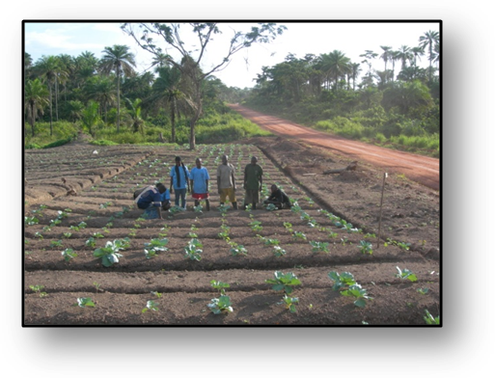
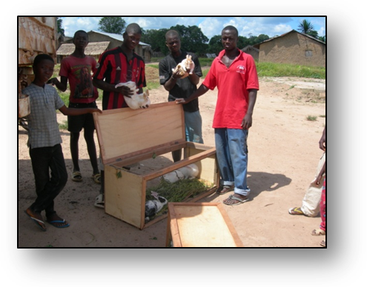
Graduates receiving their batches

