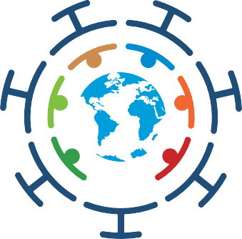

**Global Interim Report of the UN COVID-19 Response and Recovery Fund**

for the period October 2020 to July 2021

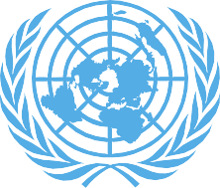

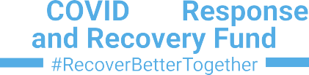

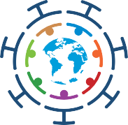**Global Interim Report of the UN**

**COVID-19 Response and Recovery Fund**

for the period October 2020 to July 2021

UN Multi-Partner Trust Fund Office

© 2021 UN MPTF Office. All rights reserved. May not be reproduced by any means without written permission, except when citing and/or reposting a copy of this PDF document with appropriate attribution.

Sources: Unless noted, all information and data are courtesy of the UN Multi-Partner Trust Fund Office (MPTF Office).

The views expressed in this publication are those of the authors and do not necessarily represent those of the United Nations, affiliated agencies or Member States.

**Global Interim Report of the UN COVID-19 Response and Recovery Fund**



for the period October 2020 to July 2021

## CONTENTS

Foreword 2

Introduction 3

Executive Summary 6

Pillar 1 on Health First 6

Pillar 2 on Protecting People 7

Pillar 3 on Economic Response and Recovery 7

Pillar 4 on Macroeconomic Response and Multilateral Collaboration 8

Pillar 5 on Social Cohesion and Community Resilience 8

Cross-Pillar Programmes 8

Cross-Cutting Results 9

Towards Gender Equality 9

Leaving No One Behind 10

Snapshots of Innovation 11

Contributors and Capitalization 12

Annex I: Achievements and Emerging Results by Country 13

Annex II: Governance Structures and Procedures 71

Operations 71

Work of the Advisory Committee 72

## FOREWORD

rom its onset, the COVID-19 pandemic presented the world with

F

an economic and social emergency on top of a severe health crisis. Today, as new waves and variants of COVID-19 hit countries, this development emergency persists. It jeopardizes progress towards the Sustainable Development Goals and threatens to put the world we want further out of reach, especially for those already at risk of being left behind.

The United Nations Secretary-General launched the COVID-19 Response and Recovery Trust Fund (the Fund) to help low- and middle-income programme countries overcome the health and development crises caused by the COVID-19 pandemic. Aligned to the 2030 Agenda and the ‘UN Framework for the Immediate Socio-economic Response to COVID-19,’ the Fund brought the UN system together to support country responses to the health and development emergency caused by the pandemic. As this Interim Report illustrates, the Fund has, in the face of a multifaceted global emergency, shown that the UN system can act collectively, swiftly, efficiently, and flexibly to meet critical needs on the ground – all across the world.

Since its inception in April 2020, the Fund financed 95 programmes

across 80 countries with the generous support of 23 governments, the

private sector, and individual donors. Undeterred by lockdowns and supply chain disruptions, the Fund programmed these resources at speed, with over 50 programmes

commencing within eight weeks of its launch.

Fund programming has emphasized core UN values, such as gender equality and the principle of Leaving No One Behind (LNOB). Approximately 73% of proposals funded from its second Call had a gender equality marker (GEM) score of three, and none of the programmes had a GEM score below two. This meant that these funded initiatives focused on making substantial contributions to gender equality and women’s empowerment

- an important priority given the pandemic’s threats to women’s well- being and equity.

The joint programmes featured in this report lent critical support to at- risk people from communities least able to prepare for and cope with the social and economic shocks the pandemic caused. Vulnerable groups like children, people with disabilities,

migrants, and refugees benefited from projects that assured the continuity, quality, and expansion of basic services like healthcare, education, and WASH. Many vulnerable people were also able to take advantage of fund- supported cash transfers, social safety nets, and livelihood opportunities,

especially in the informal sectors. The Fund also prioritized innovation, with many projects building technical

capacity to help close the digital divide so businesses, particularly micro-, small-, and medium-enterprises, and public and private services of all kinds, could reopen and stay open.

Going forward and as the world looks to recovery, it will be important to keep learning from the lessons

of this emergency. We will have to understand how the pandemic

has shaped our path forward and to continually pursue a more equitable, green, and resilient future given this reality. This means achieving the Sustainable Development Goals, and given the current context, related objectives like universal access to COVID-19 vaccines and healthcare overall. Working towards these ambitions will not only help end the current crisis, but increase awareness and readiness for the next one.

Finally, let me take the opportunity to thank Mr. Jens Wandel, former Special Adviser to the Secretary-General on Reforms and the Secretary-General’s Designate to the COVID-19 Response and Recovery Fund, for his outstanding leadership and excellent stewardship of the Fund. Mr. Wandel rapidly operationalized the Fund, built strong partnerships and always maintained a focus on achieving the SDGs and on setting the stage for recovery.

Haoliang Xu

UN Secretary-General’s Designate ad interim for the COVID-19 Response and Recovery Fund

## INTRODUCTION

lobally, as of 22 September 2021, the World Health Organization (WHO) confirmed 229,373,963 cases of COVID-19, including 4,705,111 deaths. The regional distribution

G

of these cases included the Americas with 88.4 million cases, followed by Europe with 68.7 million cases; Southeast Asia with 42.6 million cases; the East Mediterranean with 15.5 million cases; Western Pacific with eight million cases, and lastly Africa with 5.8 million cases.1

The COVID-19 Response and Recovery Fund (the Fund) has continued to respond to this crisis. Capitalized at US$ 83,331,064 as of mid-September 2021, the Fund

financed 95 programmes globally to address what became a pandemic- driven development emergency.

Since its inception, it has financed 33 programmes in Africa; 30 programmes in Asia-Pacific, two in the Arab States and Territories; 13 programmes in Europe and Central Asia; and 17 programmes in Latin America and the Caribbean.

The Fund’s investments were guided by ‘The UN Secretary General’s Framework for the Immediate Socio- economic Response to COVID-19’ (the

Framework) and its five Pillars on (1) Health First; (2) Protecting People; (3) Economic Response and Recovery;

(4) Macroeconomic Response and Multilateral Collaboration; and (5) Social Cohesion and Community Resilience. From its second Call for Proposals,

the Fund financed 36 programmes and provided earmarked funding to an additional four countries. With the objective of preventing the pandemic from eroding progress towards the 2030 Agenda, the Fund’s project

portfolio also aligned to specific SDGs, including: SDG 1 on No Poverty; SDG 3 on Good Health and Well-being; SDG 5 on Gender Equality; SDG 8 on Decent Work and Economic Growth; and SDG 10 on Reduced Inequality.

This Interim Report highlights progress made over the period of October

2020 to July 2021 towards the socio- economic response to the pandemic. It features emerging results from

36 programmes financed under the Fund’s second Call for Proposals. It also showcases achievements from 13 programmes financed under the first Call for Proposals and that concluded operations shortly after the finalization of the Fund’s Global Annual Report

for 2020. Finally, this report presents results from country programmes in Mongolia, Zambia and a programme in Kosovo2, all of which were financed by earmarked contributions

|  |  |  |  |
| --- | --- | --- | --- |
| 36 Country Programmes Financed under Call 2 | | | |
| Antigua and Barbuda | Cambodia | India | Peru |
| Argentina | Cameroon | Indonesia | Rwanda* |
| Armenia | Chile | Jordan | São Tomé and Príncipe |
| Belarus* | Costa Rica | Kenya | State of Palestine* |
| Benin* | Djibouti | Liberia | Tanzania* |
| Bolivia | DRC | North Macedonia | Turkey |
| Bosnia and Herzegovina | Ethiopia* | Maldives | Uruguay |
| Brazil | Guatemala | Myanmar | Viet Nam |
| Fiji | Haiti* | Pakistan* | Zimbabwe |

Earmarked Contributions Supporting Programmes

Kosovo

*\*Country programme not reporting to this Interim Report*

Mongolia

Sudan*

Zambia

11 Call 1 Countries Featured in the Interim Report 2021

Bhutan

Jamaica**

PNG

Tuvalu

Georgia Malawi Tajikistan Lao PDR**

Guinea

Mongolia

Tunisia

*\*\* Two projects implemented in this country reported results to this Interim Report*

1. Data sourced from: [https://covid19.who.int](https://covid19.who.int/)
2. References to Kosovo shall be understood to be in the context of Security Council resolution 1244 (1999).

The Fund required UN Country Teams answering its second Call for Proposals to have a Socio-economic Response Plan (SERP) published

on the Development Cooperation Office (DCO) COVID-19 data portal under the UNINFO platform.3 UN Resident Coordinators were then able to prioritize joint programmes within the SERPs that were unfunded and strategically relevant for their country’s coherent response efforts. This approach ensured that programmes selected for funding were timely, relevant, prioritized, realistic, evidence- based, joined-up, and immediately implementable. The second Call also included an invitation for Resident Coordinators to submit up to two concept notes to be included in a Catalogue of Solutions, which was

a pipeline of strategic and unfunded

projects used to mobilize additional resources and partnerships.

Ultimately, the second Call for Proposals selected 19 proposals for funding. It financed an additional 17 through the Catalogue of Solutions, bringing the total to 36 country

programmes. Because some of the donor contributions to Catalogue programmes were received on a rolling basis, seven Call 2 programmes commenced implementation too recently to be included in this report.4 The Fund also allowed donors to earmark contributions to a particular country or window outside the Calls for Proposals. It received earmarked contributions that ranged from US$ 89,000 to US$ 1.6 million from private sector donors and governments in support of the COVID-19 response and recovery in Kosovo, Mongolia, Sudan, and Zambia.5

Creating a Catalogue of Solutions

*UN Resident Coordinators submitted 250 joint programmes, out of which 213 programmes were initially included in a ‘Catalogue of Solutions.’ The Catalogue showcased what the UN considered urgent funding needs and currently contains programmes spanning 104 countries, amounting to US$ 244 million.*

Overall, this Interim Report demonstrates the UN System’s continued ability to deliver immediate results amidst unprecedented crises.

The Fund established, capitalized, and disbursed funding with speed and agility, and it did so with a dedicated focus on gender equality and Leaving No One Behind. In addition, and as results illustrate, many joint programmes also focused on closing the digital divide at a time of great need for the remote delivery of healthcare, business operations, and government services. Further, the Fund created the Catalogue of

Solutions and digitized the second Call through its internal Fund Management Platform. In doing so, it helped assure that the UN could act together, overcoming many pandemic-driven obstacles to deliver assistance to the people and countries that needed it most.

1. See: [https://data.uninfo.org](https://data.uninfo.org/).
2. These included Belarus, Ethiopia, Haiti, Pakistan, Rwanda, State of Palestine, and Tanzania.
3. The Sudan country programme received funding in June 2021, and therefore, did not commence in time to report to this exercise.

THE FIVE PILLARS OF THE UN DEVELOPMENT SYSTEM RESPONSE TO COVID-19

1

**HEALTH FIRST**

Protecting health services and systems during the crisis

2

**PROTECTING PEOPLE**

Social Protection and basic services



3

**ECONOMIC RESPONSE AND RECOVERY**

Protecting jobs, small and medium sized enterprises, and the informal sector workers

4

**MACROECONOMIC RESPONSE AND MULTILATERAL COLLABORATION**

5

**SOCIAL COHESION AND COMMUNITY**

**RESILIENCE**

## EXECUTIVE SUMMARY

For each of the five UN Framework Pillars, this section highlights early results from Call 2 country programmes as well as final achievements of 13 country programmes financed under the first Call for Proposals.

**PILLAR 1** ON HEALTH FIRST

Nine joint programmes reported results under Pillar 1 on Health First. These included five country programmes across Brazil, Macedonia, Peru, Turkey, and Liberia from the second Call for Proposals and four country programmes spanning Jamaica, Lao PDR, Malawi, and Tajikistan from the first Call for Proposals.

Most of the Call 2 programmes reported emerging results on, *inter alia*, provisioning COVID-19 equipment and supplies, capacity building for immunizations, and healthcare for vulnerable groups. Programmes in Brazil and Peru, for instance, lent focus to the protection of Indigenous and Traditional Peoples in the Amazon Region. In **Brazil** this meant equipping seven healthcare centers for remote consultation, training 3,609 healthcare professionals, and provisioning 46% of targeted indigenous populations with access to 100,000 rapid tests and personal protective equipment (PPE). The programme also produced 14 videos in local languages with information on COVID-19. In **Peru**,

a programme trained 90% of community health workers in one district on COVID-19 prevention, and it provided intercultural trainings for obstetrics personnel in a remote area where no such personnel were normally present.

In the **Republic of North Macedonia** an initiative outreached to 10,000 parents on the MMR vaccine, and its COVID-19 vaccine hesitancy campaign reached 77% of the adult population, jumping the percentage of the population believing in the efficacy of the vaccines from 56% to 69%. Meanwhile, in **Turkey**, funds were used to set up mobile health units (MHU), which supported 3,069 individuals who accessed healthcare services.

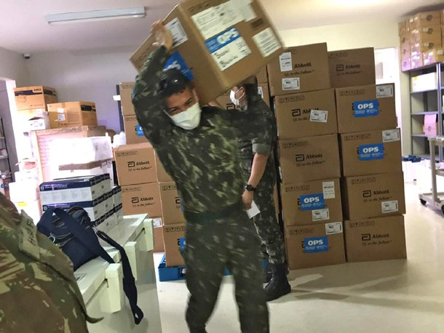

COVID-19 tests being delivered in Brazil. © PAHO.

The Call 1 programmes featured in this report focused on, *inter alia*, providing equipment, meeting reproductive health needs, and addressing gender-based violence. In **Jamaica** 6,888 healthcare workers (100%) gained access to PPE, and 7,217 persons trained on its use. The programme provided 16,000 doses of Depo Provera contraceptive and helped 14,000 people living with HIV (PLHIV) get antiretroviral treatment. An outreach campaign on sexual and reproductive health reached 228,055 people.

In **Lao PDR,** the Ministry of Health tested a simplified Sexual and Reproductive, Maternal, Newborn, Child, and Adolescent Health (SRMNCAH) service delivery system in the pandemic context. The beneficiaries included 35,988 women of reproductive age, 1,762 pregnant women, and 1,166 newborns. A programme in **Malawi,** which also focused on SRMNCAH continuity, benefitted 256,282 women who utilized services, 75,600 infants who were safely delivered by skilled health personnel, and 884 women who accessed referrals to COVID-19 treatment centers.

In **Tajikistan**, a programme that provided essential medications and supplies and training across 115 healthcare facilities benefitted 13,200 confirmed COVID-19 patients.

The initiative also helped establish tele-health technologies for the first-time, with approximately 40,780 remote online consultations related to sexual and reproductive health (SRH) and gender-based violence (GBV) conducted.

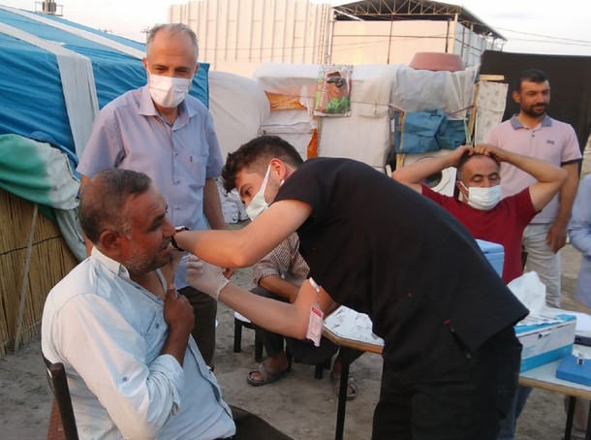

Vaccine administration by Mobile Health Units in Turkey. © UNFPA

**PILLAR 2** ON PROTECTING PEOPLE

Eight Call 2 joint programmes commenced under Pillar 2 across **Antigua and Barbuda (and the British Virgin**

**Islands), Argentina, Bosnia and Herzegovina, Guatemala, India, Indonesia, Maldives,** and **Uruguay**. Many of these initiatives extended services and protections to vulnerable groups like the elderly, people with disabilities, and refugees.

For instance, in **India,** a programme trained 62,315 child protection functionaries and partners who reached 896,451 children and women with GBV interventions. Expanded GBV related services benefitted 34,752 children and caregivers. Trainings for law enforcement and GBV responders resulted in some 2,000 GBV cases reported, and an outreach campaign on SGBV, mental health, and COVID-19 reached 737,014 people. A programme in **Bosnia and Herzegovina** helped children by strengthening girls education, preparing Guidelines on Standards for e-learning, and training 321 teachers on virtual teaching methods. Meanwhile in **Indonesia**, a programme provided entrepreneurship and skills trainings to approximately 1,500 people coming from the vulnerable groups of cis- and transgender women, transgender people, rural residents, youth, PLHIV and key populations, people with disabilities, and refugees.

An earmarked programme in **Mongolia** provided cash assistance to migrants stranded abroad in 14 countries.

The four Call 1 countries reporting results under Pillar 2 for this interim exercise included **Jamaica, Lao PDR,**

**Tunisia,** and **Tuvalu**. In **Jamaica**, a programme helped the government provide 4,552 vulnerable households with

cash transfers and marketed produce from poor farmers. An initiative in **Tuvalu** also focused on food security, benefitting 452 people across the value chain of fish harvesting, processing, and selling.

At the borders of **Lao PDR**, a programme improved WASH services and infrastructure at six quarantine centers, benefiting 11,348 people, with renovations and supplies at another four quarantine centers helping an additional 20,000 people. Meanwhile, in **Tunisia**, a programme providing psychological support and information on COVID-19 in remote areas benefitted 406 vulnerable women who received cash-based aid; 258 lesbian, gay, bisexual, and transgender (LGBT) persons who received mental and social support; 637 disabled youth who received social aid; 2,298 migrants who received store vouchers; and 328,747 people with disabilities who were reached by accessible sensitization.

**PILLAR 3** ON ECONOMIC RESPONSE AND RECOVERY

With its second Call for Proposals, the Fund financed 12 country programmes under pillar 3 across **Armenia, Bolivia, Cameroon, Chile, Djibouti, Fiji, Jordan, Kenya, Myanmar, São Tomé and Príncipe, Viet Nam**, and **Zimbabwe.**

Several of these programmes gave women (and their businesses) greater access to finance, livelihood opportunities, and personal safety. The initiative in **Cameroon** engaged artisans living with a disability to manufacture 1,000 masks. In **Chile**, 2,120 new users were introduced to the women’s employment platform MujeresEmplea.org, and the initiative’s social media campaign reached 84,757 people.

Towards women’s safety in business, an initiative in Jordan established a safe and green public space and a community center to the benefit of 37,040 local people, especially women running businesses. The **Zimbabwe** programme trained 120 youth on preventing GBV and drug abuse, and it refurbished the Mbare mass market, implementing GBV and COVID-19 operating procedures and safety measures.

Other programmes enhanced and assured education, especially for youth. In **Armenia**, a programme refurbished a vocational school, and it set up the ‘Safe YOU’ mobile application, which gained 800 users. A programme in **São Tomé and Príncipe** delivered back to school kits to 1,500 households and trained 259 women whose businesses (mostly informal) were impacted by COVID-19 to develop a recovery plan, the best of which will access a US$ 1,500 to US $5,000 microgrant. Under a programme in **Kenya**, 7,563 U-reporters served as champions to lead community

initiatives; 44 people attended a two-week training with the Farmer Business School (FBS); and 525 youth completed self-development trainings through the African Youth Marketplace (YOMA).

To support recovery of the informal economy, a programme in **Fiji, Palau, Tonga,** and **Vanuatu** commenced, with some 1,045 informal sector entrepreneurs accessing government grants for pandemic response. In **Tonga**, seven informal sector associations were created, allowing 2,000 informal sector workers and entrepreneurs to inform the National Employment Policy (NEP) and in **Fiji**, representatives of 3,000 micro-, small-, and medium-enterprises (MSMEs) helped identify COVID-19 recovery challenges and solutions, also for NEP inclusion.

An earmarked country programme in **Zambia** was building the capacity of a network of Lusaka-based tailors to produce 50,000 facemasks that met certified national standards.

The Call 1 countries of **Guinea** and **Bhutan** reported achievements under Pillar 3. In **Bhutan**, 30 unemployed tour guides completed an upskilling programme to become trekking guides. The initiative also enhanced four facilities in the tourism sector through a cash-for-work scheme, and it provided 668 smallholder farmers, of which 70% were women, with inputs and training that increased agriculture production by at least 20%. In **Guinea**, a programme ensured that 301,000 people had access to hygiene kits and PPE, while supporting 568 jobs in the local value chain

related to pandemic response. As a result, 5,000 vials of 250 ml sanitizer and 780,000 masks were produced locally.

###### **PILLAR 4** ON MACROECONOMIC RESPONSE AND MULTILATERAL COLLABORATION

The second Call for Proposals funded one programme in **Cambodia** under Pillar 4. With a focus on women-led businesses, it supported the government in rolling out, for the first-time ever, a $200 million credit guarantee

scheme for approximately 1,000 MSMEs. The resulting Credit Guarantee Corporation of Cambodia (CGCC) made 53 commercial loans for a value of US$ 7.1 million.

###### **PILLAR 5** ON SOCIAL COHESION AND COMMUNITY RESILIENCE

Under Pillar 5, the Fund financed an initiative in the **Democratic Republic of the Congo** that established four Girl Shine safe spaces and eight health facilities, benefitting 2,394 people. It also met the needs of approximately 10,000

people with the provision of five post-rape kits, and its awareness raising on GBV and COVID-19 reached 13,293 people.

**CROSS-PILLAR** PROGRAMMES

The second Call for Proposals resourced one cross-pillar programme in **Costa Rica**. Under Pillar 1, it piloted a community-based health surveillance model for 195 migrant women and granted conditional transfers to 195 women

to cover their daily needs. Under Pillar 2, it improved four community greenhouses serving border/migrant populations, increased the income of 54 women and 118 additional families, and trained 50 coffee farmers on the Labor Migration Procedures System. Under Pillar 3, it enhanced the entrepreneurship skills of 100 vulnerable women and piloted a project where 65 women worked with a business consultant to improve their business ideas in agriculture.

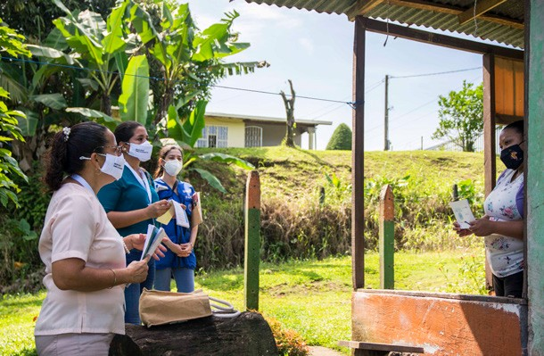

Project women visit families in Costa Rica © PAHO/WHO

One earmarked programme in **Kosovo** was also a cross- pillar programme. Under Pillar 1, it increased testing capacity ten-fold, provided two PCR machines and two RNA extraction machines, and donated 10,000 PCR tests to six regional laboratories across the country. Under Pillar 2 it

provided just over 1,000 children with disabilities with tablets or laptops and/or IT training to assure they could access distance education. It also deployed 40 teaching assistants for children with disabilities and built the capacity of 1,140 teachers to use a distance learning platform.

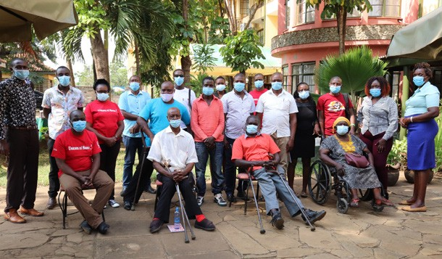For this report, the Call 1 country programmes of Georgia, Mongolia, and Papua New Guinea reported their cross- pillar achievements. **Mongolia** and **Papua New Guinea** reported concurrent results under the first two Pillars, while the achievements of the programme in **Georgia** traversed the Pillars on (1) Health First, (2) Protecting People, and (3)

Some programmatic highlights from **Georgia** included: 8,000 frontline workers equipped with PPE, and the emergency call center handled 4,500 calls per day and operated 330 ambulance crews. Towards protection of the elderly, the programme set up three municipal shelters that housed

200 elderly, and 2,749 vulnerable elderly received home care visits. The initiative outreached to 1,122,749 people via an information campaign on COVID-19. It also facilitated

continued access to essential healthcare services for 52,000 women and children. Online learning resources reached an estimated 414,000 students.

With regard to increasing COVID-19 testing capacity, the **Mongolian** programme directly served 1,827,246 people who were tested via the laboratories established and equipped by the programme. Under Pillar 2, the development of an online learning platform titled ‘Digital Adventures’ reached approximately 300,000 children,

parents, and teachers, including ethnic Kazakh and Tuvan minorities and people with disabilities previously excluded from TV-based educational programmes.

Because of the programme in **Papua New Guinea**, 13,194 children received nutritional supplementation; 5,915 community members were reached with COVID-19 related messaging; and 7,265 caregivers (mostly mothers) got counselled on child feeding practices. With regard

to maternal care, 829 pregnant and postpartum women received care at home, 104 newborns were delivered, and 6,610 community members were reached with information on COVID-19 and pregnancy. Towards improved WASH, 6,243 individuals had improved access to safe drinking water and 9,080 individuals had improved access to sanitation.

Economic Response and Recovery. Participants during the partner orientation forum in Kisumu, Kenya

© Advocates for Social Change (ADSOCK)

## CROSS-CUTTING RESULTS

This section highlights the emerging achievements of Call 2 country programmes and earmarked initiatives that helped close the digital and gender divides and worked to assure that no one was left behind.

###### TOWARDS GENDER EQUALITY

Towards improved gender equality, programmes advanced access to quality sexual and reproductive healthcare while working to enhance overall services, protections, and livelihood opportunities for women and girls.

**Healthcare** – Programmes provided equipment, trained personnel, and established mobile and/or remote services to improve women’s access to quality healthcare, especially maternal care.

* **Brazil**: 200 quilombo pregnant/postpartum women received PPE and COVID-19 information; 3,609

COVID-19 trainings held for healthcare workers serving pregnant and puerperal women

* **Peru**: 78% of a district trained on nutritional assessment of pregnant woman; obstetrics personnel trained in service an area where normally such care wasn’t available
* **Republic of North Macedonia**: mobile gynecological clinics set up
* **Turkey:** mobile health units established, which distributed 1,300 brochures on COVID-19 and sexual reproductive healthcare (SRH)

**Preventing GBV and Supporting Survivors** – To prevent violence against women and girls (VAWG) and support gender-based violence (GBV) survivors, programmes improved access to services and care.

* **Armenia:** targeting 20,000 users and those at risk of GBV, developed the mobile application called ‘Safe YOU’
* **Democratic Republic of the Congo:** provisioned five post-rape kits to the benefit of 10,000 people; awareness raising efforts on GBV and COVID-19 reached 13,293 people
* **India**: trained 62,315 child protection functionaries and partners, which then reached 896,451 children and women with GBV-related interventions; expanded

SRH and GBV services and outreach benefitted 34,752 children and caregivers; SGBV, mental health, and COVID-19 awareness raising campaign reached 737,014 people

* **Kenya:** 7,563 U-reporters (62% women) championed innovative community initiatives; 69 youth led six behavior change initiatives on preventing GBV
* **Maldives:** supported the government to develop a digital platform for GBV survivors.

**Safe Spaces –** Programmes in the Democratic Republic of the Congo, Jordan, and Zimbabwe set up safe spaces where women could access services and safely operate businesses.

* **Democratic Republic of the Congo**: four Girl Shine safe spaces were established, benefitting 2,394 people
* **Jordan:** created a safe and green public space and a community center to benefit 37,040 inhabitants in Ghor Al-Safi, especially women running businesses
* **Zimbabwe**: implemented GBV and COVID-19 operating procedures and safety measures at the Mbare mass market

**Advancing Job Training and Employment** – Women had improved access to livelihood opportunities and trainings in Chile, Costa Rica, São Tomé and Príncipe, and Tunisia.

* **Chile**: used the digital platform MujeresEmplea.org to share information on job openings, free trainings, and entrepreneurship funds targeting women
* **Costa Rica:** enhanced entrepreneurship skills of 100 vulnerable women; 65 women developed business ideas for agriculture
* **São Tomé and Príncipe**: created a digital platform to connect qualified women candidates to jobs; taught 150 adolescent girl dropouts life-skills
* **Zambia:** women tailors received payment for mask production through mobile money accounts

**Access to Finance –** Programmes in Cambodia, Djibouti, Myanmar, São Tomé and Príncipe, and Tunisia boosted women’s access to finance.

* **Cambodia**: provided low-cost and reliable financing to approximately 1,000 MSMEs; US$ 669,600 issued to women’s businesses, which unlocked another US$ 929,000
* **Djibouti**: fostered budding microfinancing schemes for women-led MSMEs working towards climate resiliency
* **Myanmar** completed a needs assessment for 22 women-led businesses with a view to enhancing their capacity to access finance
* **São Tomé and Príncipe:** 259 women with businesses (mostly informal) developed a business pandemic recovery plan, the best of which were to get a microgrant from US$ 1,500 to US $5,000

###### LEAVING NO ONE BEHIND

A core UN principle and a major thrust of funded programmes was reaching those most at risk of being left behind. Towards this objective, programmes extended support and services to meet the needs of vulnerable groups and communities of people such as children, the elderly, Indigenous Peoples, transgender people, people living with disabilities, people living with HIV (PLHIV), migrants, and refugees.

**Expanded Social Protection** – Joint programmes helped governments to expand the reach and inclusivity of social protection systems.

* **Antigua and Barbuda**: provided the government with technical assistance to implement its new Social Protection Act and digitize the social protection data management system
* **British Virgin Islands**: assisted the government to build up its social protection system to meet increased demand
* **Guatemala**: commenced a programme targeting 20,000 households to make the National Social Protection System more inclusive of vulnerable women
* **Maldives**: supported the government to expand and digitize its national social protection policy
* **Uruguay**: commenced a programme targeting 34.2% of the population (330,000 households) that will provide the government with data on vulnerability and gender

**Support for Vulnerable People and Groups -** Programmes extended services and protections to marginalized groups and people often excluded from traditional safety nets and support structures.

* **Argentina:** commenced a programme supporting comprehensive care policies and economic autonomy for women, the elderly, and people with disabilities
* **Brazil**: COVID-19-related information in Brazil was translated into the mother tongue of target populations (Indigenous Peoples living in the Amazon)
* **Djibouti**: provided COVID-19 prevention kits and means of sustenance to 400 vulnerable, pandemic- affected people, including refugees, elderly people, and people with disabilities
* **Indonesia:** provided entrepreneurship and skills trainings to approximately 1,500 cis- and transgender women, transgender people, rural residents, youth, PLHIV, people with disabilities, and refugees
* **India** offered skills trainings to 219 refugees, with 51 refugee women provided with microgrants of $INR 25,000/person to start a small business
* **Peru**: supported intercultural participation and communication to support healthcare services and gender-based violence prevention for Indigenous Peoples

**At the Border –** Programmes in Costa Rica and Mongolia supported migrants and border communities and offered assistance to nationals coping with pandemic restrictions abroad.

* **Costa Rica:** 195 migrant women participated in a community-based health surveillance pilot; four

greenhouses serving border/migrant populations were improved

* **Mongolia:** provided cash assistance to 44 migrants living abroad in 14 countries; granted return assistance to 67 migrants stranded abroad; and trained 237 border officials on pandemic safety

**Protecting Children -** Programmes provided opportunities for at-risk youth and helped governments extend the inclusivity and reach of their education platforms.

* **Bosnia and Herzegovina:** supported safe school reopenings and improved e-learning, including through assistive technologies for children with disabilities and by training 321 teachers
* **Kenya:** focusing on youth with disabilities, rural youth, youth in informal settlements, and refugees, 745 young people enrolled in the African Youth Marketplace (YOMA), creating digital resumes, with 525 registered youth completing self-development trainings
* **Kosovo:** provided just over 1,000 children with disabilities with tablets or laptops and/or IT training to assure they could access distance education; deployed 40 teaching assistants for children with disabilities
* **São Tomé and Príncipe:** delivered back to school kids to 1,500 households and offered a life skills course to 150 female dropouts

###### SNAPSHOTS OF INNOVATION

The Fund resourced innovations that improved healthcare delivery, business development, and access to education – all with the aim of creating opportunities and building up protections for disadvantaged and marginalized groups of people.

**Innovative Healthcare** – Programmes in Brazil, the Republic of North Macedonia and Turkey put in place digital technologies to improve access to and the quality of healthcare.

* **Brazil**: equipped seven healthcare centers to provide remote healthcare for Indigenous Peoples
* **Republic of North Macedonia:** developed four new digital immunization module trainings for immunization managers; a national e-immunization registry; and the website [www.kovid19vakcinacija.mk](http://www.kovid19vakcinacija.mk/)
* **Turkey:** increased the coverage of primary healthcare services through telemedicine, producing telemedicine training videos and providing software needed by the Ministry of Health

**Digitization for Business** – Programmes in Guinea, Viet Nam, and Zimbabwe provided women-led enterprises with tailored digital solutions and trainings to foster their entrepreneurship and improve business outcomes.

* **Indonesia**: held a competition and pre-acceleration programme to strengthen and foster innovative tech solutions designed by women entrepreneurs
* **Zimbabwe:** scaled up the web-based eMkambo platform to support food supply chains; trained informal female vendors on e-transacting

**Innovation for Youth Entrepreneurship** and **Education** – Initiatives in Indonesia and Kenya harnessed the energy and ideas of youth who wanted to create businesses that addressed social challenges.

* **Indonesia**: held a four-month boot camp and mentoring program for 120 youth entrepreneurs with business ideas that support disadvantaged people
* **Kenya:** contracted three innovation hubs to provide incubation, coaching, and mentoring services, financial linkages, and business growth opportunities to scale youth-led enterprises

**Expansive Social Protection –** The digitization of social protection systems helped governments efficiently and effectively reach the most vulnerable of people.

* **Antigua and Barbuda:** began digitizing social protection management through the UNICEF MIS system
* **Armenia**: developed a mobile application called ‘Safe YOU’ to address GBV
* **Guatemala:** began geo-referencing household information to help the national social protection system identify more people in need
* **Maldives:** began digitizing national social protection policy and services; and began developing a mobile app to help GBV survivors with reporting, case tracking, and referral support
* **Uruguay:** supported the interoperability of databases and georeferencing of information based on the Single Address Register

**Employment –** A number of programmes implemented digital solutions to expand livelihood opportunities, trainings, and access to finance, especially for disadvantaged people.

* **Cambodia**: operationalized a new Credit Guarantee scheme through, *inter alia*, the provision of integrated IT systems; also working to create a digital jobs platform
* **Cameroon:** trained 40 counsellors on an e-employment platform (decentralized kiosks/job terminals) to help vulnerable populations access employment and business opportunities
* **Chile**: used the digital platform MujeresEmplea.org, an online jobs platform reporting 2,120 new users, to match labor supply with demand and to provide trainings
* **São Tomé and Príncipe:** created a digital platform to connect qualified female candidates to jobs; helped equip training rooms where women could access internet and remote consultation

## CONTRIBUTORS AND CAPITALIZATION

Fund Contributors

The results in this report would not have been possible without the generous contributions to the COVID-19 Response and Recovery Trust Fund by its donors. The Fund stands capitalized at US$ 83,331,064 as of mid-September 2021, having received contributions from 23 donors, including contributions from Member States, the UN Evaluation Group for the System-Wide Evaluation of the Fund, and the private contributors of Dr. Betsee Parker and the Std Chartered Bank Zambia PLC.

AUSTRIAN Development Agency



NEW ZEALAND, Government of

SWEDEN, Government of

CAMBODIA, Government of



NORWAY, Government of

SWITZERLAND, Government of

CROATIA, Government of



PHILIPPINES, Government of

THAILAND, Government of

CYPRUS, Government of



PORTUGAL, Government of

UN Evaluation Group

DENMARK, Government of



Republic of KOREA

UNITED KINGDOM, Government of

FINLAND, Government of



ROMANIA, Government of

**Private Sector Contributors**

ICELAND, Government of



NETHERLANDS, Government of



SLOVAK Republic

SPAIN, Government of



Dr. Betsee Parker

Standard Chartered Bank Zambia PLC

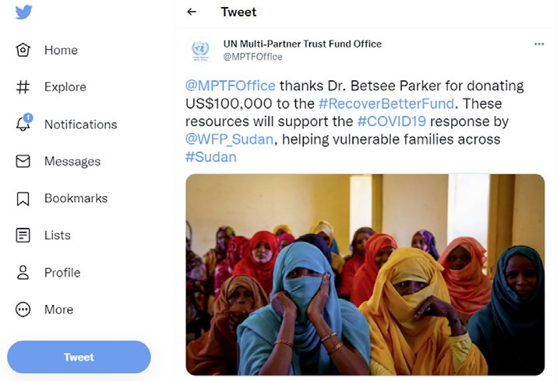

Transparency

The Fund made transparency a top priority by posting all commitments, deposits, and allocations in real-time on its [Gateway](http://mptf.undp.org/), a public website updated every two hours by enterprise resource planning (ERP) software. The Fund also continued to meet its legal obligations to issue an annual report on 31 May following the close of the calendar year. Reporting on project implementation was led by the UN Resident Coordinators that spearheaded the development of the programmes, and it required that all UN agencies involved in programme implementation provide detailed reports on how they spent the money and what programme results were achieved. The Fund released an annual report on 31 May 2021.

ANNEX 1:

**Achievements and Emerging Results by Country**

# PILLAR 1

#### HEALTH FIRST

##### Protecting health services and systems during the crisis

 BRAZIL



**CALL 2**

### Supporting Emergency Measures and Recovery Actions to Tackle COVID-19 in the Indigenous Territories in the Amazon Region of Brazil

**End Date:** 30 September 2021

PROGRAMME SUMMARY

This programme supports the implementation of emergency measures to prevent COVID-19 transmission among indigenous and traditional peoples of the Amazon Region of Brazil. The initiative improves community healthcare support; supports culturally tailored health education; and towards these objectives, promotes gender and human rights-responsive action.

EMERGING RESULTS

By supporting inter-cultural and gender-sensitive response efforts and strengthening health surveillance capacity, the programme has **contributed to a decrease in COVID-19 case fatality and mortality rates**. In addition, the initiative has:

* **Conducted 3,609 trainings for healthcare professionals** on the care and early diagnosis of COVID-19, with a special focus on pregnant and puerperal women
* Provided antigen-based rapid tests (ag-RDT) and made oximeters available for **143,429 beneficiaries** in the Amazonas, Maranhão and Roraima states. **The number of beneficiaries corresponds to 46.2% of the indigenous population of these states**.
* **Delivered 100,000 Ag-RDT** (54,500 Ag-RDT to Amazonas; 19,000 to Roraima; 26,500 to Maranhão), benefiting the equivalent to 64.4% of COVID-19 cases
* Distributed personal protective equipment **(PPE) across the three targeted states** (142,000 PPEs to Amazonas; 44,640 PPE to Roraima; 16,000 PPEs to Maranhão)
* Mapping, through community cultural facilitation, approximately **200 quilombola pregnant or postpartum women**, families, and nearby communities, and provided PPE and information about COVID-19 in the territory
* Established and equipped **seven remote healthcare assistance rooms** that provide remote medical consultations
* Produced **14 videos based on inter-cultural dialogue** in local languages with educational materials about COVID-19 transmission, targeting indigenous people

Leaving no one behind

The participating UN organizations used a pedagogical, multilingual, and intercultural approach to develop health and well-being education for indigenous populations. The objective was to collaborate on the creation and dissemination of information that could foster indigenous peoples’ protection, especially in the context of the COVID-19 crisis. The work

was carried out in the mother tongue of the populations, an important way to help preserve this intangible heritage. It also involved the traditional knowledge and rights of these communities, and it raised awareness of their cultural richness, helping to promote essential interfaces between indigenous populations and other segments of society.

LEARNING AND INNOVATION

The programme made great use of the newly established UN INFO monitoring platform, which is a new feature UN Country Teams are using to track implementation of Joint Work Plans under the Sustainable Development Cooperation Frameworks. In Brazil, the platform has helped the Recipient UN Organizations to create transparency and make the programmatic achievements readily accessible to donors as well as to the general public. The implementing UN organizations worked closely with civil society organizations (including indigenous women’s coalitions) to leverage their knowledge on the needs of indigenous populations, as well as their well-established relationships with the programme’s target groups and access to remote geographical locations.

## JAMAICA



**CALL 1**

### Suppress Transmission of COVID-19 and Save Lives in Jamaica

**End Date:** 31 January 2021

PROGRAMME SUMMARY

This programme supported the national response to COVID-19 by meeting needs within the Jamaican health sector and focusing on vulnerable communities as well as women and girls. The initiative worked to ensure equal access to essential healthcare services that were adequately staffed and equipped in the context of the pandemic.

ACHIEVEMENTS

* Provided **6,888 healthcare workers (100%) with access to personal protective equipment** (PPE), including 10,000 disposable surgical respirator FFP2/N95-masks
* **Trained 7,217 persons**, including the 6,888 healthcare workers, on the use and disposal of PPE
* Procured supportive equipment for **28 ventilators**
* Provided **16,000 doses of Depo Provera** to the National Family Planning Board
* Hired and trained, with national guidelines established, **1,000 community health workers** to strengthen capacity for antenatal care services
* Implemented an **integrated risk communication and community engagement campaign** with messaging focused on COVID-19 and gender-based violence; sexual and reproductive health (SRH) services; persons in the LGBTQI community; stigma and discrimination; and persons living with HIV (PHLIV); in this campaign, **152 new digital products reached 228,055 people**
* **100% (3,200) PHLIV** were able to access care countrywide (percentage is a self-assessment in consultation with the Ministry of Health and Wellness (MOHW)
* **Established 21 essential service hotlines** for women, men, and the elderly, and **trained 80 volunteers** to service them
* Deployed mobile units to reach vulnerable groups, including women and the elderly
* Implemented, via MOHW, a multi-month **dispensing policy for ARV** and other essential medicines, along with social support measures for PLHIV, impacting **14,000 PLHIV on ART**
* Supported the MOHW to establish the **Go.Data surveillance system**© through comprehensive training programs in all related surveillance system areas, data analysis, capacity building of laboratory personnel, and

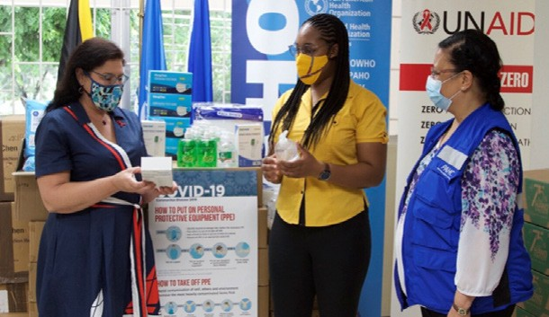

In a ceremony, the Pan American Health Organization (PAHO) and UNAIDS handed over vital personal protective equipment (PPE) to enable key community organizations to continue to provide essential support and services to some of Jamaica’s most vulnerable populations while protecting staff against COVID-19. Supplies including face shields, surgical masks, hand sanitizers, liquid soap and infrared thermometers were distributed to seven community organizations that address the needs of disadvantaged children and adolescents, people living with HIV, the transgender community and those requiring legal assistance.

© PAHO

the training in the transportation of infectious substances; PAHO donated **25 Android tablets** with the contact tracing application Go.Data© installed to MOHW

To bolster testing capacity and readiness for large scale testing the programme:

* Trained staff from the national laboratories on molecular detection of COVID-19 and results interpretation, and donated positive control primers and probes for 300 samples
* Virtually trained laboratory staff in the operation of the RT- PCR machine to detect COVID-19
* Procured extraction kits for the automated extractor at the National Public Health Laboratory

LEARNING AND INNOVATION

Anecdotal reports suggested, in Jamaica, that violence against women and girls (VAWG) worsened during pandemic. In re- sponse, this programme worked to improve gender equality and empower women and girls through its risk communication and community engagement component. A key anecdotal lesson learned was the importance of training healthcare workers in the prevention and mitigation of gender-based violence. Further, this programme amplified its results through coordination with the Spotlight Initiative, which focuses exclusively on reducing VAWG.

## LAO PEOPLE’S DEMOCRATIC REPUBLIC



**CALL 1**

### Supporting Essential Sexual, Reproductive, Maternal, Newborn, Child and Adolescent Health Services during COVID-19

**End Date:** 31 March 2021

PROGRAMME SUMMARY

This programme improved and sustained essential services for Sexual and Reproductive, Maternal, Newborn, Child and Adolescent Health (SRMNCAH) during the COVID-19 pandemic in Lao People’s Democratic Republic (Lao PDR).

Programmatic activities focused on adapting SRMNCAH services in the three districts of Luang Prabang, Phoukhoun, and Phonthong in Luang Prabang province. Across eight provinces, the initiative also strengthened civil society organizations’ (CSOs) and community systems’ access to essential HIV drugs.

ACHIEVEMENTS

Through this programme, the Ministry of Health tested a simplified SRMNCAH service delivery system that allowed health workers to operate safely during the pandemic. The beneficiaries from the three Luang Prabang districts included the 35,988 women of reproductive age, 1,762 pregnant women, 1,166 newborns, and key populations of female sex workers (FSW), people living with HIV (PLWH) and men who have sex with men (MSM), all of whom had access to health services as a result of this initiative. Overall, the programme:

* Facilitated the first **antenatal care (ANC1) visit for 1,432 pregnant women** in Phoukhoun district
* Facilitated the fourth **antenatal care (ANC4) visit for 592 pregnant women** in the Phoukhoun district and increased coverage by 745 pregnant women in the Phonthong district
* Provided **home ANC1 visits for 241 women and ANC 4 visits for 139 women**
* Provided postnatal care (PNC) checks within two days of birth to all women reached by this programme
* Provided ANC and PNC to **271 women through the telehealth services**
* Enabled seven core trainers (from the College of Health Sciences Luang Prabang, Provincial Hospital and Luang Prabang Provincial Health Department) to deliver the training on maintaining essential RMNCAH services during COVID-19 to ensure sustainability of services
* **Trained 38 health service providers from 16 health centers** and three district hospitals to maintain essential RMNCAH services, provide the telehealth for ANC, PNC, monitoring mothers, and sick children as well as tele- consultation for patients needing psychosocial support
* Introduced guidelines for healthcare providers on oxygen therapy; Through a partnership with the University of Melbourne, the programme facilitated e-modules to

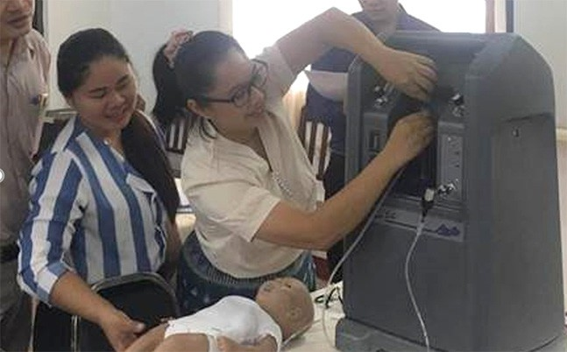

The programme supported the development and introduction of guidelines on oxygen therapy.

© UNICEF

train health providers in oxygen therapy with remote supervision

* Developed guidelines on community-based antiretroviral (AVR) drugs dispensing and used them during the country lockdown to establish a mechanism of home delivery of ARV drugs for PLWH
* Rolled out standard operating procedures for a community antiviral therapy delivery model, which was rolled out in eight sites
* Provided antiviral drugs for approximately 1,000 PLWH
* Conducted a series of trainings for representatives of CSOs working with key populations in 10 provinces and for peers working with PLWH. As a result, 99 PLWH peers, 21 MSM, 50 FSW received training on COVID-19 prevention measures in the context of HIV response. In turn, the trained peers promoted key protection messages among their communities, namely wearing mask, washing hands, and practicing social distancing

LEARNING AND INNOVATION

*Partnering to Improve Essential Health Services*: The programme relied on coordination with 12 district health offices and district hospitals and international non-governmental organizations (Swiss Red Cross and Save the Children) working in the field of SRMNCAH to expand the adapted services during the pandemic to other districts in Luang Prabang province. Likewise,

Luang Prabang Health Provincial Department was proactive in partnership with a telecom corporation, UNITEL, in supporting a telephone call credit transfer of 200,000 per month per health center to create sustainable telehealth services.

## LIBERIA



**CALL 2**

### Building Back a Resilient Health System Responsive to the Needs of Women, Children and Adolescents

**End Date:** 30 April 2022

PROGRAMME SUMMARY

This programme improves healthcare services for vulnerable and marginalized groups and strengthens the community health system in the three Liberian counties of Gbarpolu, Grand Bassa, and Grand Kru.

EMERGING RESULTS

* Conducted a rapid assessment for benchmarking, implementation, and progress monitoring
* 60 indirect beneficiaries and stakeholders participated in the project launch and inception meetings
* Varied stakeholders including local authorities and country- level implementing partners agreed on the list of sites to improve access and utilization of Reproductive Maternal Newborn Child and Adolescent Health and Nutrition (RMNCAH-N)
* Supported 12 healthcare facilities to identify their needs (including infrastructure, essential drugs, diagnostics, knowledge, and skills), with the assessment diagnostic also nurturing the design and delivery of a comprehensive package of RMNCAH-N services
* Delivered the existing stock of reproductive health commodities and maternal healthcare drugs (contraceptives, oxytocin, magnesium sulphate, misoprostol) to the counties

## REPUBLIC OF NORTH MACEDONIA



**CALL 2**

### Safe and Innovative Health Services in Times of COVID-19

**End Date:** 31 March 2022

PROGRAMME SUMMARY

This programme will help the government improve essential health services within the context of COVID-19 by building on the significant investments already made to strengthen the national health and social systems, contain disease outbreaks, and assure health responses to various emergencies. In close collaboration with Ministry of Health and with a focus on vulnerable women, adolescents, and children, the initiative will expand sexual and reproductive health services, immunizations, and psycho-social support services.

EMERGING RESULTS

Working towards the setup of mobile gynecological clinics, the programme:

* Established formal **partnerships** with the Macedonian Medical Association and the Red Cross of the Republic of North Macedonia
* Updated a **protocol for the provision of sexual and reproductive health (SRH) services** through mobile gynecological clinics, as well as **training material** for hands-on practical training of the SRH professionals
* Initiated **procurement of SRH commodities and Personal Protective Equipment** (PPE), to support the set-up of mobile gynecological clinics
* Prepared a **communications campaign** and detailed **communications tools** on the prevention of cervical cancer (a national priority theme in SRH), to promote cervical cancer screening through the mobile clinics

To address COVID-19 vaccine hesitancy, the programme:

* Held a multi-media **COVID-19 vaccine trust campaign** reaching **77% of the entire adult population** at least once
* On social media, while the COVID-19 vaccine trust campaign ran on all channels, on Facebook it included **30 posts that reached approximately 630,000 total people**
* Based on WHO Behavioral Insights Surveys, **the percentage of the population believing in the efficacy of COVID-19 vaccines jumped from 56% in December 2020 to 69%** in June 2021

To strengthen the capacities of healthcare system to provide COVID-19 immunization, the programme:

* **Trained 1,152 healthcare workers** (512 nurses, 228 doctors trained face-to-face, and 412 healthcare

professionals trained online) on COVID-19 and Measles, Mumps, Rubella (MMR) vaccines

* **420 healthcare workers completed two adapted and accredited WHO courses** on COVID-19 vaccination training for health workers and on orientation and planning for COVID-19 vaccination
* **Trained five master trainers** in inter-personal communication skills on immunization
* Five prototypes, three posters, FAQ tent, and leaflet prepared and tested for the MMR1 demand generation campaign rollout
* **Outreached to 10,000 parents** with children aged 13 months with regard to MMR vaccine
* Reached **25 at-risk families** to provide social protection and ensure service referral

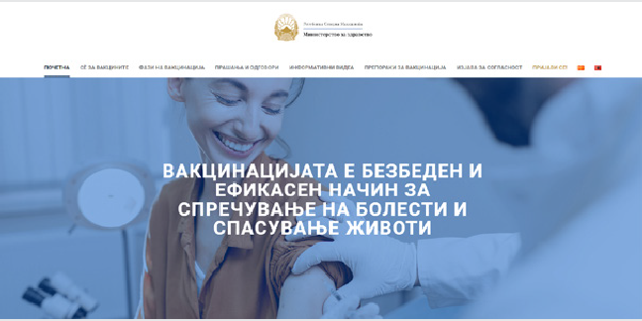 LEARNING AND INNOVATION

This programme is supporting e-Immunization, and, in collaboration with WHO, it has developed new digital modules to support the national e-Health system. Among its outcomes are **four new digital immunization module trainings** for mid–level immunization managers (vaccination teams, general practitioners) working across an array of health services; a **national e-immunization registry** to provide accurate and timely data on immunization and address lack of regular immunizations; and the website [www.kovid19vakcinacija.mk](http://www.kovid19vakcinacija.mk/).

 MALAWI



**CALL 1**

### Emergency Response for the Continuity of Maternal and Newborn Health Services

**End Date:** 31 March 2021

PROGRAMME SUMMARY

In response to the impacts of COVID-19, this programme implemented by UNFPA, UN Women, and WHO, under the leadership of the Ministry of Health, expanded the safety, accessibility, and continuity of healthcare to all women of reproductive age. The initiative pursed three central objectives in the pandemic context: (1) establish protocols and guidelines for the treatment of pregnant women; (2) strengthen the continuity of maternal and new-born care services; and

(3) support the referral system for pregnant women and newborns.

ACHIEVEMENTS

Programme beneficiaries included:

* **256,282 women** who utilized maternal and newborn services
* **75,600 infants** safely delivered by skilled health personnel
* **884 women** who accessed referrals to COVID-19 treatment centers

The initiative developed COVID-19-specific maternal and neonatal health service guidelines, distributing:

* **1,500 copies** to healthcare facilities across Malawi and a further **50,000 copies** of guidelines for treating pregnant women in the pandemic context

With regard to facilities and equipment to strengthen the continuity of maternal and newborn care services,

including comprehensive obstetric emergency services, the programme:

* Refurbished **four safe delivery areas** and assured that 33 (target 46) health centers had fully functional mechanisms and **151 specialized birth attendants** in place to treat pregnant women before, during, and after birth
* **80% of all designated** Basic Emergency Obstetric and Newborn Care (BEmONc) facilities performed all seven signal functions
* **Refurbished and equipped a maternity operating theatre** at Bwaila hospital, one of the major referral hospitals that attends 70 deliveries and 20 caesarean sections a day
* **Stocked treatment centers** with three ventilators, 10 anesthesia machines, 20 patient monitors, 10 ultrasound machines, 56 doppler fetal heart machines, 10 vacuum extraction machines, 20 infant scales, 30 suction machines, and 100 hand operated resuscitators for infants
* Provided equipment to personnel at four central hospitals, five zonal offices, and six districts across the country
* Procured approximately **60,000 pieces of personal protective equipment** and makeshift taps and sinks for healthcare professionals in the Comprehensive

Emergency Obstetric and Newborn Care (CEmONC) and (BEmONC) service centers

Under the leadership of the Ministry of Health, the programme extended communications via radio, phone, and community outreach, such that:

* An estimated **2,563,937 people accessed information**, advice, and counselling from a hotline service or public outreach campaign on community radio
* A series of **16 programmes aired on 14 different radio and television stations**, and they highlighted referral pathways and information on sexual and reproductive health and rights
* The radio campaign, which **reached an estimated 2,000,000** people, supported 114,917 men and boys involved in referral and information sharing on COVID-19
* **50 male champions** promoted the access of women and adolescent girls to health services as part of the action plans from the ‘HeForShe Barbershop Toolbox’
* **476 men and boys** were involved in referral and information sharing on COVID-19
* **182,727 women of childbearing age**, including pregnant women and adolescents, accessed advice and counselling from a hotline service
* The Ministry of Health, in coordination with UN agencies and the Public Health Institute of Malawi surveillance unit, established a reporting mechanism for COVID-19 positive pregnant women, capturing data from **all 45 testing sites countrywide**

LEARNING AND INNOVATION

The programme learned that **technology must be a complementary tool to the traditional working environment**. New and more flexible and remote services using digital technologies played a crucial role in taking pressure off the healthcare system and promoting advice and self-care services in communities. For instance, this programme used innovative virtual trainings to reduce the time service providers spent going to in-person trainings and to expand reach. It also employed mobile health services to decongest health facilities. However, while such innovations improved services, they could not replace physical interactions with and within communities. **Engaging with communities at all levels remained crucial and required a strong physical presence in the field**. Communities that engaged their local leaders face-to-face held them accountable and resolved issues that advanced the implementation of programmatic activities.

 PERU



**CALL 2**

### Nuwa Tajimat

**End Date:** 1 January 2022

PROGRAMME SUMMARY

This programme addresses Amazonian women’s access to essential services including maternal, sexual, and reproductive health services, and it supports responses to gender-based violence (GBV) and access to nutrition. The programme focuses on the three districts of the Condorcanqui province - Nieva, Cenepa, and Rio Santiago - areas with high levels of poverty and home to the Awajún and Wampis indigenous peoples.

EMERGING RESULTS

In its first six months, the programme focused on strengthening the capacities of medical practitioners and health establishments in the Condorcanqui province and facilitating access to culturally sensitive services. The programme:

* Established a **blood bank in Nieva** to support obstetrics care, which has directly helped **52,357 people** (female: 51.4%)
* Provided a complete **natal care package to 12% of pregnant women in the Nieva district**
* Provided **intercultural trainings for obstetrics personnel** from the three districts. The trainings were attended by practitioners from the outskirts of

Condorcanqui, where no obstetric personnel are normally present

* **Trained 90% of the community health workers** in the District of Nieva in COVID -19 prevention
* **Trained 35 obstetrics and technical health workers and 28 community health workers** from the three districts in family planning with a culturally sensitive approach
* Prepared **three district plans** based on ‘Intercultural Dialogues’ to understand the risk of COVID-19; preparation engaged community leaders, local government, and state institutions
* Facilitated prenatal care from mobile health brigades to 29% of women in the Nieva district
* **Trained 23 health professionals from 22 health establishments (78% of the entire district)** in nutritional assessment of pregnant woman
* Provided iron and sulfate supplementation to **213 pregnant women** in Nieva
* Carried out in-service monitoring in the **10 prioritized health establishments**

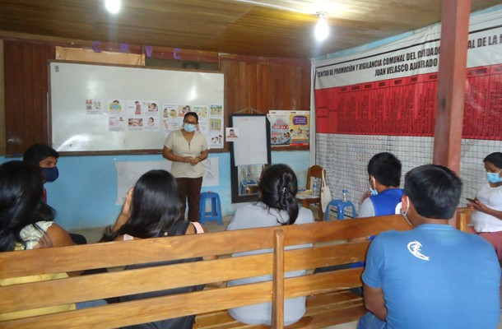

Training for health personnel in nutritional evaluation of pregnant women in Amazonas, Condorcanqui, Nieva District. © WFP/PMA

* Delivered **anthropometric equipment and hemoglobinometers to 13 prioritized health establishments**
* Designed and implemented a **maternal death surveillance and response system** for the Condorcanqui health network
* Reactivated the **provincial coordination mechanism to combat GBV** and established protocols for collaboration between Women’s Emergency Centers and health establishments to provide survivor care
* Provided socio-legal and healthcare for **81 GBV survivors**
* Strengthened the capacity of health services, social support, security, and protection in cases of sexual violence in Condorcanqui-Amazonas Region
* **32 participants** from the health sector and state entities completed a course on assisting GBV cases

LEARNING AND INNOVATION

The programme pursued **innovative approaches that would leave no one behind** by maintaining a strong focus on intercultural participation and communication, and promoting culturally sensitive and intersectoral integration of essential services in local communities. For instance, advocacy and capacity building initiatives targeted health service providers and Awajun communities to foster adequate registration of ethnicity in sexual and reproductive health and epidemiological surveillance registries.

## TAJIKISTAN



**CALL 1**

### Strengthening the Health System in Tajikistan to Prepare and Respond to COVID-19

**End Date:** 31 March 2021

PROGRAMME SUMMARY

In response to the impacts of COVID-19, this programme implemented by UNFPA, UN Women, and WHO, under the leadership of the Ministry of Health, expanded the safety, accessibility, and continuity of healthcare to all women of reproductive age. The initiative pursed three central objectives in the pandemic context: (1) establish protocols and guidelines for the treatment of pregnant women; (2) strengthen the continuity of maternal and new-born care services; and

(3) support the referral system for pregnant women and newborns.

ACHIEVEMENTS

Equipping to treat COVID-19 patients

* To support national preparedness amid the coronavirus pandemic, the programme, in consultation with the Ministry of Health and Social Protection of Population (MoHSPP), agreed on a priority list of **13 types of pharmaceuticals** and 12 kinds of equipment to procure and provide for the **intensive care units of 35 hospitals** selected to treat COVID-19 patients
* Among others, **five ventilators, six oxygen stations, 20 (10L) units of Oxygen Concentrators and five analyzers were delivered and installed** in the health facilities to ensure access to life-saving health services.

**Tailored training sessions** were provided to ICU staff on the equipment’s use and maintenance

* **115 hospitals/primary healthcare facilities** across the country benefitted from the procurement of essential supplies as per the approved MoHSPP’s Distribution Plan, and approximately **13,200 confirmed COVID-19 patients received treatment through this support**

Telehealth and the continuity of SRH care

* **Established a tele-health system** and procured, tested, and handed over tele-health equipment to the National and four Regional reproductive health centers of MoHSPP
* Established **five hotline points** at National and Regional Levels on alternate SRH and GBV related services
* Provided **22 selected sexual and reproductive health service providers** with dedicated phone numbers and stable internet connection for reproductive health clinics offering ANC, family planning, and psychosocial support services
* **Conducted 40,780 remote online consultations** related to SRH and GBV
* **Three temporary protocols** on ANC, FP and psychosocial protection were developed by the national experts group of MoHSPP and integrated into reproductive health facilities throughout the country. All protocols were developed based on WHO/UNFPA technical guidance

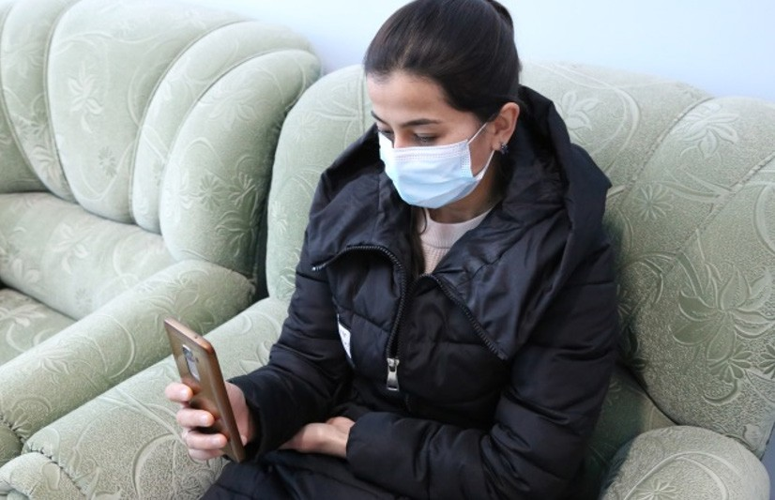

Madina Yuldosheva from Sughd Region taking an at home, online consultation from her SRH doctor.

“Due to Covid-19 pandemic I stopped visiting my doctor for SRH consultations for several months. However, the need for consultation with my doctor was very essential and one day my gynecologist informed me that I can get SRH and other psychosocial support services using telehealth methodology,” she said.

© UNFPA

notes on maternal care during COVID-19 and tested at the National SRH Clinic

* **Three cascade trainings** on the provision of online SRH services based on temporary counseling protocols were conducted at the national and regional levels, covering 91 SRH specialists along with 64 RH service providers trained

on psychosocial support services during COVID-19

Outreach and Information

* Distributed **60,000 leaflets** along with 200 posters on SRH and basic hygiene practices throughout the country along with awareness raising campaigns
* Aired a video public service announcement on national and regional TV media 152 times; it **reached over two million people**, including 200,000 pregnant women and 800,000 women using modern contraceptives



**CALL 1**

LEARNING AND INNOVATION

The programme helped **establish tele-health technologies for the first-time in the country**, introducing alternative ways of providing SRH care. Different MoHSPP affiliated structures such as the National Reproductive Health Center, the Republican Clinical Family Medicine Center along with experts from the Academy of Health Sciences were engaged in the adaptation

and development of temporary counseling protocols on SRH during COVID-19. Adjustments to the standard schedules were tested so that some appointments could be conducted using phone or video chat, and to ensure that there was no disruption in service for women’s maternity care.

To ensure transparency and efficient use of the PPE’s, medical supplies, and medicine, UNICEF team, in close coordination with the Ministry of Health and Social Protection of the Population and within the scope of humanitarian response strategy, set up a two level monitoring platform:

1. third party monitoring through a direct line with the medical facilities and doctors to ensure social accountability and a feedback mechanism on efficient use of provided materials; and a
2. digital platform to monitor needs and requests coming from the field and matching those needs with available supplies, medicines, and other equipment. This platform was very well received by partners from the Ministry and was taken to the next stage for further integration with the Ministry’s procurement and monitoring mechanisms.

 TURKEY



**CALL 2**

### Promoting Innovative Service Provision Models to Support the COVID-19 Health System Response

**End Date:** 31 March 2022

PROGRAMME SUMMARY

This programme promotes innovative service provision models that facilitate uninterrupted access to essential health services among vulnerable groups while supporting the health system response to COVID-19. The initiative sets up six mobile health units (MHU) across two provinces, assuring their staffing, training, and readiness to offer COVID-19 screening and tracking services as well as other essential primary healthcare counselling, services, and referrals. The initiative also supports the expansion of telehealth and risk communications in Turkey.

EMERGING RESULTS

This programme **commenced implementation on 12 February 2021** and has progressed towards each of this three main outputs.

Towards output #1, Mobile health for efficient service delivery among vulnerable populations:

* Established, **in two provinces, six mobile health units (MHU)** that are providing **mobile COVID-19 screening** and tracking as well as other essential health counselling, services (including **sexual and reproductive health and gender-based violence services**), and referrals
* **Staffed and trained 18 MHU personnel** (six nurses, six translators, and six drivers in six MHUs) **and two field associates**
* **Procured six vehicles along with medical equipment and PPEs** and developed communication, visibility, and accountability materials
* **MHUs were made operational** as of 21 May 2021 for Ankara and 27 May 2021 for Konya, and through 30 July 2021 **they served 3,069 individuals who accessed 5,388 services**

Towards output #2, Telemedicine for increased access and coverage of services in primary healthcare:

* Began producing **telemedicine training videos** for doctors, nurses, and midwives working at the Family Health, Healthy Life, and Refugee Health Centers
* Commenced preliminary work on the **software needed for telemedicine** and its integration into Ministry of Health information systems
* Prepared informed consent documents for patients who will receive telehealth services
* Within the scope of Telehealth, draft laws on the protection of personal data began to be formed

Towards Output #3, Enhanced risk communications on COVID-19, essential health services and social protection services:

* **Developed Standard Operation Procedures (SOP)** covering critical issues such as the provision of preventive and integrative health services; identification of risk groups and improvement of their access to healthcare; and promotion of public health literacy
* **Distributed 1,300 awareness raising brochures** covering COVID-19 prevention, hygiene, breastfeeding, prenatal, postnatal, and newborn care, pregnancy nutrition, infant feeding, violence against women, sexually transmitted infections, and contraception **to 370 people within the framework of the MHUs**

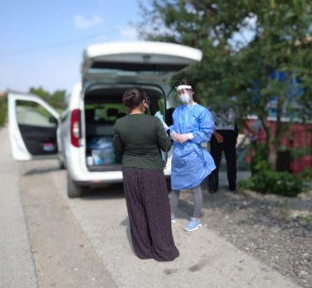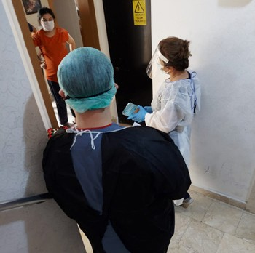 LEARNING AND INNOVATION

The programme pursued **innovative approaches that would leave no one behind** by maintaining a strong focus on intercultural participation and

communication, and promoting culturally sensitive and intersectoral integration of essential services in local communities. For instance, advocacy and capacity building initiatives targeted health service providers and Awajun communities to foster adequate registration of ethnicity in sexual and reproductive health and epidemiological surveillance registries.

Awareness raising on contraceptive methods.

© UNFPA, Ankara Mamak MHU

Informing a pregnant woman on COVID-19 preventive measures.

© UNFPA, Ankara Keçiören MHU

#### PROTECTING PEOPLE

PILLAR 2

##### Social Protection and basic services

 ANTIGUA AND BARBUDA / BRITISH VIRGIN ISLANDS



**CALL 2**

### Social Protection and Employability Promotion to Mitigate the Socio- economic Impacts of COVID-19

**End Date:** 15 November 2021

PROGRAMME SUMMARY

This programme will aid the governments of Antigua and Barbuda, and the British Virgin Islands (BVI) to address the socio-economic impacts of the pandemic. The initiative will employ a three-pronged approach to address both immediate and longer-term needs of vulnerable people through: (1) cash transfers via social protection systems to vulnerable people not already benefitting from COVID-19 assistance; (2) technical and policy support that uses data to strengthen social protection systems; and (3) employability training for those receiving cash transfers as well as for other vulnerable people whose livelihoods have been affected by the pandemic.

EMERGING RESULTS

During this reporting period, programmatic activities focused on readying and strengthening the social protection systems to provide temporary cash support to households affected by COVID-19. Most key activities will be completed by January 2022.

In **Antigua and Barbuda** the programme:

* **Trained 31 staff** from the Ministry of Social Transformation and the Social Protection Board on data collection; and **21 staff** on end to end use of the management information system: data collection, targeting, payments, reconciliations and grievances
* Developed the **online employability and entrepreneurship training course**, with materials populated into the UWI Open Campus Learning management System (LMS) for course delivery in August 2021
* Provided **technical assistance on the implementation of the new Social Protection Act** and the new government institutions that will identify social assistance

beneficiaries to receive Fund-supported COVID-19 top-ups

* Supported the transition from a **paper-based to a digitized data management system** (through the use of UNICEF MIS system), with 10% of intended beneficiaries registered for eligibility assessment

In the **British Virgin Islands**, the programme:

* Provided technical support to the Ministry of Health and Social Development to **strengthen social protection systems to meet increased demand** and reach additional vulnerable people and families as part of its COVID-19 income support programme
* Supported the design and implementation of the data management system for applications
* Strengthened capacity through trainings to enumerators with **18 staff from Social Development Department trained on digital data collection** through Kobo; the development of **technical guidance documents for the use of digital registrations**; and a **validation system**.

LEARNING AND INNOVATION

In **Antigua and Barbuda**, the **digitization of the social protection management** through the use of UNICEF MIS system was underway, and it is anticipated that the remaining 90% of the beneficiaries will be registered and the transfers completed by January 2022.

 ARGENTINA



**CALL 2**

COVID-19 Socio-economic Recovery from a Gender Perspective: Promoting the Economic Autonomy of Women and the Care of Elderly and Disabled People in Argentina

**End Date:** 1 December 2021

PROGRAMME SUMMARY

This programme implements 25 specific lines of work meant to: (1) Contribute to comprehensive care policies that improve the access to and quality of care for vulnerable groups, especially women, the elderly, and people with disabilities; while also improving the working conditions for care givers and other workers; and (2) Strengthen the economic autonomy of women through improved access to financial inclusion tools and the design of debt prevention policies, especially for households most affected by the pandemic.

EMERGING RESULTS

Thus far, this programme has:

* Begun preparing **13 studies to update information on the impact of the pandemic on vulnerable groups** and commenced **technical assistance** to the government: on the chapter addressing the care of elderly people within the draft law for the creation of a **Comprehensive Care System** with a gender perspective; and on the national survey evaluating national care services for the elderly and people with disabilities, information that will complement the Federal Care Map
* Held **two national calls** to provide **technical and financial support to civil society organizations** and care cooperatives offering services to and promoting the financial autonomy of women
* Begun designing a training course on care policies targeting **500 people working at care centers**
* **Reached 17 female beneficiaries aged 25 to 61 years with a Training of Trainers in Financial Education Course** held in coordination with the government
* On 17 May 2021, UN Women organized an **informative and educational webinar** to present programme objectives, requirements for call participation, and technical assistance to optimize eligibility opportunities: **70 organizations joined the session, and 99 projects were received from across the country** and are under evaluation. Six to seven organizations will be selected to receive an estimated $10,000 each, in addition to technical support on implementation
* Towards **improved working conditions for care workers, a quantitative study investigated 4,304 cases**

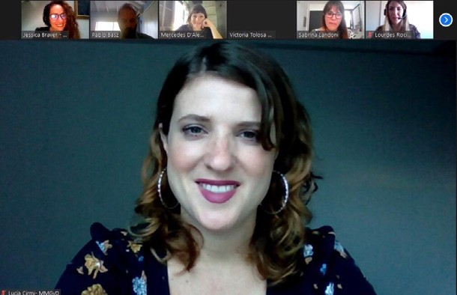

Online programme meeting with partners for the joint project Source: Ministry of women, gender and diversity

**nationwide** through telephone, online, and face-to-face surveys, which will inform public policy recommendations on care

* UNDP held **a closed call with civil society organizations**, within the framework of work with the Federal Council of Councilors and the National Directorate of Economy, Equality and Gender of the

Ministry of Economy of the Nation, to financially support to organizations promoting the empowerment of women. The call for proposals closed on 21 July 2021, with **selected recipients to receive a sum between $4,100 to $70,000 per initiative**

## BOSNIA AND HERZEGOVINA



**CALL 2**

### Reimagining Education for Marginalized Girls and Boys during and post COVID-19 in Bosnia and Herzegovina

**End Date:** 15 March 2022

PROGRAMME SUMMARY

Focused on e-learning and blended learning measures and meeting the needs of vulnerable populations during and after the pandemic, this programme improves access to education in two cantons (Una-Sana Canton and West Herzegovina Canton) and in the entity of Republika Srpska. Specifically, it seeks to deliver gender responsive crisis management to ensure the safe reopening of education facilities; monitor the impacts of school closures and gather disaggregated data on gender and vulnerable groups; and improve capacities to deliver e-learning, including through assistive technologies for children with disabilities.

EMERGING RESULTS

During initial programmatic implementation, the UN worked closely with educational authorities to have:

* Prepared **Guidelines on Standards for e-learning** in elementary, secondary (including technical and vocational education and training (TVET), and tertiary education institutions
* Delivered hygiene materials to schools in the three administrative units, including:
  + **2,471 bottles of bleach** to the Ministry of Education of Republika Srpska;
  + **2,162 pump, alcohol-based hand sanitizers** and **571 bottles of bleach** to the Ministry of Education of Una Sana Canton; and
  + **833 pump, alcohol-based hand sanitizers**, and **220 bottles of disinfectant** to the Ministry of Education of West Herzegovina

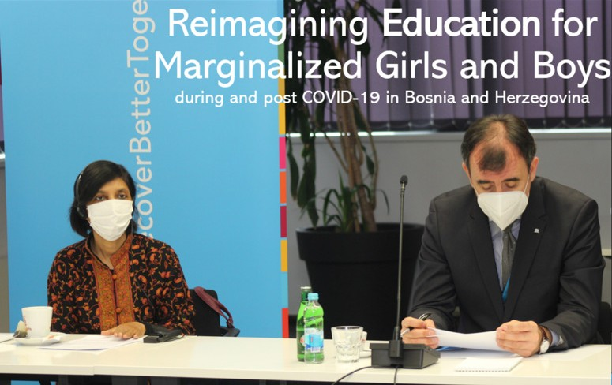

Kick-off meeting with UN and the Ministers of Education in Bosnia and Herzegovina. Venue and date: Sarajevo, UN House. 11 March 2021.

© Almir Panjeta (independent photographer)

 GUATEMALA



**CALL 2**

### Implementation of a Gender-sensitive Social Household Registry in Guatemala

**End Date:** 31 December 2021

PROGRAMME SUMMARY

This programme implements a Gender Responsive Integrated National Household Social Registry in five prioritized municipalities of Guatemala, with the aim of strengthening the capacity of the State to include more vulnerable populations, especially women, indigenous women, women with disabilities, and women-headed households, in the National Social Protection System (NSPS). To do so, it supports the development of a Social and Economic Conditions Assessment Sheet (FECS), a tool that helps the Social Registry of Households (SRH) be more inclusive of those, especially women, who are vulnerable and/or living in multidimensional poverty.

EMERGING RESULTS

The pilot exercise will target **20,000 households in six municipalities** to inform the design and implementation of the National Social Protection System, making it more

inclusive of vulnerable women. **Programme activities will commence in San Gaspar Ixil, in September 2021**.

Thus far the programme has:

* Positioned the SRH politically and strategically to enable its contribution to the National Social Protection System, presenting the programme at the Cabinet of Social Development and the Cabinet of Ministers
* Completed **five community consultations** with community leaders, local authorities, and women’s organizations in the pilot municipalities of the Social Registry of Households: San Gaspar Ixil (Huehuetenango), Santa Lucía Reforma and Santa María Chiquimula (Totonicapán), San Bartolomé Jocotenango (Quiché), Santa Cruz la Laguna (Solololá), and Santa Apolonia (Chimaltenango)
* **36 men, 43 women, and 28 young people participated**

in these consultations

* Consultations focused on access to food and water, health, employment, education, migration, climate events, and security. They validated the dimensions and variables in the socio-economic conditions assessment sheet (FECS) with local leadership, women’s organizations, and the field offices of the Ministry of Social Development (MIDES)

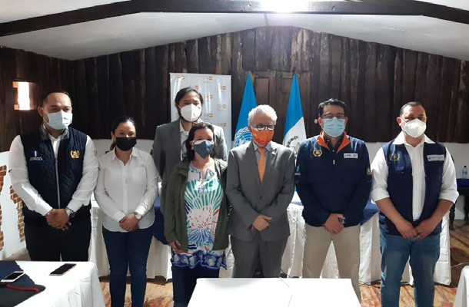

Inauguration activities of the training for the community team in charge of cartographic update of the pilot project “Social Registry of gender-sensitive households” in the department of Chimaltenango, with the participation of the Ministry of Social Development © UNFPA

* **Five Consultations** were carried out with **56 women (young women (29%), indigenous women (60%), and women with disabilities (0.5%)** to ensure their involvement in SRH implementation

LEARNING AND INNOVATION

In **Antigua and Barbuda**, the **digitization of the social protection management** through the use of UNICEF MIS system was underway, and it is anticipated that the remaining 90% of the beneficiaries will be registered and the transfers completed by January 2022.

 INDIA



**CALL 2**

### Protection of Women and Girls from Sexual and Gender Based Violence in times of COVID-19

**End Date:** 31 December 2021

PROGRAMME SUMMARY

Across 17 States, this joint programme enhances protections for women and girls from sexual and gender-based violence (SGBV) in the pandemic context. With a focus on the most vulnerable groups, it: (1) ensures availability of and accessibility to gender responsive and age sensitive SGBV protections; (2) improves access to gender sensitive justice systems for women and girls at risk and/or survivors of SGBV; (3) raises awareness among women and girls of SGBV risks and harmful practices, and empowers and engages them in decision making; and (4) reduces women’s and girls’ economic vulnerability and increases their access to livelihood and income generation programmes.

EMERGING RESULTS

Despite the devastating second wave of COVID-19, programme interventions by UNICEF, UNHCR, UN Women, and WHO strengthened the protection of women and girls in India from sexual and gender-based violence amidst the pandemic. In the first half of 2021, progress helped ensure that gender responsive and age sensitive SGBV-related essential services were available to women, girls, and

survivors of SGBV. In supporting government and partners at the national and state levels, the programme:

* UNICEF-supported the **training of 62,315 child protection functionaries and partners**, which then **reached 896,451 children and women** across the states of Chhattisgarh, Bihar, Uttar Pradesh, Madhya Pradesh, and Rajasthan with interventions that mitigated, prevented, and responded to GBV
* **34,752 children and caregivers** benefitted from community-based mental health and psychosocial Support (MHPSS) through expanded helplines, virtual safe spaces, online counseling sessions, and community-based channels that mobilized youth and local volunteers
* **7,707 functionaries and personnel** of the Department of Women and Child Development in Delhi, Madhya

Pradesh, and Rajasthan received capacity building through UN Women-supported interventions, including the **eight ‘Ask the Expert’ training sessions,** which were the first of a series of capacity building trainings

* Trained **831 personnel of the law enforcement and justice sector, 1,688 paralegal volunteers and 110 support persons on SGBV/VAC** (violence against children) and gender/child friendly procedures, **resulting in more than 2,000 cases reported** under the Protection of Children from Sexual Offences Act

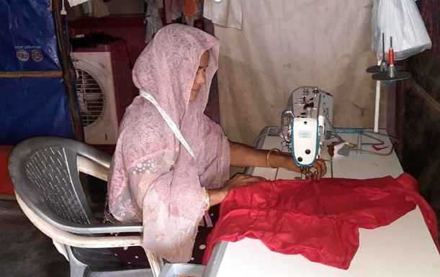

Minara sewing clothes in her small workspace at her home in Hyderabad

© UNHCR/Save The Children

* Reached and engaged 737,014 women, girls, boys, and men through online and offline outreach interventions conducted by UN agencies to raise awareness on SGBV prevention and response, mental health, and COVID-19 related information
* UN Women and partners supported a conditional and unconditional cash transfers programme by **linking women to government security and livelihood schemes** in the three programme states
* In Delhi NRC and Telangana, UNHCR conducted **skill trainings for 203 refugee women and 16 refugee men** on enterprise development, tailoring, and paper bag and jute bag making with monthly incentives; and **51 refugee women provided with microgrants of $INR 25,000/ person started small businesses**

LEARNING AND INNOVATION

The pandemic brought into focus the need for better digital communications and digital solutions for delivering programmatic results. Frontline workers could not work to full capacity, physical access and support was rendered difficult, and lack of online tools and connectivity, all hampered provision of essential GBV services. In the context of travel restriction and social distancing, technology and online platforms came in as prominent way to deliver capacity building sessions for partners on all fronts. By engaging with technology firms and digital platforms, the programme interventions could reach a broader scope of the target population, despite the limited movement. **It will be important to address the issue of digital divide while**

**promoting digital based programming, in order to ensure that the most vulnerable groups of women and children can be reached.**

## INDONESIA



**CALL 2**

### Employment and Livelihood: An Inclusive Approach to Economic Empowerment of Women and Vulnerable Populations in Indonesia

**End Date:** 31 January 2022

PROGRAMME SUMMARY

This programme offers support to target beneficiaries through three major channels: entrepreneurship training and business development; skills development for higher income and jobs; and support for a gender-equal and inclusive labor market. Ultimately, this initiative strives to empower Indonesia’s most vulnerable populations, particularly women, youth, refugees, migrant workers, people living with HIV, key populations most vulnerable to HIV, and people living in

disadvantaged regions by providing them business development and skills training. Programmatic interventions aim to help these groups recover from the adverse socio-economic impacts of the COVID-19 crisis.

EMERGING RESULTS

**Programmatic activities commenced in March 2021.** Overall, the programme is on course to achieve its intended objectives and targets, despite the ongoing impacts of the pandemic and the emergence of the Delta variant.

**As of 22 July 2021, under the first output, 444 people completed entrepreneurship training, and 344 beneficiaries completed skills training under the second output.** Thus far, the programme has achieved the following results under each of its three outputs.¹

Output 1 (Entrepreneurship)

* The number of beneficiaries that completed entrepreneurship training as of 22 July 2021 included: **327 cis- and transgender women; 27 trans gender people; 89 rural residents; 202 youth; 18 people living with HIV (PLHIV); three people with disabilities; and 61 refugees**
* ILO and UNHCR collaborated to **train 100 refugees**
* UNDP and UNAIDS trained **100 PLHIV and 100 people from key populations**

Output 2 (Skills)

* The number of beneficiaries that completed skills training as of 30 July 2021 included: **196 cis and transgender women; four transgender people; 221 rural people; 86 youth; 50 PLHIV; and 11 people with disabilities**
* ILO and UNHCR jointly organized a **training on digital marketing** for resellers that was designed exclusively for **refugees** who were not given ID cards, meaning they were denied access to formal employment.
* ILO and UNAIDS collaborated to provide **skills training to 100 PLHIV and 100 people from key populations**. The agencies selected two training programmes suitable for the target beneficiaries: fashion product development

using traditional Indonesian fabric and digital skills training. The project **selected and engaged 10 training providers** including social enterprises and NGOs

Output 3 (Inclusive Labor Market)

* Provided technical assistance and funding support to **update the National Equal Employment Opportunity Guidelines** (2008). The revision reflects recent developments including the Violence and Harassment Convention, 2019 (No. 190)
* Towards awareness raising campaigns and mobilization of popular support, the programme **engaged trade union**

**partners and will launch awareness raising campaigns on gender equality** and inclusive workforce in August 2021

1 Note that a young woman is counted twice in both categories of “women and trans gender people” and “youth.” The sum of the beneficiaries by category does not match with the total number of beneficiaries. The project has not yet estimated the number of indirect beneficiaries.

## JAMAICA



**CALL 1**

### Safeguarding and Protecting the Most Vulnerable: Enhancing Jamaica’s Shock Responsive Social Protection Mechanisms in Support of Vulnerable Groups including Children

**End Date:** 31 January 2021

PROGRAMME SUMMARY

This programme supported the safeguarding and protection of vulnerable farmers and poor Jamaicans registered with the Ministry of Labour and Social Security (MLSS) in Jamaica. It formed part of a decisive response to meet socio-economic needs within the context of a diminishing fiscal space and limited human capital, and against the backdrop of a global pandemic.

ACHIEVEMENTS

* Through **routine cash transfers** equaling approximately a US$30 increase in PATH benefits for three payments to poor and vulnerable families, and the **marketing of produce from poor farmers**, the programme **boosted the resilience of 4,552 households**, as part of the broader social protection system in Jamaica
* Of the households receiving assistance, **757 had pregnant and/or lactating women** and **2,180 had with children with disabilities**
* **1,000 households with at-risk children** ages three- to five-years old and experiencing food insecurity because of COVID-19 received **food care packages**
* The programme established the protocol to **trigger immediate humanitarian support** and cash transfers in **future emergencies** with a signed Memorandum of Understanding signed between UNICEF and Ministry of Labor and Social Security
* To facilitate the Ministry of Agriculture and Fisheries buy- back programme, the programme upgraded temperature controlled storage capacity to 41 tonnes and established a protocol for a buy-back programme to support female headed farmers and others in extremely vulnerable conditions during the pandemic recovery phase

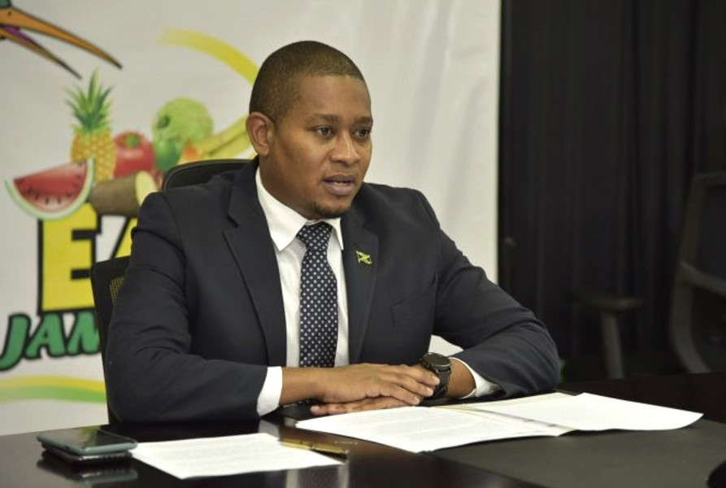

Minister of Agriculture and Fisheries, Hon. Floyd Green, says the government will continue supporting farmers by purchasing excess agricultural produce, through the Buy-Back Programme.

Source*:* <https://jis.gov.jm/more-support-for-farmers-through-buy-back-programme/>

* **615 farm families accessed additional economic protection** though participation in the agriculture buy-back programme

LEARNING AND INNOVATION

This programme opened the door for possible continued and fruitful collaboration on, *inter alia*: cash transfers, digitization of payments, improved visibility of female farmers, a national Agriculture Disaster Risk Management (ADRM) strategy to improve industry resilience to shocks, and opportunities to substitute imported food staples with local produce.

## LAO PEOPLE’S DEMOCRATIC REPUBLIC



**CALL 1**

### Supporting Provincial Health Preparedness and Surge Capacities, including at Points of Entry

**End Date:** 31 March 2021

PROGRAMME SUMMARY

This programme strengthened preventive measures and procedures at points of entry (PoE) for Lao People’s Democratic Republic (Lao PDR). The initiative used a three-pronged approach that focused on training border officials, procuring personal protective equipment, and improving operations and facilities at PoE and quarantine centers.

ACHIEVEMENTS

* Established a working mechanism for the improved capacity in screening and surveillance at PoEs and **trained 81 officers** on health compliant border procedures and facilitated debriefing sessions on these trainings for **83 additional officers** at the district and village levels
* Supported six centers across four provinces with improved WASH services and infrastructure, benefiting at least **11,348 people** who stayed in the center during the final months of programme implementation
* Held workshops with government authorities in four provinces **reaching a total of 321 participants** on their roles and responsibilities in relation to COVID -19
* Completed renovations and provided supplies that benefitted approximately **20,000 inhabitants of four quarantine centers**
* **Procured and distributed Personal Protective Equipment (PPE) to frontline officials** at the seven PoEs: personal protective coats (14), gloves (43,700), N95 masks (1,700), goggles (1,090), sanitizer (3,773), plastic face shield (924), handheld thermometer (204),

disinfectant sprayer (275), floor detergent (30 bottles), and toilet detergent (30 bottles)

* **Trained 508 people** on their responsibilities in relation to COVID-19 prevention and implementation of health- compliant border procedures
* Developed **Information, Education, and Communication (IEC) materials for migrants crossing at PoEs**, including an information sheet for inbound and outbound migrants, which can be accessed via a QR code

LEARNING AND INNOVATION

The programme facilitated development of a national quarantine center profile and occupant registry dashboard for the Ministry of Health to pilot and manage. The data entry for the dashboard, managed by border authorities, helped register and trace occupants at each center.

 MALDIVES



**CALL 2**

### Protecting Women and Children: Digitalizing and Streamlining Social Services, and Creating a Unified Platform for National Care

**End Date:** 1 November 2021

PROGRAMME SUMMARY

Through shock responsive social protection benefits, this programme aims to safeguard women from poverty and violence. Specifically, it: (1) strengthens the capacity of national stakeholders to promote social norms that prevent gender-based violence (GBV) and increases access to reproductive health and economic opportunities for women; and (2) increases

data collection and access to digital technologies and platforms for the most vulnerable of populations, such as women, children, elderly, persons with disability, people with mental illness, and people living in destitution. The initiative also supports the government to create a reformed, expanded, streamlined, and digitized national social protection policy through the consolidation and construction of an integrated, efficient, inclusive, and sustainable social protection system based on the principles of universal basic income (UBI).

EMERGING RESULTS

During the first half of the year, the programme undertook **planning and preparatory work**. Despite the recent outbreak of the COVID-19 Delta variant, which forced government partners to work from home, the programme:

* Held **multi-stakeholder consultations on developing**

**a digital platform** for the Ministry of Gender, Family and Social Services (MOGFSS) to provide services for GBV survivors, enable multi-sectoral support, and facilitate a survivor-centered tracking system

* Strengthened the data collection systems used by island councils by providing technical and ICT support to the Local Government Authority (LGA)
* Through digitalization support, **facilitated the business continuity of government agencies serving vulnerable people**, such as MoGFSS and the National Social Protection Agency (NSPA)
* **Upgraded the online portals ‘Vuna’ and ‘Gemen’** so MoGFSS and the NSPA could provide more effective service provision
* **Provided training and equipment** to support ‘Gemen,’ and training on an additional module in “Vuna” for collection of data on vulnerable populations
* Developed a term of reference for a **mobile application to support easier access to social protection** services

LEARNING AND INNOVATION

This programme is heavily focused on the **digitization and streamlining of services**. For instance, it is developing **a mobile application to help GBV survivors** with reporting, case tracking, and accessing an expanded referral support system that connects with national-level health, psycho-social, shelter, legal, and economic support.

## MONGOLIA



**EARMARKED**

### Supporting the Return of Vulnerable Mongolian Women and Children Stranded Abroad due to COVID-19 and Facilitating Labor

**End Date:** 25 September 2021

PROGRAMME SUMMARY

This programme was funded by an earmarked contribution to support the safe and sustainable return of thousands of the most vulnerable Mongolian migrant women and children who were stranded abroad by COVID-19. The programme

develops operational plans and protocols, delivers assistance to those abroad, and organizes the return and reintegration of migrants.

EMERGING RESULTS

Thus far, this programme:

* Provided cash assistance to **44 migrants of 31 households** to support their livelihoods abroad in 14 countries including Canada, Germany, Hungary, Indonesia, Japan, Lao PDR, Malaysia, Republic of Korea, the Russian Federation, Taiwan R.O.C, Turkey, Ukraine, United Kingdom, and the United States of America
* Provided **return assistance to 67 migrants** stranded abroad
* **Trained 237 border officials** in new standard operating procedures (SOPs) for points of entry (PoEs) in response to the pandemic
* Facilitated **risk assessments by 84 border officials at six border crossing points** in Mongolia

 TUNISIA



**CALL 1**

### Strengthening Social Protection and Economic Relief Systems for Vulnerable and Marginalized Segments of the Population as a Response to COVID-19

**End Date:** 31 March 2021

PROGRAMME SUMMARY

This programme supported the Government of Tunisia to ensure that vulnerable people were included in the national response to COVID-19 through the provision of tools that enabled authorities to target them. In parallel, the programme provided emergency financial and psychological support and housing to people that were not yet covered by the national response. It also offered income generating opportunities to marginalized women and supported small- and micro- businesses, promoting their inclusion in the digital economy.

ACHIEVEMENTS

To better serve vulnerable women and victims of gender- based violence, as well as members of the lesbian, gay, bisexual, and transgender (LGBTG) community and people with disabilities, the programme provided psychological support in remote areas and accessible essential information on COVID-19. Beneficiaries included:

* **406 vulnerable women** who received social aid consisting of treatments, cash-based aid, food, medicine, transportation, rent reimbursement, and utilities bill coverage
* **378 women victims of violence** who benefitted from legal, medical, psychological, and social services offered at a new shelter for women victims of violence
* **258 persons from the LGBT groups** who received mental health support (164) and social aid (94)
* **637 young people with disabilities** who received social aid consisting of treatments, medical fee coverage, medical equipment, and hygiene and dignity kits
* **328,747 people with disabilities** who were reached by the accessible sensitization
* **1,676 young people (ages 15-29)** who were reached to participate in a study on the impacts of COVID-19 on youth
* **339 youth** (63% female) who called the green line for the psychological support

Towards gender equality, the programme:

* Involved **46 public servants in gender responsive budgeting training** sessions, with 33 working in various sectoral ministries and 13 in the National Institute of Statistics (INS)
* **Trained six operators** working on the hotline 1899, in addition to five members from the National Observatory on fighting violence against women and on Law 2017-58
* **Produced six knowledge products** (policy briefs and reports) on the pandemic’s impact on women’s socio- economic conditions and access to health services

To address the economic impacts of the pandemic and assure equal access to business opportunities, the programme:

* Identified **740 vulnerable women micro-entrepreneurs** in the southern regions of Tunisia and provided them with capacity strengthening and support for their micro- enterprises
* Other direct beneficiaries included **61 craftswomen** who were supported on product design; and **57 vulnerable micro-entrepreneurs craftswomen** who were trained on communications, digital marketing, and e-commerce
* Indirect beneficiaries included **1,111 vulnerable women microentrepreneurs**
* Supported **45 female and former victims of trafficking**, through three national NGOs

The programme provided emergency interventions to help vulnerable and marginalized people cover their immediate needs. It:

* Undertook **12 distributions of vouchers** that could be used in 100+ stores; vouchers were given to **2,298**

**migrants**; all beneficiaries also received information on COVID-19 prevention, health services, and the IOM free hotline

* In collaboration with the Ministry of Social Affairs, provided **support to the Orientation and Social Support Centers hosting homeless people**; their Emergency Social Support Service (SAMU) was given in three major cities to provide the homeless with shelters, access to basic hygiene, and socio-psychological support. The center in Tunis has **hosted approximately 178 men and 230 women** since June 2020
* Supported the Ministry of Social Affairs and Ministry of Education to improve the targeting of vulnerable groups and the governance of programs by identifying vulnerable groups, and digitizing and modernizing the social protection system
* Set up the Ministry of Education database and connected it to the Ministry of Social affairs database so that **73% of households with children benefiting from school meals as safety nets could be included**



**CALL 1**

LEARNING AND INNOVATION

The **digital divide study** helped the project understand the needs of women in southern Tunisia, and it revealed gender inequalities in access to digitization. Lack of awareness of the importance of the digital transition kept female entrepreneurs from ensuring their socio-economic resilience.

With regard to youth, the project enhanced youth access to mental health services by offering a free and accessible solution in the Greenline. Through this innovative initiative, new challenges to the mental healthcare of young people were raised and will be addressed within the national strategy to promote adolescent and youth health and well-being. Further, the **Youth Needs Assessment** on the impact of COVID-19 on young people will inform this national strategy. This assessment was the **first of its kind to be conducted in Tunisia.**

## TUVALU



**CALL 1**

### Enhancing Food Security and Building Socio-economic Resilience to COVID-19 in Tuvalu

**End Date:** 31 March 2021

PROGRAMME SUMMARY

This programme helped to improve food security and nutrition for fishing-dependent households in outer islands and supported government efforts to better understand and address the pandemic’s impacts on the labor market. Specifically, the initiative provided technical support to increase fishing opportunities for nearshore pelagic species; improved data collection and analysis to inform policy development and the planned National Housing Census in 2022; and provided recommendations to the Government of Tuvalu based on an assessment of the impact of COVID-19 on the labor market and remittances.

ACHIEVEMENTS

Boat building and the provision of resources and materials to support aquaculture and help restore and/or increased nearshore oceanic fisheries in the outer islands

* Overall, the FAO activities in the project **benefitted approximately 452 fishers, men and women across the value chain** of harvesting, processing and selling. The programme:
* Finalized a boat building manual and made templates for wood cutting to speed up boat production
* **Hired a local boat builder and trained six boat building apprentices** from the National trade school in Funafuti

to build the one-man paddling canoe; building of the first canoes served as the training platform for the apprentices to build all **45 canoes**

* An estimated **50 families (approximately 200 people) benefitted** from the paddling canoes built for the outer islands.
* **Repaired Community Fisheries Centers in three outer islands (benefitting 80 women and 60 men)** and provided **fish handling and processing equipment to the Funafuti fish market, benefitting 112 people directly**, as well as, indirectly, all that use the market
* Made templates for the postharvest solar fish dryers

The IOM and ILO developed and disseminated a national assessment report evaluating the impact of COVID-19 on Tuvalu’s labor market, specifically the impacts on employment, businesses, and households.

* The national assessment covered the **following indirect beneficiaries: 32 enterprises; 189 workers (57% female); 23 laid-off employees (8% female); and 87 households** on the main island of Funafuti.
* Report findings and recommendations were **disseminated to 43 participants** from Government of Tuvalu, as well as survey participants for discussion and for future planning and action during a roundtable meeting held on 10 March 21
* **110 hardcopies** were shipped to Tuvalu for further dissemination
* **The Government of Tuvalu agreed to consider the recommendations in its national development strategy** covering its entire population

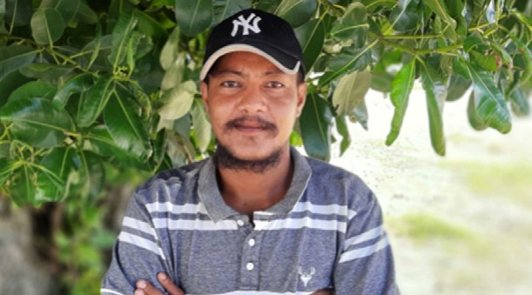

Prior to COVID-19, Mr. Pule Telsia worked on fishing vessels as a seafaring fisherman. He loved life out at sea and was happy that he could contribute financially towards his families well-being. Tuvaluans are known for their seafaring skills, traditional knowledge of the ocean and their ability to read the waves. Many seafarers like Pule could not find work on overseas vessels because of the closure of borders, and now that reality is harder since certifications need to be updated on a regular basis. Pule did not hesitate to join the seafarers refresher course training that was organized by the project team, Department of Tuvalu, and the Tuvalu Maritime Training Institute (TMTI) as it provided participants with a lifeline to undertake the expensive refresher course training for free. As a result, Pule now believes that he is in a better position to seek employment when border opens. © ILO and IOM

* Based on the findings, the Department of Labour collaborated on the implementation of **refresher course trainings for 23 seafarers** with the Tuvalu Maritime Training Institute, preparing them for employment once borders opened

Support for the Population and Housing Censuses in 2012 and 2017, and the 2015/16 Tuvalu Household Income and Expenditure Survey (HIES)

* FAO, in collaboration with the Tuvalu Central Statistics Division and South Pacific Community (SPC) Statistics for Development Division, **prepared an analytical report that provided agricultural data** collected in the Population and Housing Censuses in 2012 and 2017, and the 2015/16 Tuvalu Household Income and Expenditure Survey (HIES)
* The report, which covered cropping and livestock activities, household fishing and handicraft activities, as well as details of climatic and natural disaster events impacting households, was **well accepted by the national partners and disseminated** in [https://stats.gov.tv](https://stats.gov.tv/)



**CALL 2**

Helping the Visually Impaired

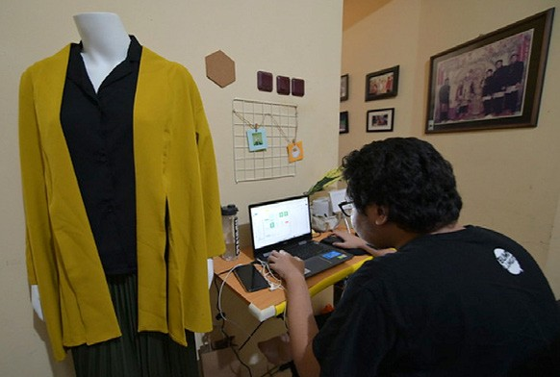

Employment and Livelihood project, funded by UN’s COVID-19 pandemic response initiative, aims to support vulnerable groups including people with disabilities in the spirit of Leave No One Behind. It’s objective is to make the recovery from COVID-19 pandemic inclusive. **One of the activities under the project is to provide training to vulnerable groups to help them attaining new skills and opening new economic opportunities**. Digital marketing skill training was offered as part of the project.

Kenichi Satria Kaffah, who is blind, has been interested in digital marketing for a while now. When he was in Junior High School, he was already keen on earning his own money. He started with selling things online, mainly phone cases. This interest and experience made him jump at the chance to join the training on Digital Marketing.

Digital training programmes help young entrepreneurs improving their businesses

© ILO/F. Latief

“Today is the Digital Era, Era 4.0. It requires us, whether we want it or not, to be digital. Because the competition today is rough, gaining a new skill in digital marketing is very useful,” said Kenichi. “I found the Business Analysis session really useful, we were taught how to do analysis using Business Model Canvas which I believe really important and helpful for my business,” he added.

There are many challenges faced by Kenichi and his peers, and the biggest one come from people surrounding them. Many people with disabilities face stigma every day. Moreover, they are often times excluded or looked over in the public life and development process.

“Trust,” he said simply. “I’m totally blind, and when others see me, they think ‘can he really do the job?’ They wonder how I am going to create digital contents,” he elaborated. When the pandemic is eventually over, will we go back to “normal” where people with disabilities were disadvantaged in the labor market and in the society? Can we take a different path

of recovery so that we can build an inclusive society where talents like Kenichi can fully utilize his skills despite his visual impairment? This choice is in our hands.

Source: <https://www.ilo.org/jakarta/info/public/fs/WCMS_815639/lang--en/index.htm>

LEARNING AND INNOVATION

This initiative is organizing a **women’s entrepreneurship accelerator programme**. Agencies teamed up with the Indonesia Women Empowerment Fund (managed by YCAB and Moonshot Ventures) and Creatella Impact to conduct a competition and pre-acceleration programme aiming to strengthen and **foster innovative tech solutions by women entrepreneurs**, with

a focus on contributing to the SDGs, business scaling, gender lens investments, and impact measurement. Fifty selected participants will go through two rounds of mentoring and pitching, with the top 20 finalists selected to participate in the pre- acceleration programme in August.

Further, the programme is **fostering youth entrepreneurship** through a four-months long training and mentoring boot camp. This will be part of the Youth Co:Lab Initiative led by UNDP and Citi Foundation. With the support from the Fund, the number of participants will be doubled to **120 youth entrepreneurs** from outside Java.

Also with regard to youth, the programme **deliberately partnered with youth social entrepreneurs** who demonstrated workable ideas to support disadvantaged groups of people. For instance, the project funded activities proposed by **young Italy- educated fashion designers** who work with village women, weavers of traditional clothes. They fuse modern fashion design with Indonesia’s traditional fabric making, adding value to products of village women. In another example, the project funds a **young UK-educated digital content specialist** who started a **social enterprise to train visually impaired persons**. Digital content making can be performed at home as freelance work and generates income for people with visual disabilities.

## URUGUAY



**CALL 2**

### Strengthening a Gendered and Generational Socio-economic Response through Evidence-based Policy Advocacy and Analysis

**End Date:** 1 April 2022

PROGRAMME SUMMARY

This programme will support the government to protect vulnerable groups that, if left unattended, could face extreme poverty as well as increased difficulties in addressing new COVID-19 outbreaks. Specifically it will: (1) Generate integrated information systems and analytical reports on vulnerability to improve resource mobilization; (2) Support the early childhood care program affected by the pandemic and pilot an employment/childcare program for vulnerable women; (3) Implement

a national time use survey to update information for the formulation of gender equality policies; (4) Preserve educational continuity of secondary school students from vulnerable sectors; and (5) Through the UNDP’s Accelerator Lab, activate a platform connecting data, information systems and community experiences to create transformative solutions for the future delivery of social protection programs.

EMERGING RESULTS

**Programmatic beneficiaries**, based on the 2019 household survey and using the official poverty line, will be **34.2% of the population of Uruguay**, which comprises **330,000 households and 1.2 million people**.

Thus far the programme:

* Released **a brief and social media cards** to publicize 2020 Continuous Household Survey data showing the impacts of the pandemic on vulnerable groups and women (Two presentations were made; one to the legislators of the Bicameral Women’s Bank on 04/20/2021 and to the edilas of the Canelones department on 06/25/2021)
* Towards an **Integrated data system**, the programme reached an agreement with the Unit of Methods and Access to Data (UMAD) of the Faculty of Social Sciences
* Prepared a proposal for **economic empowerment indicators** to be included in the Gender Information System (GIS) of the National Institute of Women and the Observatory of Social Policies of the Ministry of Social Development (MIDES)
* Began developing a **Unique System of Geographic Addresses of Uruguay**, which will allow State institutions to use the same registry for the georeferencing of

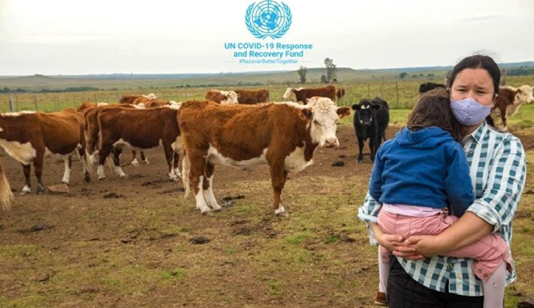

© FAO

personal data, thereby advancing the integration of different agencies’ databases that inform public policy

* Developed a **back-to-school communications campaign**

titled, ‘Every Day Counts,’ [[Video Link]](https://es.unesco.org/news/esta-vuelta-clases-cadadiacuenta)

* The UCC program and the National Institute for Women began the implementation of **a new socio-educational and labor programme** within the institutional offer that targets exclusively **vulnerable women**

LEARNING AND INNOVATION

The programme, as it is implemented, will bring innovative approaches and ideas to the region. For instance, the interoperability of the databases will be complemented with the georeferencing of the information based on the Single Address Register, and given the increasing importance of using administrative records, this will offer a leap in terms of the availability of information for the elaboration of public policies. Further, the preparation of the Multidimensional Gender Poverty Index, will be the first experience in the region, as will the implementation of the Policy Acceleration Laboratories.

# PILLAR 3

#### ECONOMIC RESPONSE AND RECOVERY

Protecting jobs, small and medium sized enterprises, and the informal sector workers



## ARMENIA



**CALL 2**

### Accelerating Women’s Empowerment for Economic Resilience and Renewal: The post-COVID-19 Reboot in Armenia

**End Date:** 31 December 2021

PROGRAMME SUMMARY

This programme empowers Armenian women and girls living in the most vulnerable and marginalized contexts to act as agents of change by: (1) providing them with targeted business and digital STEM (science, technology, engineering, and math) skills that support their adaptation to market change in the pandemic context; (2) offering them new sources of income and livelihood opportunities; and (3) ensuring that at-risk women and survivors of violence benefit from access to gender-based violence (GBV) information and protections adapted to the COVID-19 context.

EMERGING RESULTS

To date, the programme reached **1,036 women**, helping them to increase their economic security in response to the impacts of the COVID-19 pandemic in Armenia. The programme:

* Selected **18 women entrepreneurs** to receive micro-, small-, and medium enterprise (MSMEs) support, with nine of participants from the rural communities/regions of Aragatsotn, Lori, Syunik, and Tavush
* Kicked off online **trainings for 168 women on technology, innovation, and business management**
* Commenced **trainings of 50 girls** from Yerevan **on tech and innovation skills** to facilitate careers in **STEM**; targeted recruitment resulted in **80% of the participants coming from vulnerable communities, including displaced populations**
* Refurbished **one of the targeted colleges/VET (vocational and education training) institutions with new equipment** to facilitate up-skilling and reskilling opportunities for vulnerable women and girls in the town of Gavar
* **Assessed 10 civil society organizations** on their capacity to develop tailored content for the prevention of violence against women and girls and identified a private partner

to set up the ‘Safe YOU’ mobile application to spread information on protection against GBV

* **800 people were using the “Safe YOU” mobile application**

LEARNING AND INNOVATION

The programme is developing **a mobile application called ‘Safe YOU’ to assist in the prevention of and response to GBV and to broaden the delivery of services for survivors**. Working with civil society organizations, individual professionals, international organizations, and State Authorities, the application and platform were designed to help combat violence against women and girls (VAWG) by providing security functions that help them seek assistance during emergency situations. The application connects women with service providers, knowledge resources, and community support. It also collects valuable, anonymous information that fills data gaps in the fight against VAWG. At the end of the reporting period, the application had 800 users. The UNICEF Armenia office is facilitating the completion of a second generation of the application with improved mobile features and content for March 2022. **It is expected to host 20,000 mobile users** by the end of the project. Additional information on the application can be found here: <https://www.unicef.org/innovation/stories/virtual-safe-space-women>.

 BHUTAN



**CALL 1**

### Protecting Livelihoods and Reinforcing the Tourism and Agriculture Sectors in Bhutan

**End Date:** 31 March 2021

PROGRAMME SUMMARY

This programme addressed the direct impacts of the COVID-19 pandemic on livelihoods by mitigating food insecurity, creating jobs, and strengthening Bhutan’s tourism and agricultural sectors to “build back better.” The initiative provided cash-for-work incentives to vulnerable groups as well as reskilling and upskilling activities, with a particular focus on women. Another component focused on people affected by the pandemic in the tourism and hospitality sector, whereas an agricultural component primarily targeted smallholder farmers and helped them enhance local vegetable production.

ACHIEVEMENTS

Under its tourism component, in partnership with the Tourism Council of Bhutan, the programme benefitted **286 people (40% women).** There were 146 direct beneficiaries and 140 indirect beneficiaries. Specifically, it:

* **Upskilled 100 young (18 women/average age 27) laid off licensed national cultural tour guides** who were trained as trekking guides, of which 97 were certified and licensed, from National Certificate Level two to three, enhancing their employment prospects and marketability. Four private training institutes were engaged for this training programme
* Through a cash for work scheme, fully rehabilitated the popular trekking route, ‘Phajoding Culture Trail’ in

partnership with Guides Association of Bhutan, an activity that **engaged 30 unemployed people** from the tourism sector; The route now has public washrooms, canopies and benches as rest areas, and signage

* **Surveyed the ‘Snowman Trek’ route for digitization** in partnership with the National Land Commission
* Enhanced the **Tourism Council of Bhutan’s external capabilities** to promote tourism through development of a communications plan and initiation of platforms to engage stakeholders

The agriculture component reached **668 direct beneficiaries (smallholder farmers), which were over 70% women** from the two districts of Zhemgang and Samtse. Indirect beneficiaries numbered approximately 2,016 additional people belonging to the farming households. The programme:

* In partnership with the Ministry of Agriculture and Forests and the local government, supported the local production



Lhamo signed up for the Trekking Guide Course offered through the Tourism Council of Bhutan (TCB) and the UNDP project. © UNDP

and **sale of vegetables in the two vulnerable districts of Zhemgang and Samtse**

* Provided **668 smallholder farmers, of which 70% were women,** with high quality vegetable seeds and tools, as well as green technologies such as drip kits, sprinklers, flexible pipes, mulching plastic, low-cost poly-houses, water storage tanks, water harvesting materials, and electric fencing materials
* **Increased production by at least 20%** compared to previous years, with over 44MT of local vegetables produced by the targeted beneficiaries; 35MT of vegetables sold for US$28,000

LEARNING AND INNOVATION

The programme supported the Tourism Council of Bhutan to institute the **Bhutan Tourism Dialogue Series**, which aimed to rethink and reinforce tourism in the country. It shared knowledge and best practices, and it helped develop the travel sector in Bhutan through dialogue. Through this programme, UNDP embarked on another initiative with the Tourism Council of Bhutan to **devise a blueprint on the ‘Digitalization of the Tourism Sector in Bhutan,’** which will guide Bhutan’s tourism sector in partnership with national stakeholders and leverage ICT for the benefit of the whole tourism industry.

With regard to learning, through the joint action of the Economic Contingency Plan and other programmes, the production of agriculture commodities showed remarkable progress. To avoid market glut and price drops due to excess produce supply, it was realized that the district and technical agencies should advise farmers on properly planning and staggering production, as well as on post-harvest handling and storage solutions.

 BOLIVIA



**CALL 2**

### Mitigating the Socio-economic Impact of COVID-19 on Employment and Income of Own-account Women Workers in the Informal Economy

**End Date:** 31 December 2021

PROGRAMME SUMMARY

This programme reduces the socio-economic impacts of the COVID-19 pandemic on own account women workers in the informal Bolivian economy. It seeks to establish social protection mechanisms; create a focus on access to decent work; and offer capacity building and training to improve business skills and access to financing. Overall, the programme seeks to prevent women from falling into poverty through the promotion of gender equality and economic empowerment.

EMERGING RESULTS

This programme has faced serious delays due to a shifting political landscape and a drastic rise in COVID-19 cases. The Bolivian 2020 election resulted in a change in government, which delayed government collaboration as new officials had to be introduced to previously agreed programmatic objectives. Concurrently, a third wave of COVID-19 cases greatly limited opportunities to engage own account workers in the planned activities. Several of the targeted women got sick and had to pause their business activity.

In its first months of implementation, the programme:

* Completed a **characterization study of own account workers**, while initiating two additional studies. The characterization study helped determine connections between the rising burden of unpaid care work due to the pandemic and the concentration of own account

workers in the informal economy. The testimonies of the interviewed women expressed the need to develop an integrated care system in Bolivia, as a first step to support their formalization and access to decent work

* Started **preparation for skills and entrepreneurship trainings of own account workers** and commenced a **partnership with civil society organizations to facilitate trainings for government institutions on**

**social protection and co-responsibility care systems** that promote targeted policies and programmes for formalization of own account workers. Once initiated, co- responsibility care systems will help redistribute the load of unpaid care work between State, market, community, and families (and, within the families, between women and men)

 CAMEROON



**CALL 2**

### Support to Jobs, the Resilience of Small Enterprises, and Informal Workers during and beyond the COVID-19 Pandemic

**End Date:** 1 January 2022

PROGRAMME SUMMARY

This programme supports vulnerable women, youth, and informal workers in the two municipalities of Yaoundé and Douala through the: (1) promotion of rapid and sustainable jobs based on high labor intensive activities (HLIA) and related support for cooperatives, micro-, small-, and medium-enterprises (MSMEs) and employment services; (2) strengthening of technical and professional skills that underwrite self-employment and the socio-professional integration of vulnerable women and youth affected by the pandemic; and (3) strengthening of life skills and protections that empower vulnerable women and youth living in pandemic-affected, peri-urban areas. The initiative also supports vulnerable women and youth in the five municipalities of Maroua, Ngaoundere, Bertoua, Bamenda and Buea by enhancing their self-employment skills, professional integration, and protection.

EMERGING RESULTS

* In collaboration with the Ministry of Youth and Civic Education and the municipalities of Maroua Ngaoundere and Bertoua, **48 youth were selected and placed in workshops** and small scale production industries to improve their technical capacities before being trained on leadership and entrepreneurship
* Procured **technical equipment** (sewing, secretarial, office, and restaurant) to support **16 youth activities**
* In collaboration with the Ministry of Employment and the municipalities of Douala and Yaoundé, **100 women micro-entrepreneurs in the green economy were**

**selected** from the database of the Integrated Programme of the Informal Sector (PIAASI); **25 will receive a small business improvement grant**

* **Trained 40 municipal counsellors and jobs and enterprise counsellors from the National Employment Fund (NEF),** and social partner organizations on

the e-employment platform (job terminals), which are decentralized employment NEF kiosks to help

vulnerable populations access employment and business opportunities

* Trained **four municipal staff** in focus group facilitation techniques and community engagement
* Prepared municipal data collection and project sheets to assess the level of access to water, waste collection

points, public toilets, and watercourses in areas at risk of landslides and flooding

* Held a **workshop for municipal staff on the installation and configuration of software** for the design of water supply and distribution works
* Procured technological equipment to support the extension of employment services and training tools (**one computer, two tablets, and three internet connection kits delivered**)
* Engaged **artisans living with a disability to manufacture 1,000 masks**
* Identified **40 community radio stations in six regions** to give communications support to activities
* Put in place two **modules on COVID-19 response** on disinformation and on the production of interactive programs by the media, particularly community radios
* Launched a call for the **selection of 10 artistic projects**

to benefit from a loan and professional support

* Identified **30 artists** to be trained on cultural and creative entrepreneurship and on aspects inherent to copyright and neighboring rights, intellectual property and digital rights, digital broadcasting and social networks
* Identified **10 Family Farm Schools** in the Far North, North, and Adamaoua regions for a training program on improved agricultural production techniques and the sale of agricultural products

LEARNING AND INNOVATION

Links between this programme and the **National Green Jobs Programme offer a path towards additional resource mobilization.** The Green Jobs Programme has a resource mobilization plan, and one project component will pilot an initiative to boost green jobs employment through support for women-led MSMEs working in this sector.

 CHILE



**CALL 2**

### Immediate Response to Sustainable Economic Reintegration of Young Women in Chile

**End Date:** 5 April 2022

PROGRAMME SUMMARY

This programme utilizes the technology-driven and digital sectors in Chile to counter the COVID-19 pandemic’s effect on women’s labor market participation. By collaborating with a diverse array of institutions, including central and local

government and employers’ and workers’ organizations, the initiative promotes economic measures that support decent working conditions and better coordination of employment programmes targeting women. Specifically, it uses the digital platform MujeresEmplea.org to match labor market supply with demand and to provide trainings on digital skills and in STEM (science technology engineering and mathematics). It also promotes care services to support women’s access to labor markets.

EMERGING RESULTS

The Government’s Paso a Paso Plan to curb COVID-19 resulted in strict lockdowns that prevented participation and implementation of activities requiring in-person training.

However, the programme successfully collaborated with the private and public sectors to identify labor market demands and map existing offers to vulnerable women (i.e., programmes, training, and funds). Thus far, the programme:

* **Promoted the reintegration of women into the labor market** through the creation of a website that

disseminates private and public information on job offers, free training opportunities, and entrepreneurship funds targeting women and available care services

* **Gathered information on programmes, trainings, and job opportunities** under one online portal using the already existing website MujeresEmplea.org
* Introduced filters to online employment portals to highlight opportunities for women in predominantly male sectors
* **Introduced 2,120 new users** to the online job platform
* Engaged relevant actors in the design and implementation of local care services programmes for children
* Launched a **media campaign** with **18 appearances in the written press, two television interviews, and posts** on the agencies’ social media accounts, which reached approximately **84,757 users**

LEARNING AND INNOVATION

The programme facilitated coordination between public and private institutions and the different programs offered to women by utilizing an online platform in collaboration with employers’ and workers’ organizations, civil society, and local and central governments. In doing so, the programme paid particular attention to companies’ needs to develop relevant initiatives based on actual labor market requirements.

 DJIBOUTI



**CALL 2**

### Climate Resilient, Women Centric Economic Empowerment for Inclusive and Greener Post COVID-19 Recovery

**End Date:** 15 April 2022

PROGRAMME SUMMARY

This programme empowers women and enhances their entrepreneurship and leadership skills through the promotion and improvement of micro-, small-, and medium-scale enterprises (MSMEs). The programme fosters budding microfinancing schemes and introduces innovative and practical practices and mechanisms to engage women in climate resilient business. Through the initiative, MSMEs promote local production and accelerate women’s contributions to the national blue and green economies.

EMERGING RESULTS

This programme **commenced implementation in April 2021**, with a formal launch planned for July 2021.

* In collaboration with the Ministry of Social Affairs (MASS), UNDP **provided prevention kits and means of sustenance to 400 vulnerable people**, including refugees, elderly people, and people with disabilities, all affected by COVID-19
* The programme identified: **three cooperatives** and one start-up owned or led by women to which technical and financial support can be provided; **two potential women’s user groups** for Ali Sabieh and Arta; and a potential **service provider** to provide support to the

women and youth led value-chain based market linkages

* Other project activities that progressed during this reporting period included: a mapping and **needs assessment of potential beneficiaries**, a feasibility assessment of the financial and technical aspects of the needs, and the development of tentative support packages based on the identified beneficiaries’ needs.

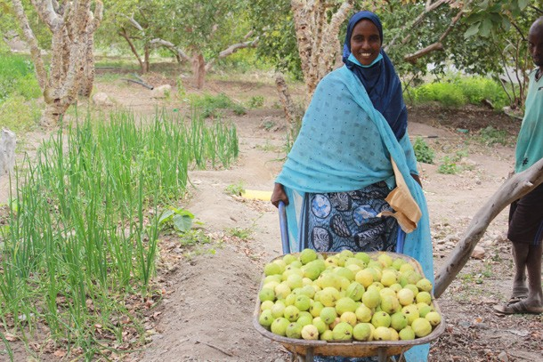

Fatiah, a young lady managing her own farm in a remote area of Djibouti, proudly shows her guava harvest from a farm in Assamo.

© UNDP Djibouti/Stephanie Schaefer

## FIJI



**CALL 2**

### Inclusive Economic Recovery through Sustainable Enterprises in the Informal Economies of Fiji, Palau, Tonga and Vanuatu

**End Date:** 1 November 2021

PROGRAMME SUMMARY

Under this programme, UN agencies work with national and regional institutions to introduce social security mechanisms for informal workers, as well as regulatory mechanisms for legally empowering the informal economy. The initiative engages the formal private sector, national trades unions, national training institutions, creative associations,, and producer organizations in the design and deployment of Business Development Services (BDS), social security and business continuity plans. It supports the organization of business owners and workers to understand their rights and ensure they have adequate representation in public consultations and policy formation. Finally, the programme helps creative industry entrepreneurs as well as new entrants into informal agriculture transition to operating in the pandemic context.

EMERGING RESULTS

For **all countries**, the programme:

* Developed COVID-19 **advisory materials to strengthen Business Development Services (BDS),** which, thus far in Fiji, enabled informal sector micro-, small-, and medium enterprises (MSME) to open for business, avoid fines or imprisonment, and continue to employ others
* **2,000 MSME’s** have received durable COVID-19 safe signages to strengthen their compliance

In **Tonga**, the programme:

* Supported the creation of **seven informal sector associations** that, for the first time, held a dialogue with the Minister of Economy to present their COVID-19 recovery priorities, which will inform Tonga’s COVID-19 strategy and National Employment Policy (NEP)
* Supported **1,045 informal sector entrepreneurs** to access the government’s first-ever grants for informal sector COVID-19 response
* **Two trade shows** were held in Tonga for the informal sector:
* Show for tapa makers had women from 34 villages participate, **engaged 545 women**, and **T$150.000 worth of orders** was received on the day
* Show for Tongan mates saw 16 villages participate, engaged **345 women engaged**, and **T$110,000 worth of orders** was received on the day

In **Fiji**, the programme:

* Supported a dialogue with the government and representatives of **3,000 informal sector MSMEs to identify COVID-19 recovery challenges** and solutions and improve existent safe business protocols; Key solutions on supporting cash flow and e-commerce were included in the new government budget, and dialogue recommendations will be included in the NEP
* Trained **19 businesses on the ILO’s enterprise development tool**, using activity-based learning (ABL)

LEARNING AND INNOVATION

methods and Community Based Enterprise Development (C-BED), which are on-line capable

* Trained four private sector Business Development Services on COVID-19 safe services, which will relay the information to approximately **200 MSMEs**, using on-line delivery
* Supported **1,045 organizations** to access the government’s informal sector business grants.
* Trained 19 trained (50% women and 20% youth) to be in

**e-business trainers** that can outreach to approximately **400 micro enterprises this year**.

In **Vanuatu**, the programme:

* Launched the payment gateway of the mobile apps M-VATU (Vodafone) and MyCash (Digicel) to the Vanuatu National Provident Fund
* **6,000 were boarded**, allowing informal sector workers and entrepreneurs to access social security

The programme also launched an **entrepreneurship training for culture and arts.** In **Palau, Tonga and Vanuatu**, training in the Creative and Cultural industries will begin in mid-August, and will target, handcrafts, visual arts, fashion, performing arts and music. Through this training programme, the initiative fostered culture sector recovery by:

* Provided online training to 24 managers from 15 dance companies to run a dance company and create a brand for the first time
* Provided online training to 15 individual artists in both technical skills and product development, branding, and supply chain in visual arts
* Kicked off the legal constitution of two collective bodies, the Fiji Islands Dance Association and the Viti Association of Visual Artists
* With regard to agriculture entrepreneurship, the programme outreached to **120 smallholder farmers** and informal sector workers to engage them in agriculture and strengthen domestic food and nutrition security during by the pandemic.

The second wave of COVID-19 in Fiji created **demand for on-line content and services**, with COVID-19 safe business protocols becoming a major component of business services. Given this context, on-line capable business training materials (e.g. CBED) were used to deliver services. Further, Facebook was used to promote the sale of products at the trade shows, targeting the diaspora, and mobile phone apps were used to establish payment gateways to ease access to social security.

 GUINEA



**CALL 1**

### Mitigating the Immediate Impact of COVID-19 on the Formal and Informal Private Sector in Guinea

**End Date:** 31 March 2021

PROGRAMME SUMMARY

This programme used mobile applications to assist entrepreneurs, especially women, to sustain and expand their businesses during the COVID-19 pandemic. Concurrently, the initiative worked to break COVID-19 transmission chains and ensure business continuity through the dissemination of awareness materials along with support for the manufacture and supply of quality, affordable, and sufficient personal protective equipment (PPE).

ACHIEVEMENTS

Overall, the initiative helped strengthen national production capacities and contributed to the availability of and universal access to hygiene and PPE, especially for vulnerable people. Specifically the programme:

* Provided **150 women with access to digital bookkeeping** systems through the M’mawali application
* Provided equipment to **four small and medium enterprises (SMEs)** to enhance mask production
* Upgraded local pharmacy production of hydro-alcoholic gel; produced approximately **5,000 vials** of 250 ml disinfectant at the industrial standard
* **Upgraded 18 SMEs** to comply with the international business standards of AFNOR (Association Française de Normalisation) and ECOSTAND (Economic Community of West African States Community Committee for Standardization)
* Enabled **local production of 780,000 masks**
* Ensured **301,000 people** had access to hygiene kits and PPE
* Conducted COVID-19 awareness campaigns in Conakry and in the Kindia, Kankan, and Boke regions

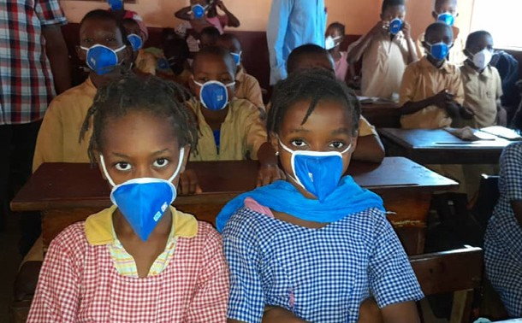

Fight against COVID19: awareness and distribution of protection kits at the primary school © UNDP

* **Supported 78 businesses** to build resilience and assure operational continuity
* Provided technical and financial **support to five innovative projects** in collaboration with an incubator and relevant government agencies to support their formalization, marketing, and networking strategies
* Created and/or **maintained 568 local jobs**, especially in relation to PPE production

LEARNING AND INNOVATION

Digital innovation

As part of the UNDP Accelerator solution package ‘Imagetronism’, which aims to develop visual digital innovations, the M’mawali **digital application is designed for women entrepreneurs in rural areas with low literacy rates.** In the local language Soussou, M’mawali means “My daily work/business.”

**The app is built based on women’s daily business transactions** and is comprised of three blocks of data entry: revenue, expenses, and accounting. For each data entry block, there is an illustration (image) to help the beneficiary understand what type of transactions should be entered.

Colors are used as monitoring tools. For instance, when the result of the daily accounting shows red, there were more expenses than revenue. When the accounting shows green, revenue exceeded expenses. According to the transactions report on the last trimester provided by the National Agency for Innovation and Digital Economy, **the rate of app use**

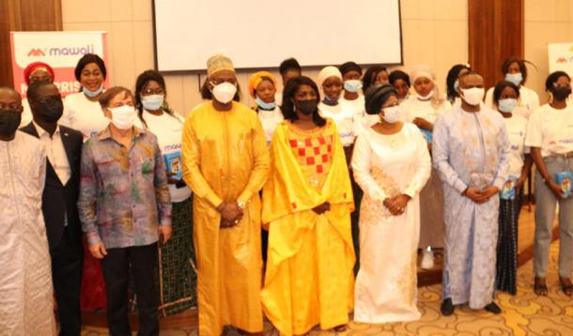

Launching of M’mawali with the UN, the Ministers in charge of Posts, Telecommunication & Digital Economy, Women Rights and Empowerement, Tourism and Communication © UNDP

**increased from 401 interactions to approximately 1,500 over its first two months.**

## JORDAN



**CALL 2**

### Socio-Economic Empowerment of Vulnerable Women in Ghor Al-Safi through Improved Access to Safe and Green Public Spaces

**End Date:** 14 January 2022

PROGRAMME SUMMARY

This intervention aims to enhance the socio-economic conditions of vulnerable women living in Ghor Al-Safi through the provision of a safe and green public space and the creation of livelihood opportunities. The programme employs an enabling environment and tools to assist women in developing small businesses in a secure and inclusive environment.

The creation of a green public space supports ecological solutions to climate change and improves the urban environment.

EMERGING RESULTS

This programme strives to serve the **whole Ghor Al-Safi population** and underserved neighboring communities. The public space and community center directly benefits the **37,040 Ghor Al-Safi inhabitants** and **indirectly benefits at least 26,868 more people** from the communities of

Al-Mazraa, Al-Maamoora, and Ghor Fifa, which classify as poverty pockets lacking safe public spaces. Direct and indirect beneficiaries include **vulnerable women, Syrian**

**refugees, vulnerable youth, people with disabilities, and women-headed microenterprises.**

Thus far the programme has achieved the following results under each of its intended outputs.

* Conducted a **Site-Specific Assessment**, a **topographic survey**, and prepared the conceptual and detailed designs for the public space and community center
* Held **two community consultation sessions** (19 April and 19 May) for **74 participants (54 women)** to validate the assessment findings and present the design ideas
* Zaha Cultural Centre conducted **two community needs assessments**, with one **engaging 55 community members** (31 women) and another to gain feedback

on the multi-service community center and women’s trainings

* Proposed an area within the architectural design to be dedicated to market and kiosk space
* **Conducted a Training of Trainers (ToT)** in Amman for **nine participants**, and **20 trainers from Ghor Al-Safi** took part in the second ToT held in July

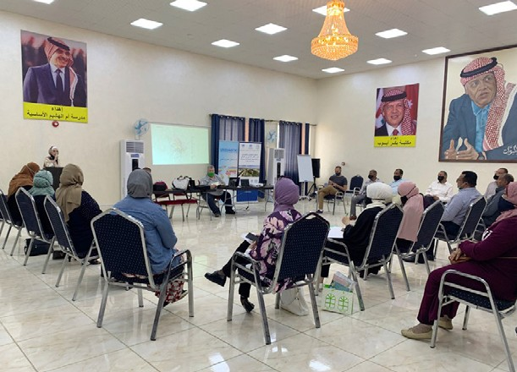

A workshop looked at the priorities of the local community regarding the design of Ghour Al-Safi Public Park in Southern Jordan. © UNHABITAT

* **132 women from Ghor Al-Safi applied** for Women Do Business (WDB) training, which commenced in August at Ghor Al-Safi
* **44 women finished the WDB course** (three rounds), and by the end of September all WDB training rounds will be conducted

LEARNING AND INNOVATION

The needs assessment identified that a large portion of community wanted an e-marketing training program as one of the micro project entrepreneurship trainings to be provided through the multi-service community center.

 KENYA



**CALL 2**

### Improving the Livelihoods and Protection of Young Women and Men in Kenya

**End Date:** 1 December 2021

PROGRAMME SUMMARY

This programme enables young people to benefit from transformative, inclusive, equitable, and sustainable socio-economic systems. The initiative builds on existing youth programmes to address the social impacts of the pandemic through

three main outputs: (1) economic empowerment of youth with disabilities, rural youth, youth in informal settlements, and refugees; (2) enhanced youth civic engagement; and (3) support for youth-led behaviors that prevent gender-based violence and the spread of COVID-19.

EMERGING RESULTS

* Developed sexual and gender-based violence (SGBV), youth and disability-friendly information, education, and communication (IEC) and behavior change communication (BCC) materials to raise awareness and sensitization
* **69 young women and men led six behavior change initiatives** (three in Turkana and three in Kisumu) to prevent and respond to GBV through the Safe Spaces for Women and Girls Project
* **7,563 U-reporters (62% women)** identified as champions to lead innovative community initiatives
* 21 youth farmers, 21 county staff, and two private sector partners **(44 total people) attended a two- week training** with the Farmer Business School (FBS) in Kisumu County
* **745 young people enrolled in the African Youth Marketplace (YOMA)**, creating digital resumes and accessing a suite of personalized courses, trainings, and community activities
* **525 registered youth completed self-development trainings** on YOMA

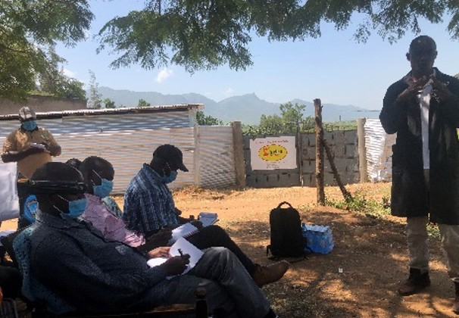

A poultry site visit for the Farmer Business School

© FAO

* **3,025 youth registered on the Yunitok platform** (62% women), which allows them to share information on their circumstances and contribute to the national dialogue leading up to the UN Food Systems Summit 2021

LEARNING AND INNOVATION

In Nairobi, Kisumu, and Turkana, the programme contracted **three innovation hubs** to provide incubation, coaching and mentoring services, financial linkages, and business growth opportunities meant to scale youth-led enterprises. In addition, **32 youth-led enterprises and groups with more than 120 young people responded to the expression of interest** to be

supported under this initiative. **Two youth-led enterprises have already begun** the incubation programme in Nairobi, with the other counties set to begin in August.

 MYANMAR



**CALL 2**

### Accelerating COVID-19 Socio-Economic Recovery in Myanmar through Resilient and Gender Transformative Enterprises

**End Date:** 1 April 2022

PROGRAMME SUMMARY

Against the backdrop of the COVID-19 pandemic, this programme engages non-state actors in Myanmar to support women led micro- small- and medium-enterprises (MSMEs), through evidence based approaches. The initiative enhances the capacity of women-led enterprises through business acceleration, digital transformation, and innovation support with a view to improving women’s knowledge and technical capacity for better access to finance. The programme is implemented in cooperation with associations, service providers, and the private sector.

EMERGING RESULTS

Due to the February 2021 military takeover of the country, the UN Country Team revised some project outcomes according to UN established engagement principles on the promotion of democracy, respect for human rights, and assurance that the local population could truly benefit from programmatic interventions. Though the military takeover and related crisis slowed down the initial stages of the programme implementation, the initiative:

* Completed a needs assessment survey that included

**interviews with 22 women led businesses** as well

as a **needs assessment of six entrepreneur support organizations** - knowledge that will inform the design of accelerator programmes

* Conducted a **Training of Trainers workshop for 14 participants** on how to create inclusive and gender transformative businesses
* Built a pipeline of potential investors based on research on the current financing landscape for MSMEs in Myanmar

## SAO TOME AND PRINCIPE



**CALL 2**

### Women Economic Empowerment Window (WEEW)

**End Date:** 2 November 2021

PROGRAMME SUMMARY

As a direct response to the structural issues identified in the consecutive National Strategies for the Promotion of Gender Equality and Equity (ENIEG), this programme supports financial and economic empowerment initiatives for vulnerable women. Specifically targeting women-led startups and micro-, small-, and medium- enterprises (MSMEs), the programme aims to increase entrepreneurial technical capacity, access to funding, and business association for MSMEs, all while improving the education-related safety nets available to adolescent girls and households led by women, particularly those in vulnerable situations.

EMERGING RESULTS

Thus far, to increase entrepreneurial technical capacity, the programme:

* **Trained 259 women** whose businesses (mostly informal) were impacted by COVID-19 to develop a **business expansion and/or recovery plan.** The best business plans will have access to microgrants between US$1,500 and US$5,000
* For these GERME (Gerir Melhor a sua Empresa / Better Manage Your Business) **trainings**, **attendance was above 90%** in all classes, and 85% of attendees owned a small business
* Created **a digital platform** (already operational and functional) on **employment services and opportunities for women** to connect job offers with qualified candidates
* Supported the Ministry of Labor to **equip training rooms** where women can access internet and receive online consultation using the tool and other income-generating opportunities

To increase education-related safety nets available to adolescent girls and households led by women, the programme:

* **Created a back-to-school kit to be delivered to 1,500 households led by women**. All women with children participating in the entrepreneurship trainings will also

receive this kit. The kits contain **1,500 backpacks, notebooks, pencils, erasers, and pens**

* **Identified 300 girls at-risk** of dropping out of high school;

**150 girls** received **small group counselling**

* **Delivered 12 (out of 36) school counselling sessions** in three districts
* **Identified 150 out-of-school adolescent girls across the country through the Youth Interaction Centers;** girls will participate in a **life-skills curriculum**, which includes trainings on vocational learning, empowerment, employability, and active citizenship

**Quotes from school girls on their trainings:**

*“ I learned that a woman can be what she wants to be and what she wishes to be in society. [...] Today I leave here more confident of myself. I feel I can do anything I want.” Idalmira, 19 years old*

*“I am part of the School Association, and after these sessions, I will convince the other members to talk more about women’s rights and other women’s issues. I will also talk to my physical education teacher or the school headmaster so that we can form a girls’ team in the school.” Daniela, 17 years old*

Testimonials on the Business Development Courses

*“Before, I used to buy the food products in the city to sell in my shop, but for me to set my prices I would first try to know what price other shops in my area are practicing, so I would also practice the same price. Now with the training I already know that for me to set the price of my products in my shop, I need to know first which price I bought each product. But another thing I already know is that this value is only for the purchase of the product. I also have to deduct the money from the motorbike, energy and rent for the space that I pay every month. Now I know the true value of the cost of 1 kg of rice, so I know what price I can put on each product so as not to make a loss. After that, I can see what price the other shops nearby are charging and also try to know what price the people in the area are willing to pay for each kg of rice.”*

*“Before, I thought business was just about having space, having money to buy things that we will sell or use to produce something else, and knowing how to make these things and how to sell them. But now I have learned that if we want our business to be successful, we need to do many things to improve our business: before even starting our business, we have to study the market, know and study our competitors, our customers. We also have to analyze ourselves to know what we know how to do well and what our difficulties are. When we start our business, we have to know how to treat our customers well, be nice to our customers, be clean with ourselves and with our space. And we also have to try to do some innovation in our business to be different and better than others who already have the same business. If we take all*

*these precautions our business will not be another one in the market that came and closed. We will have a better chance of succeeding and making more profit in our business to help our family.*



**CALL 2**

LEARNING AND INNOVATION

The implementation of the digital platform on employment services highlighted the need to **digitalize interventions to increase the potential for South-South cooperation** and knowledge transfer. Further, the programme learned that there are **not enough safe spaces where women and girls can be encouraged to learn** and search for employment. Given the high demand for such spaces, it will be essential to partner with civil society organizations and NGOs to ensure the proper logistics and conditions are provided.

 VIET NAM



**CALL 2**

### Building Forward Better: A Resilient Women and Youth Centered and Digitally Enhanced Value Chain Development in Vietnam

**End Date:** 30 April 2022

PROGRAMME SUMMARY

With a focus rural women and youth in Dong Thap and Ben Tre provinces, this programme aims to rebuild and digitally enhance the agricultural value chain. The initiative aims to (1) create a women- and youth-centered business enabling environment; (2) enhance competitiveness, safety, and sustainability of value chains; and (3) improve access to new markets.

EMERGING RESULTS

This programme officially **commenced implementation in July 2021**.

Leading up to its official start, the programme held consultation meetings with the two provinces and the Ministry of Agriculture and Rural Development (MARD), reviewed past/ongoing projects to identify synergies, developed a detailed workplan, and identified service providers.

* Chose the two **value chains of mango and pomelo** along with a list of women-led farmer’s groups for project intervention, following consultation with the two provinces
* Linked the provinces with the One Commune, One Product (OCOP) management in order to utilize the ICT- based marketing application developed by IFAD
* Developed a plan for policy and advocacy activities for each province
* Reviewed and selected good practices and technologies for project promotion
* Established a **monitoring and evaluation system**

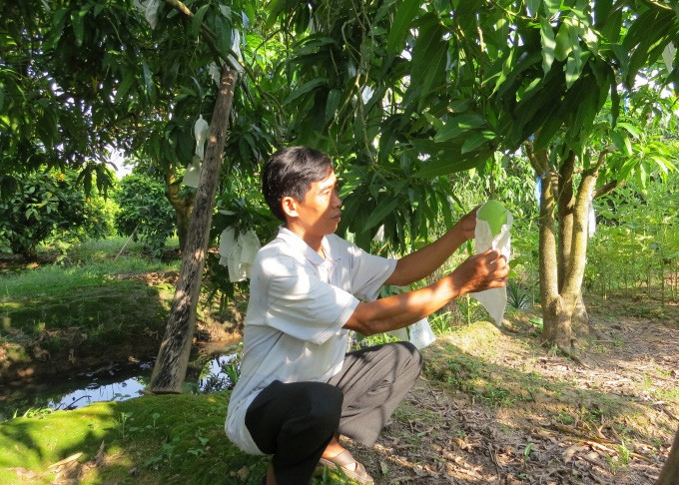

A current difficulty is the limited number of mango production areas that meet VietGAP standards. © Le Hoang Vu

LEARNING AND INNOVATION

The programme is working to create a digitized value chain model that can underwrite policy advocacy and be replicated to other products and sectors. Towards this end, digital technology along the value chain will aim to bring benefits to all the stakeholders – for instance increase profit and business opportunities for farmers and small businesses; support for

government management and decision making; and improved transparency and traceability of the value chain’s produce and products.

 ZAMBIA



**EARMARKED**

### Empowering Vulnerable and At-risk Communities to Adjust to the New Normal in Zambia

**End Date:** 1 December 2021

PROGRAMME SUMMARY

This programme was funded by an earmarked contribution to support the local production of face masks for at-risk communities in Zambia. The programme builds the capacity of a network of Lusaka-based tailors to produce 50,000 face masks that meet certified standards as regulated by the Zambia Bureau of Standards. It sets up, in collaboration with the Zambia Federation of Women in Business (ZFAWIB), a revolving fund for women tailors to receive payment for mask production through mobile money accounts.

EMERGING RESULTS

In its first months of operation, the programme

* Established a partnership with ZFAWIB, which covers a network of 500 women tailors
* To assure standardization mask production, programme partnerships focused on women-led cooperatives
* At the time of reporting, production and distribution of masks had commenced in September 2021

## ZIMBABWE



**CALL 2**

### Empowering Women through Safe, Resilient, Gender Responsive Food Markets and Systems in Response to COVID-19

**End Date:** 30 April 2022

PROGRAMME SUMMARY

The programme, jointly implemented by UN Women, UNDP and ILO, aims to empower vulnerable women marketers for recovery and resilience from socio economic shocks, in particular the impacts of COVID 19. Through the programme women are supported to effectively participate in safe, inclusive and violence free markets.

EMERGING RESULTS

Project implementation, which began mid November 2020, focused on the foundational activities and preparations implementation in 2021. Thus far:

* **120 youth ( 66 women/girls) were trained** on gender based violence and drug abuse
* Through Oxfam, the project re-engaged earlier identified beneficiaries, **training 10 food chain players (8 women) and 20 (12 women) youth volunteers on food safety and hygiene**
* Continued **refurbishment of the Mbare mass market**, the implementation of standard operating procedures related to market regulation as well as UN Volunteers community engagements and awareness raising on COVID-19 and gender based violence contributed to a safe operating environment and improved livelihoods of women marketers
* City of Harare came joined the initiative, **providing skilled architects** and engineers to design the market sheds
* Engaged financial institutions (Knowledge Transfer Africa and VIRL) to allow women marketers and other vulnerable groups to have **access to e- platforms**; receive training on transformative leadership, business management, and e-commerce; and access credit facilities, insurance and other services
* Began **scaling up the online eMkambo platform** through Agritex by procuring ICT equipment, and to support food supply chains, informal female vendors to be trained in e-transacting

Conducted a National and Harare Province Key Stakeholders Awareness and Engagement Workshop in July

LEARNING AND INNOVATION

Through linkages with financial institutions and **trainings on financial literacy and ICT in marketing**, the joint programme seeks to increase the economic security of **women marketers**. The initiative is pursing engagements with private sector companies such as Knowledge Transfer Africa (working though Government RP - Agritex) and VIRL. The companies have expressed interest and commitment in partnering with the programme to provide services and goods that will help beneficiaries in the value chain system and with acquiring business knowledge and skills. Further, Agritex and Knowledge Transfer Africa (with the help of Community UN Volunteers) **will provide training to women in the use of e-platforms and the value chain systems.** VIRL will be engaged to conduct trainings in business management and transformative leadership.

# PILLAR 4

#### MACROECONOMIC RESPONSE AND MULTILATERAL COLLABORATION



**The COVID-19 MPTF Global Interim Report**

October 2020 to July 2021

 CAMBODIA



**CALL 2**

### Unlocking Cambodian Women’s Potential through Fiscal Space Creation

**End Date:** 1 January 2022

PROGRAMME SUMMARY

This programme supports the Government of Cambodia in rolling out, for the first-time ever, a $200 million credit guarantee scheme to provide low-cost and reliable financing to micro-, small-, and medium-sized enterprises (MSMEs) and boost growth in this sector. With a view to reducing poverty and increasing employment, the scheme will maximize the participation of and benefits to women-owned MSMEs operating in the informal sector as well as labor intensive businesses and businesses requiring low skilled labor, in particular, migrants.

EMERGING RESULTS

* Organized and implemented an **international dialogue on credit guarantees** to support the formulation process of the policy and legal framework to the establish the Credit Guarantee Corporation of Cambodia (CGCC)
* Finalized and **approved the CGCC legal framework** and policy
* Established the CGCC as a legal entity to support the government’s COVID-19 recovery strategy
* Developed partnerships (Moody’s) and introduced a risk management unit and policy and procurement of international credit missions
* **Operationalized the CGCC**, with the following data applicable;
  + **53 commercial loans** released with credit guarantee (CG)
* **Value of loans = US$7.1 million**
* **Value of guarantees = US$5.1 million**
* Average Loan / Guarantee Ratio = 72%
* Smallest loan = US$10,000; and Largest loan = US$1 million
* **Average loan size US$137,464**
* **21% of the guarantees were issued to women- owned businesses**
* **US$669,600 of guarantees were issued to women’s business** (13% total by volume)
* **Unlocked US$929,000** for women’s businesses to- date

LEARNING AND INNOVATION

The development of and consultation on a **policy framework initially shared and amended by the private sector and neighboring countries accelerated the establishment of the CGCC**. These professional and peer reviews brought out the best international practices. The programme also brought in professional solutions to support the CGCC in terms of risk management (Moody’s) and capacity building via partnering and arranging staff embedment with Thai Credit Guarantee as opposed to developing in-house solutions, thus optimizing the project budget and implementation, and providing industry

standard professional solutions. The application of the MPTF grant facility accelerated operationalization of the CGCC, providing a sound integrated IT systems, supporting human capacity development, and helping the CGCC to sign on participating financial institutions, all of which has hastened the issuance of the first guarantees.

Further, and with regard to innovation, the programme is working to create a **digital platform with information on job opportunities for migrant workers** and that electronically links provincial job centers with women-owned M/SMEs.

PILLAR 4

**58**

**SOCIAL COHESION AND COMMUNITY RESILIENCE**

PILLAR 5



**The COVID-19 MPTF Global Interim Report**

October 2020 to July 2021

## DEMOCRATIC REPUBLIC OF THE CONGO



**CALL 2**

### Concerted Action for Forcibly Displaced Women, Girls, and Host Communities: Countering the Consequences of the COVID-19 Crisis

**End Date:** 1 November 2021

PROGRAMME SUMMARY

This programme fosters participatory, collective, and inclusive grassroots actions in the Democratic Republic of the Congo’s North Kivu Province, the country’s second most COVID-19-affected province. With a focus on refugees, internally displaced persons (IDPs), host communities and survivors, and those at risk of sexual and gender-based violence (SGBV), the programme offers rapid and improved access to basic supplies, integrated and quality reproductive health care (maternal and reproductive health services), access to protection services to safeguard rights, and cash transfers. It also distributes kits with food and medical items at SGBV and COVID-19 awareness raising events.

EMERGING RESULTS

Thus far the programme has:

* Provided infection prevention and control (IPC) kits, personal protective equipment for COVID-19, and essential reproductive health commodities to **eight health facilities and four women’s and girls’ (Girl Shine) safe spaces;**
* For these targeted health facilities, the programme provided **handwashing facilities that benefitted 2,394 people**
* **17 women and 23 men from the health facilities** benefited from training sessions facilitated by the provincial health departments and the National Reproductive Health Programme
* Supported **255 children to get birth certificates**
* Met the needs of approximately **10,000 people with the provision of five post-rape kits**
* **Distributed 242 dignity kits** during the awareness- raising activities for IDPs, women and girls from host communities, GBV survivors, and vulnerable women
* **Pre-positioned 158 dignity kits** in the health zones for GBV survivors and affected persons
* Trained **57 midwives, nurse supervisors of health zones, and community health workers** on sexual and reproductive health and responses during COVID-19
* **Strengthened 53 providers’ abilities** to provide mental, psychosocial, and GBV services
* From February to June 2021, **330 GBV cases were documented** and benefited from various services such as psychosocial care, medical care, and legal and judicial referrals
* **Sensitized 13,293 people** through local media and community relays on GBV prevention, referral pathways and available services, and prevention and response to COVID-19
* **44 beneficiaries** (women at high risk/GBV victims) received **cash transfers**
* With the government, UN Women **trained 31 police officers**, prison guards, and social workers (eight women/25 men) on GBV prevention and **provided 14 police offices with equipment to support the investigation of GBV cases**
* **Established four Girl Shine safe spaces**, and provided 11 community leaders with technical support and communication materials on the spaces
* Gave **five women’s organizations** technical and financial support to work with **women with disabilities** to ensure their rights and understanding of COVID-19

LEARNING AND INNOVATION

A road blockage cut traditional transport routes from Goma to Masisi at a time when kits of supplies needed to be delivered. The programme overcame this hurdle by **working closely with local authorities and community relays**, which carried supplies on foot and bicycle to ensure that they successfully reached project implementation areas. Ensuring the close collaboration with local authorities and the community relays helped **ensure service provision in a timely manner**.

PILLAR 5

**60**

# CROSS PILLAR

**PROGRAMMES**

## COSTA RICA



**CALL 2**

### Integrated Support for Health and Socio-economic Recovery Focused on Local Women, Migrants, and Vulnerable Asylum-seekers

**End Date:** 24 November 2021

PROGRAMME SUMMARY

This program coordinates interagency efforts in five municipalities (La Cruz, Upala, San Carlos, León Cortés, and Corredores) along Costa Rica’s northern and southern borders to strengthen community health and livelihood opportunities in the context of the pandemic. Regarding health, the initiative supports the government and its partners to identify

health needs and to acquire and distribute protective equipment, supplies, and carry out health promotion and prevention actions related to COVID-19, which allows for a better institutional response to the pandemic. The program also supports stabilization projects in four communities through the delivery of agricultural inputs, the improvement of public spaces, and the purchase of sports equipment for young people with the aim of greater integration of migrants, asylum seekers, and refugees in their host communities. In addition, the program adapts the national labor intermediation program to ensure the inclusion of migrants and refugees in the national employment system.

EMERGING RESULTS UNDER PILLAR 1

The programme piloted a **community-based health surveillance model** in which **195 migrant women participated**.

With this model, the programme:

* Promoted **safe practices and behavioral changes** for the prevention of infection, xenophobia, and discrimination related to COVID-19
* Reached **870 families and 850 local business establishments** in one and a half months to increase community COVID-19 prevention awareness
* Granted conditional transfers to **195 women** to cover their daily needs
* Organized joint response plans between the institutions of the cantons of Upala, San Carlos, León Cortés,

and Corredores and the community to provide a comprehensive response to the COVID-19 pandemic

EMERGING RESULTS UNDER PILLAR 2

The programme launched an integrated response mechanism to COVID-19 in border and agricultural areas. It aimed to restore the livelihoods of host communities, asylum seekers, and labor migrants, particularly women.

With this mechanism the programme:

* Worked with a cooperative (50% women - including migrants) located in La Cruz, Guanacaste to improve **four community greenhouses** that provided for consumption and distribution

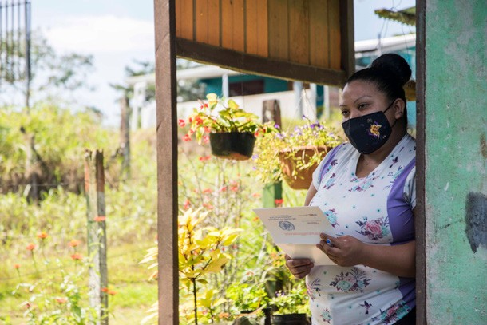

Woman from targeted community receiving information. © PAHO/WHO

* Increased **production and income of 54 women** and their families, and an additional **118 producer families**
* Fast-tracked **access to labor markets** for migrants, refugees, and asylum seekers, particularly women
* **Trained 50 coffee farmers** in the use of the Labor Migration Procedures System (SITLAM), for the registration, regularization, and traceability of labor migrants in the sector

EMERGING RESULTS UNDER PILLAR 3

The programme launched an entrepreneurship training program (or other work alternatives, such as self-employment) to increase the numbers of migrant, refugee, and host communities’ women entering the labor market. Through this training programme, the initiative enhanced the entrepreneurship skills of **100 vulnerable women**; and it launched a **pilot project in the Upala Municipality where 65 women** worked with a business consultant to improve their business ideas towards a productive chain with the Food Institutional Program (PAI) and local and regional supermarkets.

## GEORGIA



**CALL 1**



### Assisting the Georgian Government and Local Communities in Mitigating the Impact of COVID-19

**End Date:** 31 March 2021

PROGRAMME SUMMARY

This programme strengthened the capacity of government to support community resilience and recovery from the pandemic. It created a safer environment for civil servants; offered assistance to the elderly; supported distance education for children, and enhanced access to basic farming inputs for self-subsistence farmers. In supporting the continuity of health, education, and social services for vulnerable people, the initiative maintained a strong focus on gender, noting that in the Georgian context, the three major beneficiary groups – healthcare workers; public-sector workers; and vulnerable elderly were, to a large extent, made up of women.

ACHIEVEMENTS UNDER PILLARS 1, 2 & 3

Pandemic Response and Healthcare Continuity

* Equipped **8,000 frontline workers** (60% women) at the central and local levels with personal protective equipment (PPE)
* Helped equip the 144-emergency center with specialized GPS dashboards to handle large call volumes, resulting in a 9% increase in response rate to emergency calls. The 144 center is the focal point for the COVID-19 emergency response in Georgia, handling **4,500 calls per da**y and operating **330 ambulance crews**
* Provided **ICT packages to 126 Mayor’s Representatives to Administrative Units** (Villages) to improve the delivery of public services to rural populations during the pandemic
* Trained **1,200 healthcare providers** in COVID-19 IPC and referral

The Elderly

* Provided personnel (approximately 97% women) of

**11 state-funded institutions** for older people (with approximately 250 beneficiaries total (about 80% women) with PPE and sanitizers

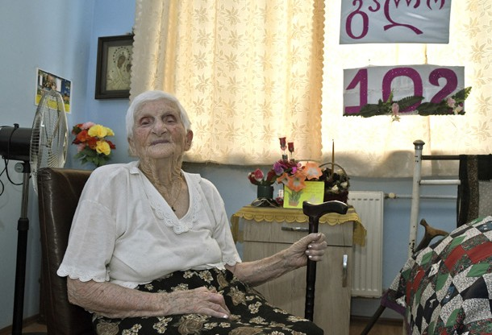

Galina Zakradze turned 102 this year. Each of her birthdays is a true celebration for the staff and residents of the municipal home for elderly people in the small town of Samtredia in western Georgia. But in 2020, as the COVID-19 pandemic swept Georgia, it assumed particular significance. Zakradze, like most of her fellow residents in the home, fell ill with COVID-19 and had to be hospitalized. Happily, she survived and has returned to brighten the Samtredia facility with her tenacious good humor.

© UNDP

* Supported the Ministry of Health (MoH) elaboration and approval of the standards for prevention and management of COVID-19 in residential institutions and community care homes (LTC) for older persons and persons with disabilities; Developed and operationalized a monitoring tool to ensure the adherence to these standards
* Set up **three municipal shelters housing 200 elderly**, and equipped homeless persons with household and medical equipment, kitchen and laundry appliances and supplies, PPE, and sanitary supplies
* **95 elderly people** living alone in remote rural settlements without any communication means **received basic mobile phones** with Georgian soft and preinstalled GRCS hotline number
* Reached **2,749 vulnerable elderly with home care visits** (up to 80% women, up to 25% - ethnic minorities) that provided food and hygiene parcels, PPE, sanitizers, and information on COVID-19 in the Georgian, Azeri and Armenian languages as well as 24/7 hotline contacts

Outreach and Communications

* **Reached 1,122,749 people via an information campaign** avoiding COVID-19 related economic and health impacts
* Produced information materials in Georgian, Armenian, and Azeri languages (**110,000 flyers**) in partnership with the National Center for Disease Control and Public Health (NCDC) and disseminated them in all regions through the Public Health Centers (local NCDC branches)
* Produced **three short and one long animated videos in Georgian, Armenian, and Azeri languages** (total 16 files) and three short audio files for radio transmission in Georgian, Armenian and Azeri Languages (total nine files) specifically targeting older people; the video and audio productions aired through the three national and four regional radio stations and were broadcasted through the

regional TV channels (About 14 channels/ 14 spots per day per channel, including five spots in prime time)

* Disseminated materials through social media, including UNFPA social media channels, national media and press, local municipalities, and Georgia Red Cross Society Facebook pages, **reaching up to 36,000 people through social media only**



**CALL 1**

* Seven regional TV channels broadcasted 14 special news programs, totaling 74 editions on COVID-19 updates, protective measures, and guidelines. TV channels,

Marneuli and Parvana, aired 60 programs on COVID-19 in Azerbaijani and Armenian languages. Nearly **one million viewers** were reached via TV broadcasting and over 14,000 viewers on social media channels of the

given TV stations [https://www.youtube.com/channel/UCFgsg-](https://www.youtube.com/channel/UCFgsg-5bTLDkLrFfIYkhWkw/videos) [5bTLDkLrFfIYkhWkw/videos](https://www.youtube.com/channel/UCFgsg-5bTLDkLrFfIYkhWkw/videos)

* In partnership with the Administration of All Muslims of Georgia, Regional Media Association, and NCDC,

UNICEF continued to share videos featuring Muslim religious leaders, animations, and social media posters on COVID-19 in the Azeri language, reaching up to **30,000 ethnic minority community members**

* In collaboration with NCDC, contributed to the development and implementation of the national RCCE Strategy on COVID-19, **reaching over a million people**, including ethnic minorities, with crucial information about COVID-19

Children and education

* Facilitated continued access to **essential healthcare services for 52,000 women and children**, including prenatal and postnatal care and COVID-19 case detection and management
* Provided **WASH and hygiene supplies to 1,095 peopl**e, including the distribution of hygiene supplies to maternities, social services, and vulnerable children
* Supported government efforts to develop guidelines for teachers and schools for online learning programmes and **trained elementary teachers across 100 schools in distance education**
* Developed online learning resources that reached an estimated **414,000 students**
* Developed and implemented an advocacy campaign for the safe reopening of school

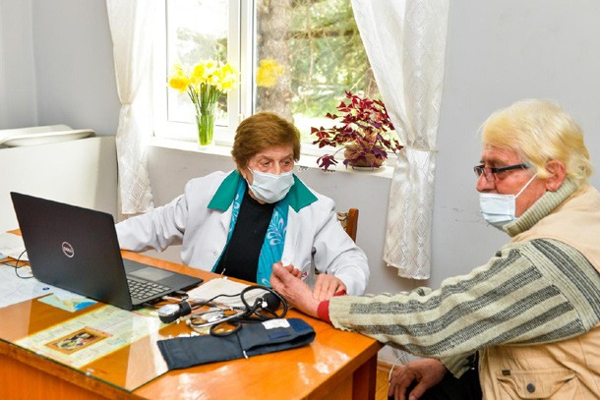

Rural doctors improve COVID-19 case management

© UNICEF/GEO-2021/Turabelidze

* Helped launch a TV-school broadcast through the Georgia Public Broadcasting to educate children without internet connectivity. The TV-school covered all levels of national curriculum, including in Armenian and Azerbaijani languages, and was accompanied by sign language translation

Agriculture and livelihood support

* Allocated four agricultural grants to two women and two men to support innovative agriculture in Gagra, Gudauta, and Ochamchire districts – the first mushroom farm in Abkhazia, and a greenhouse complex powered by bio-gas

– **projects that created 11 new jobs and reached 60 direct beneficiaries/ households of 15 farmers**

* Provided **480 vulnerable households engaged in small family farming** in seven regions with agricultural inputs. The beneficiary families included female-headed families, single mothers, large families, women taking care of family members with disabilities, IDPs, minorities, and families under the poverty line from six regions

LEARNING AND INNOVATION

The programme was successful due, in part, to United Nations’ **long-term partnership with the Government of Georgia** and state institutions including the Ministry of Health, National Center for Disease Control and Public Health, Ministry of Education and Science, and the newly established State Care Agency.

 KOSOVO



**EARMARKED**

### Return to (New) Normal in Kosovo: Strengthening Resilience through a Safe and Inclusive Return to Normality in Health and Education in the Wake of COVID-19

**End Date:** 31 March 2021

PROGRAMME SUMMARY

This programme was funded by an earmarked contribution in support of Kosovo’s recovery process and reduced vulnerability to future waves of COVID-19. The initiative helped assure continuous access to health and education services for the most vulnerable groups of children (including children living with disabilities), young women and girls, and non- majority groups, including the Roma, Ashkali, and Egyptian communities.

EMERGING RESULTS UNDER PILLAR 1

Overall programme activities greatly improved capacity of Kosovo to contain the COVID-19. It:

* Helped **increase testing capacity ten-fold** since the beginning of the crisis
* Provided **two PCR machines and two RNA extraction machines** to the newly established regional labs in Prizren and Gjilan/Gnjilane
* **Donated 10,000 PCR tests** to six regional laboratories across the country
* **Donated 1,206 vaccine carriers/cold boxes** to the Ministry of Health, which supported immunizations in areas where vaccinations lagged
* Provided **one mobile x-ray machine** to the Gračanica/ Graçanica Health Center, serving one town and 15 villages
* Implemented a catch-up door to door **vaccination campaign** with **teams in 20 municipalities** reaching

EMERGING RESULTS UNDER PILLAR 2

To facilitate the safe and inclusive reopening of schools, the programme:

* Provided practical guidelines and hygiene kits to **over 95% of public schools (1,020 schools) in Kosovo**
* Provided COVID-19 protection kits to **3,108 teachers**
* Assessed the **WASH conditions of 100 schools** along with their COVID-19 protection measures
* Targeted training and support, as well as the delivery of essential IT equipment to children, schools, and parents, **assuring at-risk groups didn’t fall behind on education** during ongoing COVID-19 mitigation measures
* Provided **948 children with disabilities** with tablets or laptops

children whose scheduled immunizations were delayed by lockdown

* Reached at least **4,121 children** and **5,645 families**

through the vaccination programme

* **Distributed 2,503 baby kits** to vaccinated children and vaccination centers
* **Trained 44 youth** (15 girls) from Roma, Ashkali, and Egyptian communities to conduct door-to-door visits to families to collect vaccination data and raise awareness on immunization
* Vaccinated **1,886 children from vulnerable families,**

mostly from Roma, Ashkali and Egyptian communities

* Assured **remote diagnostic services could go forward** by **delivering 186 tablets** with sim cards/internet credit to 16 primary health centers in Pristina, which **averaged 300 virtual consultations per week** during the first weeks of programme implementation
* Provided **190 children with disabilities** with laptops and training on basic IT and research skills to ensure access to distance learning
* Approximately **2,000 teachers increased their knowledge of tools and resources** to better support students dealing with **mental health challenges** during COVID-19 and to further promote mental health wellbeing as a part of core education
* **Deployed 40 teaching assistants for children with disabilities** in six municipalities
* **Built the capacity of 1,140 teachers** to use the distance learning platform [www.shkollat.org](http://www.shkollat.org/) and related digital services, ensuring that everyone could access quality education



**EARMARKED**

LEARNING AND INNOVATION

The programme took an innovative approach to COVID-19-related data collection and visualization by **creating a digital mapping platform with gender disaggregated date to identify patterns in drop-out rates amongst girls and children from vulnerable communities.** The platform is available to both local and central institutions and authorities and displays key data on education through user-friendly data visualization tools. The Platform can be accessed at [www.digitalplatform.unkt.org](http://www.digitalplatform.unkt.org/).

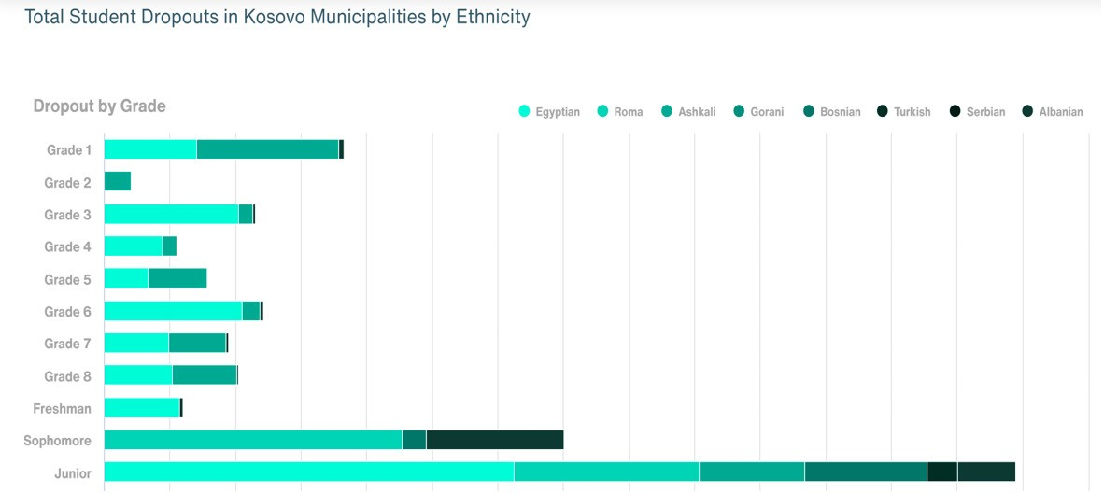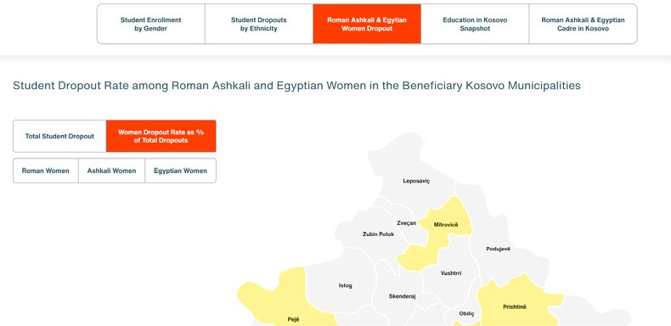

## MONGOLIA



**CALL 1**

### Strengthening the National Capacity to Suppress Transmission and Maintain Essential Services during the COVID-19 Pandemic

**End Date:** 31 March 2021

PROGRAMME SUMMARY

This programme supported the efforts of the Government of Mongolia to implement its National COVID-19 Preparedness and Response Plan. It focused on the provision of critical education and health services.

ACHIEVEMENTS UNDER PILLAR 1

This programme, with regard to increasing COVID-19 testing capacity, **directly served 1,827,246 people in Ulaanbaatar and seven provinces**, who were tested via the laboratories established and equipped by the programme (10,477 tested positive). **Indirect beneficiaries included the 2,078,369 people** living in the areas that can now access this testing. Overall, programmatic activities helped Mongolia ready itself for large-scale community outbreak; it:

* **Increased national COVID-19 testing capacity from five to 16 laboratories**, which increased COVID-19 daily **testing capacity by tenfold** from 600 to 6,000 PCR tests per day
* **Trained 112 staff in 21 provinces on specimen handling** (collection, storage, and transportation)
* **Trained 10 more laboratories** on various laboratory diagnosis techniques for COVID-19
* Procured and distributed laboratory kits and reagents for **40,0000 RT-PCR tests** for all existing and newly established laboratories
* Installed **Gen Xpert machines in seven provinces** and procured and distributed **2,080 Gen Xpert cartridges**

ACHIEVEMENTS UNDER PILLAR 2

The development of an online learning platform titled ‘Digital Adventures’ for pre-primary, primary, and secondary education launched in November 2020 and **reached approximately 300,000 children, parents and teachers, including ethnic Kazakh and Tuvan minorities and people with disabilities** previously excluded from the TV- based educational programmes.

* Improved the Ministry of Education and Science (MoES) official educational resource repository website of econtent.edu.mn (which was later changed tomedle.mn) to serve the whole of pre-primary and general education sector, accounting over **860,000 children** with newly implemented Learning Management System features
* **Developed 104 interactive lessons** to promote children’s learning through fun and by nurturing a passion for learning via an innovative learner-centered approach; these were made available on medle.mn and **gave health education special importance** given pandemic-related increased risks to youth of early pregnancy, sexually transmitted disease, and psychological distress, trauma, and gender-based violence

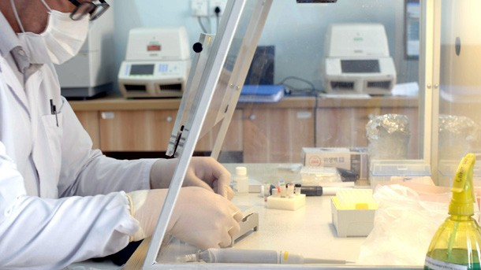

Strengthening laboratory capacity © WHO

* Conducted **2,263,366 tests for COVID-19** (as 31 March 2021), with **daily national laboratory testing capacity reaching 42,000 tests** in the capital city during the February ‘One-door – One test’ campaign
* Procured personal protective equipment **(PPE) for 500 frontline essential service staff**
* To ensure equitable access to education, **all contents were signed for the deaf,** and 60 pre-primary and primary education, including health education, lessons **offered language options in the ethnic minority** languages of Kazakh and Tuvan
* 94% of 268 teachers surveyed believed the interactive contents met children’s learning needs
* Supported the continuity of education for disadvantaged groups such as children from herder families in remote areas as well as those with no access to TV or internet by developing **30 audio lessons based on the teaching by storytelling method and delivering them through emergency audio devices to 1,300 children; reaching approximately 15,000 children nationwide through radio broadcasting**
* **Built the e-learning/education capacity and engaged 147 educators and methodologists** of the Institute

of Teacher Professional Development (ITPD), the main government counterpart

* **Trained 40 education officials, educators, and core ITPD teachers** on e-learning teaching skills and pedagogy



**CALL 1**

* **Strengthened institutional capacity** to prepare and deliver **e-contents on health education;** the **National Health Education Cabinet was established** at ITPD
* Submitted the final report of **regional and global best practices in ICT in Education, on-line learning, and distance learning digital resources** to the Ministry of Education and Science
* Consulted approximately 40 government officials and 10 government institutions in an **ICT policy review process** and carried out a **feasibility study** on existing e-learning platforms to make a short- and long-term solutions for the Mongolian context
* **Completed the ICT in Education Policy Review Report**, with key policy recommendations submitted to the Ministry of Education and Science

LEARNING AND INNOVATION

**E-learning was a relatively new area for Mongolia**, particularly for the pre-primary and general education sectors, and this programme supported the integration of online learning in education policy and the development of a regulatory framework that will cover all levels of education, including health and with the use of gender-sensitive language. As such, **this particular initiative was both pioneering and innovative**, contributing significantly to the digital transformation of the education sector.

A new partnership was established with the **‘Advocates for Youth’ NGO to adapt AMAZE videos** to increase access to **quality e-content on comprehensive sexuality education for young people** in Mongolia. As a result, 28 factual and age- appropriate videos for children up to 14 years of age were translated and adapted.

Towards this end, the project shared its best practices and lessons learned with the Ministry of Education and Science, which is preparing an ICT policy and master plan. A validation seminar for the ICT Policy Review Report drew 20 officials and the final report will guide the **Ministry in the development of a new ICT policy framework and master plan – a direct result of this programme.**

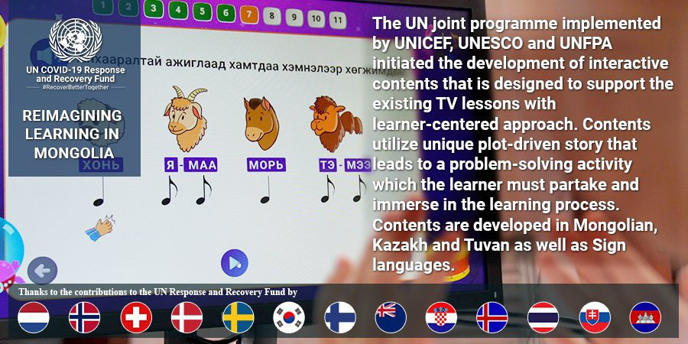

© UNICEF

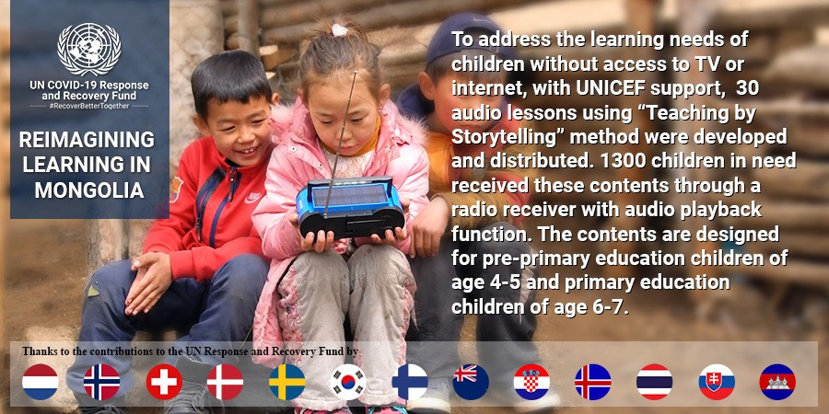

SCHOOL IN THE STEPPES: In rural Mongolia, keeping children learning while at home © UNICEF

 PAPUA NEW GUINEA



**CALL 1**

### Integrating WASH, Nutrition, and Maternal and Newborn Health (MNH) Interventions for COVID-19 Response in Western Province, Papua New Guinea

**End Date:** 31 March 2021

PROGRAMME SUMMARY

This programme improved basic service delivery in four villages of the North Fly District of Western Province, a border area with COVID-19 cases. It supported the provision of WASH services, the reduction of severe malnutrition rates in young children, and the improvement and continuity of maternal care services.

ACHIEVEMENTS UNDER PILLARS 1 & 2

The nutrition component was fully achieved and exceeded the expected project results:

* **172 children** (45% female) cured of Severe Acute Malnutrition (SAM) out of a total of 215 children admitted and treated, against a target of 150
* **9,469 children** aged 6-59 months (52% female) received Vitamin A supplementation against a target of 1,500 people
* **3,725 children** (47% female ) under five received Micronutrient Powder supplementation against a target of 1,500
* **3,272 caregivers** of children aged 0-23 months received Infant and Young Child Feeding (IYCF) counselling against a project target of 1,500
* **3,993 pregnant and lactating women** received nutrition education against a target of 2,000
* **5,915 community members** (56% female ) reached with COVID-19 related messaging against a target of 1,000
* **7,265 caregivers** comprised of mostly mothers of children aged 6-23 months reached with counselling on appropriate child feeding practices
* **62 Village Health Volunteers** (VHVs) and **43 health care workers** (51% female) **trained** on treatment of SAM, micronutrient supplementation, and support and promotion of appropriate child feeding
* **5,915 individuals in the target geographical** area reached with COVID-19 related messages specifically focused on infection prevention and control

Under the maternal and newborn health (MNH) component, the following results were achieved in the seven target communities:

* **829 pregnant and postpartum women** received antenatal and postnatal care at health facilities and through home visits
* **104 newborns** delivered and provided with neonatal care
* Built the capacity of **62 healthcare providers** to provide quality maternity and neonatal care with adequate infection, prevention, and control (IPC) measures
* Reached **6,610 community members** with information on COVID-19, danger signs in pregnancy, the importance of delivery in a health facility, newborn care, and family planning
* Established an emergency transport system for prompt transport of pregnant, postpartum women and newborns for advanced care

**Meeting Needs for Expectant Mothers**

The capacity of health facilities and service providers to provide quality MNH services was strengthened through the provision of 400 clean reproductive health delivery kits, six anti-shock garments, and mannequins to the six project health facilities and the VHVs, to aid the safe delivery of mothers and newborns, particularly in situations of lockdowns and restricted movement.

A basket fund was also established for the emergency transport of mothers and newborns from rural communities and facilities to the Rumginae referral hospital. The renovation of the Matkomnae Sub health center and Rumginae Rural hospital was completed to facilitate appropriate maternity care services.



**CALL 1**

Following a needs assessment identifying 25 target sites (six health centers/posts, 12 schools and seven other sites) in eight villages for WASH infrastructure rehabilitation and upgrade, the WASH component achieved the following results:

* **6,243 individuals** (40% female) had improved access to **clean and safe drinking water** against a target of 5,000 individuals
* **9,080 individuals** (48% female) had improved access to decent **sanitation** against a target of 872 individuals
* 20 individuals (four female) had access to the Water Point Minder against a target of 20 individuals
* 61 individuals (10 female) equipped with skills and knowledge on Water Point Maintenance against a target of 60 individuals
* **7,056 individuals** (54% female) provided with Participatory Health and Hygiene Education and Risk Communication and Community Engagement **awareness** against a target of 5,000 individuals
* **1,203 households** (approximately 8,060 individuals) **received soap and water containers** against a target of 1,000 households

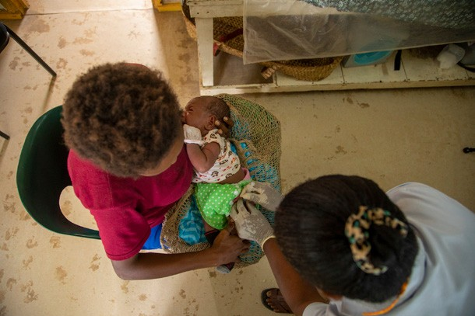

Babies and families receive immunizations at Matkomnai Sub-Health Center

© UNFPA

* The Participatory Health and Hygiene Education and Risk Communication and Community Engagement awareness raising programs improved hygiene practices thereby mitigating COVID-19 spread

LEARNING AND INNOVATION

Partnerships with civil society organizations (CSOs) were effective in programme delivery and in the achievement of set targets in the area of nutrition. Further, the engagement of Village Health Volunteers (VHVs) in nutrition promotion and community mobilization helped achieve scale. It was noted that there needed to be consistent advocacy with government and

engagement with private partners for the provision of emergency transport for mothers and babies in situations when transport restrictions were necessary. The programme also learned that **expanding access to information and services to the**

**rural, disadvantaged, and hard to reach communities and not just to the urban population was critical in mitigating community spread of COVID-19 and reducing maternal and newborn mortality.**

## ANNEX 2:

**Governance Structures and Procedures**

The Fund was designed to complement the World Health Organization (WHO)’s Strategic Preparedness and Response Plan and the UN Office for the Coordination of Humanitarian Affairs (OCHA)’s Consolidated Global Humanitarian Appeal for COVID-19.



**Humanitarian System**

**Development System**

**•**

**OCHA’s Global Humanitarian Response Plan**

**Coverage:** humanitarian populations of concern in 50+ “priority countries **UN Fund Instruments:**

Humanitarian Agency programmes,

CERF, CBPF

**Target: $2 billion 2020**

**•**

**•**

**•**

**WHO’s Strategic Preparedness and Response Plan**

**Coverage:** all affected countries Global response

Focus on tackling the health emergency

**UN Fund Instruments:** WHO Health Emergency Fund, WHO Solidarity Fund; **SG’s COVID-19 MPTF**;

Agency programmes

**Target: $675 million - New SPRP2 to be announced**

**•**

**•**

**•**

**•**

**•**

**•**

**•**

**•**

**SG’s Framework for Socio- economic impact**

**Coverage:** low- & middle- income programme countries

Multisectoral crisis response, socio- economic impact, safeguarding progress to SDG’s

**Instruments: SG’s COVID-19 MPTF:** Agency programmes **Target: $1 billion for 2020 ($2**

**billion overall)** for COVID-19 MPTF

**Country HUMANITARIAN RESPONSE PLANS**

**GUIDED BY NATIONAL PLANS FOR COMBATTING COVID-19 (RC/WHO COORDINATED) AND SOCIO-ECONOMIC MITIGATION ANALYSIS (RC COORDINATED)**

###### OPERATIONS

The COVID-19 Response and Recovery Fund operated under the overall leadership of the UN Secretary-General through his Designate to the Fund, who served as the Chair of the Advisory Committee. The Fund’s transparent governance structure also consisted of an Advisory Committee, a Fund Secretariat, Recipient Organizations, and an Administrative Agent.

The Designate provided oversight and strategic direction, leading the mobilization of resources, approving programmes for funding, and overseeing progress against expected results. Essentially, the Designate articulated the Fund’s priorities and made allocation decisions in consultation with the Advisory Committee.

The Advisory Committee supported the Designate in the timely allocation and disbursement of donor resources, and it provided advice on the management of the Fund. It included

representatives of UN agencies, funds and programmes that covered key sustainable development areas related to the COVID-19 response, five representatives of contributing partners, and five ex-officio members representing WHO, OCHA, UN Development Coordination Office (DCO), UN Women, and the MPTF Office.

The Fund’s portfolio was selected from investment proposals developed and vetted by the UN Resident Coordinator in consultation with a UN Country Team (UNCT) that maintained an excellent working relationship with

the national government as well as with communities in need. Multiple UN agencies, presenting a compendium of expertise worked on formation of these proposals along with their implementation.

Once UN Resident Coordinators in each country prioritized and endorsed proposals, they were submitted to the

**GOVERNANCE STRUCTURE**

**Advisory Committee**

**Secretariat**

(supports SG’s designate & AC)

**Contributors** (public, private, foundations, IFIs & individuals.)

**Administrative Agent**

(MPTF Office)

Recipient UN Organizations, Governments, NGOs

Fund transfers Decisions

SG’s Designate

**UNSDG** Chair

Secretary-General’s Designate. Funding decisions on country proposals were made by the UN Secretary-General’s Designate, in consultation with the Advisory Committee.

The decision making process for Fund allocations to country programmes was outlined in the Fund’s [Fact Sheet.](https://mptf.undp.org/factsheet/fund/COV00)

UN Recipient Organizations (UN agencies, funds, and programmes) implemented joint programmes. Government entities and civil society organizations also accessed the Fund as implementing partners of Recipient Organizations.

The Fund Secretariat provided technical and management support to the Designate of the Secretary-General. It prepared the Fund strategy, assured rapid development of

investments, and managed calls for proposals. Together with UN Agencies, it provided technical assessment of requests in line with the strategic priorities of the Fund and in line with an ever-evolving pandemic. The Fund Secretariat was also tasked with monitoring and reporting on the Fund’s programmatic performance and communicating these results.

The UNDP Multi-Partner Trust Fund Office ([http://mptf.undp.](http://mptf.undp.org/) [org/](http://mptf.undp.org/)) acted as the Administrative Agent of the Fund. It was responsible for fund design, legal agreements with UN entities and donors, administration of donor contributions, fund disbursement and consolidated reporting.

###### WORK OF THE ADVISORY COMMITTEE

The Advisory Committee was a unique facet of the Fund that proposed solutions, gave direction, and facilitated the dialogue needed to help the UN Secretary-General’s

Designate guide the Fund and to make informed, fast, and strategic decisions on how funding should be allocated.

Advisory Committee members included: representatives from ILO, UNCTAD, UNICEF, UNDP, WFP, and UNFPA;

representatives of the contributing partners of Denmark, the Netherlands, Norway, Sweden, and Switzerland; and five ex-officio members of WHO, OCHA, UN Development Coordination Office (DCO), UNWOMEN and the MPTF Office.

The Advisory Committee met regularly, and to adapt to the context of COVID-19, meetings were held virtually. These remote consultations provided an opportunity for substantial discussion amongst donors, UN agencies and the Designate on the strategic direction of the Fund and the comparative value of the programmes it would finance.

The Committee offered strategic guidance on major decisions for:

* Designing a collaborative and integrated Fund, assuring its fit into the UN overall response to COVID-19;
* Instituting an After-Action Review to gather lessons learned from the first Call to inform subsequent allocations; supporting system-wide evaluation of the Fund;
* Building a strong gender lens into programming, requiring funded programmes to have a GEM score of 2 or 3;
* Assuring the Fund served as an expression of UN reform, such that Call 2 proposals derived from SERPs; and
* Guiding Fund communications and outreach initiatives as well as fundraising initiatives; including the June Partnership Forum led by the Deputy Secretary-General.

The Advisory Committee helped assure that the Fund supported high-quality programmes that were as much urgent as they were implementable. Sixty-six reviewers from UN Agencies, Funds and Programmes and five members

of the Fund Secretariat reviewed proposals submitted for funding.

The Advisory Committee also supported efforts to generate the Solutions Catalogue, which put forth an additional

213 unfunded, priority country programmes derived from Socio-economic Response Plans (SERPs). In addition, and to support achievement of gender marker goals, gender- responsive programing webinars were conducted by

the International Labour Organization (ILO), International Organization for Migration (IOM), the Pan-American Health Organization (PAHO), UN Children’s Fund (UNICEF), UN Conference on Trade and Development (UNCTAD), UN Development Programme (UNDP), the UN Population Fund (UNFPA), UN Women, World Food Programme (WFP), and the World Health Organization (WHO) colleagues from UN Inter-Agency Network on Women and Gender Equality (IANWGE), to ensure high quality proposals addressing inequalities and leaving no one behind. The IANWGE COVID-19 Gender Equality Checklist was developed to support integration of gender equality in SERPs.

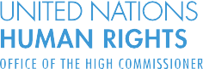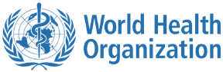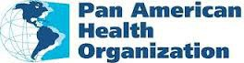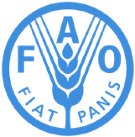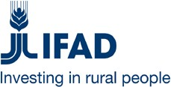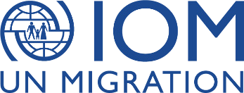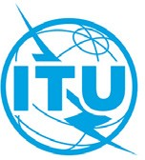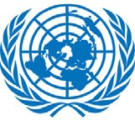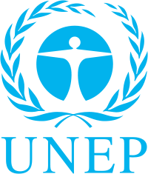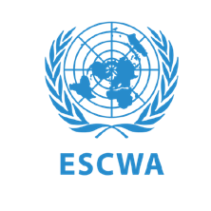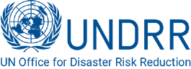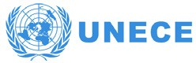

## RECIPIENT UN ORGANIZATIONS



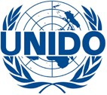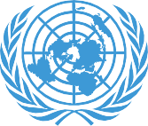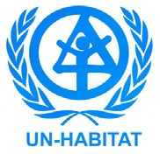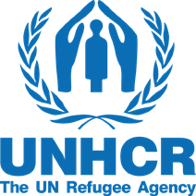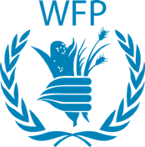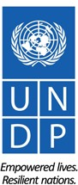UNITED NATIONS

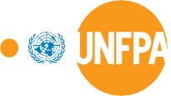

UNCTAD

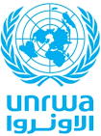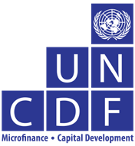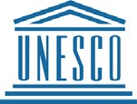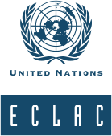



UN Multi-Partner Trust Fund Office

© 2021 UN MPTF Office. All rights reserved.

Author: COVID-19 Response and Recovery Fund Secretariat Copy Editor: Lauren Anderson

Graphic Designer: Edgar Mwakaba Production: Graphics Service Bureau, Digital

