 |    | 
Life-saving support to and empowerment of older women
REPORTING PERIOD: 1 May – 31 December 2021

Programme Title & Project Number |  |  | Country, Locality(s), Priority Area(s) / Strategic Results
- Programme Title: Life-saving support to and empowerment of older women  - Programme Number (if applicable): UDD44  - MPTF Office Project Reference Number: 00127767 |  |  | Country/Region: Republic of Moldova: Soldanesti district (Raspopeni, Samascani), Rezina district (Ciniseuti, Tareuca), Basarabeasca district (Sadaclia, Carabetovca, Iordanovca, Abaclia), Leova district (Cazangic, Sarata Noua), Orhei district (Donici, Mitoc) and Straseni district (Zubresti).
Priority area/ strategic results:
COVID-19 response – recovery – empowerment of older people and building dialogues between generations.
Participating Organization(s) |  |  | Implementing Partners
- UNFPA, United Nations Population Fund  - OHCHR, Office of High Commissioner for Human Rights |  |  | - Ministry of Labour and Social Protection  - HelpAge International  - Moldcell Foundation
Programme/Project Cost (US$) |  |  | Programme Duration
Total approved budget as per project document:  MPTF /JP Contribution:  - UNFPA:  - OHCHR: | $77,916  $79,234 |  | Overall Duration (months): | 12
Agency Contribution  - UNFPA:  - OHCHR: | $18,700 |  | Start Date (dd.mm.yyyy): | 08.07.2021
Government Contribution  - Ministry of Labour and Social Protection: | $26,564 |  | Original End Date (dd.mm.yyyy): | 30.04.2022
Other Contributions (donors)  - Moldcell Foundation: | $12,500 |  | Current End date(dd.mm.yyyy): | 30.04.2022
TOTAL:
Programme Assessment/Review/Mid-Term Eval. |  |  | Report Submitted By
Assessment/Review - if applicable please attach  Yes No Date: dd.mm.yyyy  Mid-Term Evaluation Report – if applicable please attach  Yes No Date: dd.mm.yyyy |  |  | - Name: Eduard Mihalaș  - Title: Programme Analyst  - Participating Organization (Lead): UNFPA  - Email address: mihalas@unfpa.org

(DELETE BEFORE SUBMISSION)

Guidelines:

The Narrative Progress Report template is based on the UNDG 2003 template, which is currently under review and is in line with the UNDG Results Based Management Handbook (October 2011).

Building on continued efforts made in the UN system to produce results-based reports, the progress report should describe how the activities (inputs) contributed to the achievement of specific short-term outputs during the twelve month reporting period, and to demonstrate how the short-term outputs achieved in the reporting period collectively contributed to the achievement of the agreed upon outcomes of the applicable Strategic (UN) Planning Framework guiding the operations of the Fund.

In support of the individual programme reports, please attach any additional relevant information and photographs, assessments, evaluations and studies undertaken or published.

Where available, the information contained in the Programme Summaries and Quarterly and/or Semi-Annual Updates prepared by the Participating Organizations may be useful in the preparation of the Annual Narrative Progress Report. These Summaries and Updates, where applicable, are available in the respective Fund sections of the MPTF Office GATEWAY (http://mptf.undp.org/).

Formatting Instructions:

- The report should be between 10-15 pages. Include a list of the main abbreviations and acronyms that are used in the report.
- Number all pages, sections and paragraphs as indicated below.
- Format the entire document using the following font: 12point _ Times New Roman
and do not use colours.
- The report should be submitted in one single Word or PDF file.
- Annexes can be added to the report but need to be clearly referenced, using footnotes or endnotes within the body of the narrative.

List of abbreviations:
- CNAS – National Social Insurance House
- e-Government Agency – Agency for Electronic Governance
- HRBA – Human Rights Based Approach
- MoLSP – Ministry of Labour and Social Protection
- OHCHR – UN Human Rights Office
- MSU – Moldova State University
- NASA – National Agency for Social Assistance
- UNFPA – United Nations Population Fund

NARRATIVE REPORT FORMAT

EXECUTIVE SUMMARY
- In ¼ to ½ a page, summarise the most important achievements of Programme during the reporting period and key elements from your detailed report below. Highlight in the summary, the elements of the main report that you consider to be the most critical to be included in the MPTF Office Consolidated Annual Report.
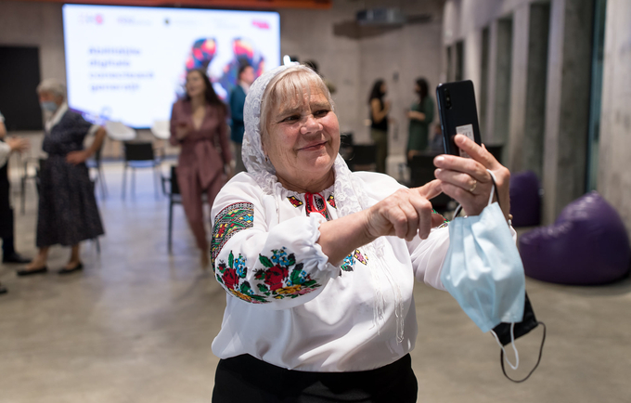
In 15 localities, over 300 older women and men (234 women, 66 men) and 85 young volunteers (72 girls, 13 boys) were engaged in creating bonds between generations and building digital skills for seeking social, medical, informational and psychological assistance. UNFPA innovative programme was implemented in partnership with Ministry of Labour and Social Protection, HelpAge International, funding from Swiss Agency for Development and Cooperation, with in-kind support of Moldcell Foundation, National Social Insurance House and e-Government Agency. The new phase of intergenerational dialogue programme “Digital technologies unite generations” is empowering older people to actively engage in partnership with young people in acquiring digital skills and seeking medical, social and psychological support. The second phase of the project was launched wih the aim of creating a bridge of communication between generations, especially during a pandemic. Thus, with SDC and Moldcell funding, another 100 older people from the districts of Soldanesti, Rezina, Basarabeasca, Leova, Orhei and Straseni received mobile phones connected to the Internet and learned with the help of young volunteers how to use them.
The National Agency for Social Assistance (NASA) and the Social Work Department of the Moldova State University (MSU) actively engaged in the process of ensuring the integration of human rights and Human Rights Based Approach (HRBA) in the initial and continuous training program of the (future) social workers. To better understand the needs for capacity building, a training needs assessment was conducted among 597 out of 1110 social workers (510 social workers at community level and 87 social workers with supervision function). Based on the needs assessment the curricula of the continuous training program was developed. The training program and related materials are presently being developed.
Related to the initial training program, based on the agreement with the Social Work Department, MSU the following options were selected: a) development of an optional course on HRBA for social field that will be made available from the beginning of September 2022 to students from all faculties of the University and b) analysis and integration of human rights and human rights based approach in the existing courses. Based on this, the curricula for the optional course was developed. The existing courses are presently being analyzed.

The project has achieved the following results, based on the planned activities:
  - Build digital skills of most vulnerable older women and men to seek medical, social, informational and psychological assistance through intergenerational dialogue with young people.
The launch of second phase of the intergenerational dialogue progamme expanded to 15 localities, engaging over 300 older women and men (234 women, 66 men) and 85 young volunteers (72 girls, 13 boys) in creating bonds between generations and building digital skills for seeking social, medical, informational and psychological assistance. To achieve this result, UNFPA engaged a range of institutions – SDC and Moldcell Foundation provided their financial and in-kind support, National Social Insurance House and e-Government Agency provided their in-kind support through trainings to young volunteers and older people, while the overall programme is implemented in partnership with the Ministry of Labour and Social Protection and HelpAge International.
Preparation and coordination activities were held for overall project needs through local coordination meetings of NGO and volunteer teams, coordination meetings of project partners and local implementing partners, technical planning meetings with CNAS (CTAS), e-Gov, contracted facilitators, also meetings for coordination of the work of young volunteers. Focus of this activity was on three key elements – acquiring digital skills, learning social services, and access public services. More details here: https://bit.ly/3vDYp9M
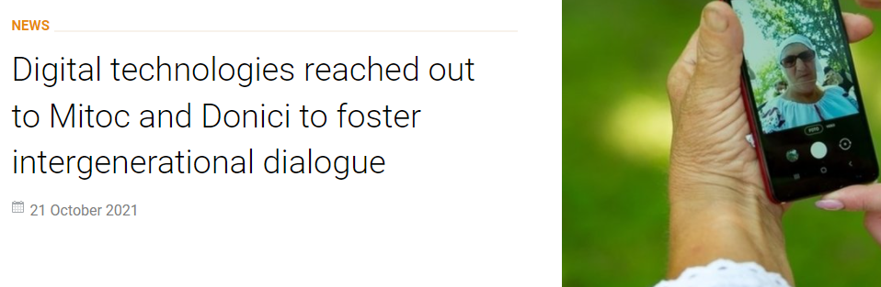
Acquiring digital skills. Online trainings for newly recruited young volunteers in 5 new sites and other new comers in existing 10 sites, on instructions how to guide older people to use a smartphone, Internet and applications, 4 sessions doubled for two groups in each of the communities (8 sessions total), divided by the types of mobile phones (SamsungA01 and Xiaomi). All trainings were held in July 2021 and each participant received for support a guide elaborated with main instructions to be used for trainings for older people. There were organized offline trainings for 100 older persons beneficiaries held by young volunteers in 5 new sites, to guide them in using a smartphone. In each of the sites, beneficiaries attended 4 sessions, in July-August, where each session gathered on average 25 participants. Support to beneficiaries continued to be offered during the period post-trainings, trough support of young volunteers online or through home visits, where one young volunteer guides 3-6 older person. UNFPA in partnership with SDC and Moldcell Foundation conducted a visit to two localities engaged in these trainings – Mitoc and Donici, to interact with volunteers and older persons and provide an overview on the role of this programme in building dialogue between generations, details here.
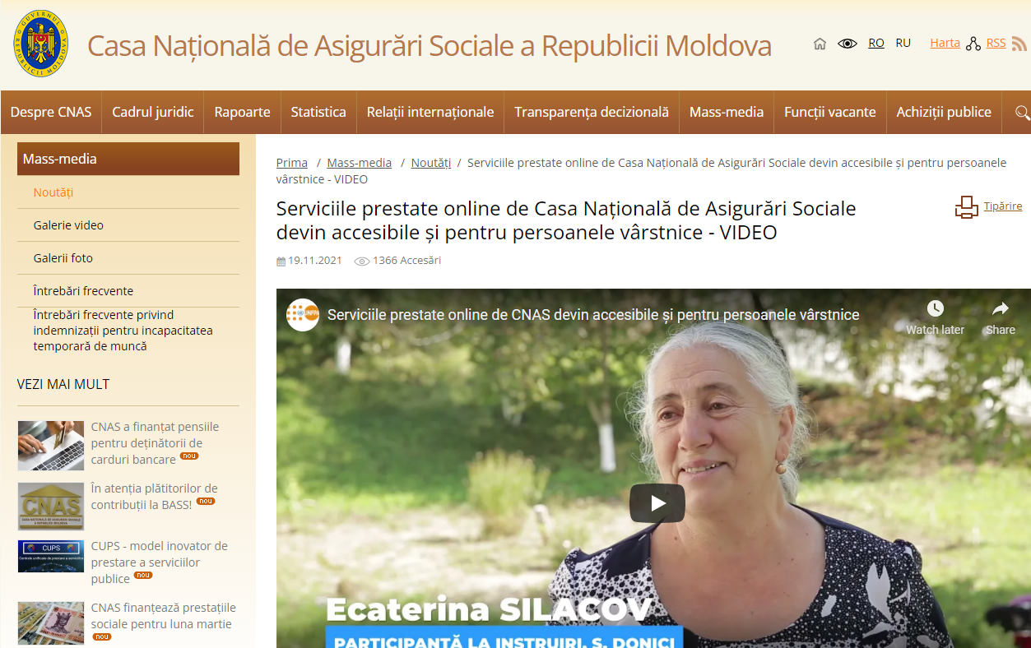
Social services. The National Social Insurance House (CNAS) stepped out of its box of conventional services to teach the older people from the Republic of Moldova to use the provided public online services with their phone. Over 300 older women and men attended trainings organized in 15 localities across the districts of Șoldănești, Rezina, Basarabeasca, Leova, Orhei and Strășeni. The trainings were carried out in every locality by two members of the district-level Territorial Social Insurance Houses. The civil servants helped the older people log into their personal account via the website – www.cnas.gov.md, and learn more about the information and services, such as:
- amount of the salary and the social insurance premiums paid by employers to the state social insurance budget;
- online submission of the retirement pension review application;
- using the retirement age calculator;
- making online appointments with services provided by the territorial social insurance offices, to avoid unnecessary travel, especially amid the pandemic, etc.
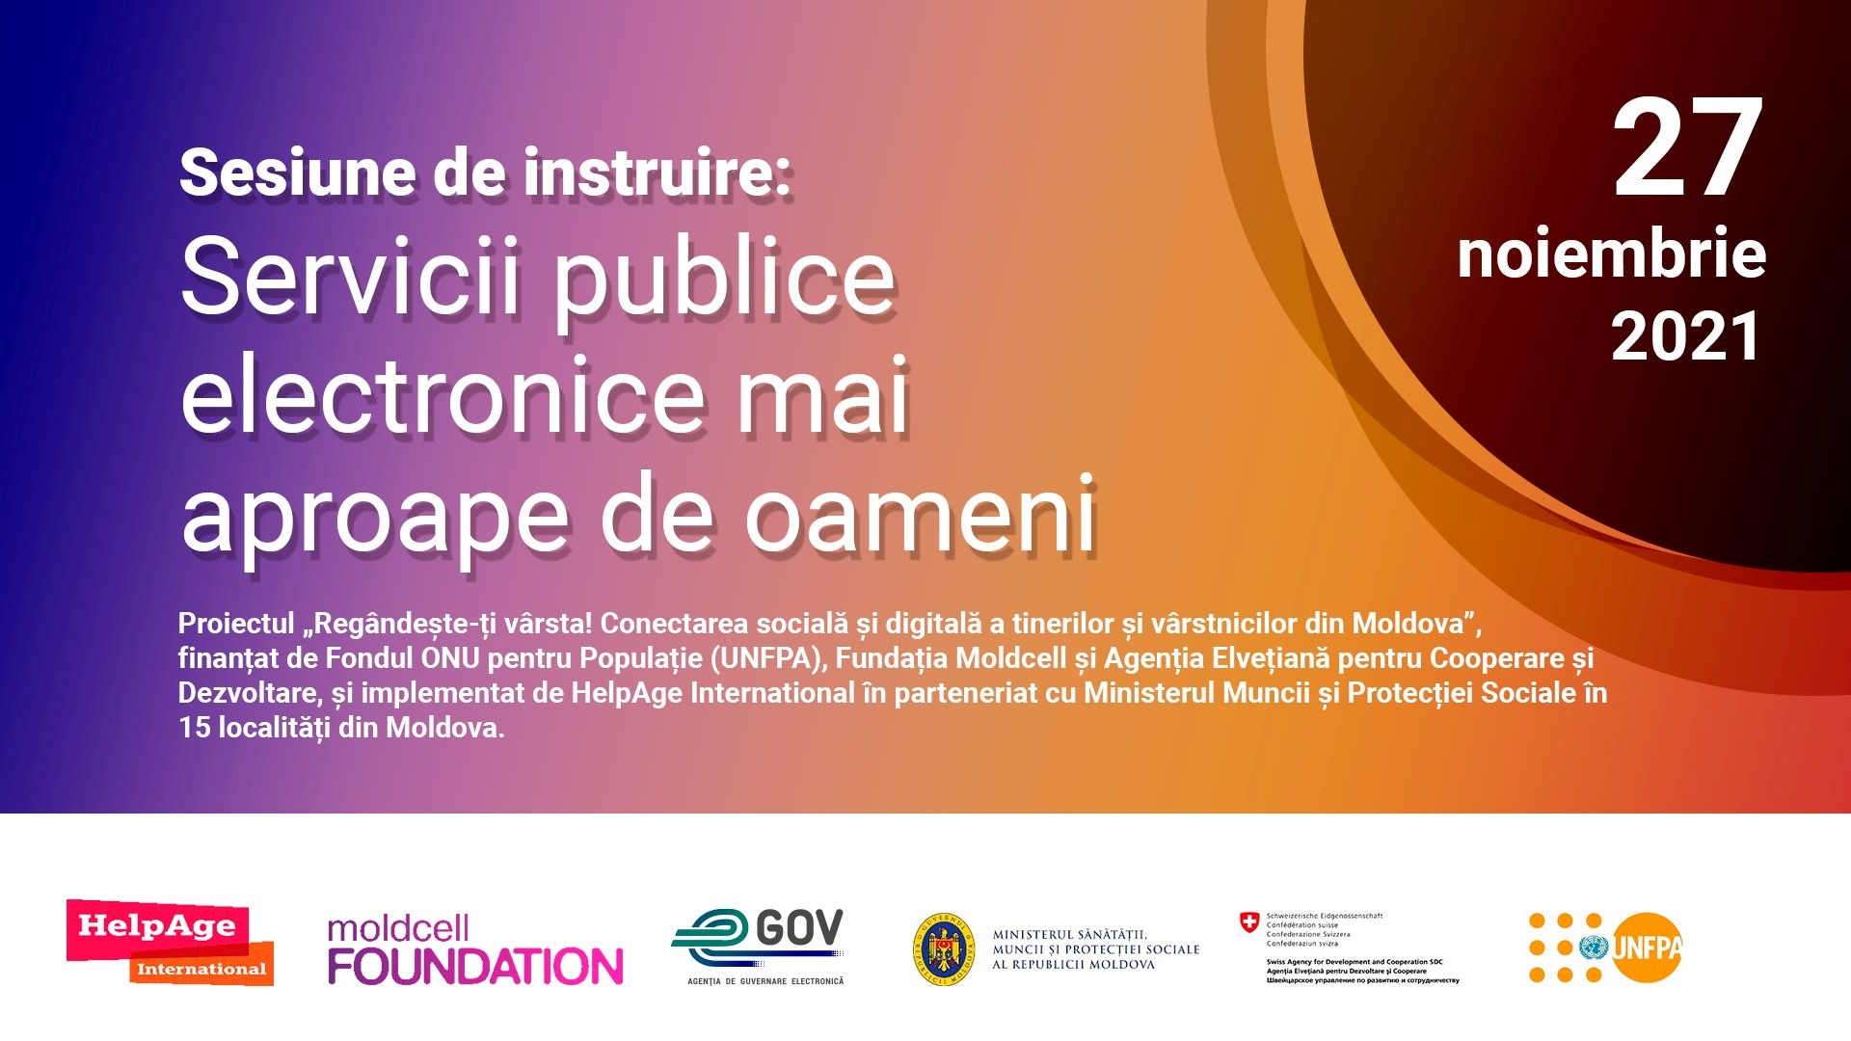
Participants mentioned other useful information they received about submitting request to benefit for free of sanatorium treatment and about recent changes in the public pension system. Details on this intervention (including images, video and press release) are available at this link.

Public services. One information session was held by the Moldova e-Governance Agency (offline) on 27 November, for representatives of 15 local partner NGOs (17 persons). Participation was limited due to pandemic restrictions. Another session is to be held for other volunteers online, in January 2022. Participants are informed about main public services of interest for older persons available online, about the use of mobile and electronic signature, and about new amendments in the E-government are expected in 2022. Details available at this link: https://cutt.ly/pYXpsSX

1.2. Provide psychological and informational support, social and medical advice to lonely and isolated older people through a series of dedicated psychological sessions.
Over 45 psychological sessions were conducted in 15 localities (3 sessions per locality). The topics of the psychological sessions have been consulted with local partner NGOs/initiative groups and three theme have been prioritized:
- psychological support to maintain mental health during Covid-period and isolation;
- information about prevention of domestic violence and protection measures and services;
- health of older persons during the pandemic of Covid-19, immunization, recovery post-infection.
For each topic an expert in the area has been contracted and during the period November-December 2022 all 45 sessions have been conducted both offline and online. Each session was attended by average 15 persons, mainly older persons beneficiaries. For online sessions, the beneficiaries have been guided by young volunteers to connect to the session and use online meeting apps. Based on older people feedback, the sessions have been very useful, in the context of limited information for vulnerable population and for older persons. Most of them have had for the first time in their life opportunity to talk to a psychologist and have a discussion about their emotional state and mental health. The services for assisting persons affected by domestic violence are known to a small extend and the stereotypes about gender inequalities still prevail, which requires a long-term intervention. The expert, who is also a lawyer, has also offered pro-bono free consultancy for some older persons affected by domestic violence, in the period post-sessions.
1.3. Conference on digitalization and intergenerational dialogue
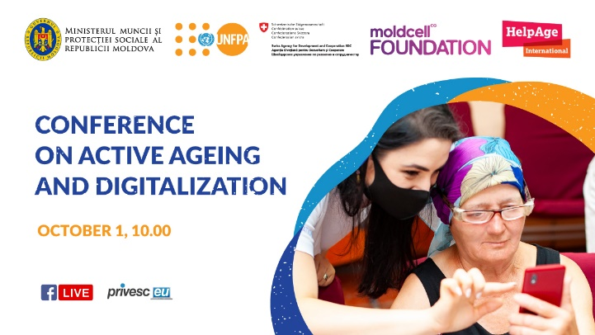
As part of the larger intergenerational dialogue programme, UNFPA conducted the Conference on ageing and digitalization, which looked at reduction of digital divide through intergenerational dialogue. The event, organized on the International Day of Older Persons, celebrated in 2021 under the theme “Digital Equity for All Ages”, focused around three pillars:
- Policy dimension - identifying policy measures that worked in other countries and which can be relevant for Moldova’s context in strengthening active and healthy ageing along with building digital skills.
- Tech and banking sectors – sharing existing practices of tech companies in building digital skills of older people, what role young people can play and how partnerships can be built in Moldova for reducing digital divide in a rapidly ageing country with a shrinking working-age population.
- People – presenting people experience both volunteers and beneficiaries engaged in the intergenerational dialogue programme and identifying the success stories and challenges in reducing the digital divide through intergenerational dialogue.
The event included discussions about the policies required for active and healthy ageing in the Republic of Moldova, reducing the digital divide between generations and empowering young and older persons.
The event was attended by over 100 older and young persons, representatives of the Government and IT companies, civil society, development partners (EBRD, ITU, UNCT) and academia.
Guests from abroad also shared their own experience regarding involvement of the older persons in active ageing and digitization programs. This included representatives of JD.COM, the largest online marketplace in China, Tara Kerk from the University College of London provided solutions for overcoming isolation among the older persons, and Biljana Radonjic Ker-Lindsay from the European Bank for Reconstruction and Development (United Kingdom) related to EBRD’s support packages for the older persons during the pandemic. Representatives of IT companies also provided solutions for digital inclusion of the older persons. During the event, UNFPA Moldova launched the Active Ageing Index – a tool for comparison of the process of active ageing between European countries and for identification of strong and weak points in the ageing evolution in each country. According to the study, the Republic of Moldova, compared to the European Union, requires substantial efforts to create a favorable environment for active ageing and to make progress as Sweden, the Netherlands or Denmark, which are at the top of the ranking.
The Conference on active ageing and digitalization was part of UNFPA’s larger programme on intergenerational dialogue, led by UNFPA in partnership with Moldcell Foundation, Swiss Agency for Development and Cooperation, Ministry of Labour and Social Protection and HelpAge International.
A video intro of the event is available at this link and all communication and visibility materials are available at this link.
1.4. Social media campaign
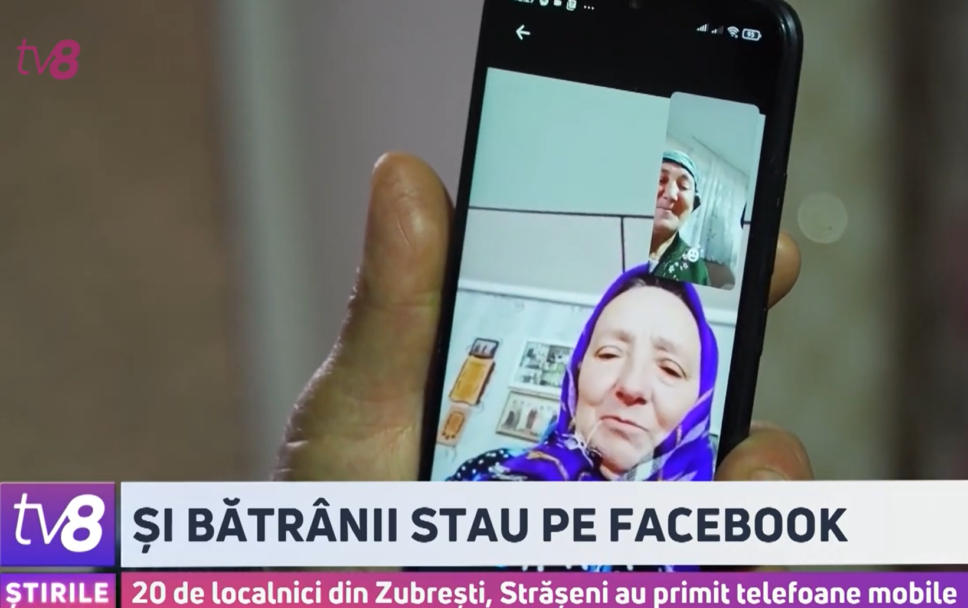
The ‘Older people go online’ campaign was symbolically launched in the context of the International Youth Day celebrated annually on 12 August and ended on 1st October, on the International Day of Older Persons. Thus, for almost two months, those 300 older people and 85 young volunteers engaged in the ‘Digital skills connect generations’ project communicated and documented their lives through photos and videos. Older people assisted by young volunteers took photos and videos about their daily life and shared them on social networks. In this way, the project facilitated to overcome older people isolation, by connecting them to community life and digital changes.

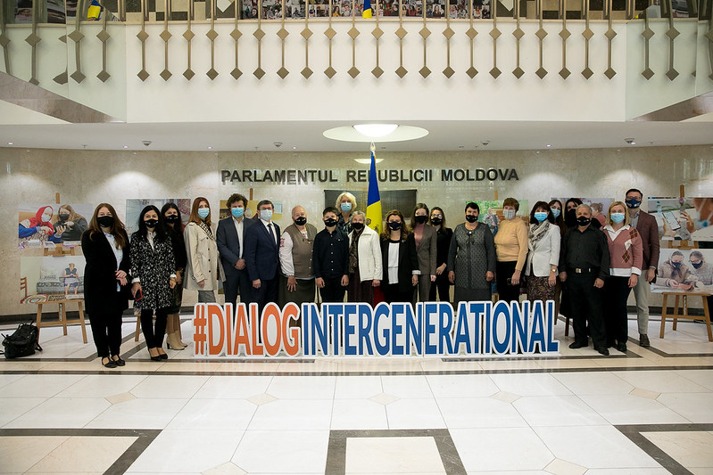
In implementing the campaign, Moldcell Foundation conducted trainings in 14 (out of 15) localities on how to take photos with the mobile and how to post them on social media. Each session gathered on average 25 persons, including young volunteers, older people beneficiaries, local NGO staff, trainers of Moldcell Foundation. Additionally, an online session (repeated for two groups) was held with young volunteers to agree on their support for older people. Following the social media training, almost all beneficiaries have for the first time created an account on Facebook, they have learned how to connect with other people, how to post pictures and share posts they like. As a result, the project contributed to the production and posting of an array of pictures of older persons and their life on Facebook and promoted a positive image of older persons online. A Facebook group has been created to join all persons involved in the project and share pictures and information and these can be searched using hashtags: #DialogIntergenerational, #AbilitatiDigitale, #RezilientaDemografica, #LikeDeLaBunei. The pictures posted by older people beneficiaries and by young volunteers were distributed as part of the social media campaign ”Varstnicii trec online / Older persons go online”, highlighted around the date of 01 October, that marked the International Day of Older Persons. TV broadcast (TV8) on this activity https://cutt.ly/jYL6qwc.

The collected pictures together with other pictures from the project have been exposed in the Parliament building on the eve of 01 October – International Day of Older Persons, that promoted older people and ageing are in Moldova, the importance of digitalization during the lifetime and the intergenerational dialogue. The event was attended by the Speaker, MPs, older people, young volunteers and project partners. sOther photography exhibition opportunities are to be explored for 2022, depending on the pandemic situation and appropriate locations in target communities. Details here.

Activities and results achieved under the output 2: The staff of the faculty of social assistance are enabled to apply a human rights based approach to their teaching, and trainers of the social assistance services have an increased knowledge of human rights and human rights based approach.

2.1. Revise curricula of social assistance students from a HRBA perspective and train lecturers on the revised curricula.
The training needs assessment on human rights and human rights based approach to social work was conducted in partnership with NASA among 597 social workers (including 510 social workers at community level and 87 with supervising role) out of total number of 1110 social workers. The needs assessment report (Annex 1 Report on the identification and assessment of the training needs of Community social workers in the field of human rights and the human rights-based approach) was developed. The main findings highlight the needs and interest of training on: rights of older persons and HRBA to social work of older persons; rights of persons with disabilities and HRBA to social work of persons with disabilities; rights of ethno-linguistic minorities, preventing and interving in domestic violence, mainstreaming human rights/human rights based approach in the activity of social workers, and importance of economic, social and cultural rights. Based on the needs assessment results, the concept and the curricula of the training program on Human Rights Based Approach to socials assistance (Annex 2) was developed. Presently the consultants are in the process of developing the training materials that will serve as a basis for the training of trainers.

2.2. Conduct capacity building of staff of public social assistance services, including those working in residential institutions for persons with disabilities and older women, on a human rights-based approach to social services including in the context of the COVID-19 pandemic.
Strong cooperation and consultation initiated with the Social Work Department, MSU on the mainstreaming of human rights and human rights based approach to social work. Based on discussions, it was agreed to have two ways through which human rights and HRBA will be mainstreamed in the initial training of (future) social workers:
- Mainstreaming human rights/HRBA in the existing courses. Nine courses were selected for further mainstreaming of human rights/HRBA. The consultants are in the process of development of the materials to be integrated in the existing training courses that will further contribute to improvement of the teaching content.
- Optional course on Human rights in social fields is being developed and will be proposed to students from all the faculties of the MSU. So far the training curricula was developed (Annex 3) and was introduced in the list of optional courses to be available to students. Among the topics included in the curricula there is also: human rights based approach to social work in the context of COVID-19 pandemic and other crisis. The consultants are further working on the development of the course training materials.
Note: for the activity 2.1 and 2.2 the process will be oriented at finalization of the process of developing training materials and conducting of the planned trainings.
- Describe any delays in implementation, challenges, lessons learned & best practices: If there were delays, explain the nature of the constraints and challenges, actions taken to mitigate future delays and lessons learned in the process. Provide an updated risk analysis (have any of the risks identified during the project design materialized or changed? Are there any new risks?). Were there any programmatic revisions undertaken during the reporting period? Please also include experiences of failure, which often are the richest source of lessons learned.
OHCHR is still in the process of implementation of the activities planned. The process was delayed given the search for consultants with extensive knowledge, experience and expertise in the human rights field, as well as experience in working with state institutions and development and conduct of capacity building programs (vacancy announcement was extended 3 times). Also the conduct of the needs assessment required a longer period of time for the mobilization of social workers to fill in the questionnaires and further analysis of all the responses. With regards to the Social Work Department MSU, there are certain procedures that need to be respected in order to ensure the further mainstreaming of the new concepts, materials and topics/courses in the existing training programs.
With all the aspects already arranged, the work will now be oriented at finalization of the training materials and conduct of trainings.
Due to the existing refugee crisis, the NASA is mainly focused on responding to the refugee crises, ie there will be delays in the conduct of trainings of trainers. Based on this, a no-cost extension of the project until November 2022 will be necessary and requested.

- Qualitative assessment: Provide a qualitative assessment of the level of overall achievement of the Programme. Highlight key partnerships and explain how such relationships impacted on the achievement of results. Explain cross-cutting issues pertinent to the results being reported on. For Joint Programmes, highlight how UN coordination has been affected in support of achievement of results.

OHCHR has strong partnership relations with the National Agency for Social Assistance. The work and communication was facilitated due to the long term partnership. Also, NASA facilitated the process of mobilization of around 600 social workers to participate in the training needs assessment process.

The cooperation with the Social Work Department of the Moldova State University was initiated within the framework of the project. The initial communication was started in the process of developing the project’ documents. As all the activities were agreed from the planning process, no issues in related to communication and cooperation in the implementation of the project were encountered. A focal point from the Department facilitated the communication and decision making process.
ii) Indicator Based Performance Assessment:
Using the Programme Results Framework from the Project Document / AWP - provide an update on the achievement of indicators at both the output and outcome level in the table below. Where it has not been possible to collect data on indicators, clear explanation should be given explaining why, as well as plans on how and when this data will be collected.
 | Achieved Indicator Targets | Reasons for Variance with Planned Target (if any) | Source of Verification
Outcome 1
Indicator:
Baseline:
Planned Target:
Output 1. 200 older women and men and 50 young people are empowered to overcome social isolation and transfer knowledge and skills in using digital devices to better cope with the pandemic.
Indicator 1.1. # of vulnerable older women and men that are empowered by young people through development of digital skills to seek medical, social, informational and psychological assistance.  Baseline: 150  Planned Target: 250 | 300 (234 women and 66 men) | The target was overachieved given additional in-kind contribution received from Moldcell Foundation that donated 100 mobile phones, compared with 50 initially planned. This allowed engagement of a larger number of older people involved in the project. | Annual Report of HelpAge International
Indicator 1.1. # of young people engaged in prevention of ageism, discrimination and in building intergenerational dialogue with older persons.  Baseline: 50  Planned Target: 50 | 85 young volunteers (72 girls and 13 boys) |  | Annual Report of HelpAge International
Output 2. The staff of the faculty of social assistance are enabled to apply a human rights based approach to their teaching, and trainers of the social assistance services have an increased knowledge on human rights and human rights based approach.
Indicator 2.1 # universities that have the human rights-based approach mainstreamed in the curricula of the social assistance students.  Baseline:  Planned Target: 1 | The human rights and HRBA is being mainstreamed in the initial training program of the Social Work Department, Moldova State University – human rights to be mainstreamed in 9 existing courses and one new optional course on human rights in social fields to be developed. | No variance.
Indicator 2.2 # professionals in the field of social work have access to an online in-service training program on human rights-based approach to social service developed in cooperation with the National Agency for Social Assistance.  Baseline:  Planned Target: 7600 professionals in social field | Needs assessment conducted among social workers and training curricula developed. The training and materials will serve as a basis for further training of trainers and development of the training for an on-line training platform of NASA. |  | Annex. 1 Training needs assessment report and Annex 2 Curricula

iii) A Specific Story (Optional)
- This could be a success or human story. It does not have to be a success story – often the most interesting and useful lessons learned are from experiences that have not worked. The point is to highlight a concrete example with a story that has been important to your Programme in the reporting period.
- In ¼ to ½ a page, provide details on a specific achievement or lesson learned of the Programme. Attachment of supporting documents, including photos with captions, news items etc, is strongly encouraged. The MPTF Office will select stories and photos to feature in the Consolidated Annual Report, the GATEWAY and the MPTF Office Newsletter.

Problem / Challenge faced: Describe the specific problem or challenge faced by the subject of your story (this could be a problem experienced by an individual, community or government).

Olga Carabet was born in the Republic of Moldova and spent her entire life in Cazangic village, Leova district. Aged 72, she has been living alone for the past 12 years, after her husband died and her three children have left for abroad, either to study or live. In 2020, when the COVID-19 pandemic started, Olga Carabet become socially isolated - starting with 25 March 2020, the Commission on Exceptional Situations prohibited older persons aged 63 and above from leaving their domicile or being in public spaces without an urgent need. Over the night, she’s become isolated in her own house, without any connection to the outside world and her loved ones.

Programme Interventions: How was the problem or challenged addressed through the Programme interventions?

Thousands of other older people from the Republic of Moldova ended up in a similar situation as Mrs Olga. In the fall of 2020, just a few months after the onset of the COVID-19 pandemic, UNFPA Moldova launched the Digital Skills Connect Generations project to help older people overcome social isolation and create intergenerational dialogue. As part of the project, 300 older people, including Olga Carabet, received a phone connected to the Internet and were trained by young volunteers how to use it to keep in touch with their loved ones, overcoming the isolation in which they found themselves.

Result (if applicable): Describe the observable change that occurred so far as a result of the Programme interventions. For example, how did community lives change or how was the government better able to deal with the initial problem?

Mrs. Olga confessed that thanks to the phone she received within the UNFPA project, she has never again felt alone. For example, more than a year ago, she became a great-grandmother. She has never met her great-grandson, as he was born and lives in Romania. The phone helps her to see him growing up, and she feel as if she were next to him. She now can see and hear her children, grandchildren and great-grandchildren whenever she wants. She also feels connected to the world, as she has now access to the Internet, social media channels. She even seeks medical support, contacting her family doctor via her phone.

Lessons Learned: What did you (and/or other partners) learn from this situation that has helped inform and/or improve Programme (or other) interventions?

The COVID-19 pandemic has affected the most vulnerable groups of people, with a greater impact on older people who have experienced phenomena such as discrimination or isolation. The devastating effects of the pandemic arose due to two factors - firstly, older men and women were already socially and economically vulnerable before the pandemic, and secondly - the response to the pandemic did not address the special needs of these categories of people.

III. Other Assessments or Evaluations (if applicable)
• Report on any assessments, evaluations or studies undertaken.
UNFPA conducted the evaluation of the Country Programme 2018 – 2022. As part of this, it was also assed the intergenerational dialogue programme. The evaluation report is attached for further references and findings of evaluation team.
OHCHR conducted a study on the impact of COVID-19 on human rights, that is available in Romanian, Russian and English. The findings of the study will be also integrated in the training materials developed.

IV. Programmatic Revisions (if applicable)
• Indicate any major adjustments in strategies, targets or key outcomes and outputs that took place.
No major adjustments in strategies, targets and outcomes took place in case of OHCHR. The further main adjustments refer to the period of implementation of the project. A non-cost extension of the period of implementation of the project would be needed until end November 2022.
V. Resources (Optional)
• Provide any information on financial management, procurement and human resources.
• Indicate if the Programme mobilized any additional resources or interventions from other partners.

The project mobilized funds from multiple stakeholders – private sector, government and development partners, as follows:
- Moldcell Foundation donated 50 mobile phones and conducted trainings on social media use in 1 localities of the project.
- National Social Insurance House conducted 15 trainings (one in each locality), on how to access social services.
- e-Government Agency started a series of seminars on how to access public services.
- Ministry of Labour and Social Protection provided a set of grants to grassroots NGOs that promote active ageing.
- Parliament hosted a photo exhibition on intergenerational dialogue, with pictures of older people engaged in the programme.

Czech Republic was interested to learn more about this programme and in December 2021 it decided to allocate $168.384,19 to expand the programme to other localities. This will allow to launch the third phase of the project. Moldcell Foundation confirmed their availability to donate an additional 100 mobile phones, thus reaching out an additional 200 older women and men as part of 3rd phase.

OHCHR allocated additional funds in the core budged beyond the project period for further coaching and monitoring the lectures and group of trainers, who will be involved in conducting lecturers for students and further trainings for acting social workers.

Annexes

Raport
privind identificarea și evaluarea necesităților de instruire ale asistenților sociali comunitari în domeniul drepturilor omului și abordării bazate pe drepturile omului

Chișinău, 2021

CONȚINUT
Sumar executiv 3
Introducere 5
metodologie 6
Informații generale privind respondenții 7
principalele constatări 8
Aspecte privind programul de instruire 18
Concluzii Generale 19
Conceptul Programului de dezvoltare a competențelor profesionale prin prisma drepturilor omului 20
Anexe 22
Anexa 1. Chestionar pentru evaluarea necesităților de instruire a asistenților sociali comunitari (autoevaluare)
Anexa 2 Chestionar pentru evaluarea necesităților de instruire a asistenților sociali comunitari (supervizori)

Sumar executiv
Raportul privind identificarea și evaluarea necesităților de instruire ale asistenților sociali comunitari în domeniul drepturilor omului și abordării bazate pe drepturile omului (în continuare raport) are scopul de a identifica și prezenta domeniile /subiectele și competențele profesionale-cheie care sunt necesare de a fi dezvoltate în procesul de instruire continuă a asistenților sociali comunitari.
Exercițiul de identificare a necesităților de instruire profesională a constat în elaborarea a două chestionare specifice, destinate asistenților sociali comunitari și asistenților comunitari care exercită atribuții de supervizare. Esența chestionărilor elaborate a fost de a colecta datele cu privire la cunoștințele, atitudinile și competențele practice ale asistenților sociali comunitari în baza metodei de autoevaluare cât și de a scoate în evidență necesitățile de instruire ale acestora în baza dificultăților cu care se ciocnesc în activitate și nu au cunoștințe și competențe suficiente de a le soluționa.
Chestionarele privind identificarea necesităților de instruire au fost distribuite spre completare către toți asistenții sociali comunitari. Chestionarele au fost completat de un număr reprezentativ de respondenți și anume: 597 din numărul total 1110 asistenți sociali comunitari, dintre care 510 – asistenți sociali comunitari și 87 – asistenți sociali cu atribuții de supervizare.
Potrivit datelor analizate în exercițiul de identificare a necesităților de instruire, 30,8% din asistenții sociali comunitari chestionați dețin mai mult 10 ani de experiență profesională în domeniul și 32,2 % din asistenții sociali cu atribuții de supervizare chestionați dețin între 5 și 10 ani de experiență profesională.
Majoritatea asistenților sociali comunitari (91.8%) care au completat chestionarul au menționat că au beneficiat de instruire inițială imediat după angajare și 99% consideră necesară acest tip de instruire.
În baza informațiilor obținute în urma chestionării, se trasează următoarele constatări:
- Respondenții asistenții sociali comunitari consideră că pentru a-și realiza atribuțiile din fișa postului au nevoie de instruire și consideră importantă instruirea atât cea inițială la angajare, cât și cea continuă pe parcursul carierei profesionale;
- Atât asistenții sociali comunitari, cât și supervizorii au apreciat că ar avea nevoie o de îmbunătățire a cunoștințelor în privința cadrului normativ privind asistența socială și drepturile omului;
- Majoritatea supervizorilor respondenți au optat pentru consolidarea cunoștințelor și abilităților privind implementarea abordării bazate pe drepturile omului în domeniul asistenței sociale;
- Mai mult de jumătate din numărul asistenților sociali supervizori chestionați au notat că asistenții sociali comunitari supervizați ar avea nevoie de îmbunătățire a abilităților de identificare a necesităților beneficiarilor din comunitate.
- supervizori chestionați au specificat că asistenții sociali comunitari ar avea nevoie de perfecționare a cunoștințelor privind cadrul normativ referitor la clasificarea serviciilor sociale, supervizorii acestora ar vedea o necesitate în acest sens.
- Printre cele mai des întâmpinate probleme în activitate, personalul grupului țintă a identificat concurența dintre drepturile fundamentale;
- Programul de instruire urmează să conțină subiecte separate pentru a spori abilitățile asistenților sociali comunitari de identificare a semnelor de vulnerabilitate, de comunicare cu beneficiarii, de cooperare cu alți actori relevanți în situații de restricții/criză;
- Pentru a-și realiza atribuțiile din fișa postului, atât asistenții sociali comunitari, cât și supervizorii au considerat că au nevoie inclusiv de abilități organizaționale și administrative, dezvoltare personală.
În baza rezultatelor exercițiului privind identificarea necesităților de instruire, s-au conturat următoarele subiecte prioritare de intervenție în procesul de instruire (în ordinea necesității și importanței):
- Fenomenul violenței domestice: prevenire, combatere și intervenție (72, 4% din supervizori și 60, 2% din asistenții sociali comunitari);
- Drepturile persoanelor în etate – prestarea serviciilor sociale axate pe necesitățile și nevoile persoanelor în etate (60,9% din supervizori și 52,7% din asistenții sociali comunitari);
- Drepturile persoanelor cu dizabilități - prestarea serviciilor sociale axate pe nevoile persoanelor cu dizabilități (56, 3% din supervizori și 52% din asistenții sociali comunitari);
- Conceptul general al drepturilor și libertățile fundamentale ale omului și abordarea bazată pe drepturile omului în asistența socială (33,3% din supervizori și 41, 6% din asistenții sociali);
- Integrarea drepturilor omului în activitatea profesională (35,6% din supervizori și 43,1% din asistenții sociali comunitari);
- Incluziunea socială a persoanelor cu dizabilități (48,3% din supervizori și 42,9% din asistenții sociali comunitari);
- Drepturile economice, sociale și culturale și nivelul de trai adecvat (34, 5% din supervizori și 41,4% din asistenții sociali comunitari);
- Egalitatea și nediscriminare, respectarea diversității etnice, culturale și religioase (23% din supervizori și 24,5% din asistenții sociali comunitari).

Tabloul final al datelor obținute în urma acestui exercițiu compilează de la sine necesitățile de instruire, în special care competențe necesită a fi consolidate printr-un program de instruire continuă.
În vederea asigurării calității procesului de formare profesională continuă a asistenților sociali comunitari, se recomandă ca Programul de instruire să fie dezvoltat în jurul acestor subiecte, listate de respondenți ca fiind prioritate pentru activitatea lor. În egală măsură, programul urmează să includă și tematici în vederea dezvoltării abilităților și competențelor identificate ca fiind deficitare, care duc la apariția problemelor în activitatea cotidiană a asistenților sociali comunitari.
Cu alte cuvinte, programul trebuie să răspundă cu informații teoretice la problemele practice identificate de respondenți ca fiind problematice a fi rezolvate. Programul de instruire trebuie să vizeze dezvoltarea capacităților profesionale ale asistenților sociali comunitari pentru exercitarea eficientă a atribuțiilor de serviciu, prin prisma abordării bazate pe drepturilor omului.
La final raport prezintă viziunea conceptuală a Programului de instruire ce urmează a fi dezvoltat, indicându-se scopul, obiectivele, structura și formatul recomandat. Conform conceptului, programul de instruire urmează să fie structurat în trei module tematice.
În vederea asigurării durabilității Programului de instruire, se propune pilotarea acestuia într-un format de curs de Formare de Formatori. Ulterior, în baza feedback-ului obținut urmează a fi definitivat/ajustat programul și împuternicirea formatorilor să livreze programul către colegii lor.

Introducere
Raportul privind identificarea și evaluarea necesităților de instruire ale asistenților sociali comunitari în domeniul drepturilor omului și abordării bazate pe drepturile omului a fost elaborat în cadrul proiectului „Sprijin și împuternicirea femeilor în etate și a femeilor cu dizabilități”, implementat de Oficiul ONU pentru Drepturile Omului (OHCHR), în parteneriat cu Fondul ONU pentru Populație (UNFPA), cu suportul financiar al Agenției Elvețiene pentru Cooperare și Dezvoltare.
Scopul activității este de a dezvolta capacitățile profesionale ale angajaților din domeniul social (în special asistenții sociali comunitari) în aplicarea unei abordări bazate pe drepturile omului în activitatea acestora. Abordarea bazată pe drepturile omului cuprinde modelul potrivit căruia principiile drepturilor omului trebuie încorporare a în toate domeniile de activitate, la toate etapele intervenției și, desigur, în toate documentele de politici ale statului. Respectarea principiilor drepturilor omului poate fi garantată de către stat prin consolidarea capacităților profesionale ale angajaților săi în calitate de ”purtătorii/titularii de obligații” față de ”deținătorii/titularii de drepturi”, care sunt beneficiarii serviciilor pe care le oferă.
Astfel, asistenții sociali comunitari sunt acei actori cheie din comunitate, care identifică persoanele în dificultate, evaluează nevoile acestora și îi ghidează spre accesarea de prestații sociale și/sau serviciilor sociale existente la nivel de comunitate. Construirea rezilienței sociale a persoanelor aflate în dificultate și îmbunătățirea accesului acestora la servicii sociale de calitate este direct proporțională cu nivelul de profesionalism al acestor ”purtători de obligații”. Asistenții sociali comunitari sunt cei ce oferă ghidare/ sprijin persoanei și familiei în identificare soluțiilor pentru problemele de ordin financiar, social, emoțional contribuind la crearea condițiilor pentru o viață decentă persoanelor vulnerabile. Conform Legii asistenței sociale nr. 547 din 25.13.2003, asistentul sociale este profesionistul care prestează servicii sociale persoanelor și familiilor care temporar se află în dificultate și care, din motive de caracter economic, social, fizic sau psihologic, nu sunt în stare să își asigure prin mijloace și eforturi proprii un nivel decent de viață. De asemenea, principiile asistenței sociale enunțate în lege corelează cu principiile drepturilor omului/abordării bazate pe drepturile omului.
Asistenții sociali comunitari sunt prestatori de servicii sociale primare la nivel de comunitate, colaborând într-o echipă locală cu lucrătorii sociali, reprezentanții primăriei, precum și cu alți specialiștii/actori care activează în comunitate (polițistul de sector, pedagogii, lucrătorul medical, biserica, etc.), conjugând-și eforturile pentru a mobiliza resursele din comunitate pentru rezolvarea problemelor sociale ale beneficiarilor și grupurilor de persoane aflate în dificultate.
Gradul de competență profesională a asistenților sociali comunitari condiționează direct calitatea serviciilor prestate grupurilor de persoane aflate în dificultate. Astfel, formarea profesională a asistenților sociali comunitari trebuie să cuprindă atât o formare inițială la încadrare în prestarea serviciilor sociale, cât și o pregătire profesională continuă de-a lungul parcursului profesional.
Factori care condiționează necesitatea dezvoltării, menținerii și actualizării periodice a programului de formare continuă a asistenților sociali comunitari sunt următorii:
- Necesitatea de adaptare la standardele internaționale în materie de asigurare a unui trai decent persoanelor;
- Dezvoltarea continuă a sistemului de protecție socială la nivel de prevederi normative;
- Schimbarea continuă a naturii problemelor sociale care atrage necesitatea creării și prestării a noi servicii sociale, adaptate necesităților specifice persoanelor în dificultate;
- Reorganizarea serviciilor sociale existente;
- Apariția diferitor situații imprevizibile care impune mobilizare colectivă și reacție pe măsură;
- Sporirea exigențelor față de nivelul de pregătire a asistenților sociali comunitari.

Metodologie
Procedura de identificare a necesităților de instruire profesională a asistenților sociali comunitari în domeniul drepturilor omului și abordării bazate pe drepturile omului (în continuare grup țintă vizat în proiect) a fost desfășurată în baza chestionării reprezentanților grupului țintă.
În acest sens, au fost elaborate două chestionare cu un set de întrebări specifice, care au avut ca obiectiv să contribuie la stabilirea, cât mai exactă a necesităților de instruire a grupului țintă. Astfel, un chestionar a fost destinat asistenților comunitari sociali, iar celălalt pentru asistenții comunitari sociali care au atribuții de supervizare. Chestionarele au fost structurate în următoarele componente:
- date generale despre respondent (precum sexul și perioada de activitate);
- autoaprecierea nivelului de posedare a cunoștințelor, abilităților și competențelor conform atribuțiilor din fișa de post și a nivelului care urmează a fi dezvoltate;
- indicarea problemelor necesităților specifice de instruire;
- aspecte tehnice privind proiectarea programului de instruire.
Conținutul chestionarelor a fost coordonat cu reprezentanții Agenției Naționale Asistență Socială (ANAS) responsabili de procesul de consolidare a capacităților profesionale ale personalului din sistemul de asistență socială. Conținutul acestora a fost proiectat sub forma chestionarelor online, întrebările fiind de tipul celor închise cu bifare a răspunsului potrivit situației respondentului. Distribuirea chestionarelor către grupul țintă a fost facilitat de către reprezentanții ANAS.
Analiza calitativă a datelor cantitative colectate în baza aplicării chestionarelor sus indicate este desfășurată în continuare.

Informații generale privind respondenții
Chestionarele privind identificarea necesităților de instruire au fost completate, în total, de 597 (54%) din totalul de 1100 angajați în calitate de asistenți sociali comunitari. Dintre aceștia, 87 (14,57%) respondenți care dețin și atribuții de supervizare, iar 510 (85,42%) – asistenți sociali comunitari.
Mai jos este ilustrată clasificarea respondenților după sex (la general) și categorie de personal (asistenți și supervizori).
Figura nr.1: Distribuția după sex | Figura nr.2: Distribuția după categorie de personal
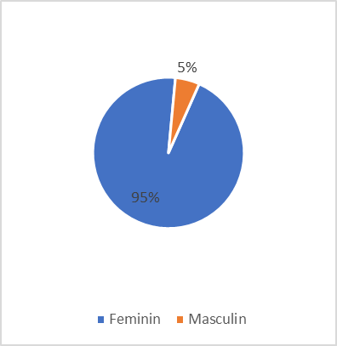 | 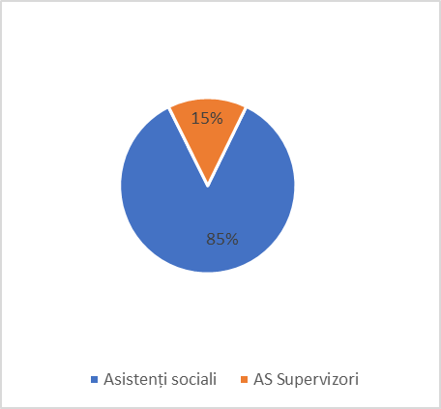

În graficul nr.3 sunt oferite date privind numărul de ani de experiență profesională a respondenților în funcția deținută.
Graficul nr.4: Distribuția angajaților din grupul țintă după ani de experiență  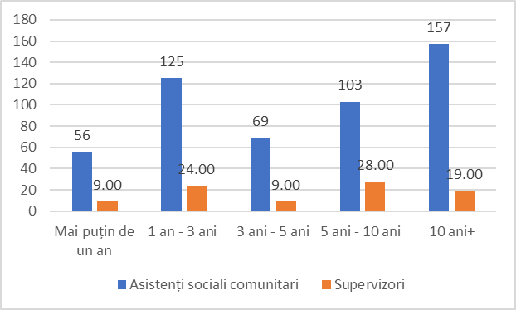 | 30,8% din asistenții sociali comunitari chestionați dețin mai mult 10 ani de experiență profesională și 11% dintre cei chestionați au indicat o experiență mai puțin de un an  32,2 % din asistenții sociali cu atribuții de supervizare chestionați dețin între 5 și 10 ani de experiență profesională, iar 10,3% din supervizorii chestionați au am puțin de un an

Principalele constatări
Majoritatea asistenților sociali comunitari (91.8%) care au completat chestionarul au menționat că au beneficiat de instruire inițială imediat după angajare și 99% consideră necesară acest tip de instruire.
Figura nr.1: La angajare, ați beneficiat de instruire inițială privind atribuțiile de serviciu, conform fișei post a asistentului social comunitar? | Figura nr.2: Considerați necesară instruirea inițială imediat după angajare?
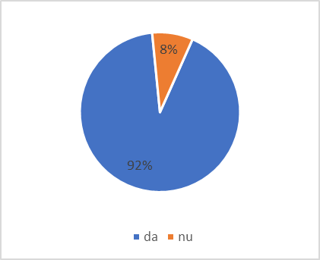 | 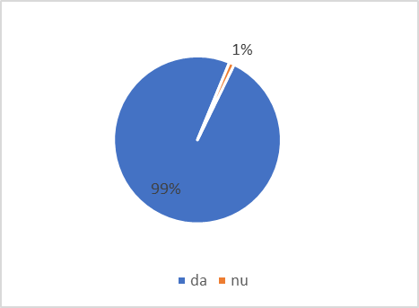

Grafic privind numărul de ore de instruire continuă de care au beneficiat în ultimul an de activitate asistenții sociali comunitari respondenți
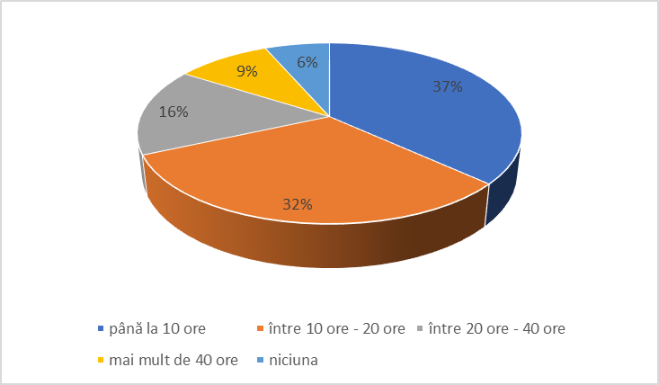 | 37% din asistenții sociali comunitari chestionați au indicat că în ultimul an de activitate au beneficiat de instruiri într-un număr de până la 10 ore  32% din asistenții sociali comunitari chestionați au indicat că în ultimul an de activitate au beneficiat de instruiri într-un număr între 10 ore și până la 20 ore

În figura de mai jos se prezintă distribuția procentuală pe nivelul cunoștințelor posedate, din perspectiva autoevaluării
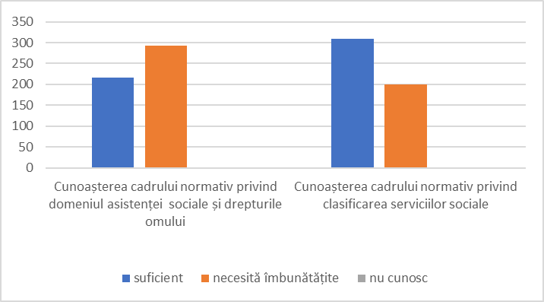  60,6% din asistenții sociali comunitari chestionați consideră că posedă suficiente cunoștințe privind cadrul normativ privind clasificarea serviciilor sociale, 39% au indicat că ar avea nevoie de îmbunătățire. | 42,5% din asistenții sociali comunitari chestionați consideră că posedă cunoștințe suficiente privind cadrul normativ privind domeniul asistenței sociale și drepturile omului, iar 57,3% consideră că ar putea fi îmbunătățite;

Aceleași cunoștințe posedate de asistenții sociali comunitari supervizați, din perspectiva supervizorilor
43,7% din supervizorii chestionați consideră asistenții sociali comunitari supervizați posedă suficiente cunoștințe privind cadrul normativ privind clasificarea serviciilor sociale, iar 55,2 % au indicat că ei ar avea nevoie de îmbunătățire. | 43,7% din supervizorii chestionați consideră că asistenții sociali comunitari supervizați posedă cunoștințe suficiente privind cadrul normativ privind domeniul asistenței sociale și drepturile omului, iar 55,2% consideră că ar necesită a fi îmbunătățite;

Concluzii: Atât asistenții sociali comunitari, cât și supervizorii au apreciat că s-ar impune o îmbunătățire a cunoștințelor privind cadrul normativ privind asistența socială și drepturile omului. Totodată, deși asistenții sociali comunitari în proporție mai mică consideră că ar avea nevoie de perfecționare a cunoștințelor privind cadrul normativ referitor la clasificarea serviciilor sociale, supervizorii acestora ar vedea o necesitate în acest sens.
În diagrama de mai jos se prezintă distribuția procentuală pe nivelul abilităților, din perspectiva autoevaluării
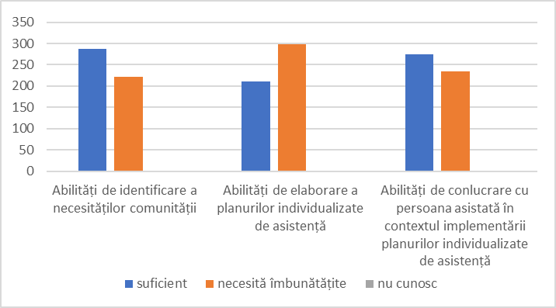  Nivelul suficient al abilităților de conlucrare cu beneficiarii în contextul asistenței acordate a fost apreciat de 45,9%, respectiv 53,9% au nevoie de îmbunătățire a acestor abilități. | 59,9% din asistenții sociali comunitari chestionați s-au evaluat că posedă abilități suficiente pentru identificarea necesităților comunităților și 39,% ar avea nevoie de îmbunătățire a acestora;  Abilități de elaborare a Planului Individual de Asistență (PIA), la nivel suficient, posedă 41,1% din respondenți, iar 58, 6% ar avea nevoie de îmbunătățire;

Aceleași abilități posedate de asistenții sociali comunitari supervizați, din perspectiva supervizorilor
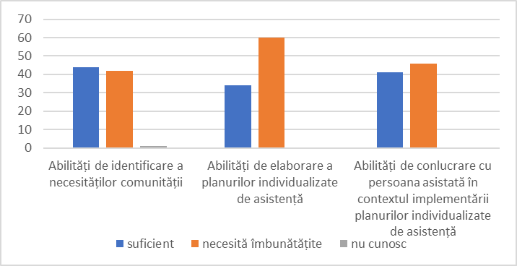  Nivelul suficient al abilităților posedate de asistenții sociali comunitari supervizați de conlucrare cu beneficiarii în contextul asistenței acordate a fost apreciat de 47,1% din supervizorii respondenți, respectiv 52,9% au bifat că ai ar avea nevoie de îmbunătățire a acestor abilități. | 48,3% din asistenții sociali supervizori chestionați au evaluat că asistenții sociali comunitari supervizați posedă abilități suficiente pentru identificarea necesităților comunităților și 50,6% consideră că ei ar avea nevoie de îmbunătățire a acestor abilități;  Doar 39,1% din supervizori consideră că abilitățile asistenților comunitari supervizați de elaborare a PIA sunt suficiente, iar 60,9% consideră că ei au nevoie de îmbunătățire a acestor abilități;

Concluzii: Mai mult de jumătate din asistenții sociali comunitari chestionați consideră că au nevoie de a-și îmbunătăți abilitățile de elaborare a planurilor individuale de asistență acordată beneficiarilor și de cele de conlucrare cu ei în procesul prestării serviciilor. Această concluzie este dedusă și din răspunsurile date
de supervizori cu mențiunea că aceștia ar avea nevoie de îmbunătățire și a abilităților de identificare a necesităților beneficiarilor din comunitate.
În diagrama de mai jos se prezintă distribuția procentuală pe nivelul cunoștințelor și abilităților (privite în coroborare), din perspectiva autoevaluării
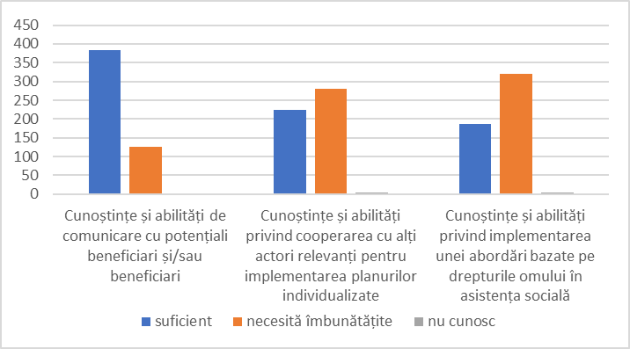  36,5% din asistenții sociali comunitari chestionați consideră că posedă suficiente cunoștințe și abilități de implementare a abordării bazate pe drepturile omului în domeniul asistenței sociale, respectiv 62,7% notează că au nevoie de îmbunătățire a acestor cunoștințe și abilități. | 75,3% din asistenții sociali comunitari chestionați s-au evaluat că posedă cunoștințe și abilități suficiente de comunicare cu beneficiarii și doar 24,5,% ar avea nevoie de îmbunătățire a acestora;  44,1% din asistenții sociali comunitari chestionați consideră că posedă cunoștințe și abilități de cooperare cu actorii relevați în contextul exercitării atribuțiilor suficiente, iar 54, 9% consideră ar avea nevoie de îmbunătățire a cestora;

Aceleași cunoștințe și abilități posedate de asistenții sociali comunitari supervizați, din perspectiva supervizorilor
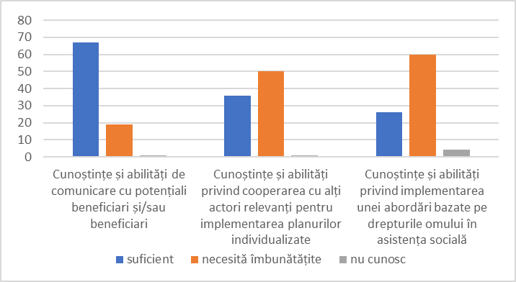  29,9 din supervizorii chestionați au evaluat că asistenții sociali comunitari supervizați posedă cunoștințe și abilități suficiente privind implementarea abordării bazate pe drepturile omului în domeniul asistenței sociale, respectiv 69% notează că au nevoie de îmbunătățire a acestor cunoștințe și abilități. | 77% din supervizorii chestionați au evaluat că asistenții sociali comunitari supervizați posedă cunoștințe și abilități suficiente de comunicare cu beneficiarii și potențialii beneficiari și 21,8% consideră că ei ar avea nevoie de îmbunătățire a acestor abilități;  41,4% din supervizori consideră că abilitățile și cunoștințele asistenților comunitari supervizați de cooperare cu alți actori în contextul serviciilor prestate sunt suficiente, iar 57,5% consideră că ei au nevoie de îmbunătățire a acestora;
Concluzii: Majoritatea asistenților sociali comunitari, inclusiv majoritatea supervizorilor respondenți au optat pentru consolidarea cunoștințelor și abilităților la nivel de cooperare cu alți actori în contextul serviciilor acordate și îmbunătățirea cunoștințelor și abilităților privind implementarea abordării bazate pe drepturile omului în domeniul asistenței sociale.

În figura de mai jos se prezintă distribuția procentuală pe nivelul competențelor posedate, din perspectiva autoevaluării
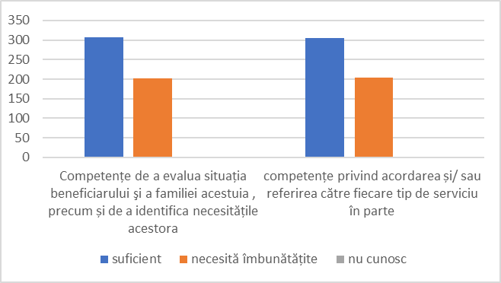  59,8% din asistenții sociali comunitari chestionați consideră că dispun de competențe suficiențe privind referirea beneficiarilor către servicii corespunzătoare, respectiv 39,8% au indicat că ar avea nevoie de îmbunătățire a acestor competențe. | 60% din asistenții sociali comunitari chestionați consideră că dispun de competențe suficiente privind evaluarea necesităților beneficiarilor și 39,6% consideră că ar putea fi îmbunătățite;

Aceleași competențe posedate de asistenții sociali comunitari supervizați, din perspectiva supervizorilor
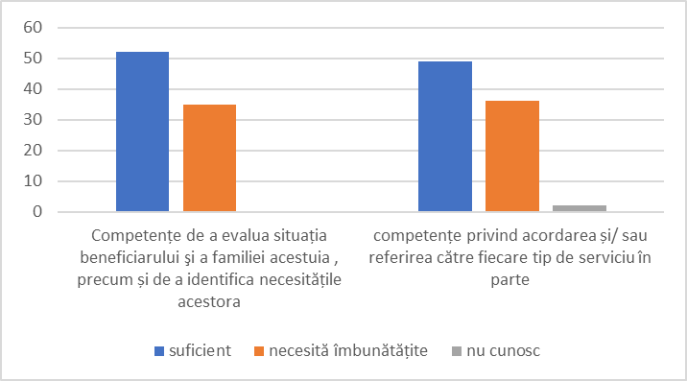  56,3% din supervizorii chestionați consideră că asistenții sociali comunitari supervizați dispun de competențe suficiente privind referirea beneficiarilor către servicii corespunzătoare, respectiv 41,4% au indicat că ei ar avea nevoie de îmbunătățire a acestor competențe. | 59,8% din supervizorii chestionați consideră că asistenții sociali comunitari supervizați dispun de competențe suficiente privind evaluarea necesităților beneficiarilor și 40,2% consideră că ar putea fi îmbunătățite;

Concluzii: Atât asistenții sociali comunitari, cât și supervizorii chestionați în proporție mai mult de 50% consideră că competențele privind evaluarea necesităților beneficiarilor și referirea acestora către servicii corespunzătoare sunt suficiente.
În graficul de mai jos sunt indicate topul celor mai des întâlnite probleme care nu au putut fi soluționate în baza cunoștințelor/competențelor și abilităților deținute
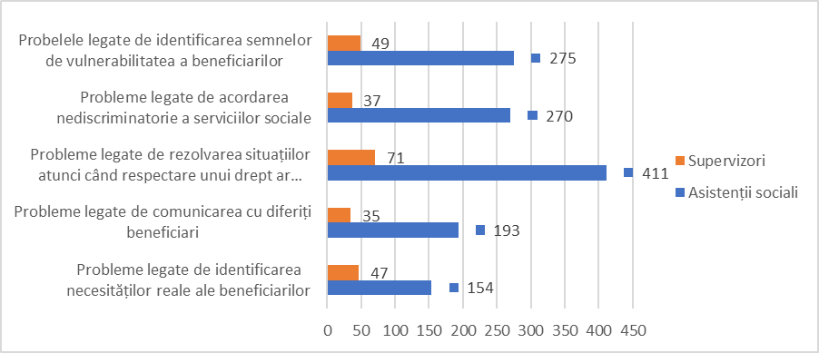
Din prelucrarea datelor din chestionare principalele trei probleme pe care cel mai des le întâmpină în activitate personalul grupului țintă sunt următoarele:
- Probleme legate de rezolvarea situațiilor atunci când respectarea unui drept ar încălca un al drept - concurența dintre două drepturi (81,6% din supervizori și 80, 6% asistenți sociali comunitari);
- Probleme legate de identificarea semnelor de vulnerabilitatea a beneficiarilor (56,3% din supervizori și 53,9% asistenți sociali comunitari);
- Probleme legate de acordarea nediscriminatorie a serviciilor sociale (42,5,3% din supervizori și 52,9% asistenți sociali comunitari).
Concluzii: Identificarea semnelor de vulnerabilitate este în corelare cu procesul de identificare a necesităților particulare de asistență a beneficiarilor. Or vulnerabilitatea acestora indică asupra dificultățile care urmează a fi compensate prin sericii și/sau alte tipuri de asistență. Identificarea acestea drept o problema în activitate confirmă poziția supervizorilor (50,6%) că asistenții sociali comunitari au nevoie de a-și îmbunătăți abilitățile de identificare a semnelor de vulnerabilitate respectiv de stabilire corectă a necesităților particulare a beneficiarilor. În aceeași undă de ideii, se înscrie și problema de acordare nediscriminatorie a serviciilor sociale. Cu alte cuvinte, identificarea exactă a necesităților particulare a beneficiarilor din comunitate va scădea riscul acordării serviciilor într-o manieră discriminatorie. Concurența între drepturile fundamentale în contextul acordării serviciilor sociale urmează a fi dezvoltat ca tematică separată în programul de instruire care va fi conceput.
Mai jos sunt reflectate necesitățile de instruire, devenite actuale în contextul și/sau în legătură cu situația pandemică.
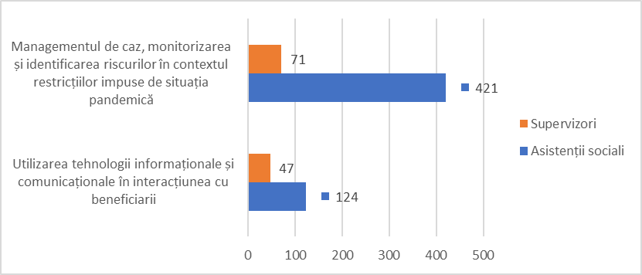
În baza rezultatelor obținute, se atestă că, în legătură cu situația pandemică, atât din perspectiva asistenților sociali comunitari, cât și din perspectiva supervizorii managementul de caz, monitorizarea și identificarea riscurilor în contextul restricțiilor impuse de această situație, a devenit o provocare pentru aceștia (81,6% din supervizori și 82,5% asistenți sociali comunitari).
Concluzii: Identificarea riscurilor și asigurarea managementului de caz în condiții restrictive din puncte de vedere al contactului direct este în corelare cu abilitățile de comunicare atât cu beneficiarii, cât și de cooperare cu alți actori relevanți ai procesului. Pentru a răspunde acestei provocări, programul de instruire urmează să conțină subiecte separate pentru a spori abilitățile asistenților sociali comunitari de identificare a semnelor de vulnerabilitate, de comunicare cu beneficiarii, de cooperare cu alți actori relevanți în situații de restricții/criză.
Graficul de mai jos redă cunoștințele de care au nevoie asistenții sociali pentru a-și realiza mai bine atribuțiile prevăzute în fișa de post
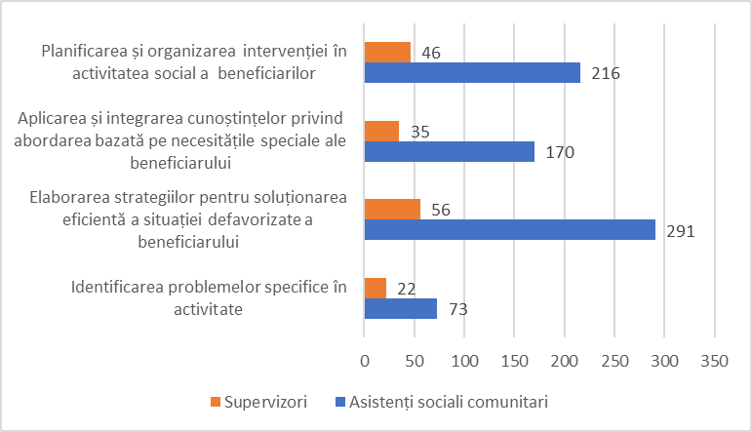
Pentru a-și realiza mai bine atribuțiile prevăzute în fișa de post asistenții sociali comunitari au nevoie de următoarele cunoștințe:
- privind elaborarea strategiilor pentru soluționarea eficientă a situației defavorizate a beneficiarului (64,4% din supervizori și 57,1% asistenți sociali comunitari);
- privind planificarea și organizarea intervențiilor sociale în situația beneficiarilor (52,9% din supervizori și 42,4% asistenți sociali comunitari).
Concluzii: Informațiile listate ca fiind necesare a fi capacitate prin instruiri corespund necesităților de îmbunătățire a abilităților de elaborare și implementare a planurilor individuale de asistență în baza necesităților specifice ale beneficiarilor.
Graficul de mai jos ilustrează abilitățile necesare a fi dezvoltate pentru ca asistenții sociali să-și realizeze mai bine atribuțiile prevăzute în fișa de post
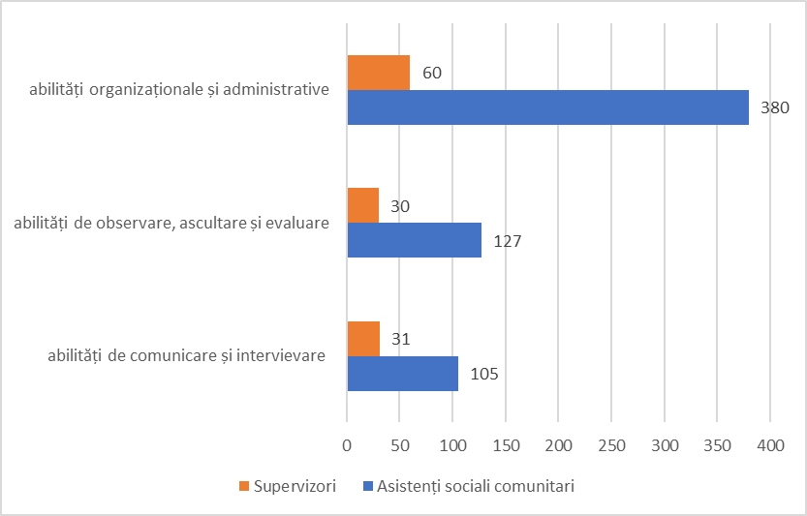
Concluzii: Pentru a-și realiza atribuțiile din fișa postului, atât asistenții sociali comunitari, cât și supervizorii au considerat că au nevoie prioritar de abilități organizaționale și administrative.

Graficul privind topul subiectelor care reflectă cele mai importante nevoi de dezvoltare și formare profesională a asistenților sociali.
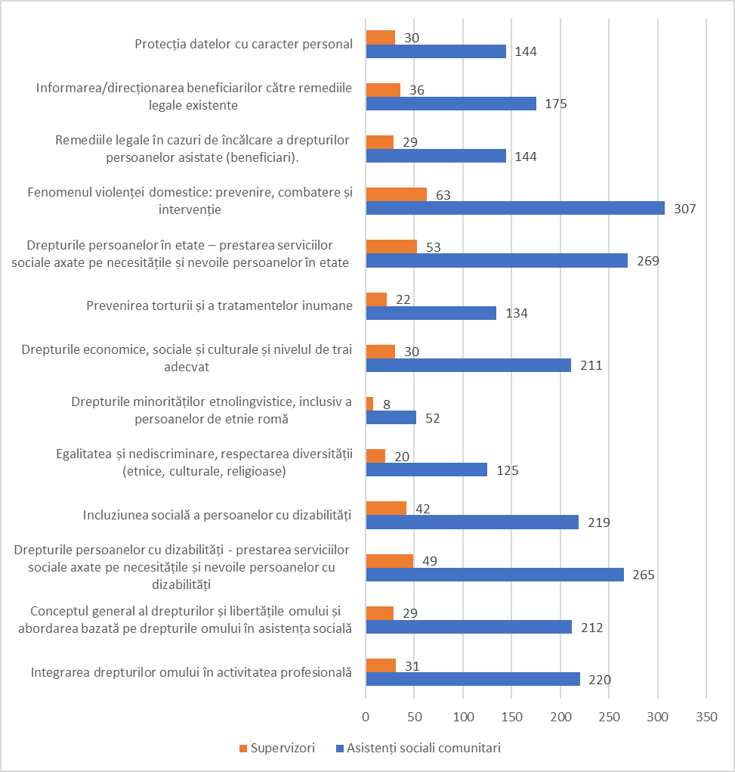
Concluzii: În baza rezultatelor exercițiului privind identificarea necesităților de instruire, s-au constatat următoarele subiecte prioritare de intervenție în procesul de instruire (în ordinea necesității și importanței):
- Fenomenul violenței domestice: prevenire, combatere și intervenție (72, 4% din supervizori și 60, 2% din asistenții sociali comunitari);
- Drepturile persoanelor în etate – prestarea serviciilor sociale axate pe necesitățile și nevoile persoanelor în etate (60,9% din supervizori și 52,7% din asistenții sociali comunitari);
- Drepturile persoanelor cu dizabilități - prestarea serviciilor sociale axate pe necesitățile și nevoile persoanelor cu dizabilități (56, 3% din supervizori și 52% din asistenții sociali comunitari);
- Conceptul general al drepturilor și libertățile omului și abordarea bazată pe drepturile omului în asistența socială (33,3% din supervizori și 41, 6% din asistenții sociali);
- Integrarea drepturilor omului în activitatea profesională (35,6% din supervizori și 43,1% din asistenții sociali comunitari);
- Incluziunea socială a persoanelor cu dizabilități (48,3% din supervizori și 42,9% din asistenții sociali comunitari);
- Drepturile economice, sociale și culturale și nivelul de trai adecvat (34, 5% din supervizori și 41,4% din asistenții sociali comunitari);
- Egalitatea și nediscriminare, respectarea diversității etnice, culturale și religioase (23% din supervizori și 24,5% din asistenții sociali comunitari).

Deși acest ultim subiect nu a fost listat ca unul din subiectele prioritare necesare a fi include în programul de instruire, fiind un principiu transversal în materia respectării drepturilor omului trebuie să se regăsească în program.

Aspecte privind proiectarea programului de instruire

În contextul aplicării chestionarului, s-a cercetat și disponibilitatea asistenților sociali comunitari în privința numărului de ore, la care ar fi dispuși să participe pentru parcurgerea instruirilor continue, pentru a avea o viziune de ansamblu în privința duratei programului care urmează a fi conceput, astfel încât să fie integrat cu acceptabilitate de către beneficiari.

În egală măsură, s-a colectat date privind organizatorii care au livrat în ultimul an de activitate instruiri tematice care pot fi atribuite dezvoltării profesionale continue. Nu în ultimul rând, pentru a estima care ar fi recomandările privind componența nominală a grupului de formatori care urmează a fi instruiți în baza programului de instruire ce va fi dezvoltat s-a colectat date privind persoana pe care asistenții sociali comunitari ar fi predispuși să-i accepte mai lejer în calitate de formatori.

Figura nr.1: Distribuția privind numărul de ore care ar putea fi alocate anual instruirii continue | Figura nr.2: Distribuția privind organizatorul instruirilor în ultimul an de activitate
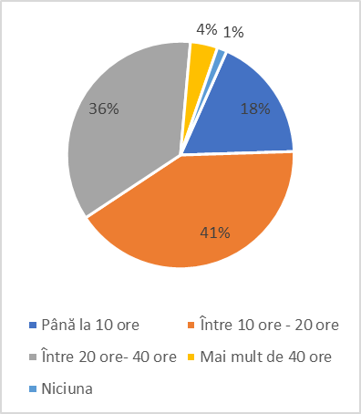 | 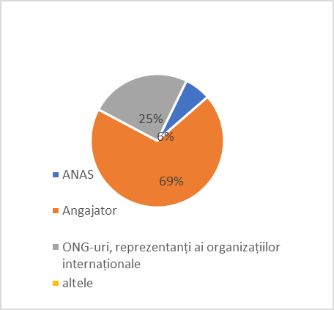

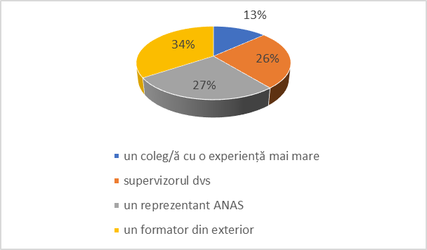 | Figura nr.3: Distribuția privind calitatea formatorului
Concluzii generale
Dezvoltarea competențelor profesionale ale personalului din sistemul de asistență socială trebuie să constituie o prioritate în procesul de îmbunătățire a sistemului drepturilor omului din Republica Moldova.
Astfel, pentru realizarea atribuțiilor, personalul din domeniul asistenței sociale, aici asistenții sociali comunitari au necesitate absolută în obținerea de cunoștințe integrate privind sistemul drepturilor omului. Ori cunoștințele fragmentate, precum cele obținute, spre exemplu în ultimul an de activitate, nu sunt suficiente pentru a considera că aceștia dispun de cunoștințe generice în materia drepturilor omului. Prin urmare, integrarea în programul de instruire a conceptului general al drepturilor și libertățile omului și abordarea bazată pe drepturile omului în asistența socială vor contribui la o mai bună asimilare și integrare a acestora în activitate.
Totodată, s-a constatat o necesitate ridicată în dezvoltarea abilităților de identificare a necesităților exacte a beneficiarilor din comunitate, de evaluare corectă a tipurilor de servicii de care au nevoie, de competențe privind cooperarea cu alți actori cheie în vederea acordării asistenței beneficiarilor- toate aceste prin prisma abordării în baza drepturilor omului, nediscriminării și egalității.
De asemenea, chestionații au listat tematicile/subiectele exacte care ar vrea să fie dezvoltate în cadrul programului de instruire, dezvoltându-le abilitățile și competențele necesare realizării atribuțiilor prevăzute în fișa postului.
O altă necesitate identificată vizează dezvoltarea abilităților organizaționale și administrative, care ar cuprinde printre altele: comunicarea organizațională, comunicarea interpersonală, managementul conflictelor, soluționare a problemelor, managementul timpului, lucrul în echipă, luarea deciziilor etc.

Conceptul programului de dezvoltare a competențelor profesionale a personalului din sistemul de asistență socială (aici vizați asistenții sociali comunitari)
Introducere:
Prezentul concept al programului de instruire a asistenților sociali comunitari este propus în baza necesităților identificate în rezultatul procesului de evaluare a deficitului de cunoștințe și abilități aferente domeniului drepturilor omului.
În sensul prezentului concept, Programul de instruire include scopul și obiectivele de instruire pentru asistenții sociali comunitari, durata instruirii, conținutul instruirii – lista orientativă (propusă) a subiectelor care urmează a fi dezvoltate, metodele care urmează a fi aplicate, indicarea timpului prevăzut pentru fiecare subiect.
Scop:
Scopul general al Programului de instruire este dezvoltarea potențialului sistemului asistenței sociale prin îmbunătățirea competențelor profesionale ale asistenților sociali comunitari necesare pentru realizarea optimă și calitativă a atribuțiilor stabilite în fișa postului, prin prisma abordării bazate pe drepturile omului.
Obiective:
La finele programului de instruire participanții vor fi capabili:
- să realizeze atribuțiile ce le revin prin abordarea în baza drepturilor omului și bunelor practici, să aplice instrumentele cele mai eficiente în domeniul de competență;
- să analizeze situația beneficiarilor și necesitățile acestora prin prisma abordării bazate pe drepturile omului
- să identifice riscurile eminente și problemele cu care se confruntă beneficiarii din comunitate și cauzele acestora; să identifice factorii interni și externi, să propună soluții pentru remedierea situației;
- să îmbunătățească calitatea planurilor individualizate de asistență elaborate în conformitate cu necesitățile reale ale beneficiarilor;
- să dezvolte abilitățile specifice privind cooperarea cu alți actori relevanți pentru implementarea planurilor individualizate.
Participanții:
Participanții la Programul de instruire vor constitui asistenții sociali comunitari. Se recomandă a constitui grupe de 25 de persoane pentru parcurgerea programului, pentru asimilarea mai eficientă a informațiilor.
Conținut:
În fond, pentru îmbunătățirea realizării atribuțiilor de funcție, din perspectiva drepturilor omului, asistenții sociali comunitari au nevoie de / consolidarea cunoștințelor pe următoarele grupuri de competențe profesionale și anume:
- Competențe profesionale generice în domeniul drepturilor omului;
- Competențe profesionale în realizarea atribuțiilor prevăzute în fișa postului din perspectiva drepturilor omului.
Totodată, ținând cont de faptul că programul este prevăzut de a fi livrat și pilotat pe un grup care, ulterior va disemina informațiile în format cascadă către ceilalți colegi (ToT), se impune a fi prevăzută și componenta de dezvoltare a abilităților de formator.
Structură:
Programul de formare este conceput într-o succesiune logică de 3 (trei) Module, cuprinzând 24 ore. Modulul trei este destinat doar grupului pe care va fi pilotat, cei care vor trebui să livreze programul în continuare.
Prin urmare, se propune ca programul să fie structurat în trei module, după cum urmează:
Modulul nr. 1 – Aspecte generale privind sistemul drepturilor omului și abordarea bazată pe drepturile omului
Conceptul drepturilor omului: caracteristici de bază și principii:
- Abordarea bazată pe drepturile omului (ABDO): conceptul privind abordarea bazată pe drepturile omului;
- Principiul egalității și nediscriminării;
- Obligațiile statului în materie de drepturile omului;
- Aplicarea abordării intersecționale în asistența socială a persoanelor din grupurile vulnerabile violării drepturilor omului.
Sistemul internațional și național în domeniul drepturilor omului:
- Drepturi fundamentale: dreptul la viață, dreptul de a nu fi supus torturii și relelor tratamente, dreptul la un proces echitabil, dreptul la viață privată (accesul la bunuri și servicii), dreptul de proprietate; dreptul la sănătate, inclusiv sănătatea sexual reproductivă. Concurența dintre drepturile fundamentale;
- Standardele internaționale în domeniul drepturilor omului: drepturile economice, sociale și culturale și nivelul de trai adecvat; integrarea drepturilor omului și abordării bazate pe drepturile omului în domeniul protecției sociale;
- Drepturile omului în Republica Moldova. Cadrul legal și instituțional național.

Modulul nr. 2 – Grupurile vulnerabile și prestarea serviciilor sociale prin prisma ABDO:
Supraviețuitoarele violenței în familie și a violenței de gen:
- Standarde internaționale și cadrul național în domeniul protecției împotriva violenței;
- Definiții și forme ale violenței de gen; Înțelegerea fenomenului violenței în familie, delimitarea dintre violență și conflict. Norme sociale stereotipe; Prevalența violenței de gen în RM
- Răspunsul sistemului de asistență socială la cazurile de violență în familie;
- Aspecte practice din jurisprudența/cazuistica organismelor internaționale și naționale.
Persoanele cu dizabilități:
- Standardele internaționale și cadrul național în domeniul protecției persoanelor cu dizabilități;
- Abordarea dizabilității bazată pe drepturile omului. Principiile abordării bazate pe drepturile omului față de dizabilitate. Aplicarea principiului egalitate și nediscriminare în practică: accesibilitate, acomodare rezonabilă, măsuri pozitive. Prestarea serviciilor sociale axate pe drepturile și nevoile persoanelor cu dizabilități. Aplicarea ABDO în prestarea serviciilor sociale destinate persoanelor cu dizabilități. Prestațiile sociale destinate persoanelor cu dizabilități;
- Răspunsul sistemului de asistență socială în cazul persoanelor cu dizabilități intelectuale și psiho-sociale;
- Aspecte practice din jurisprudența/cazuistica organismelor internaționale și naționale.
Persoanele în etate
- Standardele internaționale și cadrul național în domeniul protecției persoanelor în etate;
- Prestarea serviciilor sociale axate pe necesitățile și nevoile persoanelor în etate; prestațiile sociale destinate persoanelor în etate;
- Rolul asistentei sociale în combaterea discriminării pe bază de vârstă și promovarea îmbătrânirii active și a dialogului inter-generaționale;
- Aspecte practice din jurisprudența/cazuistica organismelor internaționale și naționale.
Persoanele ce trăiesc cu HIV
- Standardele internaționale și cadrul național în domeniul protecției persoanelor care trăiesc cu HIV;
- Abordarea bazată pe drepturile omului și HIV/SIDA;
- Răspunsul sistemului de asistență socială în cazul persoanelor ce trăiesc cu HIV;
- Aspecte practice din jurisprudența/cazuistica organismelor internaționale și naționale.
Persoane condamnate/ ex-condamnate
- Standardele internaționale și naționale în domeniul protecției persoanelor condamnate/ex-condamnate;
- Prestarea serviciilor sociale axate pe respectarea drepturilor și nevoilor persoanelor condamnate/ ex-condamnate;
- Răspunsul sistemului de asistență socială în cazul persoanelor ce execută pedepse non-privative de libertate sau au fost liberate din detenție și au în grijă copii sau persoane adulte aflate în dificultate; Rolul asistenței sociale în incluziunea și re-socializarea persoanelor ex-deținute;
- Aspecte practice din jurisprudența/cazuistica organismelor internaționale și naționale.

Minoritățile etno-lingvistice:
- Standardele internaționale și naționale în domeniul protecției persoanelor aparținând minorităților etnico - lingvistice;
- Problemele minorităților etnico - lingvistice și abordarea acestora în dependență de necesitățile specifice ale fiecărui grup;
- Răspunsul și rolul sistemului de asistență socială în incluziunea socială a minorităților etnico - lingvistice;
- Aspecte practice din jurisprudența/cazuistica organismelor internaționale și naționale.

Modulul nr. 3 – Dezvoltarea abilităților de formator:
Forme și metode de instruire a adulților:
- exerciții de conectare, lucrul în grup, întrebările ca instrument de lucru cu grupul, prezentarea, discuția, studiul de caz, concluzii, feedback, instrumente interactive pentru trainingul online.
Elaborarea și utilizarea materialelor:
- elaborarea suportului de curs;
- comunicarea în cadrul activităților de instruire;
Managementul activităților de instruire:
- întocmire program de instruire;
- desfășurarea instruirii. evaluarea activităților de instruire.

Suport de curs:
Suportul de curs trebuie va permite/să permită transmiterea cunoștințelor de bază, conform tematicilor modulelor și sesiunilor de instruire. Suportul de curs va include prezentarea conceptelor-cheie specifice domeniului ABDO, cu procedurile aplicabile în Republica Moldova, într-un limbaj nejuridic, cu specificarea rolului special pe care asistenții sociali îl pot avea în promovarea și apărarea drepturilor omului. Astfel, acesta va cuprinde informațiile teoretice care vor fi sistematizate sub formă de prezentări Power Point, resurse adiționale sistematizate sub formă de extrase/paseze din manuale sau din alte surse.

Metode și metodologie de instruire:
Metodele de instruire vor fi mixte. Se va combina prezentarea (oferirea informației) pentru descrierea cadrului teoretic și exerciții practice (cu exemple din activitatea formatorilor, a participanților). Cursul va combina lucrul individual cu lucrul de grup, studiu de caz, brainstorming și exerciții de feed-back, jocuri de rol, simularea.
La selectarea metodelor de instruire trebuie să fie luate în considerare tematica, scopul/rezultatul scontat, obiectivele și conținutul activității de instruire, specificul procesului de instruire a adulților. ( de exemplu - pentru a obține/ a aprofunda cunoștințe teoretice - prezentări urmate de discuții; pentru a dobândi/dezvolta abilități analitice și practice - exerciții practice, exerciții în grup urmate de discuții și prezentări; pentru a dezvolta abilități de analiză a situațiilor concrete din domeniile de activitate- studii de caz și examinarea situațiilor concrete).
Metodologia de instruire va urmări principiul învățării prin experimentare, având în vedere că participanții vor forma la rândul lor în viitor alți asistenți sociali comunitari. Astfel, exercițiile și prezentările realizate vor urmări stabilirea unei legături directe între cunoștințe și abilități și vor avea relevanță directă în problemele zilnice cu care se confruntă participanții.
Recomandări privind implementarea/livrarea programului:
Se recomandă a analiza livrarea ulterioară a programului (primele două module), folosind modelul mixt de livrare, combinând sesiunile online cu cele față în față. Eventual 12 ore online (3 zile a câte 4 ore) și 12 ore cu prezentă față în față ( 2 zile a câte 6 ore).
Evaluarea cursului:
Formatorul va elabora și va aplica un Chestionar pentru evaluarea gradului de atingere a așteptărilor participanților, precum și chestionare de evaluare a nivelului informațiilor asimilate.

Strategic Results, as formulated in the Strategic UN Planning Framework (e.g. UNDAF) or project document;
The MPTF Office Project Reference Number is the same number as the one on the Notification message. It is also referred to as “Project ID” on the project’s factsheet page the MPTF Office GATEWAY
The MPTF or JP Contribution, refers to the amount transferred to the Participating UN Organizations, which is available on the MPTF Office GATEWAY
The start date is the date of the first transfer of the funds from the MPTF Office as Administrative Agent. Transfer date is available on the MPTF Office GATEWAY
As per approval of the original project document by the relevant decision-making body/Steering Committee.
If there has been an extension, then the revised, approved end date should be reflected here. If there has been no extension approved, then the current end date is the same as the original end date. The end date is the same as the operational closure date which is when all activities for which a Participating Organization is responsible under an approved MPTF / JP have been completed. As per the MOU, agencies are to notify the MPTF Office when a programme completes its operational activities.
In 2020, in response to the COVID-19 pandemic, UNFPA launched an initiative to promote intergenerational dialogue for the digital inclusion of the older people, signing a Collaboration Agreement with the Moldcell Foundation. In the first phase of the project, more than 200 older people from four districts received mobile phones and were taught how to use them by a group of young volunteers.
Note: Outcomes, outputs, indicators and targets should be as outlined in the Project Document so that you report on your actual achievements against planned targets. Add rows as required for Outcome 2, 3 etc.
Conform art. 3 al Legii asistenței sociale, activitatea în domeniul asistenței sociale se bazează pe următoarele principii: a/ recunoașterea independenței şi autonomiei personalității, respectarea demnității umane; b) universalitatea dreptului la asistență socială, garantarea accesibilității acesteia; c) solidaritatea socială; d) flexibilitatea măsurilor de asistență socială, aducerea lor în concordanță cu necesitățile reale ale persoanei sau ale familiei aflate în dificultate; e) parteneriatul social ca mijloc de realizare şi evaluare a măsurilor de asistență socială; f) responsabilitatea personală a beneficiarului de asistență socială.
Aplicat doar pentru chestionarul destinat asistenților sociali comunitari.

