
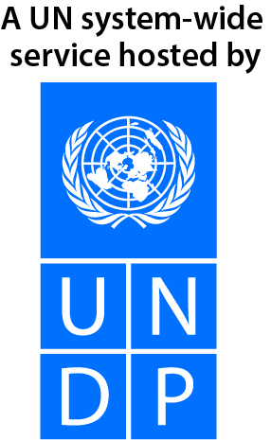
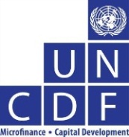


Local Government Initiative on Climate Change (LoGIC)
MPTF OFfice GENERIC ANNUAL programme NARRATIVE progress report
REPORTING PERIOD: 1 january – 31 December 2019
Programme Title & Project Number |  |  | Country, Locality(s), Priority Area(s) / Strategic Results
- Programme Title: Local Government Initiative on Climate Change (LoGIC)  - Project ID/Award ID in ATLAS:  UNDP 00085984 UNCDF 00101390 (EU),  00102142 (SIDA)  - MPTF Office Project Reference Number: 00103800 |  |  | Country/Region: Bangladesh
 |  |  | Priority area/ strategic results: By 2020, relevant state institutions, together with their respective partners, enhance effective management of natural and man-made environment focusing on improved sustainability and increased resilience of vulnerable individuals and groups.
Participating Organization(s) |  |  | Implementing Partners
United Nations Development Programme (UNDP)  United Nations Capital Development Fund (UNCDF) |  |  | Local Government Division, Ministry of Local Government, Rural Development and Co-operatives
Programme/Project Cost (US$) |  |  | Programme Duration
Total approved Prodoc Budget:  MPTF/JP Total Contribution: | 20,000,000  UNDP 4,239,059  UNCDF 3,574,874  Total US$ 7,813,933 |  | Overall Duration (months) | 48
 |  |  | Start Date (dd.mm.yyyy) | 11 May 2017
Agency Core Contribution: | UNDP 200,000  UNCDF 200,000 |  | Original End Date (dd.mm.yyyy) | 30 June 2020
Government Contribution | GoB 729,888 |  | Current End date(dd.mm.yyyy) | 30 June 2020
Other Contribution -EU | UNDP 4,486,996  UNCDF 4,480,973
Programme Assessment/Review/Mid-Term Eval. |  |  | Report Submitted By
Assessment/Review - if applicable please attach  Yes No Date: dd.mm.yyyy  Mid-Term Evaluation Report–if applicable please attach  Yes No Date: dd.mm.yyyy |  |  | - Name: Sudipto Mukerjee  - Title: Resident Representative  - Participating Organization (Lead): UNDP  - Email address: sudipto.mukerjee@undp.org

Acronyms and Abbreviations

AWP Annual Work Plan
BMD Bangladesh Meteorological Department
CCA Climate Change Adaptation
CFF Climate Fiscal Framework
CRA Community Risk Assessments
CRF Community Resilience Fund
CSO Civil Society Organization
DEM Digital Elevation Model
DMC Disaster Management Committee
DPP Development Project Proforma
DRR Disaster Risk Reduction
EU European Union
FYP Five Year Plan
GCF Green Climate Fund
GED General Economics Division
GoB Government of Bangladesh
HHRRAP Household Risk Reduction Action Plan
LCFF Local Climate Fiscal Framework
LDP Local Development Plan
LGD Local Government Division
LGED Local Government Engineering Department
LGI Local Government Institution
LGSP Local Government Strengthening Project
LoGIC Local Government Initiative on Climate change
M&E Monitoring and Evaluation
MIS Management Information System
MoDMR Ministry of Disaster Management and Relief
MOU Memorandum of Understanding
MPTF Multi Partner Trust Fund
NIM National Implementation Modality
NPD National Project Director
PBCRG Performance Based Climate Resilience Grants
PIC Project Implementation Committee
PMU Programme Management Unit
PSC Project Steering Committee
RRAP Risk Reduction Action Plan
SIDA Swedish International Development Cooperation Agency
TBD To Be Determined
ToR Terms of Reference
UNCDF United Nations Capital Development Fund
UNDAF United Nations Development Assistance Framework
UNDP United Nations Development Programme
UP Union Parishad
WARPO Water Resource Planning Organization

Executive Summary
The Local Government Initiative on Climate Change (LoGIC) project has emerged as a system to deliver climate finance to the most vulnerable households (HHs) and to the local government institutions/Union Parishads (UPs). As such, it has established itself with prominent visibility and responsiveness of the central government, particularly at higher levels for more effective buy-in.
Throughout 2019, LoGIC has been successfully transferring climate resilient grants to 71 UPs and 17,000 vulnerable households, through the Performance Based Climate Resilience Grants (PBCRG) and Community Resilience Fund (CRF). The grants helped to implement CCA actions at community and HH levels. Ensuring “whole of society approach” and engagement of UPs with diverse stakeholders in the process of Community Risk Assessment (CRA) and developing risk reduction plans at community level has been a critical success factor towards achieving the notion of “leaving no one behind”. This diverse stakeholder community includes ethnic minority groups, fisherfolks, persons with disability, marginal occupational groups, adolescent mothers etc.
Compared to the first and second year, CRF now demonstrates more structured scheme, with various disbursements and activities pursued, such as stress-tolerant crops to tackle increased salinity. 98% of the CRF beneficiaries were exclusively women. Shared knowledge and top-down approach through providing a “menu” has been proved to be a good idea since there are currently more global picture on climate adaptation. As co-benefit, LoGIC enhanced the financial inclusion of the most vulnerable 17,000 women, who never thought of having access to the formal banking system. It has resulted in enhanced confidence among the women beneficiaries, expressed through their empowerment and internalizing meaningful ways in building resilience.
The PBCRG schemes are now more structured and the results are visible, through the culvert, hydroponics and rainwater harvesting instruments in different areas. The PBCRG support added climate change additionality to the infrastructures so that those can reduce the climate risk at community and household levels. In 2019, 62% schemes were gender responsive and 71% targeted poor and marginalized groups. However, there are rooms for improvements in building technical capacity particularly to support nature-based solution, in order to avoid harming the environment.
For scaling up the LoGIC mechanism, the recent assessment by the European Union (EU) identified three options, which includes (1) reaching all eligible vulnerable groups with different grants packages or reaching the most vulnerable people with common grant package; (2) scaling-up of the most viable climate resilient livelihood options with formal credit market with higher environmental safeguard (i.e. crab fattening); and (3) facilitating private sector actors and co-design business case for scalable business opportunities on climate resilient means of livelihoods, where vulnerable people would secure income, backed-up by skill training and social guarantee.

Purpose

Objectives
The UNDAF and Country Programme Document (CPD) for Bangladesh set one of the outcomes to be " By 2020, relevant state institutions, together with their respective partners, enhance effective management of natural and man-made environment focusing on improved sustainability and increased resilience of vulnerable individuals and groups." In alignment with this outcome, the overall objective of the LoGIC is “Improved and inclusive local level planning, and increased funding for community based CCA-DRR solutions, supported by a strengthened financing mechanism”.

The three key output level results envisaged to be achieved by LoGIC are:
- Strengthened capacity of local governments, households and other local stakeholders to develop local plans that integrate CCA-DRR solutions.
- Established financing mechanism to fund local governments and communities for implementing climate change adaptation measures.
- Experience and evidence inform and contribute to further improvements in policies and practices for UPs and national systems in relation to CCA.

Results
- Key Achievements:
All components of the Local Government Initiative on Climate Change (LoGIC) project became fully operational in 2019. The planned activities made progress and significant initial results were achieved in relation to the expected project outcome of “Improved and inclusive local level planning, and increased funding for community based CCA-DRR solutions, supported by a strengthened financing mechanism”.
Rolling out the LoGIC Model as delivery mechanism: LoGIC has emerged as a system to deliver climate finance to the most vulnerable households and to the local government institutions (Union Parishads). The selection process undertaken to identify the 72 most vulnerable, physically disconnected and hardest-to-reach Union Parishads frequently affected by environmental hazards (particularly cyclone, sea level rise, salinity, flood and flash flood) is justified by the national vulnerability ranking and hard-to-reach areas mapping, and is acknowledged by the government and the other stakeholders in general. The facilitation provided by the project for carrying out the technical and participatory CRA has supported the design of long-term strategic climate actions for the Local Government Institutions (LGIs).
Enhanced the financial inclusion: The direct transfer of grants to the vulnerable institutions for implementing project actions (through PBCRG) and individual households (through CRF) made the process roll. At the same time, the effectiveness of the PBCRG and CRF in curving down the climate vulnerability of the people in high risk areas is yet to be measured. However, as co-benefit, the LoGIC project enhanced the financial inclusion of the most vulnerable 17,000 women, who never thought of having access to the formal banking system. It has resulted in enhanced confidence among the women beneficiaries expressed, through their empowerment and internalizing meaningful ways in building resilience.
Economic and social empowerment: Women are not alone while they implement their adaptive livelihood options, but are in groups with unified business plans to reduce their investment risks. There are 16800 women beneficiaries out of 17000. The CRF beneficiaries formed 1070 groups to start their livelihood options together. This has created enthusiasm among the local stakeholders to engage in the process of resilience building.
Mainstreaming adaptation at the local level: LoGIC, through the CRA process, facilitated the participatory representation of the LGIs and the vulnerable communities. The CRA process helped brainstorming and identifying the risks with a bottom-up approach, which was prioritized while planning and incorporating the long-term strategic plan of the UPs. UPs have received PBCRG grants (amounting to USD 1.79M) for implementing 228 climate change adaptation (CCA) schemes from their RRAP to create climate resilient public goods. 17,000 vulnerable households of the community received USD 4.64M and came up with 22 types of gender-responsive adaptive livelihood options. Both the grants support (PBCRG & CRF) is promoting adaptation actions to reduce the vulnerability to climate change and both followed the community risk assessment methodology. However, such links between households to community level require further strengthening and be informed from science-led predictions and scenarios of climate-induced risks.
Use of innovation for tracking and measuring adaptation: LoGIC demonstrates a comprehensive approach to ensure climate resilience. To keep records, track and measure adaptation, LoGIC has developed and put in place the state-of-the-art Accounting & Management Information Systems (MIS), Adaptation Tracking and Measuring (ATM) system for the project to make sure all the climate funding is spent with rationale, the data is regularly entered and updated in the software which generates reports and tell stories of change in the field. Tapping upon innovation towards maximizing results, project has successfully trained 71 Union Parishads Secretary on Accounting & MIS software. Field level project staffs have been provided hands-on training on filed-level data entry in changing context, future risks, use of grants etc. in the app tab-based ATM software. This approach has started to evolve as a transparent and accountable tool to measure climate change and adaptation data on the ground.
Leaving No One Behind: LoGIC followed participatory approach for developing climate change risk reduction action plan to engaging ethnic minority groups, fisherfolks, Persons with Disability, marginal occupational groups, and adolescent mothers in climate risk assessment and Risk Reduction Action Plan at household and Union Parishad level. In the CRF beneficiary selection the ethnic, marginal e.g. disadvantaged groups were also emphasized and out of 17,000 CRF beneficiaries 14,110 are from the disadvantaged groups.

- Key challenges and mitigation measures:
The key difficulties encountered by the project in the reporting period are bulleted below with mitigating measures:
- During the Executive Committee of National Economic Council (ECNEC) approval of Development Project Proposal (DPP) of LoGIC, the Hon’ble Prime Minister mentioned that the project can contribute to reducing migration of climate vulnerable people through developing improved housing, tree plantation, sanitation etc. It was very difficult to address the observations and revise the activity plan, because as a climate change adaptation project, LoGIC has no specific budget allocation for housing construction.
Measures to overcome: The issue was discussed in the PSC, PIC and with DPs. Following the discussion, a note was prepared and submitted to the Prime Minister’s Office (PMO) through Local Government and Rural Development (LGRD) Minister and Local Government Division (LGD) Secretary. Finally, the Hon’ble PM approved the revised project activity plan. Project will build low-cost climate resilient houses for the prospective migrants following the concept of existing “Ashrayan” and other housing related projects of GoB. LoGIC will explore additional resources for climate resilient housing.
- While government ownership over the project at the local level (district and Upazila level) is impressive, lack of technical guidance and financial support climate change induced risks to ensure quality of the climate schemes selection was compromised.
Measure to overcome: LoGIC planned to organize a workshop on building knowledge and skills on climate change and its induced risks, quality resilience planning and quality assurance of the adaptive actions at the local level.
- Due to country-wide Upazila election, the progress of PBCRG and CRF related activities such as RRAP workshop, scheme selection, bank account opening for HH/UP was delayed.
Measures to overcome: The field activity plan was revised to overcome the gaps and make it manageable.
- The influence and pressure of UP Chairman, UP members and local elites in the CRF beneficiary selection process interrupted the process to some extent.
Measures to overcome: LoGIC engaged the government officials to deal with the local influencers. District officials of the project also initiated rapid discussions with UPs and community people about the unique beneficiary selection process adopted by LoGIC.
- Delay in the CRF beneficiary bank account opening caused by the lack of capacity with Dutch Bangla Bank.
Measures to overcome: Project staff provided extended support on the ground to expedite the process and explored more options for agent banks operational in working area.
- As the UPs are not well-oriented on PBCRG and CRF processes, they faced problems in selecting climate adaptive schemes and ensure preparatory activities. Hence, they could not support enough and provide guidance in facilitating the CRF beneficiary selection process.
Measures to overcome: The project team provided regular supports to the UPs so that they are well acquainted about all the aspects of project activities especially in selecting beneficiaries.

Potential Challenges
- The results and impact of LoGIC depend largely on the utilization of PBCRG by UPs and CRF by the beneficiary households. While many of the schemes and livelihood options respectively taken up by the UP and households are aligned with the CCA, the quality and performance of UPs as well as households in this regard pose both risks and challenges. The limited understanding of CCA both by UPs and HHs poses an important risk to quality implementation of the proposed schemes to achieve expected results and outcomes.
- The timing of grants release can be an issue, which is now tied to the pace of the implementation of last year’s schemes to conduct UP’s performance audit. Since the performance audit results are often delayed, the grants from LoGIC are likely to be made available only at the end of the fiscal year, leaving little time to implement the same within the Fiscal Year.
- Lessons Learned:
Government and Community ownership of LoGIC is high: Government ownership and community engagement in the LoGIC project is high, effective and integrated. Among the most positive elements of the project, the ownership of the government and the engagement of the communities score among the highest. Newly appointed National Programme Director (NPD), the National Focal Point, field-level administrators like Deputy Commissioner, Deputy Director of Local Government (DDLG) and several district-level officials own the project as a core government function. This has been reflected by their acknowledgment and presentation of LoGIC as a government intervention, demonstrating a full buy-in.
Advancements on the Community Resilience Fund (CRF) is higher: Compared to the first and second year, in this year CRF is now a more structured scheme, with various disbursements and activities pursued, such as climate-adaptive crops to tackle increased salinity. Several communities have demonstrated a good understanding of the scheme and some data managing instruments. At the second phase, when the communities will reinvest the money gained, more instability may appear, and this should be monitored to avoid internal tensions. Furthermore, the programme should establish a clearer system to provide inputs from the CRF groups to the PBCRG.
Advancements on the Performance Based Climate Resilient Grants (PBCRG) is there: PBCRG is also relatively higher than last year. The PBCRG is more structured and the results are visible, such as culvert, hydroponics and rainwater harvesting instruments in different areas. However, during the mission undertaken in March 2020 the discussions at the local level were perceived as less structured, and woman were less able to take the floor. Technical capacity should be improved, particularly to support nature-based solution, to avoid harming the environment.
Development versus adaptation interventions need to be considered: There is still an issue regarding the traditional development approach and livelihoods options as opposed to climate adaptation interventions. Due to the importance of having a common understanding with local government authorities about the particular angle of the LoGIC programme, focus from now on, should be given to shared knowledge and perhaps a more top-down approach through providing a “menu”, since we currently have a more global picture on climate adaptation. This should be done allowing the parties to understand the idea underneath, for instance, setting up a “functioning mechanism” that can be scaled up in the future. Such an approach will also help the application to the GCF.
Risks of negative environmental impacts need to be reduced: Many of the CRF beneficiaries have reported they will use the additional funds gathered for sheep, duck or chicken rearing. These activities, despite being economically encouraging, may pose an additional impact on local environment, if the roots of sourcing are not thought properly. LoGIC should think ahead about this forthcoming issue.
Increased inequality by the CRF needs to be considered: There is also a concerning issue about increased inequality by the CRF grants among communities, especially in case the land used for the activities is leased from third parties. In those cases, a loan with limited interest could be more appropriate to decide where to use grant schemes to local authorities.
Complexity of the PBCRG system should be addressed: The selection and decision-making process regarding the second scheme remains more complicated and should be streamlined/simplified. All this, particularly as “political influences” may impact the process while they should not distort the aim of the initiative including the identification of targeted groups.
Selection of PBCRG schemes should be well thought-out: When choosing interventions for the grants, a system to ensure innovation and climate-smart longer-term thinking should be applied, through specific assessments or similar. Nature-based solutions should be kept in mind, avoiding the excessive use of concrete for gray infrastructural works.
Managing Government and beneficiaries expectation on LoGIC needs to be sorted out strategically: The project is not a panacea. It must be commonly understood that the benefit of the project, apart from bringing funding and capacity building to the local authorities, is to have a long-term thinking when it comes to adaptation activities. Additional effort in this view should be put.
Visibility and responsiveness of the Government at central level needs to be strengthening. The project structure remains complex and beneficiaries are not fully aware about who is funding the project. LoGIC is a system that must be emphasized throughout the system, particularly at higher levels for more effective buy-in.
Need to limit the administrative frictions. Ways have to be figured out to avoid bottlenecks such as delays in starting the activities or signing key documents. These delays have already happened in several occasions in the past and should not create frictions in future implementations. The facilitation of NPD with the line Ministries is critical in this regard.
Trickling down issues. The staff at the local level must work more together (Helvetas and UNDP). Apparently, passing through the HQ is a common habit of Helvetas and may slow down implementation, and lead to creating misunderstandings. At the same time, the changes should not hamper the field activities.
Expectations from beneficiaries. Transparency and clarity are needed with an effort to avoid conflicts and tensions within the community. There is also the need to be careful regarding the expectations that is raised around the LoGIC project, acknowledging that not all the potential beneficiaries will be part of it, and pointing out that the system is not a plethora.

- Way Forward
- LoGIC developed a participatory and advanced technology-based vulnerability assessment process (via DEM, Drone, Remote Sensing, Open Street Map) and used a formula-based computerized method (algorithm) for CRF beneficiary selection, which enabled the project to select the most climate-vulnerable households that reduces community grievances significantly. GoB can capitalize such mechanism for other grants and safety-net programs.
- LoGIC facilitated the CRF recipient, i.e. 17,000 vulnerable households to form groups to initiate the alternative livelihoods in group-approach to reduce business risk, skills sharing and gain more profit. Based on homogeneity, geographic proximity and communication, a total of 1,070 CRF beneficiary groups were formed. The group enterprise approach for promoting climate-resilient sustainable livelihood diversification and resilience helped create a climate resilient pathway for the vulnerable households, particularly women.
- To promote financial inclusion of the most vulnerable people through agent banking, LoGIC explored local banking institutions for providing extended banking supports to beneficiaries at the community level. The banking institution, centrally selected so far, is not enough for supporting financial inclusion of large number climate-vulnerable and poor beneficiaries in geographically-remoted areas.
- At present, the project needs to measure the impact of the PBCRG and CRF in reducing the climate change induced vulnerability of the most vulnerable people. When the system is established, it is important that the climate change attribution to the model is strengthened. It is also important that it ensures to proof the model in relation to the reduction of vulnerabilities in the next two years, so that it is scalable to more than 200 climate vulnerable UPs in 2023, with support from Green Climate Fund (GCF), Government of Bangladesh (GoB) and other development partners.

- Risk Management:
# | Risk | Date Identified | Risk Type | Impact &  Probability  (1=low & 5=high) | Countermeasures / Management | Owner | Status
1 | Political unrest that may prevent/delay the implementation of the action. | January 2017 | Political | Delay in initiating planned activities.  P =3  I = 4 | Impact on local level activities will be mitigated through a comprehensive contingency plan. | National Project Director | No change
2 | GoB staff positions related to the project remaining vacant affecting project delivery. Change in LGI political leadership may require additional capacity building and cause delays. | January 2017 | Organizational | Delay in field activities and approval/ transfer of PBCRG/CRF allocation  P =2  I = 3 | Flexibility in the budget for catering to the additional capacity building support in case of change in LGI leadership. | National Project Director | No change
3 | Political influence on geographical targeting of the implementation. | January 2017 | Political | Climate change vulnerable areas may be excluded from project geographical coverage.  P =2, I = 2 | Identify project areas based on agreed selection criteria and endorsement of that by all key parties. | Project Manager | Dead
4 | Reduction in allocations of development funds at the LGIs level. | January 2017 | Financial | Targeted beneficiary couldn’t be reached & project expected result may not be achieved. Engagement of LGIs in project operations may reduce.  P =2, I = 3 | Advocacy at central level as well as close monitoring of the allocation of resources to local government will be in place. | National Project Director | No change
5 | Improvements in Government Public Financial Management (PFM) processes do not take place to the extent expected, affecting the availability of finance at local levels. | January 2017 | Regulatory | Weak management of PBCRG and CRF may increase misuse of funds at LGI level.  P =3, I = 3 | Capacity building support for LGI on government system and financial audits will be undertaken. | National Project Director | No change

- Partnership
A partner NGO with experience of working with Union Parishads has been hired by UNDP under Responsible Party Agreement to implement community level activities of the LoGIC project. It is mainly responsible for capacity development of Union Parishads and beneficiaries’ households. The partner NGO, Helvetas Swiss Intercooperation, comprises of seven (7) project officers at the district level and 142 Community Mobilization Facilitators (CMF) at Union level to ensure the deliverables timely with quality.

The main responsibilities of the NGO are:
- Conducting capacity building activities and facilitating social mobilization of beneficiaries;
- Facilitating Community Risk Assessment (CRA) process and updating Risk Reduction Action Plan (RRAP) at UP and household level;
- Conducting regular visit to the CRF beneficiaries and PBCRG schemes for quality implementation its management functions;
- Supporting the PMU in supervision and monitoring of household and community level climate change adaptation schemes using Adaptation Tracking and Measuring (ATM) system;
- Facilitating advocacy with local administration and local stakeholders in mobilizing local financing for CCA-DRR linked scheme plan and implementation.

LoGIC also engaged Institute of Remote Sensing (IRS) of Jahangirnagar University to do the scientific modelling (Digital elevation) and analysis of risk and vulnerabilities of LoGIC project areas (7 Districts) based on secondary data such as BMD, WARPO, LGED etc. A national level Banking Institution had been contracted to ensure e-transfer of the cash grant (CRF) to the individual bank account of the selected 17000 CRF beneficiaries in 71 Unions of project area.
- Monitoring & Evaluation
Monitoring the PBCRG funded UP schemes and the HH livelihood activities in the remotest areas is a challenge. Therefore, local government division, by using the existing public outreach and the project staff ensures the proper guidance to the monitoring process. Project developed it’s monitoring and evaluation framework including tools and guidelines. The project staff were trained on the project monitoring system.
The training on Adaptation Tracking and Measuring (ATM) software for Community Mobilization Facilitator (CMF) was organized in 7 project Districts. Total 142 CMFs attended the training. The training events were inaugurated by Deputy Director, Local Government (DDLG). The hands-on day long training sessions were very interactive and participatory. All the participants were given TAB to use the ATM software for future data entry.
The training on Accounting and MIS software of LoGIC for the UP Secretary and Community Mobilization Facilitators (CMF) were organized in 7 project Districts. In most cases, the training events were inaugurated by Deputy Commissioner (DC) and chaired by Deputy Director, Local Government (DDLG) of the district administration. A total of 71 UP Secretaries, 142 CMFs, 7 Project Officers of Helvetas, 7 DCCs and 6 DGMFs participated in the training. The training sessions were very interactive and participatory. The UP Secretaries were found interested to use the software. The Accounting and MIS software is being developed in Bangla with an expectation that it would be more understandable and user friendly.

- Cross-cutting issues
LoGIC project has special focus on vulnerability and adaptive capacity to climate change are gendered and consequently to ensure the local development planning process is integrated and strengthened. Project adopted an inclusive approach for all vulnerable and marginalized communities. Also given additional emphasis on women and girls for all the components of the project especially, gender sensitive and inclusive CRF beneficiary selection and priority on women’s issue to select the PBCRG funded UP scheme selection.
LoGIC followed participatory approach for developing climate change risk reduction action plan to engaging ethnic minority groups, fisherfolks, persons with disability, marginal occupational groups, and adolescent mothers in climate risk assessment and Risk Reduction Action Plan at household and Union Parishad level. In the CRF beneficiary selection the ethnic, marginal e.g. disadvantaged groups were also emphasized and out of 17,000 CRF beneficiaries 14,110 are from the disadvantaged groups. LoGIC also focused on marginal groups e.g. blacksmith, potter, weaver, barber, cobbler, behara, washer-folk, swineherd etc. and the households which have person with disability (PWD) as targeting the CRF beneficiaries, reached about 20% of both.
It is documented that women are more disadvantaged than men in terms of their access to assets, credit, employment, and education. Consequently, it is often assumed that female-headed households are poorer than male-headed ones, and are less able to invest in livelihood, health or education of the children. Typically, the group includes widows, divorced and/or single women, abandoned women and women whose husbands have migrated away in search of employment. 98% of these households identified women member of the household as primary participant in the CRF and therefore, 16,660 are women as primary beneficiaries of CRF.
In this year, total 228 UP schemes were implemented with the support of PBCRG. 62% of the schemes are gender responsive and 71% targeted poor and marginalized groups.
LoGIC project developed gender sensitive and inclusive M&E framework to ensure gender disaggregated data collection and measure the progress on gender and inclusiveness in project interventions and results.

- Qualitative assessment
During the reporting period PMU, District Staff and Partner NGO staff visited UP and community to support the ongoing activities. Activity wise monitoring checklists were used to assess the progress of PBCRG schemes implementation and the quality of the capacity development on livelihood options for the CRF beneficiaries.
LoGIC has made partnership with some organizations/institutions to ensure delivery of project interventions and quality of the project results.

- LoGIC Exposure in Media
LoGIC project activities in the district are covered by the local media. The events like Union Inception workshops, District level Inception Workshops, MIS and ATM Training for the Union Parishad Secretaries and the Community Mobilization facilitators (CMFs) etc. came up with the wide presence of the participants and subsequently attracted local media to report on that. The events ensured the mentioning of the partners like European Union, Sida, GoB, UNDP and UNCDF. These events have always been branded with the partners logos. Also, LoGIC shares messages from the events with its Facebook page and its messenger group for sharing information on a regular basis.
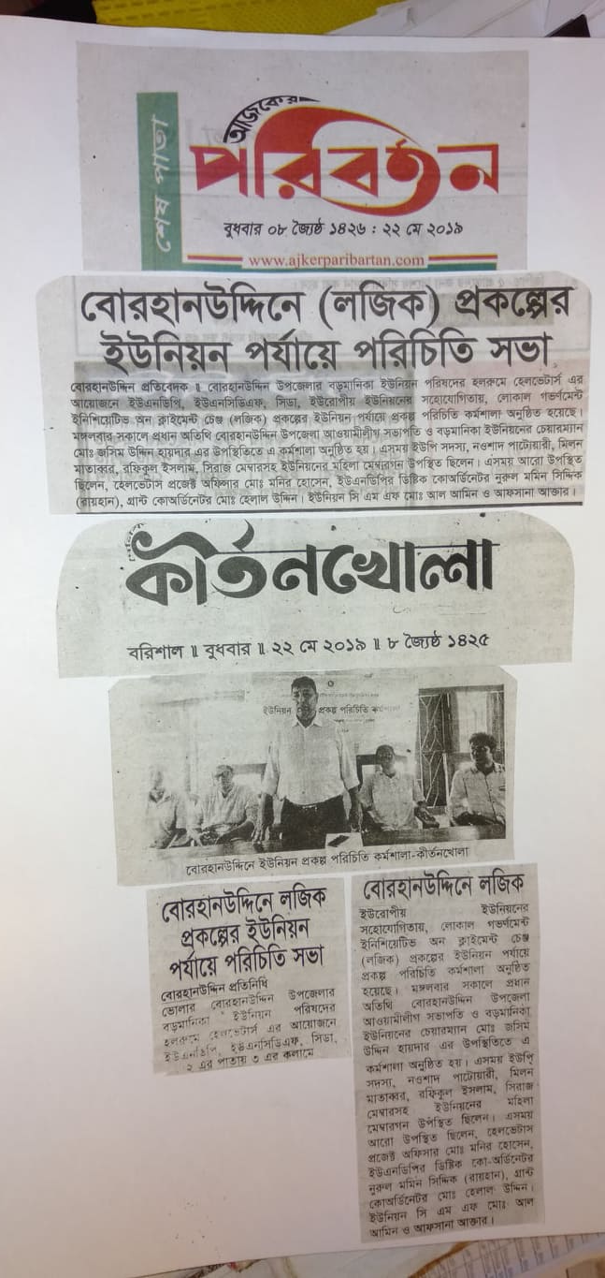
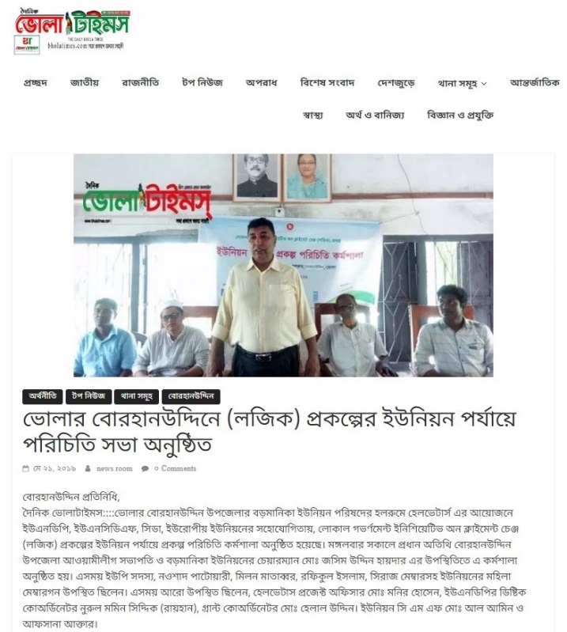
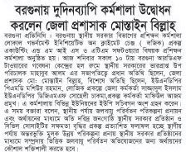
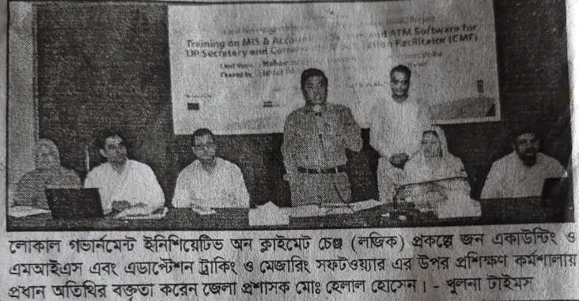
LoGIC project got widely covered by the local newspapers. Presence of District administrators (DC/DDLGs) is vital in promoting LoGIC.

III) Indicator Based Performance Assessment:

 | Achieved Indicator Targets | Reasons for Variance with Planned Target | Source of Verification
Outcome 1  Indicator: % of 72 UPs that have incorporated climate change adaptation actions into their development plans (LDP).  Baseline: 13.9% (Jan, 2018)  Planned Target: 80% (Project Total) | - 99% UPs have incorporated climate change adaptation into their annual development plans through developing Risk Reduction Action Plan (RRAP)  - Whether this integration will continue without LoGIC is yet to understand. | One UP, Moudubi in Patuakhali had no-administrative set up establish by GoB. | Annual Progress Report 2019
Indicator: % of 72 UP plans that have addressed the adaptation needs and priorities of vulnerable women and girls.  Baseline: 6.9% (Jan, 2018)  Planned Target: 50% (Project Total) | - 100% of UPs have prioritized adaptation needs and priorities of vulnerable women and girls.  - However, 98% of the CRF schemes are gender responsive and 60% of the PBCRG are gender responsive.  - More effort is required to make the PBCRG with higher gender marker. | NA | Annual Progress Report 2019
Indicator: % of UP that have established and are implementing the Climate Resilience Financing system.  Baseline: 0% (Jan, 2018)  Planned Target: 80% (Project Total) | - 100% of the UP partially established and implemented the PBCRG (fully from their own financing and accounting system) and CRF with their administrative system (understand the CRF mechanism, fully engaged in the process, redress the grievances mechanisms and aware about the types of work CRF beneficiaries are undertaking in curving down their climate change vulnerabilities).  - Climate Resilience Financing mechanism for CRF is yet to fully establish in the UP system. This requires higher fiduciary risk management and corruption reduction in the selection of beneficiaries. | NA | Annual Progress Report 2019
Indicator: % of 27 UPs that are allocating other resources to implementing CCA linked schemes.  Baseline: 31.9% (Jan, 2018)  Planned Target: 70% (Project Total) | 20% of target UPs that are allocating other funding resources to implementing CCA linked community schemes. | NA | Annual Progress Report 2019
Output 1  Indicator (1): % of women, poor and marginalized people that participate in the formulation of climate risk integrated LDPs  Baseline: 1.3% (Reference: LoGIC Baseline Study 2018)  Target: 52% (Project Total) | Progress: 28% of the poor and vulnerable people (18% women, 3% representative of marginal group, 3% Persons with Disability (PWD) representatives and 4% extreme poor representatives) participated in the RRAP workshop at UP level and Wardshava (LDP formulation meeting).  Analysis: In 2018, CRA was conducted and subsequent RRAPs in 71 UPs have been developed. Following the RRAPs in 2019, LoGIC facilitated LDP discussions at the ward level through Wardshava. Wardshava proposed the specific priority risk reduction schemes of respective wards. This is typically conducted through a meeting with citizens of the Union. A total of 9,849 number of people participated in the Wardshava to develop the risk integrated development plans. | NA | Annual Progress Report 2019
Indicator (2): % of target UPs that integrate CCA solutions into LDPs to support the most vulnerable households.  Baseline: 31.9% (Reference: LoGIC Baseline Study 2018)  Target: 90% (Project Total) | Progress: 99% of targeted UP integrated CCA solutions into LDPs.  Analysis: In 2018, RRAPs were developed in 72 UPs. Based on the RRAPs, in 2019, the 71 UPs planned for 228 CCA linked schemes (76% schemes on climate adaptive infrastructures, 16% on alternative source of safe drinking water, 4% on plantation to reduce carbon emission and 4% on the demonstration of alternative adaptation technology like hydroponics, reverse osmosis, rain water harvesting etc.) to reduce climate risk at community level. 100% of the CCA-linked schemes were identified in the Wardshava. 60% PBCRG schemes were gender responsive and 71% of the schemes benefits poor and marginalized groups. | NA | Annual Progress Report 2019
Output 2  Indicator (1): % of 17000 vulnerable households (women, poor and marginalized) who benefit from CCA finance.  Baseline: 10% (National)  Target: 60% (Project Total) | Progress: 0% (The vulnerable household selection was completed but benefit measurement is not done as it is too early)  Analysis: In 2018, 7928 households (98% women, 20% of marginal group and 19% extreme poor) were selected for the 1st round CRF and they were provided training on alternative livelihood options in 2019. The beneficiary households initiated climate adaptive livelihood with the CRF support and therefore it is too early to understand the benefits at present. | NA | Annual Progress Report 2019
Indicator (2): % of 72 UPs that secure funding to support CCA linked schemes based on their performance.  Baseline: 0% (Reference: LoGIC Baseline Study 2018)  Target: 100% (Project Total) | Progress: 99% of 72 UPs have secured PBCRG funding to support CCA linked schemes based on their performance.  Analysis: There were six (6) minimum conditions for UPs to be eligible for the PBCRG. Accordingly, in 2019 an indicative allocation was given to all UPs for selected schemes. 71 UPs prepared 228 CCA linked schemes based on that allocation and received the PBCRG money. The performance was not considered for the allocation as this was the 1st round of PBCRG. From 2nd round, performance would be a criterion to define the UP-wise PBCRG allocation. | NA | Annual Progress Report 2019
Indicator (3): % of Open Budget sessions in 72 UPs that discussed CCA linked expenditure.  Baseline: 6.9% (Reference: LoGIC Baseline Survey 2018)  Target: 90% (Project Total) | Progress: 99% of Open Budget sessions in 72 UPs that discussed CCA linked expenditure.  Analysis: According the UP Act-2009, all Union Parishads are supposed to organize open budget meeting once in every fiscal year as a step to establish downward accountability. In 2018, open budget meetings were held in all UPs but there were no specific discussions on climate change related budget and expenditures. In 2019, LoGIC facilitated structured discussions on climate change adaptation in the open budget meetings. | NA | Annual Progress Report 2019
Output 3  Indicator (1): The extent to which National Adaptation Plan (NAP) and 7th Five Year Plan (7FYP) integrate financing for local adaptation.  Baseline: 0 (No) (Reference: LoGIC Baseline Study 2018)  Target: Yes (Scale 1-10) (Project Total) | Progress: Progress was not measured in the reporting period. NAP is yet to start by MOEFCC and NDA to GCF for Bangladesh. General Economics Division (GED) is formulating the 8th FYP. Therefore, lessons of the LoGIC need to be shared with GED and NAP team to integrate in both planning. In the mid-term evaluation in 2020 the progress will be assessed. | NA | Annual Progress Report 2019
Indicator (2): The extent to which local climate fiscal framework is integrated into the national Climate Fiscal Framework.  Baseline: 0 (No) (Reference: LoGIC Baseline Study 2018)  Target: Yes (Scale 1-10) (Project Total) | Progress: Local Climate Fiscal Framework (LCFF) draft is developed based on LoGIC experience. In partnership with IBFCR (UNDP funded project implemented by Finance Ministry) working on to develop a Climate Fiscal Framework model. LoGIC has taken effort to ensure a policy provision for LCFF in the revised Climate Fiscal Framework (CFF). Once the LCFF model is recognized National Climate Fiscal framework and tested, LGD with enhanced capacity will be able to scale up it to all vulnerable UPs. | NA | Annual Progress Report 2019

Success stories:

How LoGIC is bringing happiness

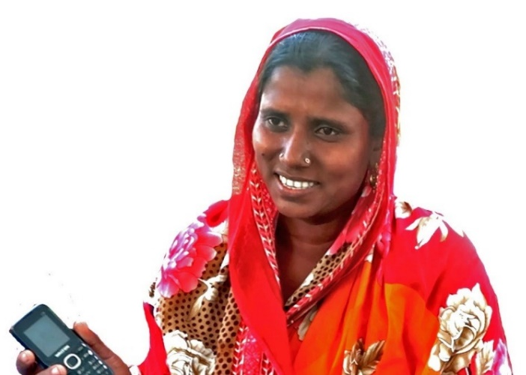
through financing adaptation
When 26-year-old Jahanara Begum, mother of 11-year-old Jahid and his six-year-old sister Mourani, received the text message on her outdated mobile phone, she was preparing lunch for her family of six, including her in-laws. Due to her limited knowledge of English, she could not interpret the message correctly but her grade-4 school education helped her identify the numbers at least.
Jahanara immediately linked the number, BDT 16,800.00 ($210), with a training on sheep-rearing that she received a month back, along with a few other women from her village. She ran to her neighbor, a graduate from Chilmari college, to confirm the message and within minutes went out running through the village path screaming “Teha aise, teha aise” which means, the money has arrived. A woman resident of Notarkandi village beside the mighty river Brahmaputra in Ashtomir char Union of Chilmari Upazila under Kurigram, could hardly imagine having a bank account under her own name let alone receive funding through it. However, the very example of empowerment through this incident cemented her belief and confidence to become self-dependent and worthy of further growth.
Trained by UNDP’s LoGIC project, many more like Jahanara are being empowered in the hardest to reach climate vulnerable areas across the districts of Khulna, Bagerhat, Barguna, Patuakhali, Bhola, Sunamganj and Kurigram. LoGIC under its Community Resilience Fund (CRF) provides grants to those trained women who need it the most. Although, Bangladesh has long been a success story for women’s financial inclusion, where 90% of the 21 million clients served by Micro Financial Institutions (MFIs) are women, a large segment of population is still deprived of the basic financial services in Bangladesh, despite the expansion of the formal bank network. However, this also shows that banks have been unable to reach the unprivileged population, especially in the hardest to reach areas. Jahanara received training on adaptive livelihood options from the LoGIC project along with learning about the various causes of the negative impacts of climate change on livelihood.
Upon confirmation of her selection, she opened her bank account along with other women in her group with support from the project. She also has plans with her peers for sheep rearing as a suitable adaptive livelihood initiative and is eagerly waiting to start their own business. Jahanara Begum is now a proud bank account holder. This is not mere a bank account but an identity for herself – the very first step for her empowerment in the way to be resilient. However, to her disappointment, there are many more women in her village whom she considers are equally vulnerable but have not been selected for the grant yet. To that, LoGIC is on its path towards mobilizing more resources to cover all the vulnerable households to adapt to the adverse effects of climate change through financial empowerment.

Annex-1: Climate Resilience Grants

Community Resilience Fund (CRF) Beneficiary
In the reporting period LoGIC completed 2nd round of CRF beneficiary selection in 38 Unions, a total of 79 Wards were identified as most vulnerable based on climate vulnerability, Digital Elevation Model (DEM), poverty rate, housing status and employment scopes. The whole CRF beneficiary selection process was technology based, comprehensive and participatory. The selection criteria were- poverty, exposure to climate variability and extremes, sensitivity of the households to climate variability and extremes and adaptive capacity of the households. Based on the criteria total 10,488 most climate vulnerable households were primarily selected. According the LoGIC grievance redress guidelines the primarily selected household lists were hanged for 7 days at different places of ward and shared with UP Chairman, Members and Secretary. The Community Mobilization Facilitators (Union level staff of Partner NGO) also visited physically all the primarily selected households to collect and revise necessary information. At the end of process 9,072 vulnerable households were finally selected.
The core process of the selection of vulnerable households include:
- CRA and RRAP,
- based on CRA, identification of two/three vulnerable wards from each UP,
- conducting the census in these 147 wards,
- identifying eligible beneficiaries (46,000) by minimum 0.5 vulnerability scores,
- selection of relatively most vulnerable (26,000) households, with a primary shortlist (17000) and a waiting list (9000 HHs),
- run a grievance register and redress mechanism and
- finalize the 17000 HHs as final beneficiaries for the CRF.

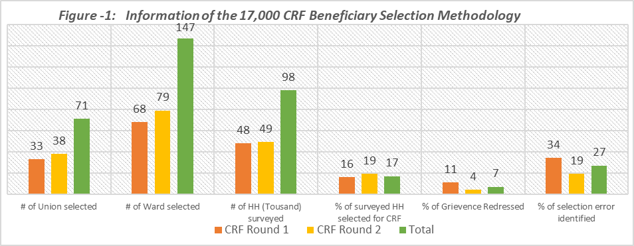

In Figure 1, data show that in 1st and 2nd round LoGIC has covered 71 Unions for CRF beneficiary. Out of total 648 wards 147 have been reached and in the selected 147 wards total 98115 households have been surveyed. Only 17% of the total surveyed households are selected as CRF beneficiaries. The community grievance has been significantly reduced 11% to 4% because of involvement of LGI, strong follow up & quality assurance in data collection and using computerized formula-based mechanism. The errors in data accuracy and authenticity was also less than 1st round.
Figure 2: CRF beneficiary profile
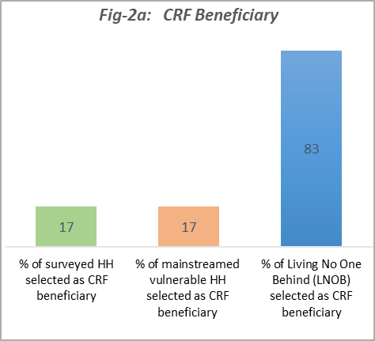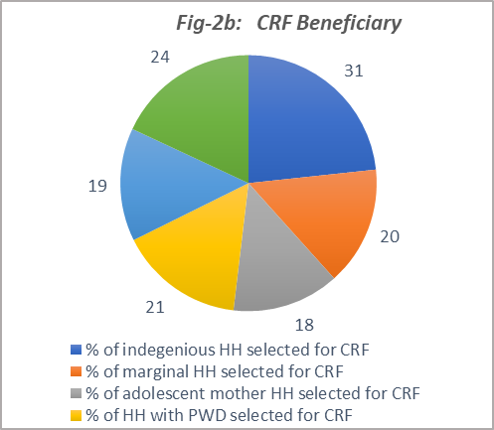

48%
38%
7%
38%
9%
27%
7%
2%
11%
1%
0%
0.50%
2%
1%
2%
1.50%
0.50%
2%
0.50%
0.50%
1%
Functionally Women Headed
Structurally Women Headed
Functionally Male Headed
Fig- 2c: CRF Beneficiary HHs
No. of HHs
Mainstream
Religious Minority
Ethnic Minority
HHs with PWDs
HHs with Adolescent Mothers
HHs from Dalits

LNOB: Indigenous, marginal, adolescent mother, PWD, safety-net recipient, HH living outside dam.

In the figure-2a, 2b and 2c data shows that LoGIC selected total 147 wards in 71 Unions for CRF beneficiary selection. In the selected 147 wards total 9,8115 households were surveyed and 17% (17000 HH) of the surveyed households were selected as CRF beneficiaries. Among the 17% selected households 17% are mainstreamed vulnerable households and the rest of 83% are the people beyond the mainstream. In LoGIC working area there are a number of ethnic minority group such as Munda, Mahato, Rakhaine who are more climate vulnerable than mainstreamed people. In 1st round 9% of the indigenous groups were covered but in 2nd round it was significantly increased to 42%. c The households who live outside the dam or embankment are most climate vulnerable due to high exposure and sensitivity to climate variability and extremes. However, LoGIC could provide CRF support only 24% of them. About 25000 (76%) households who live outside dam are beyond the support. It is documented that women are more disadvantaged than men in terms of their access to assets, credit, employment, and education. Consequently, it is often assumed that female-headed households are poorer than male-headed ones, and are less able to invest in livelihood, health or education of the children. Typically, the group includes widows, divorced and/or single women, abandoned women and women whose husbands have migrated away in search of employment.
98% of these HHs identified women member of the household as primary participant in the CRF and therefore, 16,660 are women as primary beneficiaries of CRF. These beneficiaries are pursuing 22 different types of climate resilient livelihoods in group enterprises, as a follow-up of the choices of the means of livelihoods and start-up grant support from the project in two tranches. There are three options to scale-up these livelihoods:
(1) reaching to all eligible vulnerable groups (46,000 HHs) with different grants packages or reaching to all most vulnerable people (26,000 HHs) with common grant package;
(2) scale-up of the most viable climate resilient livelihood options with formal credit market with higher environmental safeguard (i.e. crab fattening); and
(3) facilitate private sector actors and co-design business case for scalable business opportunities on climate resilient means of livelihoods where vulnerable people secured income with backed-up skill training and social guarantee. A few examples include hydroponics, bio-flake, aquaponics, sunflower, crab-fattening, saline tolerant pulse, fruits and oil seeds production.

Performance Based Climate Resilience Grant (PBCRG) Schemes:
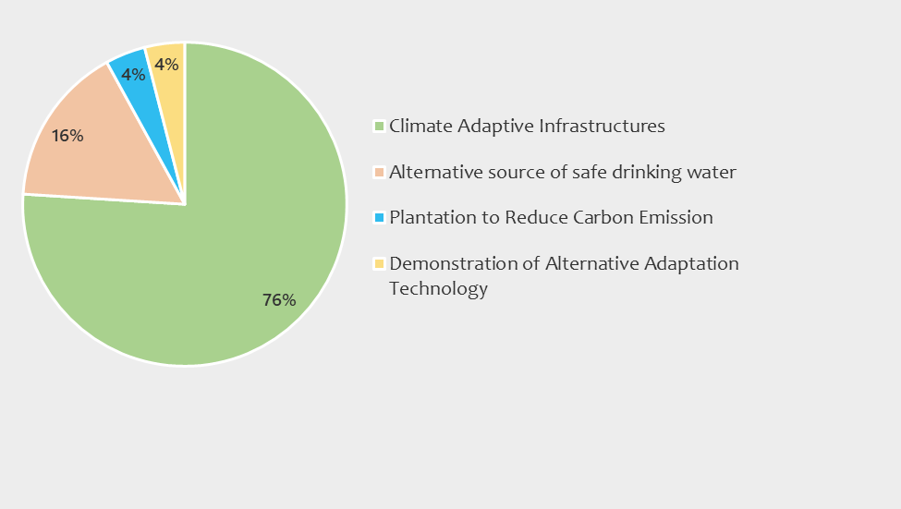
To mainstream climate change adaptation actions into development plans of Union Parishads and improve the climate change responsiveness of public goods LoGIC provided PBCRG to 71 Union Parishad in FY 2018-19. A total of 228 schemes had been finalized in 71 Unions with the support of PBCRG 2018-19. The schemes were selected from the CRA report followed by RRAP at Union Parishad level. Earlier, UP identified the schemes and discussed at Wardshava. The schemes were selected considering the local climate change context, hazard and livelihoods of the vulnerable poor. Following graph illustrates the PBCRG funded Schemes by in FY 2018-19:
Figure 3: PBCRG scheme typology

In the first round of PBCRG, the stake was for climate adaptive infrastructures which mainly included reconstruction of dam/embankment, guide wall, elevation of roads, u-drain, culvert etc. The PBCRG support added climate change additionality to the infrastructures so that those can reduce the climate risk at community and household levels. Out of 228, 174 are such schemes. Alternative source of drinking water was one of the focus issues for identifying the schemes in Khulna and Bagerhat Districts. But in that case, challenges, among many, were to define appropriate technology and prepare design and estimation. Most of the Upazila Engineers who provide support to prepare and approve the design are not well aware about the climate adaptation. Here, the demand on capacity building of the engineers were also identified. However, there are some innovations like hydroponics and Reverse Osmosis (RO) which are promoted through PBCRG but as UPs are not familiar with them, they remained less motivated.

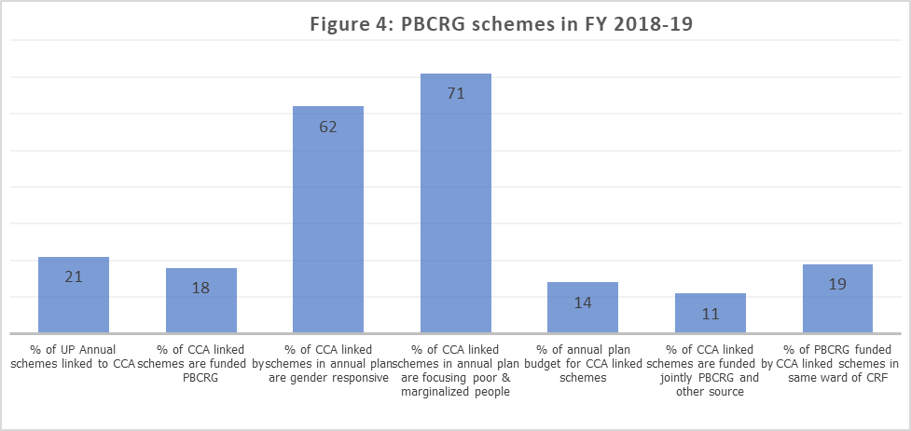

According the UP MIS report, there are total 5930 schemes in FY 2018-19 Annual Development Plan of 71 UPs but 21% of them are only climate change adaptation (CCA) linked and of which 18% are PBCRG funded. So, UPs are still focused on development schemes and for climate change schemes depend on PBCRG. Very few UPs mobilized money from other sources to implement climate change adaptation actions. In this year, 62% schemes are gender responsive and 71% targeted poor and marginalized groups. The budget of the CCA linked schemes were not bigger, on an average it was USD 9500 of each. Small budgeted schemes are less likely to create expected impact on climate adaptation.

The term “programme” is used for programmes, joint programmes and projects.
Strategic Results, as formulated in the Strategic UN Planning Framework (e.g. UNDAF) or project document;
The MPTF Office Project Reference Number is the same number as the one on the Notification message. It is also referred to as “Project ID” on the project’s factsheet page the MPTF Office GATEWAY
The start date is the date of the first transfer of the funds from the MPTF Office as Administrative Agent. Transfer date is available on the MPTF Office GATEWAY
As per approval of the original project document by the relevant decision-making body/Steering Committee.
If there has been an extension, then the revised, approved end date should be reflected here. If there has been no extension approved, then the current end date is the same as the original end date. The end date is the same as the operational closure date which is when all activities for which a Participating Organization is responsible under an approved MPTF / JP have been completed. As per the MOU, agencies are to notify the MPTF Office when a programme completes its operational activities.
Note: Outcomes, outputs, indicators and targets should be as outlined in the Project Document so that you report on your actual achievements against planned targets. Add rows as required for Outcome 2, 3 etc.
Poor who are economically unable to enjoy the minimum standard of living. Vulnerable means who (irrespectively poor and non-poor) are at risk due to climate change.
One UP, Moudubi in Patuakhali had no-administrative set up establish by GoB.
One UP, Moudubi in Patuakhali did not receive the PBCRG in 2019 due to administrative reason (no-administrative set up establish by GoB) but will receive in 2020 and 2021.
A detailed vulnerability score matrix is attached as Annex-3
Last tranche of 9072 beneficiaries are due in June 2020.

