RUNO Half Yearly Reporting TEMPLATE 4.3
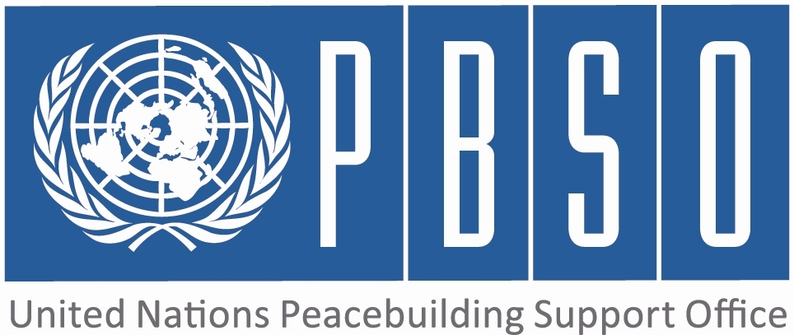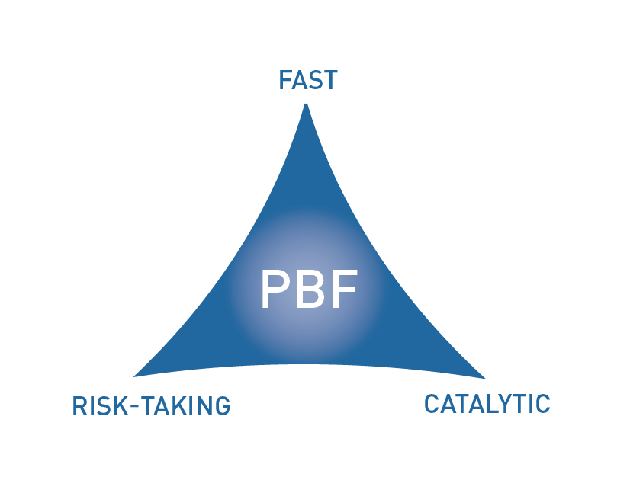
[COUNTRY: Papua New Guinea]

PROJECT HALF YEARLY PROGRESS UPDATE

PERIOD COVERED: JANUARY – JUNE 2016

Project No & Title: | PBF/Strenthening partnership and the political dialogue between GoPNG and ABG
Recipient Organization(s): | UNDP
Implementing Partners (Government, UN agencies, NGOs etc): | Autonomous Bougainville Government, Government of Papua New Guinea and other partners.
Total Approved Budget : | USD 2,500,000(Budget 2016 - $860,000)
Preliminary data on funds committed : | US$310,670 | % of funds committed / total approved budget: | 36%
Expenditure: | US$364,557 | % of expenditure / total budget: (Delivery rate) | 52%
Project Approval Date: | June 2015 | Possible delay in operational closure date (Number of months)
Project Start Date: | Aug 2015
Expected Operational Project Closure Date: | Aug 2018
Project Outcomes: | 1. The key Bougainville Peace Agreement (BPA) provisions on autonomy and on the referendum are progressed through joint decisions and actions of the PNG Government and the ABG.  2. The national and the Bougainville Parliaments have a shared understanding of the BPA and the referendum provisions and the effectiveness of the Bougainville Parliament is strengthened inline with the 2013 Autonomy Review Findings.
PBF Focus Area  (select one of the Focus Areas listed below) | 2.2 Democratic Governance

Qualitative assessment of progress

For each intended outcome, provide evidence of progress during the reporting period.  In addition, for each outcome include the outputs achieved.  (1000 characters max per outcome.) | Outcome 1:  This Outcome is aimed at progressing the key provisions of the BPA, namely the autonomous arrangements and the referendum preparations by the two governments reaching joint decisions and actions. Through UNDP a referendum expert and the Peace & Development Advisor were recruited to support this processes. Despite delays in the Joint Supervisory Body (JSB) meeting taking place on agreed dates, there has been some “positive” developments in the months of April – May within this reporting period. UNDP supported the convening of a special meeting of the Joint Referendum Committee (JRC) in Port Moresby from 19-20 April. This meeting was significant as it discussed and agreed on the key actions to progress the referendum preparations. This was a milestone that helped push for the 20 May meeting of the JSB. During this meeting the leaders of both governments endorsed the Joint Referendum Workplan of the Joint Technical Team (JTT) and proposed the referendum target date as 15 June 2019.  Outcome 2:  This Outcome is aimed at supporting the understanding of the national and the Bougainville Parliaments to progress the BPA and the referendum provisions as well as their capacity to implement the findings of the 2013 Autonomy Review. UNDP successfully delivered a parliamentary induction workshop which took place in Buka from 30th March to 1st of April this year. This was a milestone towards preparing the members of Parliament to be the agents of peacebuilding in their constituencies. These parliamentarians will become the champions of peace once they start educating their constituencies on the BPA and the referendum. Preparations have started for UNDP to support Parliamentarians to conduct awareness on the BPA and the referendum and disseminate key joint messages in their constituencies. The Parliamentary ICT support is being implemented well on schedule and the procurement processes have been completed.  Outcome 3:  Outcome 4:
Do you see evidence that the project is having a positive impact on peacebuilding?  (1000 characters max.) | The project is political in nature and addresses key sensitive issues that have never been given much attention given the lack of mutual understanding between both governments about their roles and responsibilities and the numerous challenges of the UN and other partners in dialogue facilitation. Overall, since the engagement of the Referendum Expert as of March, there has been significant progress. The special extraordinary meeting of the Joint Referendum committee (JRC) 19-20 April extended to 21-22 April produced some positive outcomes that have significantly advanced the referendum planning. The adoption of a proper strategy by the project team to facilitate meetings with stakeholders in Buka and Port Moresby hugely influenced the convening of the JSB in POM on Friday 20 May to progress the referendum workplan and agree on some of the key decisions relating to the referendum date, establishment of the independent authority, the autonomy review 2016 and awareness raising issues
Were there catalytic effects from the project in the period reported, including additional funding commitments or unleashing/ unblocking of any peace relevant processes?  (1000 characters max.) | There is a positive shift in momentum since April this year. What could have been a long wait for the JSB to progress key issues relating to the referedum was made a lot more easier when the Joint Referendum Committee meeting took place in Port Moresby from the 19-20 of April. This led to a joint approach in developing the workplan which captures the nine critical components; electoral, weapons disposal, goood governance assessment, civic education (awareness), consultation and dialogue between governments, process for determining referendum questions, determining enrolment for BOBs, and peace and security. It was catalytic in nature because it was termed as the Special Extra-Ordinary Joint Referendum Committee Meeting. NCoBA has taken a significant role in facilitating this round table meeting and it was agreed they will be reoriented to play the effective cordination roles for the referendum. A joint government request has been made to UN to support referendum and weapons disposal.
If progress has been slow or inadequate, provide main reasons and what is being done to address them.  (1000 characters max.) | The Joint Supervisory Body (JSB) is the bilateral engagement between the two governments specifically on issues that are political in nature. The JSB endorses political obligation and commitments that are paramount to the BPA. Since December 2015, this meeting has been continuously postponed in the interest of GoPNG and due to tensions culminating over so many issues but one which seemed to have stood out was the lack of payment of Restoration and Development Grants (RDG) a commitment in the BPA. To address all these, UNDP and DPA continue to work from both fronts through meetings, dialogues and sensitization on matters significant to the BPA. This saw a Joint Referendum Committee meeting in April, where there was political representation from both the national Government and ABG. A way forward engaging an independent entity for interpretation of the RDG formula has now been agreed by both governments at the JSB of 20 May. During this period of work, some funding will be given to ABG.
What are the main activities/expected results for the rest of the year?  (1000 characters max.) | The main activities that are planned for the next six months are completion of ICT installation for the BHOR and the referendum bipartisan committee to meet in June/July. In addition to this, there will be continuous dialogue between both governments through the two chief secretaries, to progress May 20 JSB decisions. With the engagement of the new Project Officers, it is envisaged that a multidimensional approach will be taken to work with the ABG and national government to progress the 2016 review of autonomy arrangements, continue support to the implementation of the joint referendum work plan which has now been finalized and also to support BHOR Parliamentarians who participated in the parliamentary induction to conduct regular community outreach programmes in their respective constituencies on the BPA and the referendum. There will also be further training for parliamentarians in computing and other related disciplines to strengthen their capacities both within and abroad.
Is there any need to adjust project strategies/ duration/budget etc.?  (1000 characters max.) | At this stage there is a need to focus more on sensitizing the GoPNG and the national parliament on the importance of the BPA and its implementation to foster peace. Currently, much work has focused on Bougainville which has been relatively positive in terms of mobilization and unification of factions. There is however, a need to focus more strongly on unification in Bougainville and to include this work in the project framework. There is also need to strategically focus on key stakeholders at the national government level in an inclusive way for sustainable peace. It is important that national government understands the implications of some of their actions and its effect on continued peace and stability in Bougainville. GoPNG must endeavor to coherently and consistently deal with challenges by adopting an inclusive approach and better understanding their roles and responsibilities towards meeting their commitments in the BPA implementation. The trend is now positive after the JSB
What is the project budget expenditure to date (percentage of allocated project budget expensed by the date of the report) – preliminary figures only?  (1000 characters max.) | Overall the % of delivery in comparison with expenditure over allocated budget is 28%. In contrast to this, the delivery rate per annual budget allocation is 52% according to the workplan. Clearly this is an indication that despite the slow start of implementation, catalytic innovations based on sound political situational analysis has contributed positively in changing the project output and impact over the last two months. Things are expected to move well in referendum decision making that will be led by the two chief secretaries and NCOBA
Any other information that the project needs to convey to PBSO (and JSC) at this stage?  (1500 characters max.) | The JSB meeting has now set the platform for implementation of the projects in the Priority Plan. The upcoming JSC will provide strategic advice and guidance as to project next steps in the light of the request for referendum preparation and weapons disposal assistance request received from both GoPNG and ABG. A risk assessment will be done from time to time to gauge potential risk elements and how they can be tackled.

INDICATOR BASED PERFORMANCE ASSESSMENT: Using the Project Results Framework as per the approved project document- provide an update on the achievement of key indicators at both the outcome and output level in the table below. Where it has not been possible to collect data on indicators, state this and provide any explanation in the qualitative text above. (250 characters max per entry)

 | Performance Indicators | Indicator Baseline | End of project Indicator Target | Current indicator progress | Reasons for Variance/ Delay  (if any) | Adjustment of target (if any)
Outcome 1  The key Bougainville Peace Agreement (BPA) provisions on autonomy arrangements and on the referendum are progressed through joint decisions and actions of the PNG Government and the ABG. | Indicator 1.1  Level of progress in Autonomy arrangements implementation since 2013 Autonomy Review | Autonomy review 2015 | Tangible improvements with regards to 2013 Autonomy Review | ABG/GoPNG has requested UN's support to commence the review | The delay and postponement of the Joint Supervisory Body Meetings (JSB). | A target should also cover the powers and functions that have been drawn down and whether they are functional.
 | Indicator 1.2  Evidence of joint decision by two Government on date and options for referendum. | No joint decision between both governments. | Date, options, eligibility, independent body, civic awareness content. | JRC met to develop a joint referedum workplan now approved by the JSB. | The delay and postponement of the Joint Supervisory Body Meetings (JSB) | Not necessary at this stage targets are progressing
 | Indicator 1.3  Increase in funds and timely release of funds by GoPNG and ABG. | First K100 million of RDP released | No funds released | JSB meeting was a positive indication that some funds will be released to ABG whilst the RDG formula is being sorted out | The delay and postponement of the Joint Supervisory Body Meetings (JSB) | No need for adjustment of target at this stage
Output 1.1  Existence and effective use of dialogue fora for GoPNG and ABG to discuss BPA provisions and resolve bottlenecks and to communicate with the Bougainville population. | Indicator 1.1.1  Frequency of JTT Roundtable meetings. | Met once in December 2015 | JSB resolutions | JTT Resolutions of its meeting held in POM on Thursday 19 May 2016 | The delay and postponement of the Joint Supervisory Body Meetings (JSB) | No adjustment required at this stage
 | Indicator 1.1.2  Frequency of JSB meetings and recommendations with regards to autonomy arrangements and referendum | JSB meets on an ad hoc basis and does not always make decisions | JSB Minutes | JSB met in POM on Friday 20 May 2016 with very fruitful outcomes | The delay and postponement of the Joint Supervisory Body Meetings (JSB) | No adjustment required at this stage target on course
Output 1.2  Progress on implementation of key BPA provisions regarding autonomy arrangements and preparations for the referendum. | Indicator 1.2.1  Level of progress on Joint Refendum Workplan. | No workplan | A joint referendum workplan now in place and approved by the JSB | A joint referendum workplan now developed and sub-committees been set up for its implementation | Delay and postponement of the JSB meetings. | Target on course no adjustment required at this stage
 | Indicator 1.2.2  Timeliness and quality of 2015 Autonomy Review | No review | 2016 Autonomy Review | JSB approval sought for commencement of 2016 review of autonomy arrangements | Delay and postponement of the JSB meetings. | Target on course no adjustment required at this stage
Output 1.3 | Indicator 1.3.1
Output 1.3 | Indicator 1.3.2
Outcome 2  The national and Bougainville Parliaments have a shared understanding of the BPA and the Referendum provisions and the effectiveness of the Bougainville Parliament is strengthened, in line with the 2013 Autonomy Review findings. | Indicator 2.1  Level of Bougainville parliament capacity to perform its role effectively | Autonomy 2013 found important gaps. | Improvements in effectiveness and transparency of proceedings. | Parliamentary Induction Workshop and ICT support for outreach to constituents | There was a slight delay in implementation of this activity due to project start up arrangments | Target on course and no adjustment requred at this stage
 | Indicator 2.2  Existence of joint statements between two Parliaments on BPA | No such joint statements. | Statements made public and show shared understanding of the BPA. | JRC, JTT and JSB meetings of of 19/20 Arpil and 19/20 May respectively. Agreement that the referendum will be conducted by an independent agency in 2019 | Delay and postponement of the JSB meetings | Target on course and no need for adjustment at this stage
Output 2.1  Strengthened capacity of the Bougainville Parliament to fulfill its functions under the Autonomy Arrangements and the good governance provisions of the BPA. | Indicator 2.1.1  Bougainville Parliament's Website operational with the information on peace and development, BPA, human rights and gender. | No library or information services exist | Website and hansard in place with useful information on key peacebuilding information and regular updates. | Complete procurement process and contracting of local IT company to proceed with installation.Website to be developed and hansard installed | Procurement processes could take time to source reliable equipment that reflects value for money | Target on course and no adjustment required at this stage
 | Indicator 2.1.2  Level of awareness by Bougainville MPS. | To be determined by a survey | Improvement by at least 50% | Induction training conducted in March/April and a whole session committed to referendum at least 80% understanding | Delayed by a week due to some unforseen commitment on the part of ABG and national government | Target on course and no need for adjustment
Output 2.2 | Indicator 2.2.1
Output 2.2 | Indicator 2.2.2
Output 2.3 | Indicator 2.3.1
Output 2.3 | Indicator 2.3.2
Outcome 3 | Indicator 3.1
Outcome 3 | Indicator 3.2
Output 3.1 | Indicator 3.1.1
Output 3.1 | Indicator 3.1.2
Output 3.2 | Indicator 3.2.1
Output 3.2 | Indicator 3.2.2
Output 3.3 | Indicator 3.3.1
Output 3.3 | Indicator 3.3.2
Outcome 4 | Indicator 4.1
Outcome 4 | Indicator 4.2
Output 4.1 | Indicator 4.1.1
Output 4.1 | Indicator 4.1.2
Output 4.2 | Indicator 4.2.1
Output 4.2 | Indicator 4.2.2
Output 4.3 | Indicator 4.3.1
Output 4.3 | Indicator 4.3.2

Please note that where there are multiple agencies, only one consolidated project report should be submitted.
Approved budget is the amount transferred to Recipient Organisations.
Funds committed are defined as the commitments made through legal contracts for services and works according to the financial regulations and procedures of the Recipient Organisations. Provide preliminary data only. 4 Actual payments (contracts, services, works) made on commitments. 5 PBF focus areas are: PBF Focus Areas are: 1: Support the implementation of peace agreements and political dialogue (Priority Area 1): (1.1) SSR, (1.2) RoL; (1.3) DDR; (1.4) Political Dialogue; 2: Promote coexistence and peaceful resolution of conflicts (Priority Area 2): (2.1) National reconciliation; (2.2) Democratic Governance; (2.3) Conflict prevention/management; 3:Revitalise the economy and generate immediate peace dividends (Priority Area 3); (3.1) Employment; (3.2) Equitable access to social services 4) (Re)-establish essential administrative services (Priority Area 4) (4.1) Strengthening of essential national state capacity; (4.2) extension of state authority/local administration; (4.3) Governance of peacebuilding resources (including JSC/ PBF Secretariats)

