RUNO END PF PROJECT REPORTING TEMPLATE 4.5
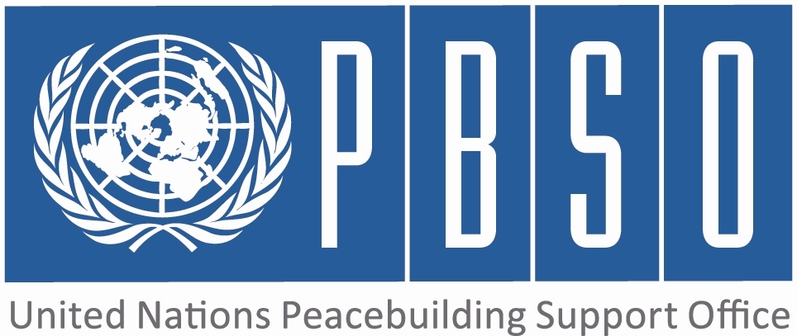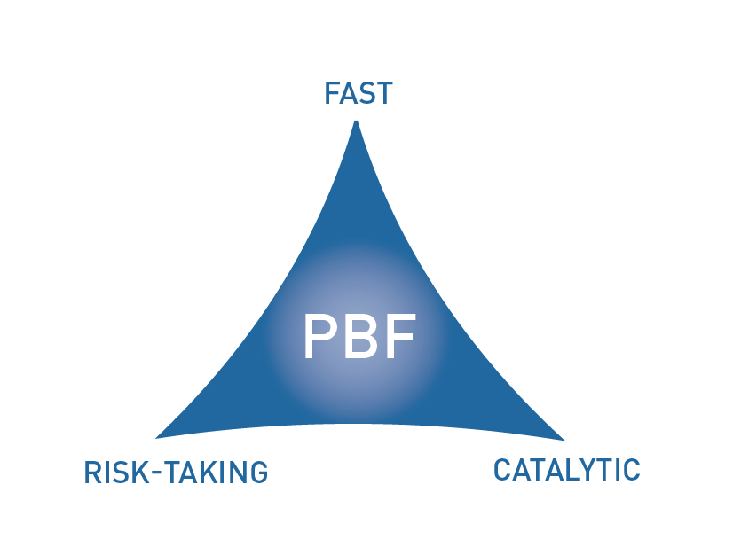

PEACEBUILDING FUND (PBF)
END OF PROJECT report
COUNTRY: Guinea Bissau
REPORTING PERIOD: 2013

Programme Title & Project Number
Programme Title: Guinea-Bissau National PBF Secretariat Support 2012-2013
Programme Number (if applicable) 00062527
MPTF Office Project Reference Number: 00072056

Recipient UN Organizations |  |  | Implementing Partners
List the organizations that have received direct funding from the MPTF Office under this programme: UNDP |  |  | List the national counterparts (government, private, NGOs & others) and other International Organizations:
Programme/Project Budget (US$) |  |  | Programme Duration
PBF contribution (by RUNO) 531,347 US$ (last contribution of 09Dec11) |  |  | Overall Duration (months) 36
 |  |  | Start Date (dd.mm.yyyy) 09/12/2011
Government Contribution  (if applicable) |  |  | Original End Date (dd.mm.yyyy) | 31/12/2013
Other Contributions (donors)  (if applicable) |  |  | Final End date(dd.mm.yyyy)
TOTAL: | 962,909 US$ (cumulative)

Programme Assessment/Review/Mid-Term Eval. |  | Report Submitted By
Mid-Term Evaluation / Review - if applicable please attach  Yes No Date:  End of project Evaluation– if applicable please attach  Yes No Date: |  | Name: Janet murdock  Title: PBF Coordinator  Participating Organization (Lead): UNDP  Email address: janet.murdock@one.un.org

PART 1 – RESULTS PROGRESS

  - Assessment of the project implementation status and results

For PRF projects, please identify Priority Plan outcome and indicators to which this project has contributed:
Priority Plan Outcome to which the project has contributed. PBF funds managed transparently, strategically, cost-effectively and catalytically maximizing PB opportunities.
Priority Plan Outcome indicator(s) to which project has contributed.

For both IRF and PRF projects, please rate this project’s overall achievement of results to date:

For both IRF and PRF projects, outline progress against each project outcome, using the format below. The space in the template allows for up to four project outcomes.

Outcome Statement 1: PBF funds managed transparently, strategically, cost-effectively and catalytically maximizing PB opportunities.

Rate the current status of the outcome:
Indicator 1:  Number of NSC decisions in line with PB Strategic Framework and PBF ToRs  Indicator 2:  Indicator 3: | Baseline:  Target:  Progress:NA  Baseline:  Target:  Progress:  Baseline:  Target:  Progress:

Output progress at the end of project

List the key outputs achieved under this Outcome (1000 character limit).Outputs are the immediate deliverables for a project.
The political developments of 2012 had posed an unprecedented set of challenges for the PBF as well as for implementing partners on the ground. Following the coup of 12 April, the PBF, along with other international partners, suspended funding for GB, with the exception of the Secretariat which was requested to provide bi-weekly political analyses that would help inform the work of the PBC and affect PBF programmatic decisions. As a result, the Secretariat saw its role and function fundamentally transformed and therefore its activity for much of 2012 focused mainly on three objectives: providing bi-weekly political analyses; exercising an oversight role (on behalf of the suspended JSC) and facilitating the reallocation of funding in select cases (see FAO story below); leading an ongoing in-house review process of the PBF portfolio reflecting the rapidly evolving political situation. In 2013, access to the IRF window allowed for the implementation of 7 IRF projects.

Outcome progress at the end of project

Describe progress made toward the achievement of this outcome. This analysis should reflect the above indicator progress and the output achievement. Is there evidence of the outcome contributing to peacebuilding and to the specific conflict triggers (3000 character limit)?
The political developments of 2012 had forced the PBF Secretariat to rethink its role from supporting the JSC to ensuring the transparent and accountable management of suspended PBF programs, the timely provision of information to PBSO (and other UN bodies, notably the Security Council and the PBC), and the development of proposals for the strategic repositioning of the PBF in GB when the freeze is lifted. The PBF Secretariat provided guidance to RUNOs during the development of IRF projects development.

Reasons for low achievement and rectifying measures

If sufficient progress was not made, what were the key reasons, bottlenecks and challenges? Were these foreseen in the risk matrix? How were they addressed (1500 character limit)?
On the aftermath of the 12 April coup, the PBF along with other national partners suspended funding on the basis that the ‘de facto’ authorities lacked a demonstrable commitment to peacebuilding. The second PBF PRF allocation of 10MUSD was then suspended and the role of the Secretariat had to changed as informed above,

Outcome Statement 2:

Rate the current status of the outcome:
Indicator 1:  Indicator 2:  Indicator 3: | Baseline:  Target:  Progress:  Baseline:  Target:  Progress:  Baseline:  Target:  Progress:

Output progress at the end of project

List the key outputs achieved under this Outcome (1000 character limit).Outputs are the immediate deliverables for a project.

Outcome progress at the end of project

Describe progress made toward the achievement of this outcome. This analysis should reflect the above indicator progress and the output achievement. Is there evidence of the outcome contributing to peacebuilding and to the specific conflict triggers (3000 character limit)?

Reasons for low achievement and rectifying measures

If sufficient progress was not made, what were the key reasons, bottlenecks and challenges? Were these foreseen in the risk matrix? How were they addressed (1500 character limit)?

Outcome Statement 3:

Rate the current status of the outcome:
Indicator 1:  Indicator 2:  Indicator 3: | Baseline:  Target:  Progress:  Baseline:  Target:  Progress:  Baseline:  Target:  Progress:

Output progress at the end of project

List the key outputs achieved under this Outcome (1000 character limit).Outputs are the immediate deliverables for a project.

Outcome progress at the end of project

Describe progress made toward the achievement of this outcome. This analysis should reflect the above indicator progress and the output achievement. Is there evidence of the outcome contributing to peacebuilding and to the specific conflict triggers (3000 character limit)?

Reasons for low achievement and rectifying measures

If sufficient progress was not made, what were the key reasons, bottlenecks and challenges? Were these foreseen in the risk matrix? How were they addressed (1500 character limit)?

Outcome Statement 4:

Rate the current status of the outcome:
Indicator 1:  Indicator 2:  Indicator 3: | Baseline:  Target:  Progress:  Baseline:  Target:  Progress:  Baseline:  Target:  Progress:

Output progress at the end of project

List the key outputs achieved under this Outcome (1000 character limit).Outputs are the immediate deliverables for a project.

Outcome progress at the end of project

Describe progress made toward the achievement of this outcome. This analysis should reflect the above indicator progress and the output achievement. Is there evidence of the outcome contributing to peacebuilding and to the specific conflict triggers (3000 character limit)?

Reasons for low achievement and rectifying measures

If sufficient progress was not made, what were the key reasons, bottlenecks and challenges? Were these foreseen in the risk matrix? How were they addressed (1500 character limit)?

  - Assessment of project evidence base, risk, catalytic effects, gender at the end of the project

Evidence base: What was the evidence base for this report and for project progress? What consultation/validation process has taken place on this report (1000 character limit)? | During the suspension period, the PBF conducted a survey among the international members of the JSC. Three out of seven members responded, highlighting among other issues: the continued relevance and importance of PBF engagement in GB; the need to restructure the in-country management structure, notably the JSC, in order to allow for greater efficiency, coherence and impact; the need for a better management of the technical processes leading up to JSC decision-making in order to avoid the JSC involvement into project management issues
Funding gaps: Did the project fill critical funding gaps in peacebuilding in the country? Briefly describe. (1500 character limit) | NA
Catalytic effects: Did the project achieve any catalytic effects, either through attracting additional funding commitments or creating immediate conditions to unblock/ accelerate peace relevant processes? Briefly describe. (1500 character limit) | During the suspension period, the Secretariat provided regular political analyses to PBSO, welcomed by PBSO senior management. The Secretariat liaised regularly with PBSO desk officers on Guinea Bissau, providing updates and exchanging relevant information with colleagues in HQ. The SRSG addressed the CSC of the PBC twice in the aftermath of the coup, both times with support from the Secretariat, emphasizing the importance of a mutually reinforcing dynamic and complementarity in GB.
Risk taking/ innovation: Did the project support any innovative or risky activities to achieve peacebuilding results? What were they and what was the result? (1500 character limit) | NA
Gender marker: How have gender considerations been mainstreamed in the project to the extent possible? Is the original gender marker for the project still the right one? Briefly justify. (1500 character limit) | NA
Other issues: Are there any other issues concerning project implementation that should be shared with PBSO? This can include any cross-cutting issues or other issues which have not been included in the report so far. (1500 character limit) | The coup and subsequent suspension in fact reinforced the role of the Secretariat as a local repository of knowledge and institutional memory.

PART 2: LESSONS LEARNED AND SUCCESS STORY

2.1 Lessons learned

Provide at least three key lessons learned from the implementation of the project. These can include lessons on the themes supported by the project or the project processes and management.

Lesson 1 (1000 character limit) | The risk of political instability identified during the project design materialized and was followed by an unprecedented reaction on the part of the international community, which, with the exception of ECOWAS, suspended virtually all non-humanitarian assistance to Guinea Bissau. No formal programmatic revision has been undertaken due to the absence of a functioning JSC, but plans have been developed and will be tabled for discussion if/when engagement resumes. If the international community does not respond to the recent progress towards greater political inclusiveness and a consensus roadmap for the transition, there is a risk of Guinea Bissau slipping into a serious humanitarian and political crisis.
Lesson 2 (1000 character limit)
Lesson 3 (1000 character limit)
Lesson 4 (1000 character limit)
Lesson 5 (1000 character limit)

2.2 Success story (OPTIONAL)

Provide one success story from the project implementation which can be shared on the PBSO website and Newsletter as well as the Annual Report on Fund performance. Please include key facts and figures and any citations (3000 character limit).

Impending food crisis in the context of instability following the 12 April coup:
Following approval from PBSO on 31 May, US$ 390,000 was re-allocated to the Food and Agriculture Organization (FAO) for the distribution of seeds to 8,000 mostly female-headed households in rural areas. Some 223 metric tonnes of seeds (rice, corn, beans, groundnut, sorghum and millet) were distributed countrywide, covering around 13,000 households, with the logistical support from WFP and the collaboration from nine national non-governmental organizations. Beneficiaries have created cereals banks in prevision of the next season, to reduce dependency on external support. Creation of cereal banks in the communities increase also the cohesion of the group of beneficiaries. 576 women around Bissau also benefited from distributions of vegetable seeds for the dry season. Thanks in part to this intervention; a food crisis was avoided in 2012, which could have driven Guinea Bissau further down the path of instability.

PART 3 – FINANCIAL PROGRESS AND MANAGEMENT ARRANGEMENTS

  - Comments on the overall state of financial expenditure

Please rate whether project financial expenditures were on track, slightly delayed, or off track:

If expenditure was delayed or off track, please provide a brief explanation (500 characters maximum):

Please provide an overview of project expensed budget by outcome and output as per the table below.

Output number | Output name | RUNOs | Approved budget | Expensed budget | Any remarks on expenditure
Outcome 1:
Output 1.1
Output 1.2
Output 1.3
Outcome 2:
Output 2.1
Output 2.2
Output 2.3
Outcome 3:
Output 3.1
Output 3.2
Output 3.3
Outcome 4:
Output 4.1
Output 4.2
Output 4.3
Total |  |  |  |  | TBC once mapping issue is solved

  - Comments on management and implementation arrangements

Please comment on the management and implementation arrangements for the project, such as: the effectiveness of the implementation partnerships, coordination/coherence with other projects, any South-South cooperation, the modalities of support, any capacity building aspect, the use of partner country systems if any, the support by the PBF Secretariat and oversight by the Joint Steering Committee (for PRF only). Please also mention if there have been any changes to the project (what kind and when) (2000 character maximum):

NA

The MPTF Office Project Reference Number is the same number as the one on the Notification message. It is also referred to “Project ID” on the MPTF Office GATEWAY
The start date is the date of the first transfer of the funds from the MPTF Office as Administrative Agent. Transfer date is available on the MPTF Office GATEWAY
As per approval of the original project document by the relevant decision-making body/Steering Committee.
If there has been an extension, then the revised, approved end date should be reflected here. If there has been no extension approved, then the current end date is the same as the original end date. The end date is the same as the operational closure date which is when all activities for which a Participating Organization is responsible under an approved MPTF / JP have been completed.
Please note that financial information is preliminary pending submission of annual financial report to the Administrative Agent.

