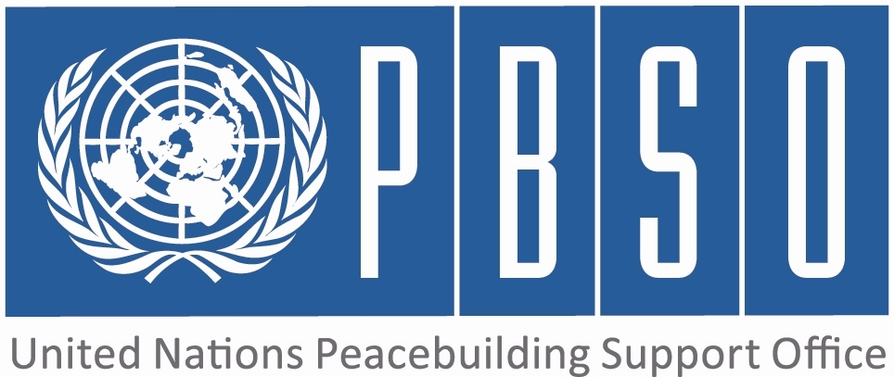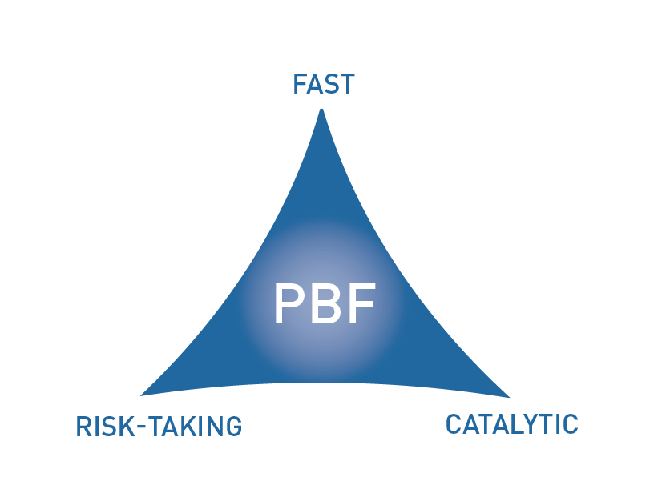

PEACEBUILDING FUND
TEMPLATE 4.2 – JOINT STEERING COMMITTEE ANNUAL REPORT ON THE PEACEBUILDING PRIORITY PLAN
Maximum length: 12 pages

Purpose: Strategic review of the implementation status of the Peacebuilding Priority Plan (PPP)

ANNUAL REPORT OF JOINT STEERING COMMITTEE IN Papua New Guinea (country)
Year of reporting: 2016

Start date of PPP (PBSO approval letter): August 2015
Original end date of PPP: Dec 2017
Current end date of PPP: Dec 2017
Date of reporting: 2016
Approved by JSC Co-Chairs (names/positions): DRAFT UNTIL SIGNED BY CO-CHAIRS
Ambassador Isaac Lupari, Chief Secretary - Department of Prime Minister & NEC,
Mr. Joseph Nobetau, Chief Secretary - Autonomous Region of Bougainville
Mr. Roy Trivedy, UN Resident Coordinator and UNDP Resident Representative

Signature Co-Chairs: ______________________________ ___________________________________ ___________________________________

Date: _____________________

NB: Note character restrictions within the fields in this report

PART 1 – FINANCIAL PROGRESS

  - Status of budget allocation and expenditure of the Peacebuilding Priority Plan (PPP)

Date of this financial estimate: December 2016

PPP Outcomes | PPP approved funds by outcome | PPP allocated funds by outcome (from MPTF to RUNOs) | PPP expended funds by outcome (RUNO financial delivery)
Outcome 1…Relationship and trust between GoPNG and ABG are strengthened to contribute to effective implementation of autonomy arrangements and of the Agreement. | USD2,500,000 | USD2,500,000 | USD1,190,201.57
Outcome 2…People of Bougainville are empowered to make informed choices at the Bougainville referendum and to have increased confidence in the BPA process through access to more objective and accurate information and to fora for dialogue and debate on key buildig issues, both within communities and with their political leaders. | USD2,500,000 | USD2,500,000 | USD890,201.57
Outcome 3…Community social cohesion and security in Bougainville are strengthened through opportunities to deal with conflict related trauma effectively, and resolution of local disputes peacefully as well as through better access to information to access appropriate post-conflict services/support. | USD1,500,000 | USD1,500,000 | USD408,501.57
Outcome 4…Establishment of the PBF Secretariat and effective coordination, monitoring, reporting, evaluation and communication on the achievement of the Peacebuilding Priority Plan results and the projects that support it. | USD800,000 | USD800,000 | USD508,519.57
Outcome 5…
Outcome 6…

  - Comments on the state of financial allocation and expenditure

Please comment on whether the rates of PPP financial allocation and expenditure are satisfactory. If they are not, provide reasons and rectifying measures.
The PPP financial allocation and expenditure for the year was satisfactory. Outcome 1 which looks at strengthening the relationship and political dialogue between both governments had an annual budget of $1,190, 201.57. To date, a total of $1,069,025.27 has been expended with a delivery rate of 86%.
Outcome 2 which looks at knowledge building and understanding of the Bougainville Peace Agreement had an annual budget of $890,201.57. To date, a total of $792,497.45 has been spent with a delivery rate of 84%.

Outcome 3 which addresses community security and cohesion had an annual allocation of $408,501.57. To date, a total of $341,728.19 has been spent with a delivery rate of 81%.

Outcome 4 which funds the PBF Secretariat to address coordination, monitoring and evaluation had an annual budget allocation of $508,519.86. To date, a total of $401,952.86 has been spent with a delivery rate of 77%.

PART 2 – RESULTS PROGRESS

  - Assessment of progress with regards to the PBF governance and oversight mechanisms in the country (including the Joint Steering Committee and the PBF Secretariat) and the set-up of the PBF support in the country
(1000 characters max.)
The PPP has progressed significantly well in 2016, because the overall PBF governance and oversight mechanisms are coordinated and functioning effectively to add value to the process chain. The implementation of the Peacebuilding Priority Plan is well supported by eight national staff, two internationals and an international consultant, managed by a P4 Coordinator and a P3 Operations Manager. DPA also compliments programmatic work through a dedicated PDA. The PDA and Referendum Expert provide substantive political analysis that assists programme planning. The co-chairs of the JSC are briefed very regularly on progress and challenges. On 13 September, a JSC meeting was convened in Port Moresby where key joint decisions were taken to progress PBF support to national government and ABG. The PBF Secretariat established monitoring mechanisms that have contributed significantly to implementation of the PPP projects. The JSC provides the strategic guidance and oversight.

  - Assessment of the current implementation status and results of the Peacebuilding Priority Plan

PPP Outcomes | Outcome indicator | Indicator baseline (B), target (T), progress (P) | Progress score: 1, 2 or 3 | Key results | Reasons for low achievement and rectifying measures
Peacebuilding situation in the country and PPP Overall Vision |  |  |  | What is the overall peacebuilding situation in the country? What are the major developments since the previous year? How well is the PPP positioned to address the current critical conflict factors? What is the overall progress of the PPP? Is the PPP theory of change working and how? If there was no PPP and PBF support, how would the situation be different now? What is the evidence for this assessment? Were there any unintended results (good or bad)?  (2000 characters max.)  The overall peacebuilding situation in the country can be rated as good. There has been consistent improvement over the past couple of months. However, certain political issues continue to affect the relationship between the national government and ABG. These include the postponement of the Joint Supervisory Body meetings from 2015 right through April 2016, minimal-payments of restoration and development grants, diversion of the BCL mining shares and the continous delays in conveneing planned joint dialogues such as the referendum committee meetings in resolving and progressing joint decisions. However, in spite of seemingly intractable public and political disagreements over these issues business has always progressed even if somewhat cautiously slow and non determinate.  Major developments since the previous year, involved the convening of the JSB on 20 May to resolve and endorse key joint decisions, progressing the establishing the Bougainville Referendum Commission and setting a target date of 15 June 2019 for the referendum. Bougainville’s Parliament has improved significantly both in ICT infrastructure and progressive members training and aqusition of ICT tools to support their work. Parliamentarians are now better equipped to conduct referendum awareness in their constituencies. There has also been progress towards establishing regional youth centres in Bougainville. The PPP has strategically supported peacebuilding effors at the political, administrative and community levels. The PPP also recognises civil society and non-state actors as key players and has therefore worked with them to deliver at community levels. Overall progress of the PPP has been very significant to achieving positive results. The PPP as an intervention, has addressed and filled in the financial situation the country is currently faced with. It has been able to meet costs that progressed government’s peacebuilding agenda. | If sufficient progress is not being made, what are the key reasons, bottlenecks and challenges? Were these foreseen in the risk matrix? How are they being addressed and what will be the rectifying measures?  (1500 characters max.)  Substantial progress was made this 2016 to roll out the PPP albeit a number of fundamental challenges related to joint decision making by both national government and the ABG. This risk was well captured in a risk log reviewed quarterly. The project team continued to work with both governments until a JSB decision of 20 May endorsed the referendum work plan. This was demonstrable political will cognisant of the sensitivities around referenda. Partnership between both parliaments though slow made some improvement. BPA implementation is a political issue and as such, requires the political will which the project has no control over. This accounts for delays in signing of the Parliamentary Partnership agreement as well as documents for the establishment of the Bougainville Referendum Commission. Although, civic education has begun rolling out to increase and improve the level of understanding and confidence of the Bougainville population on the BPA, having readily approved joint key messages by both governments still continues to be a challenge. This will be mitigated when the agreeements, arrangements and Charter for establishment of the Bougainville Referendum Commission are signed off by the national government and the ABG. The commission with a full mandate by both governments will significantly contribute to joint messaging in support of the BPA and referendum.
PPP Outcome 1  (250 characters max.)  Relationship and trust between GoPNG and ABG are strengthened with a view to effective implementation of autonomy arrangements and of the Bougainville Peace Agreement. | Indicator 1:  (250 characters max.)  Number of meetings of the Joint Supervisory Body on the Bougainville Peace Agreement with number of follow up action points.  Indicator 2:  (250 characters max.)  Agreement on "scale for questions" as outlined in the Autonomy Review 2013.  Indicator 3:  (250 characters max.)  Establishment and functioning of an inter-parliamentary committee between ABG and GoPNG parliaments. | (250 characters max per entry)  B: Not regular, sometimes stalled, in 2013 met twice, in 2014 first meeting scheduled for June 2014.  T: Quarterly meetings  P: Successful implementation of the follow up action points.  B: Existence of a series of unresolved questions with regards to BPA and implementation of autonomous arrangements.  T: Discussion of an agreement on the issues by the two Governments  P: A ToR has been jointly developed, simaltaneously complemented by the conduct of a constitutional review.  B: Idea for the committee but no committee established limited exchange between the two parliaments and their parliamentarians  T: Committee established and at least regular meetings twice a year.  P: Parliamentary Partnership Agreement developed and will be formerlised through a signing ceremony with both parliaments. |  | Which results have been achieved under this outcome, beyond the individual project outputs? How are they contributing to peacebuilding and to the specific conflict triggers identified under this outcome? What is the evidence for this? Were there any unintended results (good or bad)?  (1000 characters max.)  This outcome has delivered not only through hosting the JSB in May 20 but as a result of that meeting key joint resolutions were made which have been progressed very successfully. The components of the Joint Referendum Work plan (Electoral, Referendum decisions, Peace and Stability and awarenss are now being implemented. Both the national government and ABG have requested UN support with the referendum and weapons disposal in Bougainville. Steps are currently underway for the UN to provide this support. The conduct of the second autonomy review is progressing well after the Joint Steering Committee (JSC) met on September 13, endorsing the decisions for a joint Bougainville constitutional review before the second autonomy review is conducted. The national Bipartisan committee on referendum visited Bougainville for the first time in four years and a draft Parliamentary Partnership Agreement is yet to be signed. | If sufficient progress is not being made, what are the key reasons, bottlenecks and challenges? Were these foreseen in the risk matrix? How are they being addressed and what will be the rectifying measures?  (1000 characters max.)  This outcome has achieved tangible milestones which will eventually contribute to the targets of the PPP. The only risk that would hinder and cause delay in the timely and successful implementation of this outcome is the current financial challenges Papua New Guinea is confronted with due to fall in global commodity prices. UNDP through PBF will continue to progress this outcome to ensure that joint plans are fully supported to achieve project targets.
List of Outcome 1 projects (and in brackets the date of funding transfer to the project as per the MPTF-O Gateway page): | 1.Strengthening partnership and political dialogue between GoPNG and ABG. [August 2015]
PPP Outcome 2  (250 characters max.)  People of Bougainville are empowered to make informed choices at the Bougainville referendum and to have increased confidence in the BPA process through access to more objective and accurate information and to fora for dialogue and debate key issues. | Indicator 1:  (250 characters max.)  Number of political factions signing up to MOUs with ABG and ABG Meeting its commitments.  Indicator 2:  (250 characters max.)  Participation of women and youth in dedicated fora on peacebuilding with their views shared with ABG parliament and inter-parliamentary committees.  Indicator 3:  (250 characters max.)  Level of understanding and confidence of BPA provisions by the Bougainville population and political leaders. | (250 characters max per entry)  B: No faction has signed up to be part of political discussions.  T: At least all 5 key factions, including Meekamui, are part of the political discussions on the peace process and the political future of Bougainville.  P: No political factions signed up to any MOU with ABG, however Meekamui Government of Unity did and is working very closly with ABG now to address unification issues in Bougainville because ABG has met some of its commitments to MGU.  B: 16% of women and youth share peacebuilding views shared with ABG parliament and inter-parliamentary committees  T: At least 75% of women and youth share peacebuilding views with ABG-parliament and inter-parliamentary committees.  P: 16% of women and youth share peacebuilding views with ABG parliament and inter-parliamentary committees  B: 17% of the Bougainville population have understanding and confidence of the BPA provisions  T: At least 75% of the Bougainville population have understanding and confidence of the BPA provisions.  P: 17% of the Bougainville population have understanding and confidence in the BPA provisions. |  | (1000 characters max.)  This outcome has also been a success in achieving the milestones set for the year, despite slight delays. Although, there was no political alignment of any other factions to ABG in 2016, there has been some positive results from the work of the Meekamui Government (MGU) which signed an MoU in Dec 2015 with ABG. This year, MGU were beneficiary of ABG resources including a vehicle to support weapons disposal among the Meekamuis. This has progressed really well in the Panguna area. This year analysis done by Anglo Pacific Research has revealed that 16% of the Bougainville population have openly had the opportunity to share their views with their members and they also feel that these views have been taken up to Parliament. In addition to this, 17% of the Bougainville population have understanding and confidence in the BPA provisions. This will significantly increase by the expiration of the PPP end 2017. | (1000 characters max.)  This outcome has achieved tangible milestones which will eventually contribute to the targets of the PPP. Delays have been attributed to both governments not meeting regularly to make joint decisions. Significant progress has been made in 2016 as both governments are dialouging at all levels on key provisions of the BPA which are Referendum, Weapons Disposal and Good Governance. Chanels of communication will improve once the Bougainville Referendum Commission is established.
List of Outcome 2 projects (and in brackets the date of funding transfer to the project as per the MPTF-O Gateway page):: | Support knowledge-building and understanding of the Bougainville Peace Agreement. [August 2015]
PPP Outcome 3  (250 characters max.)  Community social cohesion and security in Bougainville strengthened through opportunities to deal with conflict-related trauma effectively, and resolution of local disputes peacefully as well as through better access to appropriate information. | Indicator 1:  (250 characters max.)  Level of understanding of services available for conflict related trauma issues.  Indicator 2:  (250 characters max.)  Level of access to trauma healing services by population who needs it  Indicator 3:  (250 characters max.)  Level of satisfaction by the population who access trauma healing services. | (250 characters max per entry)  B: 25% of the Bougainville population understand services available for conflict related trauma  T: 50% reduction from the baselines to the last year of Priority Plan, Bougainville Report on Family and Sexual Health. (P4P)  P: 25% of the Bougainville population understand services available for conflict related trauma  B: 22.1 % of the Bougainville population have access to trauma services by population who needs it.  T: At least 25% improvement  P: 22.1 % of the Bougainville population have access to trauma services by population who needs it.  B: 25% of Bougainvilleans who access trauma healing services have reported quite satisfied accessing trauma services  T: At least 50% improvement  P: 25% of Bougainvilleans who access trauma healing services have reported quite satisfied accessing trauma services |  | (1000 characters max.)  This project had a delayed start due to decision making issues of the ABG. With ABG decision at the level of the Presidency to prioritise mental health and trauma counselling the Department of Health in partnership with UNDP is targeting health facilities in the North region as pilot. Work is ongoing and trauma counselling services will be provided in these health facilities utilising a community based approach. Trainings will be conducted in 2017 for communitiy trauma counsellors as an output activity for this project. Low cost trauma services have also been supported at the healing of memories centre in South Bougainville harnessing the experiences of Planim Save.  Work on the establishment of the first youth resource centre is ongoing to support youth empowerment. Unification of factions is still been driven by this outcome to ensure that all former combatant factions work amicably with the ABG in governance.  This project was ammended by the JSC at its meeting of 13 September. | (1000 characters max.)  This outcome is yet to achieve tangible milestones which will eventually contribute to the targets of the PPP due to the late start.  However, there are no associated risks of implementation identified at this stage and the project is making steady progress. The project is building on successes of  Planim Save Kamap Strongpela under UN Women which has contributed immensely to marked behavioural changes in youths in South Bougainville. Some of these youth will eventually become beneficaries of the youth resource centre when established where they will be provided with trauma counselling and artisan skills.
List of Outcome 3 projects (and in brackets the date of funding transfer to the project as per the MPTF-O Gateway page):: | Promoting security and social cohesion in Bougainville. [August 2015]
PPP Outcome 4  (250 characters max.)  Effective coordination, monitoring, reporting, evaluation and communication on the achievement of the Priority Plan results and the projects that support it. | Indicator 1:  (250 characters max.)  JSC Annual Report submitted within 7 days of the deadline  Indicator 2:  (250 characters max.)  Quality of JSC Annual Reports rated “acceptable” by PBSO review team  Indicator 3:  (250 characters max.)  Key partners (e.g. RUNOs as well as non-UN stakeholders) satisfied with level and timeliness of PBSO communication and coordination | (250 characters max per entry)  B: 1 JSC Report Submitted in Dec 2015  T: All JSC Report submitted at least 3 days of the deadline  P: 1 JSC Report submitted in Dec 2015.  B: Rated acceptable  T: All JSC reports rated acceptable by PBSO.  P: 1 JSC report yet to be rated by PBSO.  B: Information such as PPP & M&E Plan provided to RUNOs.  T: All RUNOs are satisfied with level and timeliness of PBSO communication and coordination.  P: All staff expressed some level of satisfaction with coordination. |  | (1000 characters max.)  The successful implementation of the projects in 2016 is a clear indication that there has been proper coordination in effectively leading and supporting planning, monitoring, evaluation, reporting and communication on the achivement of the PPP. | (1000 characters max.)  There has been delays in the submission of timely reports to PBSO. The M&E Officer has responsibility for the reports. Additional expertise with M&E was needed. Focus on the support to the Secretariat began around March this year when arrangements were concluded for a baseline to be conducted along with the recruitment of an M&E IC. With the absence of the Project Staff earlier in the year, the M&E officer was more integrally involved in project implementation. This also meant a delay in completion of the external baselines in time for the submission of the annual reports.
List of Outcome 4 projects (and in brackets the date of funding transfer to the project as per the MPTF-O Gateway page):: | Support to PBF Coordinationa and monitoring in PNG [July 2015].
PPP Outcome 5  (250 characters max.) | Indicator 1:  (250 characters max.)  Indicator 2:  (250 characters max.)  Indicator 3:  (250 characters max.) | (250 characters max per entry)  B:  T:  P:  B:  T:  P:  B:  T:  P: |  | (1000 characters max.) | (1000 characters max.)
List of Outcome 5 projects (and in brackets the date of funding transfer to the project as per the MPTF-O Gateway page)::
PPP Outcome 6  (250 characters max.) | Indicator 1:  (250 characters max.)  Indicator 2:  (250 characters max.)  Indicator 3:  (250 characters max.) | (250 characters max per entry)  B:  T:  P:  B:  T:  P:  B:  T:  P: |  | (1000 characters max.) | (1000 characters max.)
List of Outcome 6 projects (and in brackets the date of funding transfer to the project as per the MPTF-O Gateway page)::

  - Assessment of Priority Plan coherence, risk, catalytic effects, value for money and other cross-cutting questions

Coherence/ coordination: Did the PPP contribute to better coherence and coordination of UN and/or Development Partner support in peacebuilding in the country? How?  (1000 characters max.) | Yes. The PPP contributed to better coherence and coordination of the UN and Development Partners' support in peacebuilding in the country. The Autonomous Region of Bougainville and Papua New Guinea Government have had continuous dialogues at the technical level complimented by political will to progress joint decisions. The Parliamentary Project has stood to be very significant as it draws on equipping the parliamentarians with tools necessary to effectively carry out their work. A Parliamentary induction workshop was held on 28 November to roll out the awareness activities of the referendum. Parliamentarians came to understand the huge responsibility they had as politicians in advocating for their constituents, ensuring they are provided acurate and reliable information . The multiplier effect is unification and weapons disposal to create a conducive environment for the referendum. BHOR will now establish a Parliamentary Committee on gender to contribute to peacebuilding.
Value for money: Did the PPP provide value for money, that is, is the level of outcomes proportionate to the level of investment? What is the evidence?  (1000 characters max.) | Yes. In a broader sense, the PPP continues to support dialogues and meetings of both governments that yields positive outcomes . The PPP funds have also supported both governments technically to develop joint referendum messages in Bougainville and outside Bougainville. The PPP funds also supported referendum information dissemination across Bougainville and PNG. As a result, 17% of the Bougainville population have understanding and confidence in the peace process. This is an improvement when compared with the PDA analysis that informed the PPP. In addition, the PPP is supporting mental health and trauma healing, counselling adopting a consistent and coordinated approach with ABG partners in North and South Bougainville. The PPP/IRF has also supported the work of Bougainville's women (BWF), the four women parliamentarians and their male counterparts to equip them with necessary peacebuilding tools. Women are contributing to civic education on the referendum.
Catalytic effects: Did the PPP achieve any catalytic effects, either through attracting additional funding commitments or creating immediate conditions to unblock/ accelerate peace relevant processes? How?  (1000 characters max.) | Yes. The ongoing support provided through the PPP have shown increased confidence by the two governments in the UN system. Evidence is the Joint request made by both governments for UN support to referendum preparations and weapons disposal. Funding is being sought to support the referendum preparations in 2017 and the project team will be liasing with the National Government and ABG on possible areas of support. The PPP supported the first meeting in 4 years of the PNG Bi-partisan Committee with the BHOR Referendum Committee in Bougainville in 2016, and the Chair reaffirmed natioal government's commitment to peace. This visit will culminate in a statement to national Parliament on the need to increase awareness on the referendum and also address the issue on weapons in Bougainville. PNG Bi-partisan Committee for the first time has called for increased national government support and attention to Bougainville and the peace process.
Risk taking/ innovation: Did the PPP support any innovative or risky activities to achieve peacebuilding results? What were they and what was the result?  (1000 characters max.) | One of the PPP projects being political has many risk factors that needed constant monitoring and mitigation strategies. Key amongst which were that the pace of implementation was directly dictated by national government's decisions and timings. For instance during this year under review, a new national Chief Secretary and a new ABG Chief Secretary were appointed. This definitely had an impact on implementation, as these new public officials needed to be properly briefed by their staff to be able to engage with existing decisions of both govenments, related to the sensitive issues of referendum and payment of unconditional grants to ABG, as provided for by the BPA. 2017 should see better support to the UN in implementing the priority plan since both national and ABG heads of administration are fully briefed and engaged with what the PPP is to achieve.
Gender sensitivity and responsiveness: How is the Priority Plan taking into account gender considerations and promoting gender equity/women’s empowerment? What is the estimate of the proportion of funds being spent directly on gender equity and women’s empowerment? Are any measures being taken to strengthen the gender focus of the Priority Plan?  (1000 characters max.) | The inclusion of the male parliamentarians under the IRF to participate in the peacebuilding and gender related lessons learned workshop in Fiji has been very fruitful. The BHOR has given prominence to the approval of the Gender Policy in 2016 after being rejected a year ago by the Bougainville Executive Council. Gender sensitisation targeted at the males worked well for them to advocate at the highest decision level making body. A Parliamentary Induction Workshop for the "Referendum ready concept" in all 33 Constituencies undertaken by BHOR provided an effective platform for Gender discourse in Parliament and reaffrimation of ABG commitment to maistreaming gender in all governance processes. A gender policy has now been launched by the ABG on 12 December 2016.
PBF/PBC synergy: For countries on the PBC agenda, how did the PPP promote the synergy between PBF support and PBC engagement? Did the PPP support the PBC to achieve its commitments in the country?

(1000 characters max.)

Any additional comments:

(1000 characters max.)

PART 3: LESSONS LEARNED AND SUCCESS STORY

3.1 Lessons learned
Provide at least three key lessons learned from the implementation of the PPP. These can include lessons on the themes supported by the PPP or the PPP processes and management.

Lesson 1 (1000 characters max.) | Key lessons:  • Always being prudent to promote the element of participation and joint decision making in the implementation of all project activities taking full cognisance of socio-cultural and political sensitivities  • Clearly setting out a comprehensive and well informed exit strategy for the UNDP to promote ownership and commitment of processes and outcomes by both governments  • Conducting regular risk analysis to gauge whether project implementation will be affected by unforeseen political decisions taken by government partners and discerning mitigating measures  • The need to always quality assure (QA) interventions with a view to making sure that project strategies are consistent with UNDP programme management normative frameworks and adhere to 'do no harm' policy
Lesson 2 (1000 characters max.)

Lesson 3 (1000 characters max.)

Lesson 4(1000 characters max.)

Lesson 5 (1000 characters max.)

3.2 Success story
Provide one success story from the PPP implementation which can be shared on the PBSO website and Newsletter. Please include key facts and figures and any citations.

(3000 characters max.)

Preliminary figures only
Provide a score for the overall progress under each Priority Plan outcome area as follows: (1) off-track; (2) on-track, with all outputs progressing as expected; (3) on-track with evidence of significant contribution to peacebuilding

