RUNO END PF PROJECT REPORTING TEMPLATE 4.5
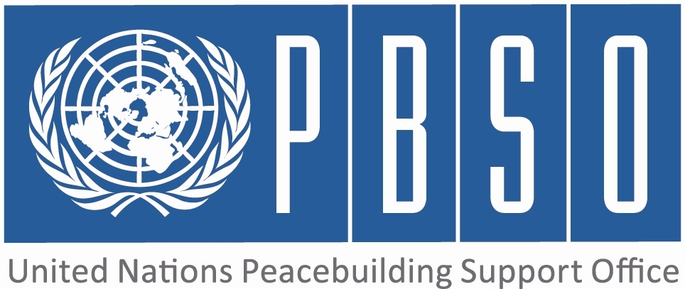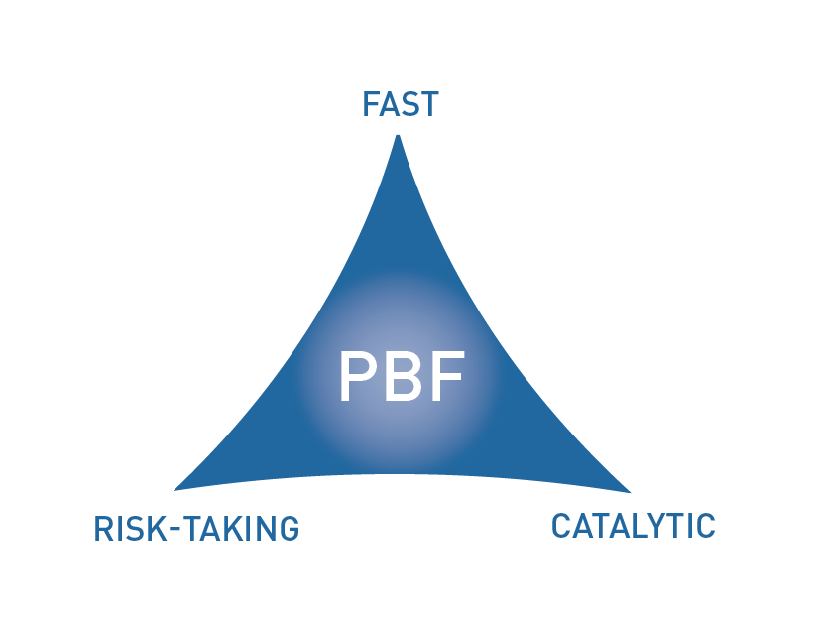

PEACEBUILDING FUND (PBF)
END OF PROJECT report
COUNTRY: Yemen
REPORTING PERIOD: June 2015

Programme Title & Project Number
Programme Title: The Social Welfare Fund (SWF) Recertification Survey
Programme Number (if applicable) 00093329
MPTF Office Project Reference Number:

Recipient UN Organizations |  |  | Implementing Partners
List the organizations that have received direct funding from the MPTF Office under this programme: UNICEF |  |  | List the national counterparts (government, private, NGOs & others) and other International Organizations: Social Welfare Fund – Governmen
Programme/Project Budget (US$) |  |  | Programme Duration
PBF contribution (by RUNO) $ 1,000,000 |  |  | Overall Duration (months) 18 months
PBF contribution (by RUNO) $ 1,000,000 |  |  | Start Date (dd.mm.yyyy) January 2015
Government Contribution  (if applicable)  $ 2,000,000 |  |  | Original End Date (dd.mm.yyyy) | June 2016
Other Contributions (donors)  (if applicable)  World bank: $ 9,000,000 |  |  | Final End date(dd.mm.yyyy) June 2015
TOTAL:

Programme Assessment/Review/Mid-Term Eval. |  | Report Submitted By
Mid-Term Evaluation / Review - if applicable please attach  Yes No Date:  End of project Evaluation– if applicable please attach  Yes No Date: |  | Name: Amal al-Ashtal  Title: Social Protection Officer  Participating Organization (Lead):  Email address: aalashtal@unicef.org

PART 1 – RESULTS PROGRESS

  - Assessment of the project implementation status and results

For PRF projects, please identify Priority Plan outcome and indicators to which this project has contributed:
Priority Plan Outcome to which the project has contributed. : Strengthened social cohesion and increased levels of resilience for conflict
Priority Plan Outcome indicator(s) to which project has contributed. 1- Number of district authorities with peace and development plans with earmarked as conflict triggers. 2- Percentage of target population with positive perception of the roles of the governorate - and district level adminstration (disaggregated by target versus non-target district, gender, age, marginalized group) .3- Percentage of target population that has been consulted in the process of developing district peace and development plans,( disaggregated by target versus non-target district, gender, age, marginalized group).

For both IRF and PRF projects, please rate this project’s overall achievement of results to date:

For both IRF and PRF projects, outline progress against each project outcome, using the format below. The space in the template allows for up to four project outcomes.

Outcome Statement 1: The most vulnerable households in Yemen, as determined by the application of objective criteria, receive assistance through the social welfare Fund, contributing to improved public and donor perception of government commitment to assisting these group

Rate the current status of the outcome:
Indicator 1:  Percentage of poorest quintile included in SWF cash transfer programme  Indicator 2:  Percentage of non-poor and non-vulnerable beneficiary cases covered by SWF cash transfer programme.  Indicator 3: | Baseline: 48 %  Target: 95 %  Progress:0 %  Baseline: 28 %  Target: 5 %  Progress:0%  Baseline:  Target:  Progress:

Output progress at the end of project

List the key outputs achieved under this Outcome (1000 character limit).Outputs are the immediate deliverables for a project.
Preparatory work for the recertification survey has been undertaken, conducting two training of trainor workshops that included social mobilization messages on the survey. This is the only thing has been done in the project at the output level.

Outcome progress at the end of project

Describe progress made toward the achievement of this outcome. This analysis should reflect the above indicator progress and the output achievement. Is there evidence of the outcome contributing to peacebuilding and to the specific conflict triggers (3000 character limit)?
No progress made at the outcome level as the World Bank has suspended the support to the Social Welfare Fund, including the planned recertification survey.

Reasons for low achievement and rectifying measures

If sufficient progress was not made, what were the key reasons, bottlenecks and challenges? Were these foreseen in the risk matrix? How were they addressed (1500 character limit)?
1- Deterioration of the security and political situation in Yemen has a major impact on the delivery of planned activities in the current project funded by PBF
2-The World Bank has suspended the support to the Social Welfare Fund, including the planned recertification survey.
3- The total budget of the survey is around 12 million USD, and the contribution from PBF, of 1 million USD, is less than 8% of the total amount. Thus, the planned survey can’t take place without WB contribution.

Outcome Statement 2:

Rate the current status of the outcome:
Indicator 1:  Indicator 2:  .  Indicator 3: | Baseline:  Target:  Progress:  Baseline:  Target:  Progress:  Baseline:  Target:  Progress:

Output progress at the end of project

List the key outputs achieved under this Outcome (1000 character limit).Outputs are the immediate deliverables for a project.

Outcome progress at the end of project

Describe progress made toward the achievement of this outcome. This analysis should reflect the above indicator progress and the output achievement. Is there evidence of the outcome contributing to peacebuilding and to the specific conflict triggers (3000 character limit)?

Reasons for low achievement and rectifying measures

If sufficient progress was not made, what were the key reasons, bottlenecks and challenges? Were these foreseen in the risk matrix? How were they addressed (1500 character limit)?
.

Outcome Statement 3:

Rate the current status of the outcome:
Indicator 1:  Indicator 2:  Indicator 3: | Baseline:  Target:  Progress:  Baseline:  Target:  Progress:  Baseline:  Target:  Progress:

Output progress at the end of project

List the key outputs achieved under this Outcome (1000 character limit).Outputs are the immediate deliverables for a project.

Outcome progress at the end of project

Describe progress made toward the achievement of this outcome. This analysis should reflect the above indicator progress and the output achievement. Is there evidence of the outcome contributing to peacebuilding and to the specific conflict triggers (3000 character limit)?

Reasons for low achievement and rectifying measures

If sufficient progress was not made, what were the key reasons, bottlenecks and challenges? Were these foreseen in the risk matrix? How were they addressed (1500 character limit)?

Outcome Statement 4:

Rate the current status of the outcome:
Indicator 1:  Indicator 2:  Indicator 3: | Baseline:  Target:  Progress:  Baseline:  Target:  Progress:  Baseline:  Target:  Progress:

Output progress at the end of project

List the key outputs achieved under this Outcome (1000 character limit).Outputs are the immediate deliverables for a project.

Outcome progress at the end of project

Describe progress made toward the achievement of this outcome. This analysis should reflect the above indicator progress and the output achievement. Is there evidence of the outcome contributing to peacebuilding and to the specific conflict triggers (3000 character limit)?

Reasons for low achievement and rectifying measures

If sufficient progress was not made, what were the key reasons, bottlenecks and challenges? Were these foreseen in the risk matrix? How were they addressed (1500 character limit)?

  - Assessment of project evidence base, risk, catalytic effects, gender at the end of the project

Evidence base: What was the evidence base for this report and for project progress? What consultation/validation process has taken place on this report (1000 character limit)? | Not Applicable given early project suspension
Funding gaps: Did the project fill critical funding gaps in peacebuilding in the country? Briefly describe. (1500 character limit) | Not Applicable given early project suspension
Catalytic effects: Did the project achieve any catalytic effects, either through attracting additional funding commitments or creating immediate conditions to unblock/ accelerate peace relevant processes? Briefly describe. (1500 character limit) | Not Applicable given early project suspension
Risk taking/ innovation: Did the project support any innovative or risky activities to achieve peacebuilding results? What were they and what was the result? (1500 character limit) | Not Applicable given early project suspension
Gender marker: How have gender considerations been mainstreamed in the project to the extent possible? Is the original gender marker for the project still the right one? Briefly justify. (1500 character limit) | Not Applicable given early project suspension
Other issues: Are there any other issues concerning project implementation that should be shared with PBSO? This can include any cross-cutting issues or other issues which have not been included in the report so far. (1500 character limit) | Not Applicable given early project suspension

PART 2: LESSONS LEARNED AND SUCCESS STORY

2.1 Lessons learned

Provide at least three key lessons learned from the implementation of the project. These can include lessons on the themes supported by the project or the project processes and management.

Lesson 1 (1000 character limit) | Not Applicable given early project suspension
Lesson 2 (1000 character limit) | Not Applicable given early project suspension
Lesson 3 (1000 character limit) | Not Applicable given early project suspension
Lesson 4 (1000 character limit) | Not Applicable given early project suspension
Lesson 5 (1000 character limit) | Not Applicable given early project suspension

2.2 Success story (OPTIONAL)

Provide one success story from the project implementation which can be shared on the PBSO website and Newsletter as well as the Annual Report on Fund performance. Please include key facts and figures and any citations (3000 character limit).

PART 3 – FINANCIAL PROGRESS AND MANAGEMENT ARRANGEMENTS

  - Comments on the overall state of financial expenditure

Please rate whether project financial expenditures were on track, slightly delayed, or off track:

If expenditure was delayed or off track, please provide a brief explanation (500 characters maximum):

The World Bank has suspended the support to the Social Welfare Fund, including the planned recertification survey

Please provide an overview of project expensed budget by outcome and output as per the table below.

Output number | Output name | RUNOs | Approved budget | Expensed budget | Any remarks on expenditure
Outcome 1: The most vulnerable households in Yemen, as determined by the application of objective criteria, receive assistance through the social welfare Fund, contributing to improved public and donor perception of government commitment to assisting these group
Output 1.1 | The SWF national recertification survey is finalized | UNICEF | 934,579 | 37,000 | The majority of the funding for the workshops was from UNICEF resources, however, with a partial contribution from PBF
Output 1.2 | The SWF national recertification survey Report is launched and approved by the Cabinet | UNICEF | No budget allocated | No budget allocated
Output 1.3
Outcome 2:
Output 2.1
Output 2.2
Output 2.3
Outcome 3:
Output 3.1
Output 3.2
Output 3.3
Outcome 4:
Output 4.1
Output 4.2
Output 4.3
Total

  - Comments on management and implementation arrangements

Please comment on the management and implementation arrangements for the project, such as: the effectiveness of the implementation partnerships, coordination/coherence with other projects, any South-South cooperation, the modalities of support, any capacity building aspect, the use of partner country systems if any, the support by the PBF Secretariat and oversight by the Joint Steering Committee (for PRF only). Please also mention if there have been any changes to the project (what kind and when) (2000 character maximum):

Not Applicable given early project suspension

The MPTF Office Project Reference Number is the same number as the one on the Notification message. It is also referred to “Project ID” on the MPTF Office GATEWAY
The start date is the date of the first transfer of the funds from the MPTF Office as Administrative Agent. Transfer date is available on the MPTF Office GATEWAY
As per approval of the original project document by the relevant decision-making body/Steering Committee.
If there has been an extension, then the revised, approved end date should be reflected here. If there has been no extension approved, then the current end date is the same as the original end date. The end date is the same as the operational closure date which is when all activities for which a Participating Organization is responsible under an approved MPTF / JP have been completed.
Please note that financial information is preliminary pending submission of annual financial report to the Administrative Agent.

