RUNO ANNUAL PROJECT REPORT TEMPLATE 4.4
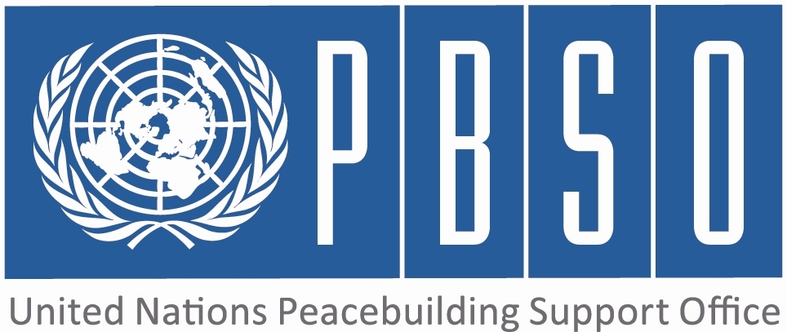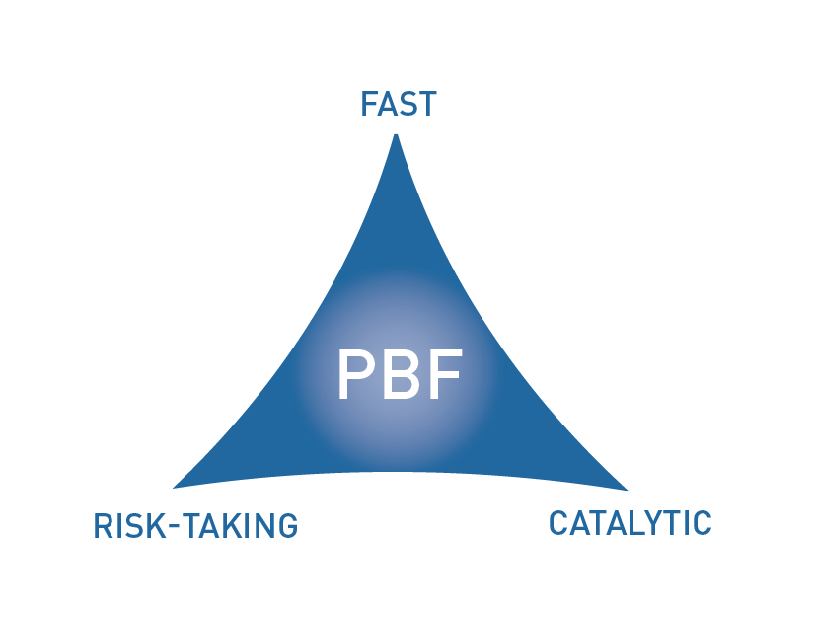

PEACEBUILDING FUND (PBF)
ANNUAL PROJECT progress report
COUNTRY: PAPUA NEWGUINEA (PNG)
REPORTING PERIOD: 1 january – 31 December

Programme Title & Project Number
Programme Title: Strengthening partnership and political dialogue between GoPNG and ABG
Programme Number (if applicable)
MPTF Office Project Reference Number: 00096333

Recipient UN Organizations |  |  | Implementing Partners
List the organizations that have received direct funding from the MPTF Office under this programme: UNDP |  |  | List the national counterparts (government, private, NGOs & others) and other International Organizations: Autonomous Bougainville Governments / GoPNG and various other partners
Programme/Project Budget (US$) |  |  | Programme Duration
PBF contribution (by RUNO) USD 2,500,00 |  |  | Overall Duration (months) 36
PBF contribution (by RUNO) USD 2,500,00 |  |  | Start Date (dd.mm.yyyy) 15 August 2015
Government Contribution  (if applicable) |  |  | Original End Date (dd.mm.yyyy) | 25 Septe  2017
Other Contributions (donors)  (if applicable) |  |  | Current End date(dd.mm.yyyy) Subject to discussion for extension as project commencement was delayed.
TOTAL: | USD 2,500,000

Programme Assessment/Review/Mid-Term Eval. |  | Report Submitted By
Assessment/Review - if applicable please attach  Yes No Date:  Mid-Term Evaluation Report – if applicable please attach  Yes No Date: |  | Name: Julie Bukikun  Title: Assistant Resident Representative (Governance)  Participating Organization (Lead): UNDP  Email address: julie.bukikun@undp.org

PART 1 – RESULTS PROGRESS

  - Assessment of the current project implementation status and results

For PRF projects, please identify Priority Plan outcome and indicators to which this project is contributing:
Priority Plan Outcome to which the project is contributing. Strengthening partnership and political dialogue between GoPNG and ABG
Priority Plan Outcome indicator(s) to which project is contributing. Supporting the implementation of peace agreements and political dialogue - Priority area 1

For both IRF and PRF projects, please rate this project’s overall achievement of results to date:

For both IRF and PRF projects, outline progress against each project outcome, using the format below. The space in the template allows for up to four project outcomes.

Outcome Statement 1: The key Bougainville Peace Agreement (BPA) provisions on autonomy arrangements and on the referendum are progressed through joint decisions and actions of the PNG Government and the ABG.

Rate the current status of the outcome:
Indicator 1:  Level of progress in Autonomy Arrangements implementation since 2013 Autonomy Review.  Indicator 2:  Evidence of joint decision by two Governments on date and options for referendum.  Indicator 3: | Baseline: Findings from 2013 Autonomy Review - many bottlenecks identified.  Target: Tangible improvements with regards to 2013 bottlenecks.  Progress:Terms of Reference have been developed to progress the 2015 Autonomy Review which should have commenced in the first quarter of 2015. This is however yet to materialise. UNDP stands ready to support the review once it is agreed by both governments when it should commence.  Baseline: Date and options for the referendum not agreed.  Target: Date and options for the referendum agreed.  Progress: At the moment there is no joint decision by the ABG and GoPNG on date and options for the referendum. This issue of date was raised by President John Momis at the last JSB meeting in Arawa, suggesting 2019 as a possible year for the referendum to be held. The GoPNG is of the view that more time is needed to discuss this tangibly. In the Joint Supervisory Body meeting on 4th December in Kokopo, their Joint Technical Team agreed that the UN will be invited to support the referednum process. This is expected to be endorsed when the JSB meets in February 2016. In addition, the high level DPA ASG Mirosia Jenca's visit to Bougainville in October may significantly strenghen the resolve of both governments to deal with the referendum with the seriousness it deserves.  Baseline:  Target:  Progress:

Output progress

List the key outputs achieved under this Outcome in the reporting period (1000 character limit).Outputs are the immediate deliverables for a project.
Progress with this output appears to be slow despite the fact that the Autonomy Review was extensively discussed at the last Joint Supervisory Board (JSB) meeting held in Arawa in March 2015. The review should have commenced in the first quarter of 2015 but unfortunately this has not materialised. Terms of Reference have been developed for the review but a decision on commencement is yet to be made by the national government and the ABG. Traction is expected on this once the JSB meet in December this year.

Outcome progress

Describe progress made during the reporting period toward the achievement of this outcome. This analysis should reflect the above indicator progress and the output achievement. Is there evidence of the outcome contributing to peacebuilding and to the specific conflict triggers? Is the theory of change that underpins the project design still relevant for this outcome (3000 character limit)?
Given that implementation has already begun, progress has been made in achieving the outcome though various participatory consultations on the ground. The Peace and Development Advisor has held series of consultative meetings with the Department of Referendum, Peace and Veteren Affairs, Meekamuis and Hardliners which brought about the signing of a series of MOA's between the stakeholders notably the one signed on Thursday 27 Aug 2015 between the ABG and 75% of the Meekamui faction. At the National level, there is now a strenghtened relationship as indicated by the recent signing of an MoU between National Coordinating Office for Bougainville Affairs (NCOBA) and the ABG Referendum office to establish a presence in NCOBA to enhance a joint approach to delivering the provisions of the BPA

The Bi-Partisan Referendum Committee which consists of Parliamentarians from the Bougainville House of Representatives and Papua New Guinea Parliament met for the first time on the 29th October 2015 to begin discussions on matters regarding the referendum and as indicated in the Press Release, regular meetings between the committees will be held come 2016 in furtherance of joint efforts to keep the refendum on track

Very little progress has begun towrds supporting Autonomy Arrangements as mentioned inter alia. Progress will be made when both governments agree on a finite date and direction for the review. UNDP will support the process through the PBF.

Reasons for low achievement and rectifying measures

If sufficient progress is not being made, what are the key reasons, bottlenecks and challenges? Were these foreseen in the risk matrix? How are they being addressed and what will be the rectifying measures (1500 character limit)?
Progress has been slower than expected given the late draw down of the UNPBF and both governments limited knowledge on the UN's main areas of support. Informing our implementing partners would help to address areas of duplication. Bilateral dialogue between key stakeholders from both governments also requires time and patience. Futhermore, the delays could also be attributed to recruitment of critical staff for the programme which was a bit delayed on account of release of funds.

Outcome Statement 2: The national and the Bougainville Parliaments have a shared understanding of the BPA and the referendum provisions and the effectiveness of the Bougainville Parliament is strengthened, in line with the 2013 Autonomy Review findings.

Rate the current status of the outcome:
Indicator 1:  Level of Bougainville parliament capacity to perform its role effectively  Indicator 2:  Existence of joint statements between the two Parliaments on BPA  Indicator 3:  Level of confidence by Bougainville population in ABG Parliament’s capacity and willingness to engage with the population on key issues | Baseline: Autonomy Review 2013 found important gaps  Target: Improvements in effectiveness and transparency of proceedings  Progress:Some of the gaps identified by the autonomy review of 2013 have been addressed by the ABG. These include but are not limited to the meeting of the Bi Partisan committees of both parliaments and their committements to progress discussions on the referendum. However there is still significant work to be done to deal with bottlenecks identified in the 2013 autonomy review  Baseline: No such statements exist  Target: Statements made public and show shared understanding of BPA  Progress:The Bi-Partisan committee of the national government and the ABG House of Representatives held their 1st consultative meeting at the national parliament in POM on 29 October 2015 and came up with a joint statement that such meetings will continue in 2016 to ensure that issues of the BPA and the referendum remain on the peacebuilding rader. The PBF will support such meetings to ensure that tangible outcomes are achieved in 2016  Baseline: To be determined by a survey  Target: To be determined by a survey  Progress:This survey is yet to be conducted and the ABG will be engaged next year by the project team to ensure that this survey is conducted

Output progress

List the key outputs achieved under this Outcome in the reporting period (1000 character limit).Outputs are the immediate deliverables for a project.
UNDP is fully engaged with the ABG in setting the stage for this output to be implemented. New Parliamentarians were briefed on the roles of UNDP and other UN agencies and specifically on the PBF support to Bougainville. There was a parliamentary needs assessment mission to Bougainville from 26-30 October and two of the mission outcomes after series of consultations with stakeholders is that more work needs to be done on autonomy arrangements and the referendum. Series of training sessions are being planned for early 2016 to deal with some of these critical areas in peacebuilding and parliamentary understanding of the the BPA and referendum processes

Outcome progress

Describe progress made during the reporting period toward the achievement of this outcome. This analysis should reflect the above indicator progress and the output achievement. Is there evidence of the outcome contributing to peacebuilding and to the specific conflict triggers? Is the theory of change that underpins the project design still relevant for this outcome (3000 character limit)?
UNDP is betrothed with the ABG in setting the stage for this outcome to be implemented. New Parliamentarians were briefed on the roles of UNDP and other UN agencies and specifically on the PBF support to the GoPNG and the ABG. There was a parliamentary needs assessment mission to Bougainville from 26-30 October and two of the mission outcomes after series of consultations with Parliamentarians were that more work needs to be done on autonomy arrangements and the referendum. Series of training sessions are being planned for early 2016 to deal with some of these critical areas in peacebuilding and to enhance parliamentary understanding of the the BPA and referendum processes that will eventually determine the future political status of Bougainville

Reasons for low achievement and rectifying measures

If sufficient progress is not being made, what are the key reasons, bottlenecks and challenges? Were these foreseen in the risk matrix? How are they being addressed and what will be the rectifying measures (1500 character limit)?
The Priority Plan was signed and approved in 2014 and the funds only drawn down in August 2015 which seriously impacted recruitment of essential staff for the PBF programme to kickstart implementation.The fast track model of recruitment just introduced by RBAP to bolster delivery in 2015 will be adopted to bring onboard additional staff required

Outcome Statement 3:

Rate the current status of the outcome:
Indicator 1:  Indicator 2:  Indicator 3: | Baseline:  Target:  Progress:  Baseline:  Target:  Progress:  Baseline:  Target:  Progress:

Output progress

List the key outputs achieved under this Outcome in the reporting period (1000 character limit).Outputs are the immediate deliverables for a project.

Outcome progress

Describe progress made during the reporting period toward the achievement of this outcome. This analysis should reflect the above indicator progress and the output achievement. Is there evidence of the outcome contributing to peacebuilding and to the specific conflict triggers? Is the theory of change that underpins the project design still relevant for this outcome (3000 character limit)?

Reasons for low achievement and rectifying measures

If sufficient progress is not being made, what are the key reasons, bottlenecks and challenges? Were these foreseen in the risk matrix? How are they being addressed and what will be the rectifying measures (1500 character limit)?

Outcome Statement 4:

Rate the current status of the outcome:
Indicator 1:  Indicator 2:  Indicator 3: | Baseline:  Target:  Progress:  Baseline:  Target:  Progress:  Baseline:  Target:  Progress:

Output progress

List the key outputs achieved under this Outcome in the reporting period (1000 character limit).Outputs are the immediate deliverables for a project.

Outcome progress

Describe progress made during the reporting period toward the achievement of this outcome. This analysis should reflect the above indicator progress and the output achievement. Is there evidence of the outcome contributing to peacebuilding and to the specific conflict triggers? Is the theory of change that underpins the project design still relevant for this outcome (3000 character limit)?

Reasons for low achievement and rectifying measures

If sufficient progress is not being made, what are the key reasons, bottlenecks and challenges? Were these foreseen in the risk matrix? How are they being addressed and what will be the rectifying measures (1500 character limit)?

  - Assessment of project evidence base, risk, catalytic effects, gender in the reporting period

Evidence base: What is the evidence base for this report and for project progress? What consultation/validation process has taken place on this report (1000 character limit)? | Though progress appears slow due to the late start up of the project the Parliamentary needs assesment conducted for the Bougainville House of Representative 26-30 October 2015 will offer the unique opportunity for a series of training sessions that will provide information to parliamentarians on the BPA and the referendum. Futhermore, the bipartisan consultative meeting held between the national government and the ABG culminating in a joint media release is some evidence of commitment by both parliaments to work together on the referendum. A leader's referendum dialogue meeting also scheduled to have taken place on 23 November 2015 to provide the platform for discussions on the BPA and its provisions relating to the referendum, is now postponed to early 2016. 25 women candidates also trained for the 2015 Bougainville elections ( Australian funded elections project) links with this outcome
Funding gaps: Did the project fill critical funding gaps in peacebuilding in the country? Briefly describe. (1500 character limit) | Though very early, it has supported the start of the process of Unification as described by the ABG. This is a process to unify the factions with the ABG. A series of meetings were held in Panguna with a signing of a MoA to start organising and reconciliting with the ABG. It is too early to affirmatively report that the project has filled critical funding gaps in Peacebuliding. However, this fund will support key peacebuilding activities once it takes off on full trottle. It will enhance parliamentarians knowledge of the BPA and processes for the referendum. It is expected that the activities it will support will strengthen the relationship between both governments to deliver the referendum within the specified timeframe of 2015-2020.
Catalytic effects: Did the project achieve any catalytic effects, either through attracting additional funding commitments or creating immediate conditions to unblock/ accelerate peace relevant processes? Briefly describe. (1500 character limit) | This flagship project is expected to generate the momentum for a series of other activites within the Bougainville peacebuilding agenda. This will be the case, because most of the decisions for further action are largley political whether at the JSB , the Joint referendum or the bi-partisan committee levels. The catalytic effect of this project is that there is improved dialogue between the ABG, GoPNG, development partners and civil socity on peace building in Bougainville
Risk taking/ innovation: Did the project support any innovative or risky activities to achieve peacebuilding results? What were they and what was the result? (1500 character limit) | The innovative approach is the linking of the Australian supported elections project with this project outcome. This nexus will improve on the interactive sessions between the women leaders supported in the elections project and ABG Government to promote women's participation in leadership.
Gender: How have gender considerations been mainstreamed in the project to the extent possible? Is the original gender marker for the project still the right one? Briefly justify. (1500 character limit) | Gender remains a very important phenomenon in the execution of the project. This is quite crucial given the low numbers of women in the Bougainville House of Representatives and indeed other important areas of government. There are only 3 reserved seats for women in a 40 member parliament. This project will complement and build on successes of the Women in Leadership (WIL) project. Women trained in the elections project and won elections will be empowered to participate in governance decision making across the Autonomous Region of Bougainville (AROB)
Other issues: Are there any other issues concerning project implementation that should be shared with PBSO? This can include any cross-cutting issues or other issues which have not been included in the report so far. (1500 character limit) | No issues reported so far concerning the project

1.3 INDICATOR BASED PERFORMANCE ASSESSMENT: Using the Project Results Framework as per the approved project document- provide an update on the achievement of key indicators at both the outcome and output level in the table below. Where it has not been possible to collect data on indicators, state this and provide any explanation in the qualitative text above. (250 characters max per entry)

 | Performance Indicators | Indicator Baseline | End of project Indicator Target | Current indicator progress | Reasons for Variance/ Delay  (if any) | Adjustment of target (if any)
Outcome 1  The key Bougainville Peace Agreement (BPA) provisions on autonomy arrangements and on the referendum are progressed through joint decisions and actions of the PNG Government and the ABG. | Indicator 1.1  Level of progress in Autonomy Arrangements implementation since 2013 Autonomy Review | Findings from 2013 Autonomy Review - many bottlenecks identified. | Tangible improvements with regards to 2013 bottlenecks. | Some of the gaps identified by the autonomy review of 2013 have been addressed by the ABG. These include but are not limited to the meeting of the Bi Partisan committes of both parliaments and their committement to the referendum | On course | No adjustment required at this stage
 | Indicator 1.2  Evidence of joint decision by two Governments on date and options for referendum | Date and options for the referendum not agreed. |  | This is a rather politically sensitive matter and was raised in the last JSB meeting held in Arawa in March 2015 by the ABG President John Momis. No concrete agreement was reached though he suggested that the referendum should be held in 2019. | On course | No adjustment required at this stage
 | Indicator 1.3  Level of confidence by Bougainville population in ABG Parliament’s capacity and willingness to engage with the population on key issues | To be determined by a survey | Suvey conducted and emperical evidence provided on confidence levels of Bougainvilleans in the ABG Parliament | Current engagement with the ABG government and the Parliament as exemplified by the just concluded Parliamentary needs assement mission which will pave the way for this survery to be conducted | On course | Not at this stage
Output 1.1  Existence and effective use of dialogue fora for GoPNG and ABG to discuss BPA provisions and resolve bottlenecks and to communicate with the Bougainville population | Indicator 1.1.1  Frequency of GoPNG and ABG Roundtable meetings | JSB meetings | At least one JSB meeting a year | One JSB meeting was held in Arawa in March 2015 and one is scheduled to take place in Kokopo in December 2015 | On course | Not Now
 | Indicator 1.1.2  Frequency of JSB meetings and recommendations with regards to autonomy arrangements and referendum  Indicator 1.1,3  Number of Council of Elders visits and number of persons consulted by the technical committees of the JSB, disaggregated by sex and | JSB meets on an ad hoc basis and does not always make decisions  None | JSB meets at least twice a year and makes recommendations on autonomy arrangements/ referendum  At least 80% of COEs by the end of the project. | One Joint Supervisory Board meeting planned for December 2015. Autonomy arrangements and referendum will be key agenda items  Work ongoing with the Department of Community Development of the ABG to ensure that such consultations are done | On course  On course | Not at this stage  Not at this stage
Output 1.2  Progress on implementation of key BPA provisions regarding autonomy arrangements and preparations for the referendum | Indicator 1.2.1  Level of progress of Referendum work streams (this indicator will be made more specific when annual work plans are developed and concrete work stream activities and targets are identified as part of this project support) | No baseline exists for this output | At least two referendum work streams make tangible progress, in line with identified areas | The project is working with the ABG Referendum office on progressing these workstreams that were technically approved at the JSB meeting in March 2015. Plans are underway to hire a consultant to assist the office in making tangible progress on this | On course | Not Now
 | Indicator 1.2.2  Timeliness and quality of 2015 Autonomy Review  Indicator1.2,3  Frequency of meetings of the Referendum Committee | Review due in 2015  Last meeting held on 12 March 2015 | Autonomy Review 2015 takes place, provides evidence of progress and is endorsed by GoPNG and ABG  One meeting to be held before JSB | Consensus is yet to be reached by the ABG and the national government on when this review should commence. However ToRs have been developed for the review process  There is still some amount of difficulty in arranging joint referendum meetings. | On course  On course but expected to improve with setting up of a secretariat to support the work of the joint referendum committee | Not at this stage  Not yet
Output 1.3  Increased understanding by the Government and the civil servants of the BPA intentions and provisions | Indicator 1.3.1  Eminent Persons’ Group is established and composed of men and women | No group exists | Group established and disaggregated by sex and age | Work has commenced in this regard and a leaders dialouge meeting scheduled to take place on 23 November 2015 now stands postponed to 2016. It will set the stage for constituting the eminents persons group | On course | Not Yet
 | Indicator 1.3.2  Eminent Persons Group develops a workplan and progresses its implementation  Indicator 1.3.3  Level of understanding of BPA key provisions by civil servants and MPs | N/A  To be determined by survey | To be adjusted when EPG established  Improvement by at least 50% | Workplan and implementation strategy will be developed once the group is constituted  Project to work with the ABG and the Bougainville House of Representatives to progress this in 2016. The parliamentary needs assessment will be used as fulcrum | On Course  On course | Not yet  Not at this stage
Outcome 2  The national and the Bougainville Parliaments have a shared understanding of the BPA and the referendum provisions and the effectiveness of the Bougainville Parliament is strengthened, in line with the 2013 Autonomy Review findings. | Indicator 2.1
 | Indicator 2.2
Output 2.1  Strengthened capacity of the Bougainville Parliament to fulfill its functions under the Autonomy Arrangements and the good governance provisions of the BPA | Indicator 2.1.1  Bougainville parliament’s website operational with information on peace and development, BPA, human rights and gender. | Baseline: No library or information services exist. | Website and Hansard in place with useful information on key peacebuilding issues and regular updates | Needs assessment for strengthening of the Bougainville House of Representatives already conducted 26-30 October and the findings will address this ouput | On course | Not yet
 | Indicator 2.1.2  Number of public consultations and number of people consulted by Bougainville Parliament, disaggregated by sex and age | None | At least one public consultation each year | This process will be integrated into the parliamentary training scheduled for early 2016 | on course | Not yet
Output 2.2 | Indicator 2.2.1
Output 2.2 | Indicator 2.2.2
Output 2.3 | Indicator 2.3.1
Output 2.3 | Indicator 2.3.2
Outcome 3 | Indicator 3.1
Outcome 3 | Indicator 3.2
Output 3.1 | Indicator 3.1.1
Output 3.1 | Indicator 3.1.2
Output 3.2 | Indicator 3.2.1
Output 3.2 | Indicator 3.2.2
Output 3.3 | Indicator 3.3.1
Output 3.3 | Indicator 3.3.2
Outcome 4 | Indicator 4.1
Outcome 4 | Indicator 4.2
Output 4.1 | Indicator 4.1.1
Output 4.1 | Indicator 4.1.2
Output 4.2 | Indicator 4.2.1
Output 4.2 | Indicator 4.2.2
Output 4.3 | Indicator 4.3.1
Output 4.3 | Indicator 4.3.2

PART 2: LESSONS LEARNED AND SUCCESS STORY

2.1 Lessons learned

Provide at least three key lessons learned from the implementation of the project. These can include lessons on the themes supported by the project or the project processes and management.

Lesson 1 (1000 character limit) | Timely recruitment of project staff and draw down of funds is quite important for delivery of such a mamoth Peace Building programme with so much expectation from the Autonomous Bougainville Government and other partners. Coordination of efforts with other development partners to enhance peacebuilding in Bougainville proved to be quite valuable as it will concisely address the issue of duplicity and leverage resources where they are most needed
Lesson 2 (1000 character limit) | The support provided by UNDP during the Bougainville elections project 2015 revealed a lot of weaknesses in ABG institutions which should take up key responsibilities in peacebuilding activities. Strengthning the ABG Chief Secretary's office to effectively coordinate PBF support at the level of Governement will significantlhy impact delivery of this project and indeed the others.
Lesson 3 (1000 character limit)
Lesson 4 (1000 character limit)
Lesson 5 (1000 character limit)

2.2 Success story (OPTIONAL)

Provide one success story from the project implementation which can be shared on the PBSO website and Newsletter as well as the Annual Report on Fund performance. Please include key facts and figures and any citations (3000 character limit).

At this very initial stage of project start up it is difficult to report a tangible success story. However the projects involvement in the 2015 elections saw women candidates empowered to participate in the governance arena of the ABG, their participation in the post elections lessons learned workshop and the upcoming leaders dialogue meeting that will take place in 2016

PART 3 – FINANCIAL PROGRESS AND MANAGEMENT ARRANGEMENTS

  - Comments on the overall state of financial expenditure

Please rate whether project financial expenditures are on track, slightly delayed, or off track:

If expenditure is delayed or off track, please provide a brief explanation (500 characters maximum):

Please provide an overview of expensed project budget by outcome and output as per the table below.

Output number | Output name | RUNOs | Approved budget | Expensed budget | Any remarks on expenditure
Outcome 1: The key Bougainville Peace Agreement (BPA) provisions on autonomy arrangements and on the referendum are progressed through joint decisions and actions of the PNG Government and the ABG
Output 1.1 | Contractual Services |  | 15,000 |  | Committed to planned actvities for 2015
Output 1.2 | Travel |  | 10,000 |  | Committed to planned actvities for 2015
Output 1.3
Outcome 2: The national and the Bougainville Parliaments have a shared understanding of the BPA and the referendum provisions and the effectiveness of the Bougainville Parliament is strengthened, in line with the 2013 Autonomy Review findings.
Output 2.1
Output 2.2
Output 2.3
Outcome 3:
Output 3.1
Output 3.2
Output 3.3
Outcome 4:
Output 4.1
Output 4.2
Output 4.3
Total: |  |  | 25,000 |  | Committed to planned actvities for 2015

  - Comments on management and implementation arrangements

Please comment on the management and implementation arrangements for the project, such as: the effectiveness of the implementation partnerships, coordination/coherence with other projects, any South-South cooperation, the modalities of support, any capacity building aspect, the use of partner country systems if any, the support by the PBF Secretariat and oversight by the Joint Steering Committee (for PRF only). Please also mention if there have been any changes to the project (what kind and when); or whether any changes are envisaged in the near future (2000 character maximum):

UNDP is working with other RUNO's to ensure that the DaO modality is working. This project though entirely implemented by UNDP draws on successes of UNWOMEN in the Women in Leadership project and the UNFPA work with the youths.The project synergistically supports the work of the PDA and the Political Liaison officer now deployed in Bougainville. The Peacebuilding fund Programme Coordinator has been recruited and in post. The M&E officer has been recruited and attended a PBSO induction training in Durban South Africa. An operations analyst is also in post and a P3 Operations Manager and 3 Project staff will be reccruited before the end of the year

The MPTF Office Project Reference Number is the same number as the one on the Notification message. It is also referred to “Project ID” on the MPTF Office GATEWAY
The start date is the date of the first transfer of the funds from the MPTF Office as Administrative Agent. Transfer date is available on the MPTF Office GATEWAY
As per approval of the original project document by the relevant decision-making body/Steering Committee.
If there has been an extension, then the revised, approved end date should be reflected here. If there has been no extension approved, then the current end date is the same as the original end date. The end date is the same as the operational closure date which is when all activities for which a Participating Organization is responsible under an approved MPTF / JP have been completed.
Please note that financial information is preliminary pending submission of annual financial report to the Administrative Agent.

