RUNO ANNUAL PROJECT REPORT TEMPLATE 4.4
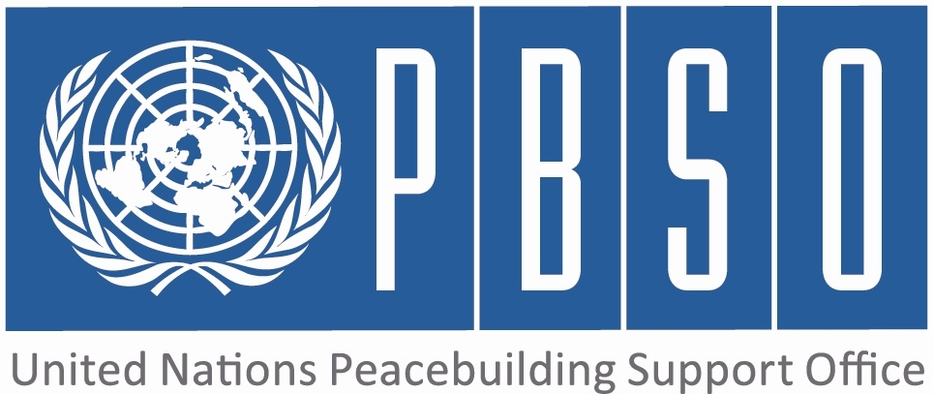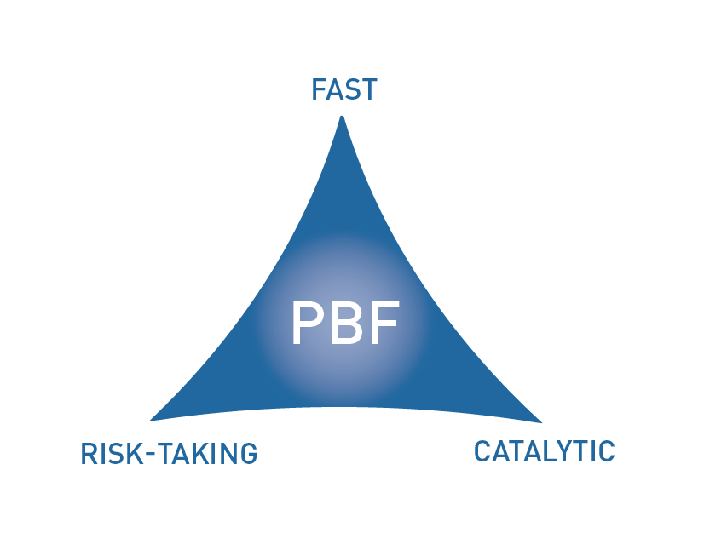

PEACEBUILDING FUND (PBF)
ANNUAL PROJECT progress report
COUNTRY: Kyrgyzstan
REPORTING PERIOD: 1 january – 31 December

Programme Title & Project Number
Programme Title: Unity in Diversity
Programme Number (if applicable) KGZ/D1
MPTF Office Project Reference Number: 00088478

Recipient UN Organizations |  |  | Implementing Partners
List the organizations that have received direct funding from the MPTF Office under this programme:  UNICEF  OHCHR |  |  | List the national counterparts (government, private, NGOs & others) and other International Organizations:  Ministry of Education and Science  Department of Ethnic, Religious Policy and Cooperation with Civil Society (President Administration)  State Language Commission  Ombudsman Institute  Local Self Government Agency  Center for Social Integration Policy at MoES  Public Association "Initiative for Development of Unity and Tolerance" (IRET)
Programme/Project Budget (US$) |  |  | Programme Duration
PBF contribution (by RUNO) UNICEF - USD 2,461,000  OHCHR - USD 915,535 |  |  | Overall Duration (months) 30
 |  |  | Start Date (dd.mm.yyyy) 01 January 2014 (UNICEF); 01 July 2014 (OHCHR)
Government Contribution  (if applicable) |  |  | Original End Date (dd.mm.yyyy) | 30 June 2016
Other Contributions (donors)  (if applicable) |  |  | Current End date(dd.mm.yyyy)
TOTAL: | USD 3 376 535

Programme Assessment/Review/Mid-Term Eval. |  | Report Submitted By
Assessment/Review - if applicable please attach  Yes No Date:  Mid-Term Evaluation Report – if applicable please attach  Yes No Date: |  | Name: Alvard Poghosyan, Bea Ferenci  Title: Child Protection Specialist, Human Rights Officer  Participating Organization (Lead): UNICEF, OHCHR Regional Office for Central Asia  Email address: apoghosyan@unicef.org, bferenci@ohchr.org

PART 1 – RESULTS PROGRESS

  - Assessment of the current project implementation status and results

For PRF projects, please identify Priority Plan outcome and indicators to which this project is contributing:
Priority Plan Outcome to which the project is contributing.
Outcome 3: Policies, pilot initiatives and approaches are developed and implemented that enable the further development of a common civic identity, multilingual education and respect for diversity and minority rights.
Priority Plan Outcome indicator(s) to which project is contributing.
1) Percentage of students, teachers and administrators and parents connected to MLE schools who increasingly value diversity;
2) Percentage of citizens in targeted communities who have changed their disposition towards "others"

For both IRF and PRF projects, please rate this project’s overall achievement of results to date:

For both IRF and PRF projects, outline progress against each project outcome, using the format below. The space in the template allows for up to four project outcomes.

Outcome Statement 1: Political, legal and organizational conditions for introduction of multi-lingual and multi-cultural education and protection of minority rights have been improved enabling implementation of multi-lingual education, social engagement opportunities and reduced the frustration and alienation among the children, women, youth and families in the project from various ethnic groups

Rate the current status of the outcome:
Indicator 1:  Policy guidelines and normative acts conducive for introduction of multilingual and multicultural education developed and adopted (UNICEF)  Indicator 2:  Number of state institutions which support measures to improve participation of minorities in public life (OHCHR)  Indicator 3: | Baseline: Multilangual and multicultural edication concept and policy adopted in 2010  Target: 2 documents developed and approved (1- regulation on MLE schools; 2- Action Plan)  Progress:Decree on piloting of MLE in target schools approved by MoES. Regulation on MLE ready and in the process of endorsement  Baseline: The state institutions do not support positive measures to improve participation of minorities  Target: By mid-2015, at least 2-3 institutions will support introducation of such measures  Progress: Preliminary discussions with authorities on possible measures to increase minority participation have taken place, including through advocacy on the findings and recommendations of the confidential studies on representation of minorities that ROCA conducted under a previous project. No measure piloted to date.  Baseline:  Target:  Progress:

Output progress

List the key outputs achieved under this Outcome in the reporting period (1000 character limit).Outputs are the immediate deliverables for a project.
- Consultations with State structures, members of minorities and NGOs
- Consultations with other partners, including OSCE, High Commissioner for National Minorities, UNHCR
- Dissemination of the findings and recommendations included in the confidential studies on minority representation in public life and law enforcement in bilateral meetings with authorities and during public events, such as UPR consultations
- Follow up to recommendations made by the Committee on Elimination of Racial Discrimination (CERD) and Human Righst Committee in relations to minority representation in public life
- A working group has been established in the Ministry of Education and Science for revision of the policy and normative framework to make it conducive to implementation of MLE models and alined with recent national and international policies and international obligations of the Kyrgyz Republic.
- The decree on Piloting MLE in Target schools and the Regulation on Multilingual Education developed

Outcome progress

Describe progress made during the reporting period toward the achievement of this outcome. This analysis should reflect the above indicator progress and the output achievement. Is there evidence of the outcome contributing to peacebuilding and to the specific conflict triggers? Is the theory of change that underpins the project design still relevant for this outcome (3000 character limit)?
OHCHR: Discussions and consultations on participation measures and pilot initiatives aimed at increasing the number of minority community members in civil service and law enforcement agencies have started with the Presidential Administration, Vice Prime Minister and Local Self Government Agency in Bishkek and Osh. Consultations with civil society and minority communities on the same topics are also being conducted in Bishkek and Osh through bilateral meetings.

Among others, the National Commission on State Language expressed interest in being one of the agencies where special measures could be piloted. Further discussions will need to take place with the State Personnel Agency and the Academy of Public Administration to discuss possible pilot initiatives. Some progress has been made in discussing with State authorities in Bishkek and Osh possible special measures to increase minority representation in public life. While some authorities (Presidential Administration in Bishkek) seem to understand that there is a need for special measures, OHCHR noted that other State authorities (Agency for Local Self Government in Osh) are of the opinion that minority communities are sufficiently represented in the civil service and do not see the need to pilot specific measures to increase the representation.OHCHR may encounter difficulties in gaining support of local authorities in Osh to this specific component of the project.

Some progress has been made in consulting civil society and representatives of minority communities on whether special measures are necessary, what kind of special measures should be implemented and in what State structures they would like to have more representation of minority communities. Some minority representatives highlighted that OHCHR may encounter resistance from State authorities to implement this component of the project. They also expressed the concern that the implementation of special measures may cause tensions and resentment from the majority population towards the minority communities and would therefore require extra-care.

UNICEF: Consultation meetings held with MoES on implementation arrangements of Unity in Diversity project in educatioal institutions and organization of Multilingual Education (MLE) pilot school selection. As a result, the selection criteria defined, implementing partners identified, a selection committee established at MoES and the decree on the announcement of the competition and decree on piloting of MLE in the target schools were approved. An international consultant supported the MoES to develop the framework for review of the legal documents that were essential for ensuring sustainability of the national language policy and multilingual education pilot initiatives. The regulation on MLE ready and pending approval.

Reasons for low achievement and rectifying measures

If sufficient progress is not being made, what are the key reasons, bottlenecks and challenges? Were these foreseen in the risk matrix? How are they being addressed and what will be the rectifying measures (1500 character limit)?

OHCHR started implementing the project on 1 July 2014. In the period January-July, ROCA carried out work on minority rights using its own resources and building on the results of a previous EU-funded project. In particular, OHCHR has shared its studies on minority representation with State authorities and disseminated the main findings and recommendations widely to civil society. OHCHR is still waiting for more project staff to be deployed. In the meantime, OHCHR has started the activities of this project, through preliminary consultations with authorities and partners. It is expected that the activities contributing to the output progress and ultimately to achieving the expected outcomes will start in January 2015.

Outcome Statement 2: Improved quality of educational provisions leading to increased inclusion, participation, relevance and learning with focus on children and youth from minority groups

Rate the current status of the outcome:
Indicator 1:  Number of in-service and pre-service institutions providing methodological support for improving multilangual education prospects and practices (UNICEF)  Indicator 2:  Number of selected models of multilangual and multicultural education implemented (UNICEF)  Indicator 3: | Baseline: In 2013 Coordination Council for Development of Multilangual and Multicultural Education established  Target: By mid-2015 in country expertise on MLE will be available in at least seven educational institutions  Progress: Two resource hubs have been established and equipped on the basis of pedagogical universities in Bishkek and Osh city. Expert teams formed for methodological support to the pilot MLE schools and preschools.  Baseline:  Target: At least three models of MLE will be piloted by end 2015  Progress:  Baseline:  Target:  Progress:

Output progress

List the key outputs achieved under this Outcome in the reporting period (1000 character limit).Outputs are the immediate deliverables for a project.
- The Handbook on implementation of MLE at school level is ready for piloting.
- TOTs for school administrators, NGOs, teachers, university professors on the overall concept of MLE, implementation requirements and organisational arrangements.
- MoES organised the competition for selection of the schools.
- Regional seminars for school principals, teachers, parents, and children conducted to present the project goals and application process

Outcome progress

Describe progress made during the reporting period toward the achievement of this outcome. This analysis should reflect the above indicator progress and the output achievement. Is there evidence of the outcome contributing to peacebuilding and to the specific conflict triggers? Is the theory of change that underpins the project design still relevant for this outcome (3000 character limit)?
UNICEF - Two working group including school teachers and university professors have been established at MoES under the Centre for Social Integration Policies (CSIP) for developing MLE teaching and learning materials. The Handbook on implementation of MLE at school level is ready and piloted in November- December 2014 during the training for the first thirteen pilot schools' administration and staff. UNICEF and CSPI organised three TOTs for school administrators, NGOs, teachers, university professors on the overall concept of MLE, implementation requirements and organisational arrangements. MoES announced the pilot school competition in June for Osh and Chuy provinces and in October for Jalalabad, Batken, Naryn and Issyk Kul provinces. As part of the competition, regional seminars for school principals, teachers, parents, children and youth were organised to present the project goals and application process and enable schools in target districts participate on equal basis. As a result, more than 160 applications have been received. The MoES selection committee identified the 35 target schools based on the application review and after evaluation visits to schools. A basiline srudy was conduced in all schools to identify the readiness of schools for implementation of MLE and social climent. The report with baseline data will be available early next year.

Reasons for low achievement and rectifying measures

If sufficient progress is not being made, what are the key reasons, bottlenecks and challenges? Were these foreseen in the risk matrix? How are they being addressed and what will be the rectifying measures (1500 character limit)?
UNICEF - It was expected that the piloting of MLE models in first pilot schools will start in September 2014. However due to the internal bureaucracy at the MoES related to approval of the competition procedures, project related documents and final list of pilot schools there are delays in implementation. Based on MoES internal procedures any activities in schools or regulations related to those activities needs to be circulated within a number of departments for comments and final approval. This is time consuming.

Outcome Statement 3: Mechanisms in place to foster inter-ethnic and inter-community cooperation and awareness

Rate the current status of the outcome:
Indicator 1:  Proportion of the population in target communities which support minority rights (OHCHR)  Indicator 2:  Proportion of the population in target communities which support multilingualism (UNICEF)  Indicator 3: | Baseline: To be identified through baseline study  Target: 10% increase by the mid-2016  Progress:  Baseline: To be identified through baseline study  Target: 10% increase by the mid-2016  Progress:  Baseline:  Target:  Progress:

Output progress

List the key outputs achieved under this Outcome in the reporting period (1000 character limit).Outputs are the immediate deliverables for a project.
-UNICEF developed a communication strategy for promoting multilingual and multicultural education
- Promotion materials on MLE project developed and desiminated
- Training modules on language courses for teachers piloted
- OHCHR: Information meetings on introduction of Unity in Diversity project have been conducted in Bishkek and Osh to set up preconditions for involving district authorities, municipal administrations and local education departments in the implementation and management of state language courses that promote inter-ethnic dialogue and cooperation.

Outcome progress

Describe progress made during the reporting period toward the achievement of this outcome. This analysis should reflect the above indicator progress and the output achievement. Is there evidence of the outcome contributing to peacebuilding and to the specific conflict triggers? Is the theory of change that underpins the project design still relevant for this outcome (3000 character limit)?
OHCHR - Some progress was made in discussing and consulting with State authorities and civil society on teaching the State language to civil servants (in particular to those with minority background). Meetings have taken place with the Presidential Administration, Local Self Government Agency in Bishkek and Osh and with the National Commission on State language. The latter's Training Centre was identified as a possible key partner in developing the teaching methodology and identifying priority locations in terms of where to pilot classes for civil servants. Consultations with civil society and minority communities on the need for such training courses have also been conducted in Bishkek and Osh through bilateral meetings.

UNICEF developed the concept note on communication strategy for promoting multilingual education and a communication plan for increasing awareness on President’s decree on “Development of State Language and Improvement of Language Policy in Kyrgyz Republic”. The plan was approved by MoES. UNICEF will facilitate the implementation of the MLE communication strategy in coordination with MoES, National Commission on State language and implementing NGOs, schools. UNICEF working closely with the National Commission on state Language developed an action plan and training modules for supporting free language courses for teachers and youth in target communities. The trainings will took place from November 2014 through January 2015.

Reasons for low achievement and rectifying measures

If sufficient progress is not being made, what are the key reasons, bottlenecks and challenges? Were these foreseen in the risk matrix? How are they being addressed and what will be the rectifying measures (1500 character limit)?
OHCHR started implementing the project on 1 July 2014. In the period January-July, ROCA carried out work on minority rights using its own resources and building on the results of a previous EU-funded project. OHCHR is still waiting for more project staff to be deployed. In the meantime, OHCHR has held preliminary consultations with authorities and partners with regards to this outcome. It is expected that the activities contributing to the output progress and ultimately to achieving the expected outcomes will start in January 2015.

Outcome Statement 4:

Rate the current status of the outcome:
Indicator 1:  Indicator 2:  Indicator 3: | Baseline:  Target:  Progress:  Baseline:  Target:  Progress:  Baseline:  Target:  Progress:

Output progress

List the key outputs achieved under this Outcome in the reporting period (1000 character limit).Outputs are the immediate deliverables for a project.

Outcome progress

Describe progress made during the reporting period toward the achievement of this outcome. This analysis should reflect the above indicator progress and the output achievement. Is there evidence of the outcome contributing to peacebuilding and to the specific conflict triggers? Is the theory of change that underpins the project design still relevant for this outcome (3000 character limit)?

Reasons for low achievement and rectifying measures

If sufficient progress is not being made, what are the key reasons, bottlenecks and challenges? Were these foreseen in the risk matrix? How are they being addressed and what will be the rectifying measures (1500 character limit)?

  - Assessment of project evidence base, risk, catalytic effects, gender in the reporting period

Evidence base: What is the evidence base for this report and for project progress? What consultation/validation process has taken place on this report (1000 character limit)? | OHCHR - Internal mission reports, internal minutes of meetings  UNICEF - MoES decrees, progress reports of implementing partners
Funding gaps: Did the project fill critical funding gaps in peacebuilding in the country? Briefly describe. (1500 character limit) | UNICEF- Funding for promotion of MLE is reflected in the draft 2015-2017 Action Plan for Education development as a co-funding for implementation of government language policy which is part of national Ethnic Unity Concept and 2013-2017 Sustainable Development Programme of Kyrgyz Republic
Catalytic effects: Did the project achieve any catalytic effects, either through attracting additional funding commitments or creating immediate conditions to unblock/ accelerate peace relevant processes? Briefly describe. (1500 character limit) | OHCHR started implementing some activities of the project through its own funding before the actual starting date on 1 July 2014.  UNICEF presented the project at donor coordination meeting of education partners. Afterwards number of donors expressed interest to contribute to the project supporting complementary activities. Specifically the following donors allocated funds for supporting the MoES MLE strategy :  - EU project "Support to the Education Sector in the Kyrgyz Republic" allocated about 10,000 euros  - Soros Foundation KR 10,000 USD  - HCNM OSCE additional 45,000 USD
Risk taking/ innovation: Did the project support any innovative or risky activities to achieve peacebuilding results? What were they and what was the result? (1500 character limit) | OHCHR - One of the project's components envisages piloting special measures to increase minorities' participation in public life, with the broader aim to foster integration among groups and restore minorities' trust into State structures. This component has some risks as it tackles the sensitive issue of systematic under-representation of minorities in State bodies, while some State authorities have already expressed their reluctance in addressing this issue.  UNICEF - N/A
Gender: How have gender considerations been mainstreamed in the project to the extent possible? Is the original gender marker for the project still the right one? Briefly justify. (1500 character limit) | UNICEF: Gender aspect was part of the inception phase study conducted by UNICEF in pilot districts. One of the main findings of the study is that parents have different perception while selecting the language of instruction. In case of boy child, the parents select Russian language instruction schools considering that as future breadwinners the Russian language provides more opportunities for them in job market. Thus, project will continue to promote gender equality through awareness raising campaigns.
Other issues: Are there any other issues concerning project implementation that should be shared with PBSO? This can include any cross-cutting issues or other issues which have not been included in the report so far. (1500 character limit) | OHCHR - From preliminary meetings with State authorities, OHCHR noted that - particularly at local level in the south of Kyrgyzstan - authorities are to some extent reluctant to openly commit to the implementation of the project component related to identifying and piloting special measures to increase minorities' participation. OHCHR will have to consult further, especially with the Department of Ethnic, Religious Policy and Cooperation with Civil Society on how to best approach this issue in order to avoid jeopardizing the relationship with the authorities. The success of this component heavily relies on the assumption that State authorities will cooperate and engage in the implementation.  UNICEF- The approved project RF has beed revised in April 2014 to reflect PBSO comments. Thus, there may be inconsistencies in approved RF and revised RF. Another challenge identified is the high turnover rate among state authorities, which makes it challenging to build capacity for the authorities in the long term.

PART 2: LESSONS LEARNED AND SUCCESS STORY

2.1 Lessons learned

Provide at least three key lessons learned from the implementation of the project. These can include lessons on the themes supported by the project or the project processes and management.

Lesson 1 (1000 character limit) | One of the major lessons learned is that the government internal procedures and bureaucracy needs to be considered while planning activities
Lesson 2 (1000 character limit)
Lesson 3 (1000 character limit)
Lesson 4 (1000 character limit)
Lesson 5 (1000 character limit)

2.2 Success story (OPTIONAL)

Provide one success story from the project implementation which can be shared on the PBSO website and Newsletter as well as the Annual Report on Fund performance. Please include key facts and figures and any citations (3000 character limit).

PART 3 – FINANCIAL PROGRESS AND MANAGEMENT ARRANGEMENTS

  - Comments on the overall state of financial expenditure

Please rate whether project financial expenditures are on track, slightly delayed, or off track:

If expenditure is delayed or off track, please provide a brief explanation (500 characters maximum):

OHCHR officially started implementing the project on 1 July 2014, while the first programmatic project staff only joined ROCA on 1 October 2014. In the period January-September, ROCA carried out work on minority rights mainly using its own resources and building on the results of a previous EU-funded project. OHCHR is still waiting for more project staff to be deployed.

Please provide an overview of expensed project budget by outcome and output as per the table below.

Output number | Output name | RUNOs | Approved budget | Expensed budget | Any remarks on expenditure
Outcome 1: Political, legal and organizational conditions for introduction of multi-lingual and multi-cultural education and protection of minority rights have been improved enabling implementation of multi-lingual education, social engagement opportunities and reduced the frustration and alienation among the children, women, youth and families in the project from various ethnic groups
Output 1.1 | Analysis and series of national and regional consultations on change to legal and normative documents for MLE | UNICEF | 155,000 USD | USD 55,464
Output 1.2 | Discussions and consultations on participation and pilot initiatives | OHCHR | 50,000 | 0 USD
Output 1.3
Outcome 2: Improved quality of educational provisions leading to increased inclusion, participation, relevance and learning with focus on children and youth from minority groups
Output 2.1 | Development of teaching and learning material | UNICEF | 657,000 USD | 40,000 USD
Output 2.2 | Training of teachers | UNICEF | 250,000 USD | 156,000 USD
Output 2.3 | Multilangual education in 30 schools and 5 pre-schools | UNICEF | 390,000 USD | 50,000 USD
Outcome 3: Mechanisms in place to foster inter-ethnic and inter-community cooperation and awareness
Output 3.1 | Free state language courses for youth, parents, teachers and state officials | OHCHR  UNICEF | 140,000 USD  40,000 USD | 20,400 USD
Output 3.2 | Advocacy campaign on raising awareness on minority rights protection | OHCHR  UNICEF | 40,000 USD  100,000 USD | 6,000 USD
Output 3.3 | National expertise on promotion of civil competencies and multi culturalism | OHCHR | 0 USD
Outcome 4:
Output 4.1 | 3.4 Training on minority rights | OHCHR | 105,000 USD | 165 USD
Output 4.2 | 3.5 Initiatives for improving participation on minorities in public life | OHCHR | 70,000 USD
Output 4.3
Total: |  |  | UNICEF - USD 2,461,000  OHCHR - USD 915,535 | UNICEF - 277, 946 USD  OHCHR - 165 USD

  - Comments on management and implementation arrangements

Please comment on the management and implementation arrangements for the project, such as: the effectiveness of the implementation partnerships, coordination/coherence with other projects, any South-South cooperation, the modalities of support, any capacity building aspect, the use of partner country systems if any, the support by the PBF Secretariat and oversight by the Joint Steering Committee (for PRF only). Please also mention if there have been any changes to the project (what kind and when); or whether any changes are envisaged in the near future (2000 character maximum):

The MPTF Office Project Reference Number is the same number as the one on the Notification message. It is also referred to “Project ID” on the MPTF Office GATEWAY
The start date is the date of the first transfer of the funds from the MPTF Office as Administrative Agent. Transfer date is available on the MPTF Office GATEWAY
As per approval of the original project document by the relevant decision-making body/Steering Committee.
If there has been an extension, then the revised, approved end date should be reflected here. If there has been no extension approved, then the current end date is the same as the original end date. The end date is the same as the operational closure date which is when all activities for which a Participating Organization is responsible under an approved MPTF / JP have been completed.
Please note that financial information is preliminary pending submission of annual financial report to the Administrative Agent.

