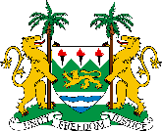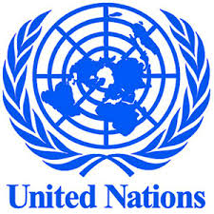
Joint Communiqué on the Establishment of the Sierra Leone Ebola Recovery Fund (SLERF)
The Government of Sierra Leone and the United Nations are delighted to announce the establishment of the Sierra Leone Ebola Recovery Fund (SLERF) to ensure the smooth implementation of the country’s National Ebola Recovery Strategy. The SLERF was developed and finalized with technical and financial support from the United Nations Development Programme in Sierra Leone.

The establishment of the Sierra Leone Ebola Recovery Fund (SLERF) follows the successful International UN Ebola Conference hosted by the Secretary-General Ban Ki-moon on 12 July 2015 in New York in which donors pledged US$3.4 billion to the three Ebola-affected countries in the Mano River Basin. Although an estimated US$894 million was pledged for Sierra Leone, the bulk of these pledges are repackaged financing from traditional development partners.
With this National Fund now established, the Government of Sierra Leone is seeking contributions from partners including donors who pledged at UN International Ebola conference, other governments, foundations, the private sector and the public at large. To demonstrate leadership and ownership, the Government of Sierra Leone is contributing US$ 1 million into the Trust Fund.
UNDP’s Multi-Partner Trust Fund Office (MPTF-O), which is appointed trustee of the fund, will perform its fiduciary role in accordance with the highest international standards in support of the governing body of the Fund – the Steering Board - which will be comprised of the Government, UN and contributing partners. The SLERF will ensure excellence and full transparency in receipt and administration of contributions, transfer of funding to approved projects and periodic reporting and monitoring highlighting achievements.

The Government of Sierra Leone took a leading role in responding to the Ebola crisis with support from international community. Furthermore, the United Nations Mission for Ebola Emergency Response (UNMEER) was set up to meet immediate needs related to the unprecedented fight against Ebola.
With the response now almost over, and the transition to recovery underway, the implementation of the National Ebola Recovery Strategy is critical to get the country back on its pre-Ebola development path. The NERS is being implemented over two phases (1) 6- 9 months period that focusses on getting to and staying at zero cases, (2) 10-24 months that focuses on implementing immediate recovery priorities in Health, Education, Energy, Water, Social Protection and Private Sector Development. The successful implementation of the 10-24 months phase will lay the foundation for transitioning back to the national development plan-Agenda for Prosperity, 2013-2018.
With the SLERF now operational, donors have a transparent and effective financing mechanism where they can place their pledges to support the Government of Sierra Leone in implementing its Ebola recovery strategy.

